CSc 8980 Spring 2020 - Dr. Daniel Takabi

Secure and Private AI Project

AbdulHaseeb Ahmed, Harnoor Singh, Naman Kanwar, Khushagra Patel

Georgia State University

Table of Contents

Attacks on Victim Model 2

Notes 2

Elastic Net Method 3

Carlini LInf Method 5

Carlini L2 Method 7

Basic Iterative Method 9

Jacobian Saliency Method 11

Universal Perturbation Method 13

DeepFool Method 15

Virtual Adversarial Method 17

Fast Gradient Sign Method 18

Attack Results Appendix 20

Elastic Net Method 20

Carlini LInf Method 42

Carlini L2 Method 64

Basic Iterative Method 87

Universal Perturbation Method 110

Jacobian Saliency Method 133

DeepFool Method 156

Fast Gradient Sign Method 179

# Attacks on Victim Model

## Notes

In this part of the project, we were able to implement nearly all the attacks described in the project rubric but due to attack specifics some of the attacks were not able to be implemented. These attacks include:

* High Confidence Low Uncertainty Attack
  + The reason why this attack was not implemented is because the classifier parameter of this attack only accepts “A trained model of type GPYGaussianProcessClassifier.” And since the victim model we are attacking is a Deep VGG style network trained on CIFAR-10, we could not implement this attack.
* Query-Efficient Black-Box Attack
  + The reason why this attack was not implemented is because the attack was NOT listed in the Adversarial Robustness Toolbox
* Decision Tree Attack
  + The reason why this attack was not implemented is because the classifier parameter of this attack only accepts “A trained model of type scikit decision tree.” And since the victim model we are attacking is a Deep VGG style network trained on CIFAR-10, we could not implement this attack.
* Adversarial patch
  + The reason why this attack was not implemented is because we could not figure out how to properly generate the patch and place it on top of the image. We did go through the limited resources online as well as within the ART toolbox, but we were still unable to properly implement this attack.
* Virtual Adversarial Method
  + The reason why this attack was not implemented is because the attack requires the output of the model to have probabilities in the range of [0, 1]. However, the attack detected probabilities smaller and larger than this range and since we cannot change the model itself, we could not fully implement this attack.

IMPORTANT NOTE:

As per our question in class, when we applied some attacks, we noticed that some images were not visually perturbed while the rest were. When we attacked our own model, which had an accuracy of 54% we found that all instances of the adversarial samples were perturbed (visible to naked eye). However, when we used the required victim model which had an accuracy of 94.5%, we found that a select few samples after being perturbed showed no visual sign of being perturbed. We consulted with Robert and he also did not find a reason to why this was happening. We tested single samples to make sure it was not a one-off incident, yet still, the problem was present. We assume that there might be some images with little to no loss when computed by the victim model that when any change is to be added to the image, the calculation results in a “value of 0” therefore the image was not altered.

## Elastic Net Method

|  |  |
| --- | --- |
| Average Accuracy Over 1 Run with max_iter = 100 | |
| Benign Samples | 94.52% |
| Confidence = 0.05 Samples | 2.0% |
| Confidence = 0.10 Samples | 2.0% |
| Confidence = 0.50 Samples | 2.0% |
| Confidence = 0.95 Samples | 2.0% |

|  |  |  |  |  |  |  |  |  |  |  |
| --- | --- | --- | --- | --- | --- | --- | --- | --- | --- | --- |
| Average Accuracy per Class Over 1 Run with max_iter = 100 | | | | | | | | | | |
|  | Airplane | Car | Bird | Cat | Deer | Dog | Frog | Horse | Ship | Truck |
| Benign Samples | 100% | 100% | 90% | 80% | 90% | 100% | 100% | 100% | 100% | 90% |
| Confidence = 0.05 Samples | 0% | 0% | 10% | 0% | 10% | 0% | 0% | 0% | 0% | 0% |
| Confidence = 0.10 Samples | 0% | 0% | 10% | 0% | 10% | 0% | 0% | 0% | 0% | 0% |
| Confidence = 0.50 Samples | 0% | 0% | 10% | 0% | 10% | 0% | 0% | 0% | 0% | 0% |
| Confidence = 0.95 Samples | 0% | 0% | 10% | 0% | 10% | 0% | 0% | 0% | 0% | 0% |

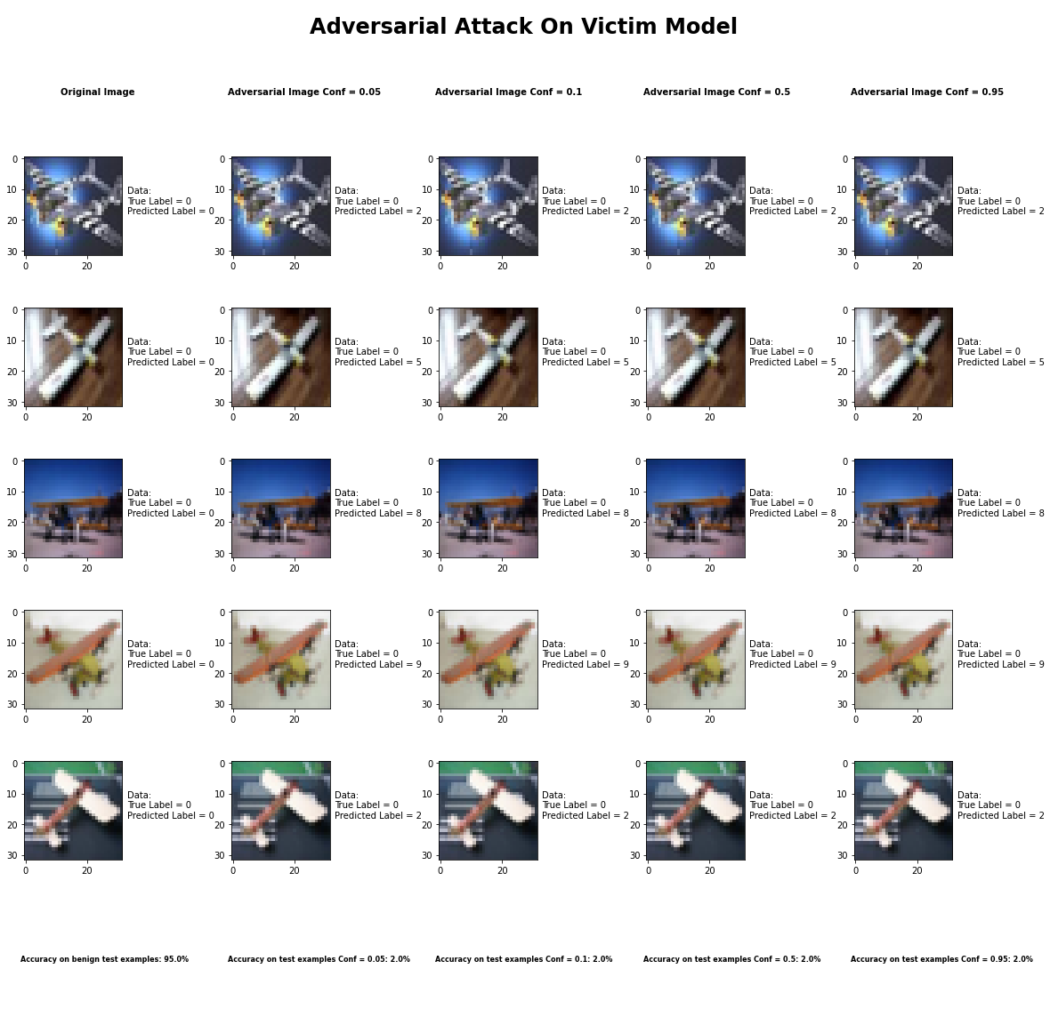

**Sample Output of the Elastic Net Attack**

**Metric 1: Is it targeted or not?**

We decided not to do a targeted attack with this attack because we were altering all 10 classes.

**Metric 2: What is the minimum modification that you need to introduce to achieve**

**misclassification?**

After experimenting with different parameters, it seemed like no matter what value we chose for the confidence parameter, the accuracy of the classifier remained the same. We decided to adjust the confidence parameter because a higher value produces examples that are farther away, from the original input, but classified with higher confidence as the target class. So, to answer the question, we would say that it is safe to say that any value for the confidence parameter will drastically reduce the accuracy of the classifier.

**Metric 3: How do you judge the visual impact of the modifications?**

The attack produced images that are completely imperceptible to the naked eye yet very good at causing misclassification.

**Metric 4: Is the attack consistent across all classes?**

For the most part the attack is consistent across all classes, however, the two classes where it the accuracy was better for the classifier was Birds and Deer.

**Metric 5: Is there a specific class the classifier tends to predict when it misclassifies the adversarial image?**

There is no specific class the classifier predicts when it misclassifies an adversarial example, for the most part it is a random class that the classifier predicts. It also depends on the true label of the class.

**Metric 6: How does varying the parameter of the attack effect both the accuracy and perceptibility of the adversarial example?**

As mentioned earlier, in this attack the confidence parameter was adjusted, however, no matter the change in the confidence parameter the results were the same. Also, it is worth mentioning that the max_iter was set to 100. Also, the confidence parameter always produced the same image perceptibility no matter the value of the confidence parameter.

## Carlini LInf Method

|  |  |
| --- | --- |
| Average Accuracy Over 10 Runs with learning_rate = 0.1 | |
| Benign Samples | 94.52% |
| Confidence = 0.05 Samples | 4.5% |
| Confidence = 0.10 Samples | 4.5% |
| Confidence = 0.50 Samples | 4.5% |
| Confidence = 0.95 Samples | 4.5% |

|  |  |  |  |  |  |  |  |  |  |  |
| --- | --- | --- | --- | --- | --- | --- | --- | --- | --- | --- |
| Average Accuracy per Class Over 10 Runs with learning_rate = 0.1 | | | | | | | | | | |
|  | Airplane | Car | Bird | Cat | Deer | Dog | Frog | Horse | Ship | Truck |
| Benign Samples | 96% | 99% | 93% | 83% | 97% | 89% | 100% | 95% | 93% | 92% |
| Confidence = 0.05 Samples | 2% | 0% | 7% | 13% | 2% | 8% | 0% | 2% | 5% | 6% |
| Confidence = 0.10 Samples | 2% | 0% | 7% | 13% | 2% | 8% | 0% | 2% | 5% | 6% |
| Confidence = 0.50 Samples | 2% | 0% | 7% | 13% | 2% | 8% | 0% | 2% | 5% | 6% |
| Confidence = 0.95 Samples | 2% | 0% | 7% | 13% | 2% | 8% | 0% | 2% | 5% | 6% |

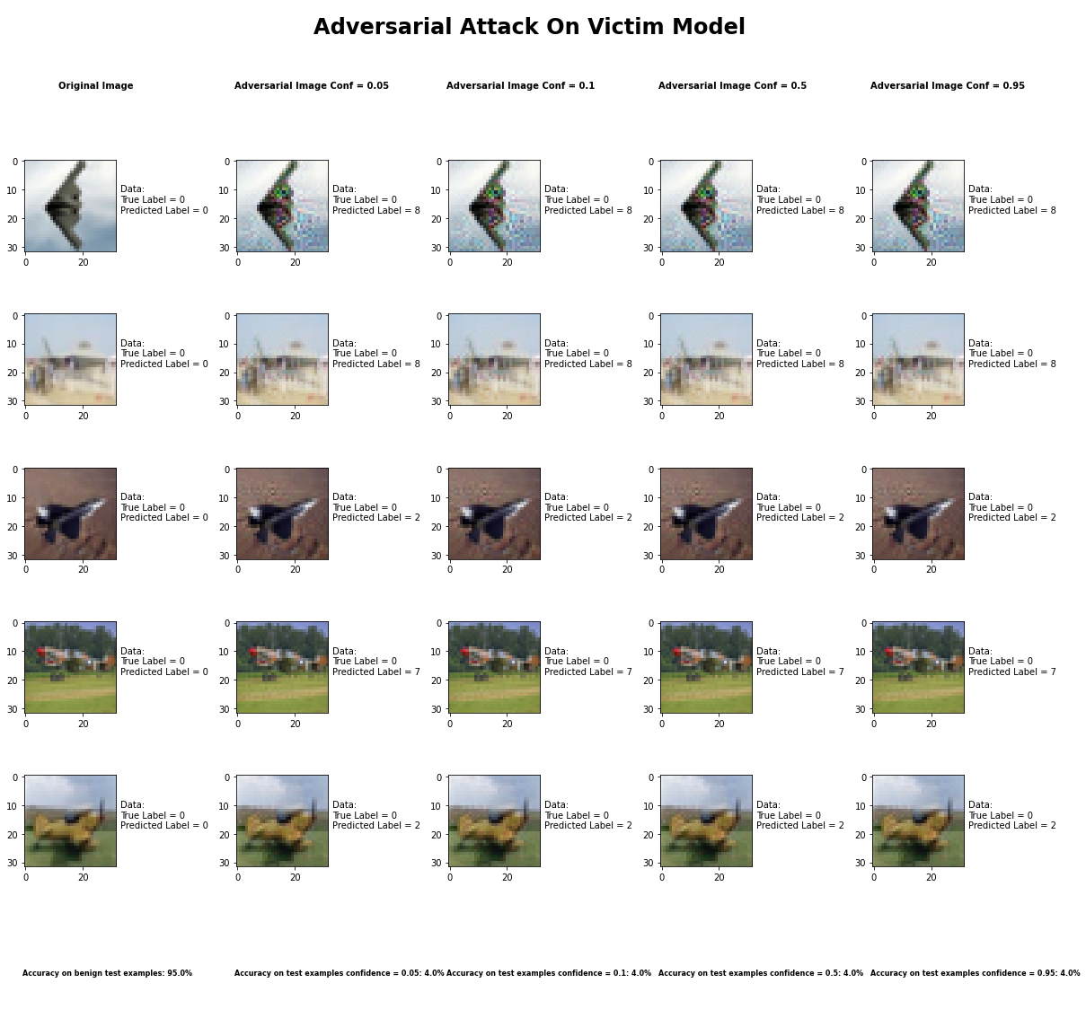

**Sample Output of the CarliniLInf Attack**

**Metric 1: Is it targeted or not?**

We decided not to do a targeted attack with this attack because we were altering all 10 classes.

**Metric 2: What is the minimum modification that you need to introduce to achieve**

**misclassification?**

After experimenting with different parameters, it seemed like no matter what value we chose for the confidence parameter, the accuracy of the classifier remained the same. We decided to adjust the confidence parameter because a higher value produces examples that are farther away, from the original input, but classified with higher confidence as the target class. So, to answer the question, we would say that it is safe to say that any value for the confidence parameter will drastically reduce the accuracy of the classifier.

**Metric 3: How do you judge the visual impact of the modifications?**

The attack produced images that have relatively little change to the image that is human perceptible. The way to describe the visual change is that it caused a slight blurring around the object in the image.

**Metric 4: Is the attack consistent across all classes?**

Within a certain degree the attack was consistent across all attacks, though it did perform exceptionally well for images labeled as cats when compared to all other classes.

**Metric 5: Is there a specific class the classifier tends to predict when it misclassifies the adversarial image?**

There is no specific class the classifier predicts when it misclassifies an adversarial example, for the most part it is a random class that the classifier predicts. It also depends on the true label of the class. Within the same class the mispredicted class are pretty consistent.

**Metric 6: How does varying the parameter of the attack effect both the accuracy and perceptibility of the adversarial example?**

As mentioned earlier, in this attack the confidence parameter was adjusted, however, no matter the change in the confidence parameter the results were the same, even after running the attack 10 times. Also, it is worth mentioning that the learning_rate was set to 0.1 in order to speed up the processing time. Also, the confidence parameter always produced the same image perceptibility no matter the value of the confidence parameter.

## Carlini L2 Method

|  |  |
| --- | --- |
| Average Accuracy Over 10 Runs with learning_rate = 0.1 | |
| Benign Samples | 94.52% |
| Confidence = 0.05 Samples | 4.8% |
| Confidence = 0.10 Samples | 4.8% |
| Confidence = 0.50 Samples | 4.8% |
| Confidence = 0.95 Samples | 4.8% |

|  |  |  |  |  |  |  |  |  |  |  |
| --- | --- | --- | --- | --- | --- | --- | --- | --- | --- | --- |
| Average Accuracy per Class Over 10 Runs with learning_rate = 0.1 | | | | | | | | | | |
|  | Airplane | Car | Bird | Cat | Deer | Dog | Frog | Horse | Ship | Truck |
| Benign Samples | 97% | 97% | 91% | 83% | 89% | 84% | 97% | 94% | 96% | 98% |
| Confidence = 0.05 Samples | 1% | 2% | 6% | 8% | 9% | 12% | 3% | 1% | 4% | 2% |
| Confidence = 0.10 Samples | 1% | 2% | 6% | 8% | 9% | 12% | 3% | 1% | 4% | 2% |
| Confidence = 0.50 Samples | 1% | 2% | 6% | 8% | 9% | 12% | 3% | 1% | 4% | 2% |
| Confidence = 0.95 Samples | 1% | 2% | 6% | 8% | 9% | 12% | 3% | 1% | 4% | 2% |

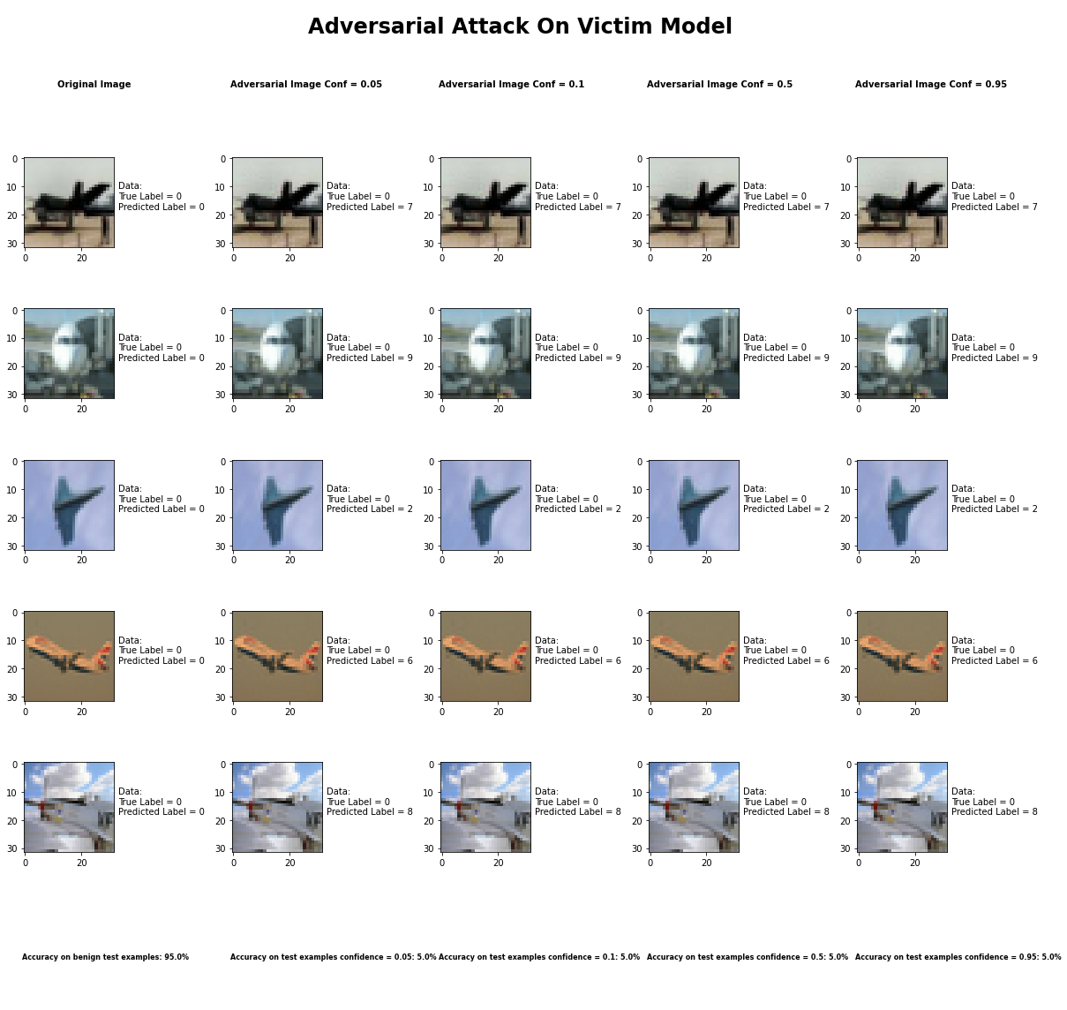

**Sample Output of the CarliniL2 Attack**

**Metric 1: Is it targeted or not?**

We decided not to do a targeted attack with this attack because we were altering all 10 classes.

**Metric 2: What is the minimum modification that you need to introduce to achieve**

**misclassification?**

After experimenting with different parameters, it seemed like no matter what value we chose for the confidence parameter, the accuracy of the classifier remained the same. We decided to adjust the confidence parameter because a higher value produces examples that are farther away, from the original input, but classified with higher confidence as the target class. So, to answer the question, we would say that it is safe to say that any value for the confidence parameter will drastically reduce the accuracy of the classifier.

**Metric 3: How do you judge the visual impact of the modifications?**

The attack produced images that have relatively little change to the image that is human perceptible. The way to describe the visual change is that it caused a slight blurring around the object in the image.

**Metric 4: Is the attack consistent across all classes?**

Within a certain degree the attack was consistent across all attacks, though it did perform exceptionally well for images labeled as dogs when compared to all other classes. This was the only real difference between the classes when compared with the Carlini LInf attack.

**Metric 5: Is there a specific class the classifier tends to predict when it misclassifies the adversarial image?**

There is no specific class the classifier predicts when it misclassifies an adversarial example, for the most part it is a random class that the classifier predicts. It also depends on the true label of the class. Within the same class the mispredicted class are pretty consistent.

**Metric 6: How does varying the parameter of the attack effect both the accuracy and perceptibility of the adversarial example?**

As mentioned earlier, in this attack the confidence parameter was adjusted, however, no matter the change in the confidence parameter the results were the same, even after running the attack 10 times. Also, it is worth mentioning that the learning_rate was set to 0.1 in order to speed up the processing time. Also, the confidence parameter always produced the same image perceptibility no matter the value of the confidence parameter.

## Basic Iterative Method

|  |  |
| --- | --- |
| Average Accuracy Over 10 Runs with max_iter = 100 | |
| Benign Samples | 94.52% |
| Epsilon = 0.10 Samples | 34.0% |
| Epsilon = 0.25 Samples | 32.3% |
| Epsilon = 0.50 Samples | 32.0% |
| Epsilon = 0.95 Samples | 32.1% |

|  |  |  |  |  |  |  |  |  |  |  |
| --- | --- | --- | --- | --- | --- | --- | --- | --- | --- | --- |
| Average Accuracy per Class Over 10 Runs with max_iter = 100 | | | | | | | | | | |
|  | Airplane | Car | Bird | Cat | Deer | Dog | Frog | Horse | Ship | Truck |
| Benign Samples | 99% | 96% | 94% | 87% | 97% | 88% | 95% | 97% | 93% | 93% |
| Epsilon = 0.10 Samples | 35% | 30% | 44% | 27% | 29% | 22% | 54% | 30% | 33% | 36% |
| Epsilon = 0.25 Samples | 35% | 28% | 41% | 27% | 28% | 22% | 47% | 30% | 31% | 34% |
| Epsilon = 0.50 Samples | 35% | 28% | 40% | 25% | 28% | 22% | 47% | 30% | 31% | 34% |
| Epsilon = 0.95 Samples | 36% | 28% | 40% | 25% | 28% | 22% | 47% | 30% | 31% | 34% |

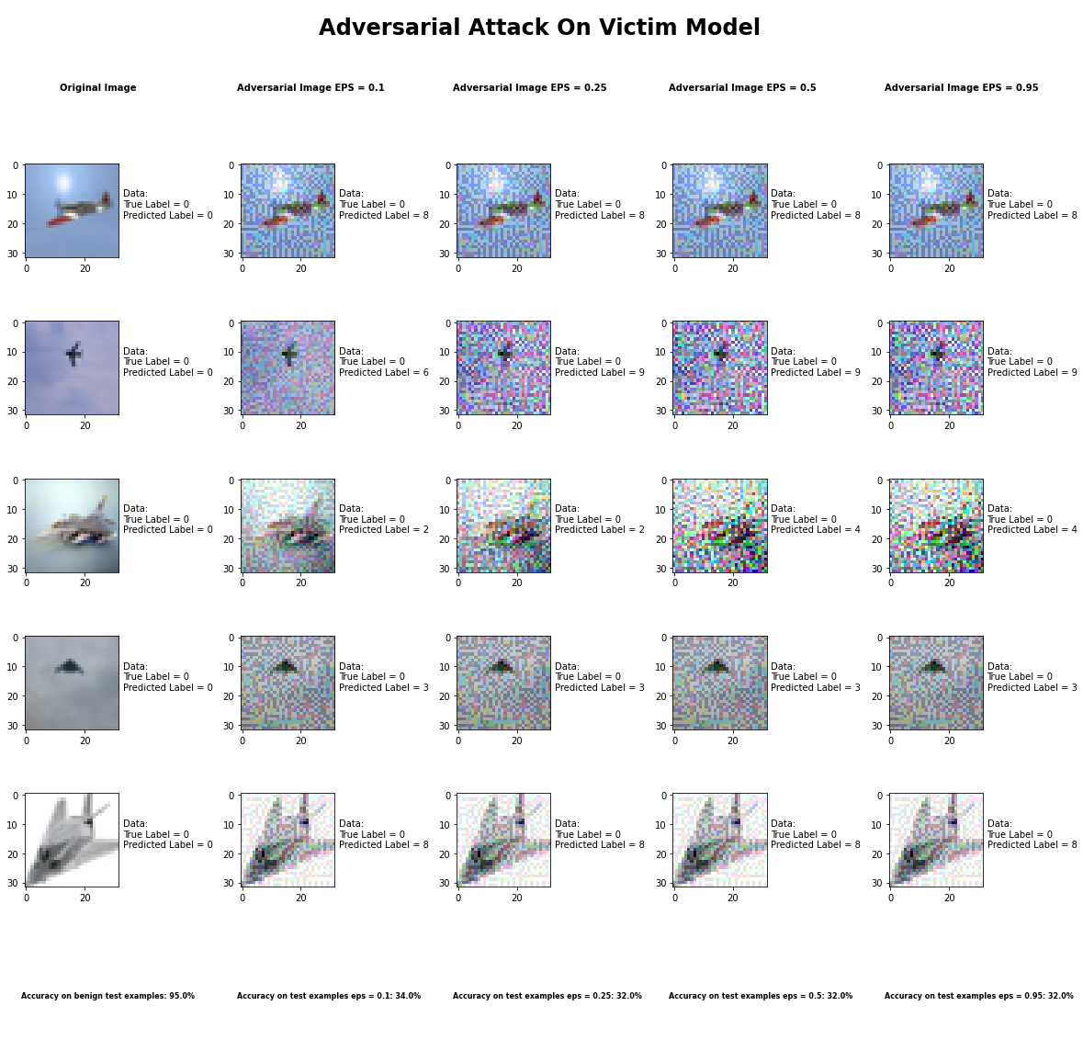

**Sample Output of the Basic Iterative Attack**

**Metric 1: Is it targeted or not?**

We decided not to do a targeted attack with this attack because we were altering all 10 classes.

**Metric 2: What is the minimum modification that you need to introduce to achieve**

**misclassification?**

After experimenting with different parameters, we found that the epsilon parameter was the one that actually caused the perturbation. The epsilon parameter is the value that is the “Maximum perturbation that the attacker can introduce”. We found that at even at a value of 0.05 for epsilon, visual modification was apparent to the naked eye. Starting at 0.1 it was without a doubt apparent. However, while adjusting the value of epsilon from 0.1 – 0.95 the accuracy of the classifier was right around 33% +- 1%.

**Metric 3: How do you judge the visual impact of the modifications?**

The attack produced images that have pretty significant alterations that are very visible. It produces a type of noise seen in old TV monitors.

**Metric 4: Is the attack consistent across all classes?**

Within a certain degree the attack was consistent across all attacks, though it did perform exceptionally well for images labeled as birds when compared to all other classes.

**Metric 5: Is there a specific class the classifier tends to predict when it misclassifies the adversarial image?**

There is no specific class the classifier predicts when it misclassifies an adversarial example, for the most part it is a random class that the classifier predicts. It also depends on the true label of the class. Within the same class the mispredicted class are pretty consistent.

**Metric 6: How does varying the parameter of the attack effect both the accuracy and perceptibility of the adversarial example?**

As mentioned earlier, in this attack the epsilon parameter was adjusted, however, no matter the change in the epsilon parameter the accuracy of the classifier was relatively the same, even after running the attack 10 times and taking the average. Also, it is worth mentioning that the max_iter was set to 100.

## Jacobian Saliency Method

|  |  |
| --- | --- |
| Average Accuracy Over 10 Runs with Theta = 0.05 | |
| Benign Samples | 94.52% |
| Gamma = 0.05 Samples | 12.5% |
| Gamma = 0.10 Samples | 2.1% |
| Gamma = 0.5 Samples | 0.2% |
| Gamma = 0.95 Samples | 0.1% |

|  |  |  |  |  |  |  |  |  |  |  |
| --- | --- | --- | --- | --- | --- | --- | --- | --- | --- | --- |
| Average Accuracy per Class Over 10 Runs with Theta = 0.05 | | | | | | | | | | |
|  | Airplane | Car | Bird | Cat | Deer | Dog | Frog | Horse | Ship | Truck |
| Benign Samples | 97% | 99% | 92% | 87% | 94% | 84% | 98% | 97% | 99% | 96% |
| Gamma = 0.05 Samples | 19% | 34% | 7% | 4% | 2% | 5% | 7% | 10% | 20% | 17% |
| Gamma = 0.10 Samples | 2% | 6% | 1% | 4% | 0% | 3% | 0% | 1% | 1% | 3% |
| Gamma = 0.5 Samples | 0% | 0% | 0% | 1% | 1% | 0% | 0% | 0% | 0% | 0% |
| Gamma = 0.95 Samples | 0% | 0% | 0% | 1% | 0% | 0% | 0% | 0% | 0% | 0% |

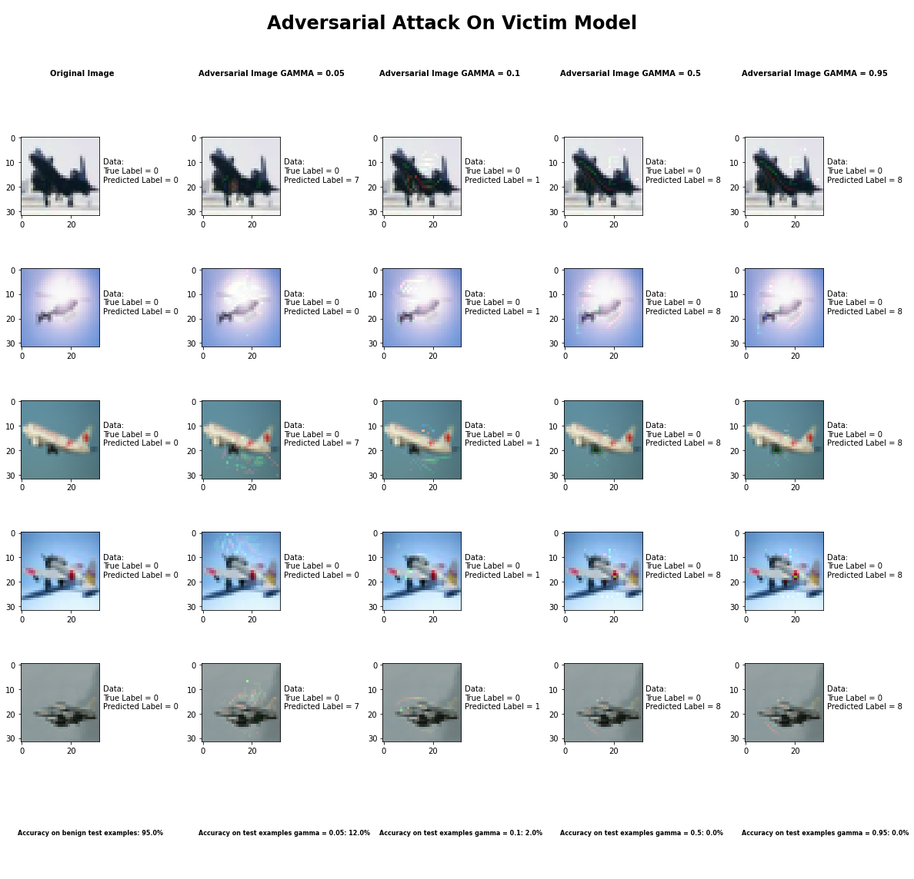

**Sample Output of the Jacobian Saliency Map Attack**

**Metric 1: Is it targeted or not?**

We decided not to do a targeted attack with this attack because we were altering all 10 classes.

**Metric 2: What is the minimum modification that you need to introduce to achieve**

**misclassification?**

After experimenting with different parameters, we found that the gamma parameter was the one that actually caused the perturbation that produced the least human perceptible changes. The gamma parameter is the value that is the “Maximum fraction of features being perturbed (between 0 and 1)”. We also found that the theta parameter is used to set the “Amount of Perturbation introduced to each modified feature per step (can be positive or negative)”.

We found that setting theta close to 0 and adjusting gamma gave the best results even though it was human perceptible in some areas of the image. The minimum modification required to drop the accuracy of the classifier was gamma = 0.05 and theta = 0.05. Increasing gamma to close to 1 gave accuracies of less than 1% even though the image itself seemed not too much more altered when gamma was close to 0.

**Metric 3: How do you judge the visual impact of the modifications?**

The attack produced images that have pretty significant alterations that are very visible but rather than being across the entire image, they are isolated in certain regions of the image. It produces a type of noise that are similar in appearance to a checkerboard.

**Metric 4: Is the attack consistent across all classes?**

This attack was pretty consistent across all classes for values of gamma greater than 0.1. However, for gamma = 0.05 the attack did better on cars when compared with other classes.

**Metric 5: Is there a specific class the classifier tends to predict when it misclassifies the adversarial image?**

There is a high correlation with a specific class that the classifier misclassifies the image with. However, it is a class by class bases as well as specific to each gamma value used.

**Metric 6: How does varying the parameter of the attack effect both the accuracy and perceptibility of the adversarial example?**

As mentioned earlier, in this attack the gamma parameter was adjusted, and adjusting it gave significant differences in accuracy. Basically:

* Keeping Gamma variable, and Theta close to 0 gave results with least perceptible changes
* Keeping Gamma variable with Theta close to abs(1) gave results with most noticeable changes
* Keeping Theta variable makes changes to image that make it seem to fade out as you get close to theta = 0
* Keeping Gamma variable increase area of changes in image, small gamma means smaller area

## Universal Perturbation Method

|  |  |
| --- | --- |
| Average Accuracy Over 10 Runs with FGSM | |
| Benign Samples | 94.52% |
| Delta = 0.05 Samples | 10.6% |
| Delta = 0.10 Samples | 9.1% |
| Delta = 0.5 Samples | 10.5% |
| Delta = 0.95 Samples | 10.4% |

|  |  |  |  |  |  |  |  |  |  |  |
| --- | --- | --- | --- | --- | --- | --- | --- | --- | --- | --- |
| Average Accuracy per Class Over 10 Runs with FGSM | | | | | | | | | | |
|  | Airplane | Car | Bird | Cat | Deer | Dog | Frog | Horse | Ship | Truck |
| Benign Samples | 94% | 97% | 93% | 95% | 97% | 90% | 96% | 98% | 94% | 96% |
| Delta = 0.05 Samples | 54% | 1% | 0% | 0% | 0% | 0% | 2% | 0% | 0% | 49% |
| Delta = 0.10 Samples | 36% | 2% | 0% | 11% | 0% | 1% | 0% | 0% | 0% | 41% |
| Delta = 0.5 Samples | 37% | 21% | 0% | 1% | 0% | 1% | 10% | 0% | 0% | 35% |
| Delta = 0.95 Samples | 56% | 5% | 0% | 2% | 0% | 1% | 3% | 9% | 0% | 28% |

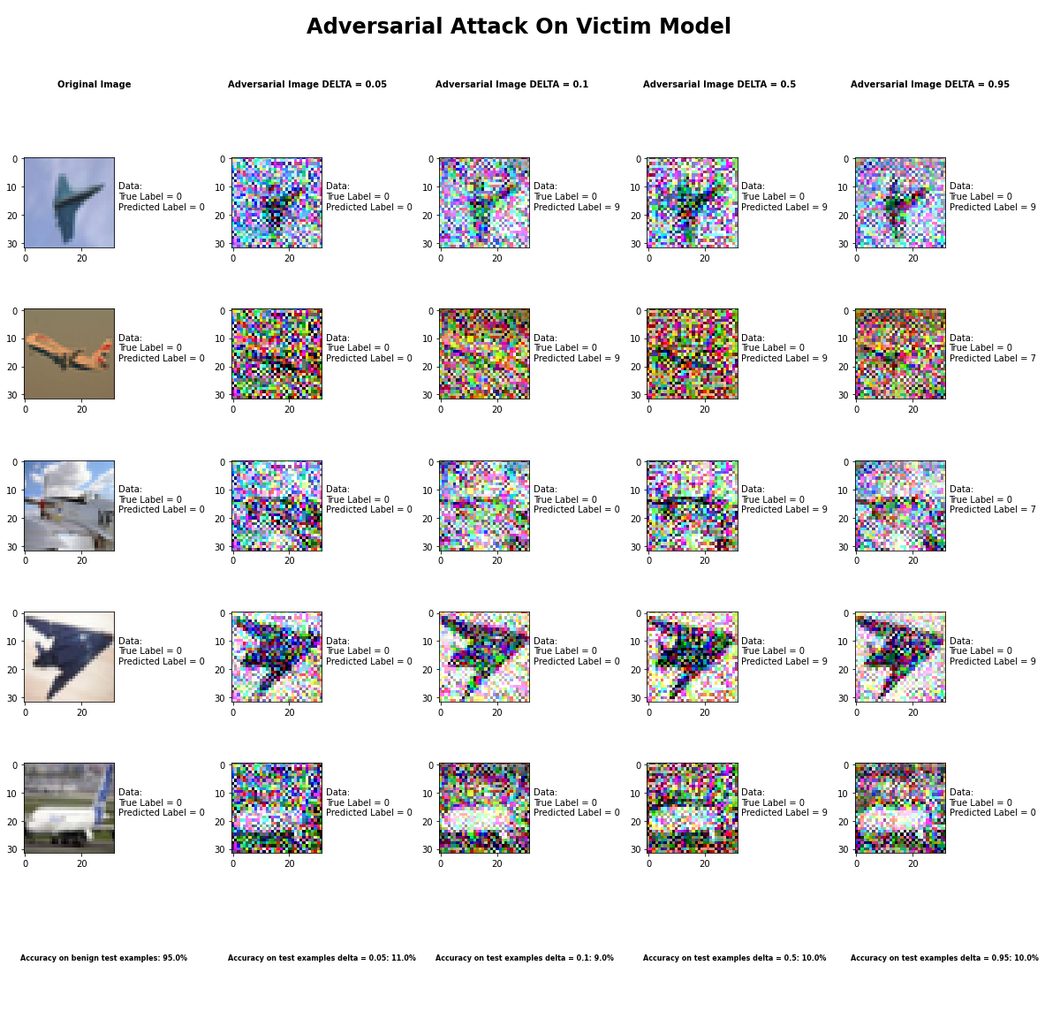

**Sample Output of the Universal Perturbation Attack**

**Metric 1: Is it targeted or not?**

We decided not to do a targeted attack with this attack because we were altering all 10 classes.

**Metric 2: What is the minimum modification that you need to introduce to achieve**

**misclassification?**

After experimenting with different parameters, we found that the delta parameter was the one that actually needed to be adjusted with this attack. This attack can use any other attack as its baseline attack therefore the parameter for the baseline attack are for the most part already predefined. The only parameter inherent with the attack itself, i.e. Universal Perturbation attack, was the delta parameter. The delta parameter is the value that is used to set the “desired accuracy”. We found that setting delta between 0 and 1 and using the FGSM as our baseline attack, we got accuracies in the range of 10% +- 1%. Since the delta value itself did not cause much change in the accuracy we would say that with FGSM as the baseline attack and any value of delta will cause the enough noise to cause a misclassification

**Metric 3: How do you judge the visual impact of the modifications?**

The attack produced images that have pretty significant alterations that are very visible and are similar to the Basic Iterative Method more so than the FGSM attack even though the baseline attack used was FGSM. This was probably the case because of the delta parameter.

**Metric 4: Is the attack consistent across all classes?**

This attack was pretty consistent across all classes except airplanes and trucks. These two classes had accuracies closer to 40-50% across all values of delta.

**Metric 5: Is there a specific class the classifier tends to predict when it misclassifies the adversarial image?**

There is no specific class the classifier predicts when it misclassifies an adversarial example, for the most part it is a random class that the classifier predicts.

**Metric 6: How does varying the parameter of the attack effect both the accuracy and perceptibility of the adversarial example?**

Varying delta did not alter the accuracy range as much. For values of 0 – 1 for delta, the accuracy of the classifier with FGSM as the baseline attack, stayed close to 10%.

## DeepFool Method

|  |  |
| --- | --- |
| Average Accuracy Over 10 Runs | |
| Benign Samples | 94.52% |
| Epsilon = 1e-6 Samples | 30.2% |
| Epsilon = 1e-3 Samples | 31.3% |
| Epsilon = 1e-1 Samples | 30.1% |
| Epsilon = 1 Samples | 31.0% |

|  |  |  |  |  |  |  |  |  |  |  |
| --- | --- | --- | --- | --- | --- | --- | --- | --- | --- | --- |
| Average Accuracy per Class Over 10 Runs | | | | | | | | | | |
|  | Airplane | Car | Bird | Cat | Deer | Dog | Frog | Horse | Ship | Truck |
| Benign Samples | 95% | 92% | 96% | 86% | 95% | 88% | 99% | 93% | 94% | 98% |
| Epsilon = 1e-6 Samples | 42% | 45% | 27% | 29% | 37% | 20% | 26% | 21% | 32% | 26% |
| Epsilon = 1e-3 Samples | 46% | 51% | 31% | 26% | 33% | 22% | 24% | 25% | 30% | 24% |
| Epsilon = 1e-1 Samples | 46% | 48% | 24% | 22% | 38% | 23% | 29% | 24% | 28% | 21% |
| Epsilon = 1  Samples | 46% | 41% | 28% | 24% | 35% | 22% | 25% | 26% | 32% | 18% |

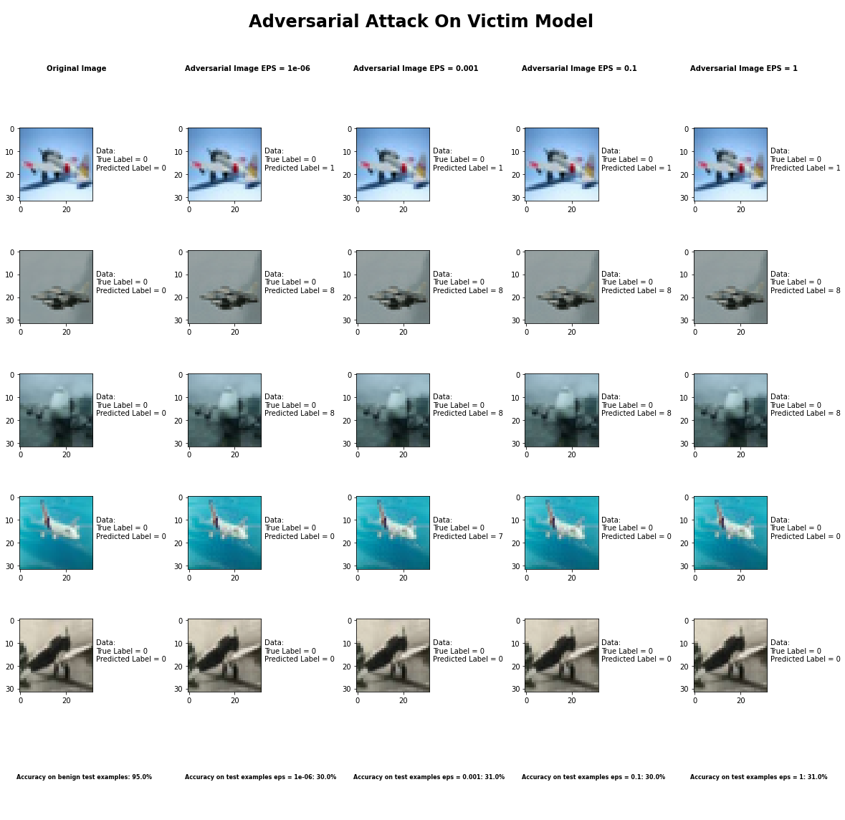

**Sample Output of the DeepFool Attack**

**Metric 1: Is it targeted or not?**

We decided not to do a targeted attack with this attack because we were altering all 10 classes.

**Metric 2: What is the minimum modification that you need to introduce to achieve**

**misclassification?**

After experimenting with different parameters, we found that the epsilon parameter was the one that actually needed to be adjusted with this attack. This attack can push the prediction to the closest hyperplane other than the true hyperplane. The epsilon parameter is the value that is used to set the “overshoot parameter”. We found by adjusting epsilon, we got accuracies in the range of 30.5% +- 1%. Since varying epsilon did not cause significant change between accuracies, any value of epsilon is enough to be consider minimum modification required to cause misclassification.

**Metric 3: How do you judge the visual impact of the modifications?**

The attack produced images that are completely imperceptible to the naked eye yet very good at causing misclassification.

**Metric 4: Is the attack consistent across all classes?**

This attack was pretty consistent across all classes though it had a high average for correctly classifying airplanes and cars across all values of epsilon.

**Metric 5: Is there a specific class the classifier tends to predict when it misclassifies the adversarial image?**

There is no specific class the classifier predicts when it misclassifies an adversarial example, for the most part it is a random class that the classifier predicts.

**Metric 6: How does varying the parameter of the attack effect both the accuracy and perceptibility of the adversarial example?**

Varying epsilon did not alter the accuracy range as much. For values of 1e-6– 1 for epsilon, the accuracy of the classifier, stayed close to 30%. Also, no matter the value of epsilon, the adversarial image always remained imperceptible.

## Virtual Adversarial Method

|  |  |
| --- | --- |
| Average Accuracy Over 10 Runs | |
| Benign Samples | 94.52% |
| Epsilon = 0.05 Samples | 48.4% |
| Epsilon = 0.10 Samples | 39.9% |
| Epsilon = 0.5 Samples | 35.3% |
| Epsilon = 0.95 Samples | 35.3% |

|  |  |  |  |  |  |  |  |  |  |  |
| --- | --- | --- | --- | --- | --- | --- | --- | --- | --- | --- |
| Average Accuracy per Class Over 10 Runs | | | | | | | | | | |
|  | Airplane | Car | Bird | Cat | Deer | Dog | Frog | Horse | Ship | Truck |
| Benign Samples | 98% | 96% | 95% | 86% | 96% | 84% | 96% | 93% | 99% | 97% |
| Epsilon = 0.05 Samples | 32% | 60% | 68% | 42% | 43% | 31% | 60% | 33% | 58% | 57% |
| Epsilon = 0.10 Samples | 30% | 40% | 70% | 34% | 28% | 23% | 68% | 24% | 45% | 37% |
| Epsilon = 0.5 Samples | 33% | 40% | 34% | 37% | 20% | 23% | 26% | 24% | 45% | 71% |
| Epsilon = 0.95 Samples | 30% | 35% | 34% | 32% | 20% | 23% | 26% | 23% | 45% | 87% |

## Fast Gradient Sign Method

|  |  |
| --- | --- |
| Average Accuracy Over 10 Runs | |
| Benign Samples | 94.52% |
| Epsilon = 0.05 Samples | 48.4% |
| Epsilon = 0.10 Samples | 39.9% |
| Epsilon = 0.5 Samples | 35.3% |
| Epsilon = 0.95 Samples | 35.3% |

|  |  |  |  |  |  |  |  |  |  |  |
| --- | --- | --- | --- | --- | --- | --- | --- | --- | --- | --- |
| Average Accuracy per Class Over 10 Runs | | | | | | | | | | |
|  | Airplane | Car | Bird | Cat | Deer | Dog | Frog | Horse | Ship | Truck |
| Benign Samples | 98% | 96% | 95% | 86% | 96% | 84% | 96% | 93% | 99% | 97% |
| Epsilon = 0.05 Samples | 32% | 60% | 68% | 42% | 43% | 31% | 60% | 33% | 58% | 57% |
| Epsilon = 0.10 Samples | 30% | 40% | 70% | 34% | 28% | 23% | 68% | 24% | 45% | 37% |
| Epsilon = 0.5 Samples | 33% | 40% | 34% | 37% | 20% | 23% | 26% | 24% | 45% | 71% |
| Epsilon = 0.95 Samples | 30% | 35% | 34% | 32% | 20% | 23% | 26% | 23% | 45% | 87% |

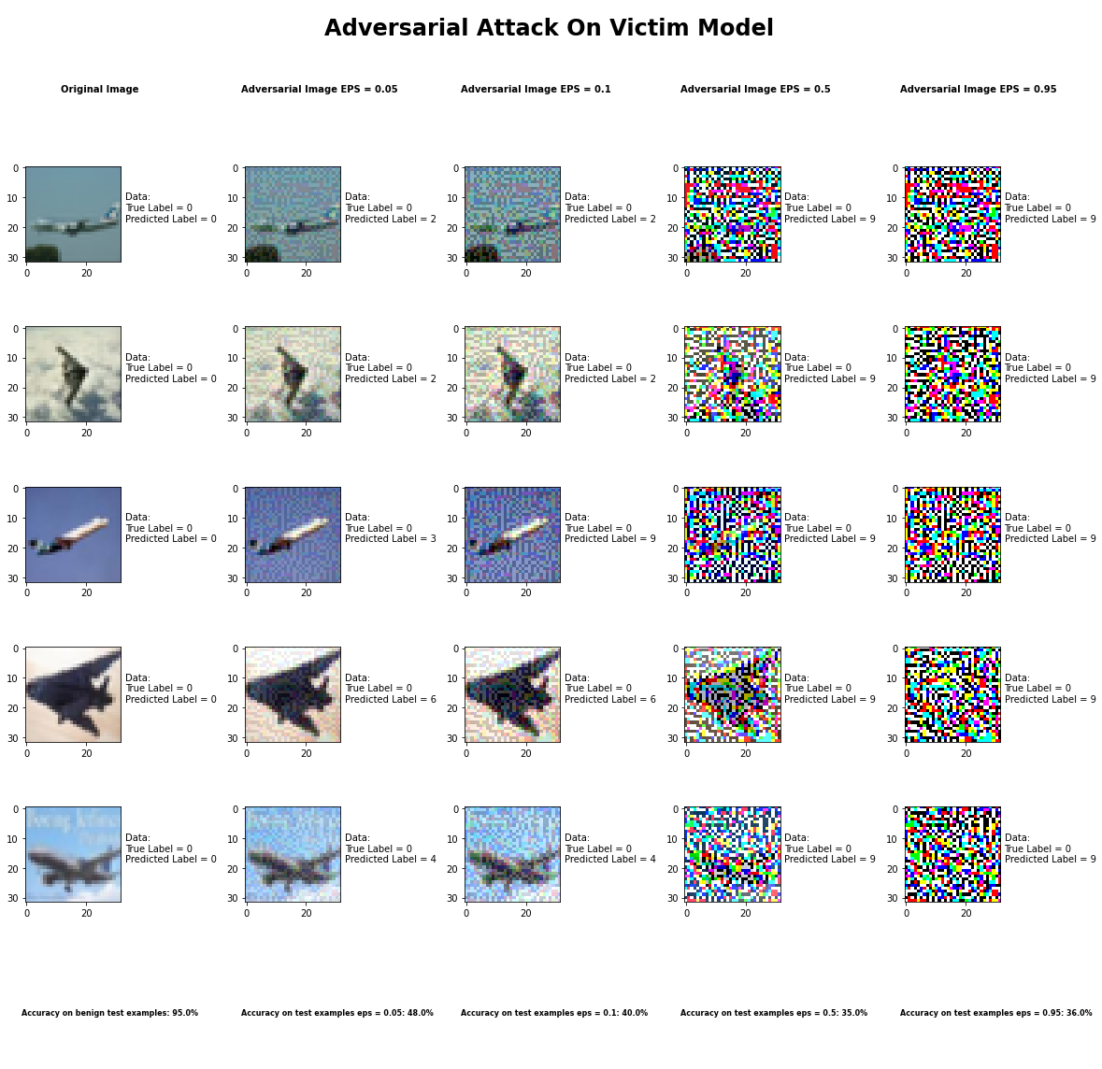

**Sample Output of the Fast Gradient Sign Method Attack**

**Metric 1: Is it targeted or not?**

We decided not to do a targeted attack with this attack because we were altering all 10 classes.

**Metric 2: What is the minimum modification that you need to introduce to achieve**

**misclassification?**

After experimenting with different parameters, we found that the epsilon parameter was the one that actually needed to be adjusted with this attack. The epsilon parameter is the value that is used to set the “Attack step size (input variation)”. We found by adjusting epsilon, we got accuracies in the range of 35% - 50%. Setting epsilon close to 0 like 0.05, will be the minimum modification that needs to be introduced to achieve misclassification.

**Metric 3: How do you judge the visual impact of the modifications?**

The attack produced images that are nearly imperceptible to the naked eye for epsilon values < 0.1 and very perceptible for epsilon values > 0.25.

**Metric 4: Is the attack consistent across all classes?**

This attack, as an average, was pretty consistent across all classes.

**Metric 5: Is there a specific class the classifier tends to predict when it misclassifies the adversarial image?**

There is no specific class the classifier predicts when it misclassifies an adversarial example, it is pretty random when it comes to the class that the classifier predicts.

**Metric 6: How does varying the parameter of the attack effect both the accuracy and perceptibility of the adversarial example?**

When epsilon is increasing the accuracy diminishes as does the integrity of the image, i.e. very noticeable to the human eye. Smaller values of epsilon also produce low accuracy but are not as apparent to the human eye.

# Attack Results Appendix

## Elastic Net Method



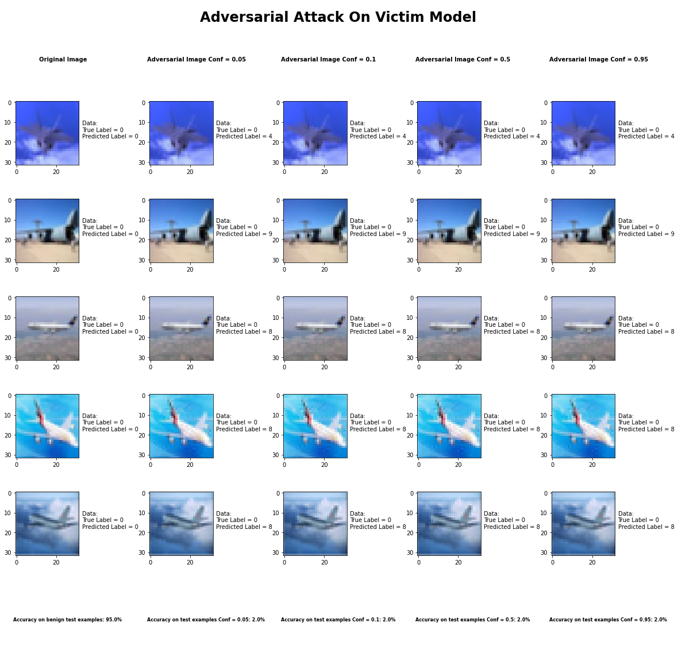

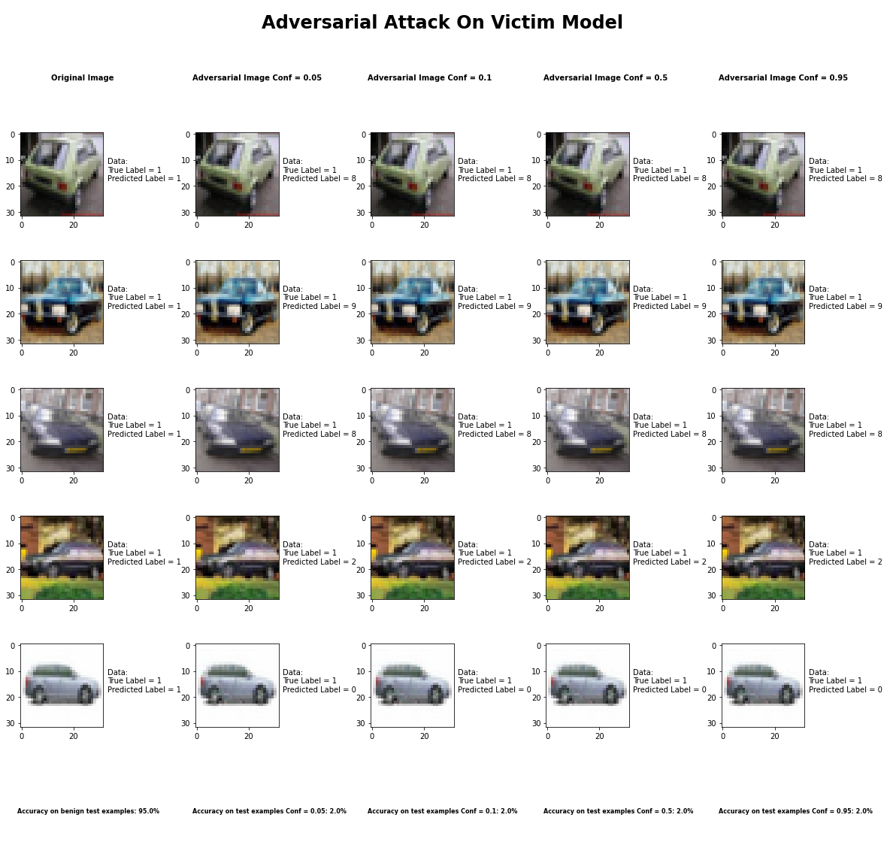

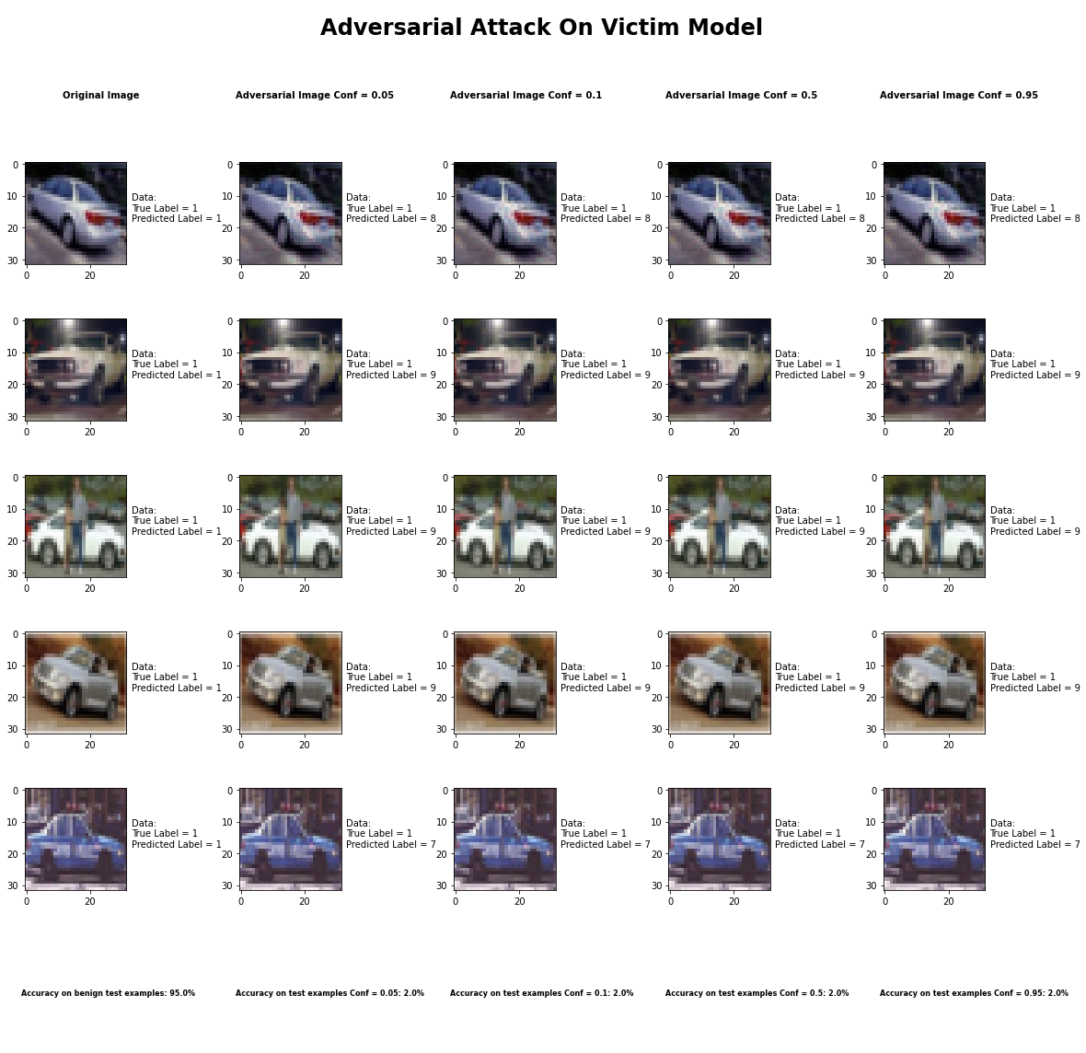

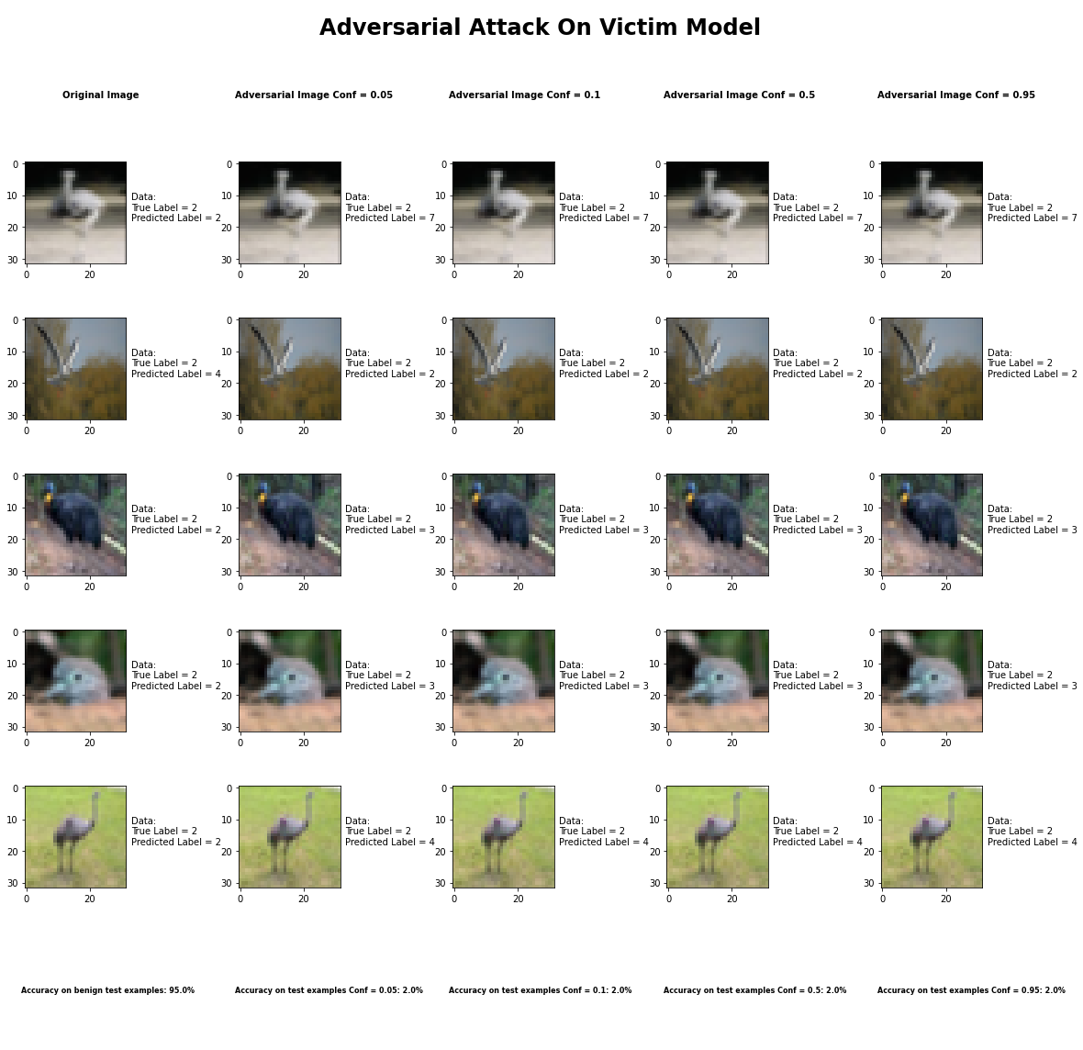

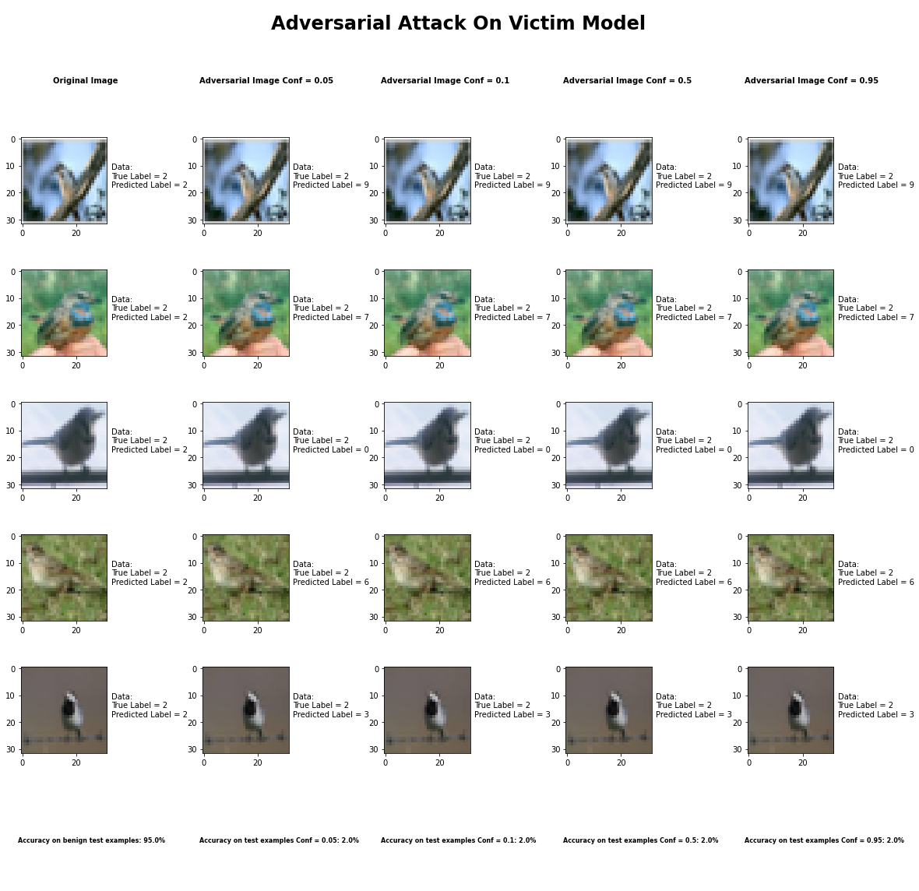

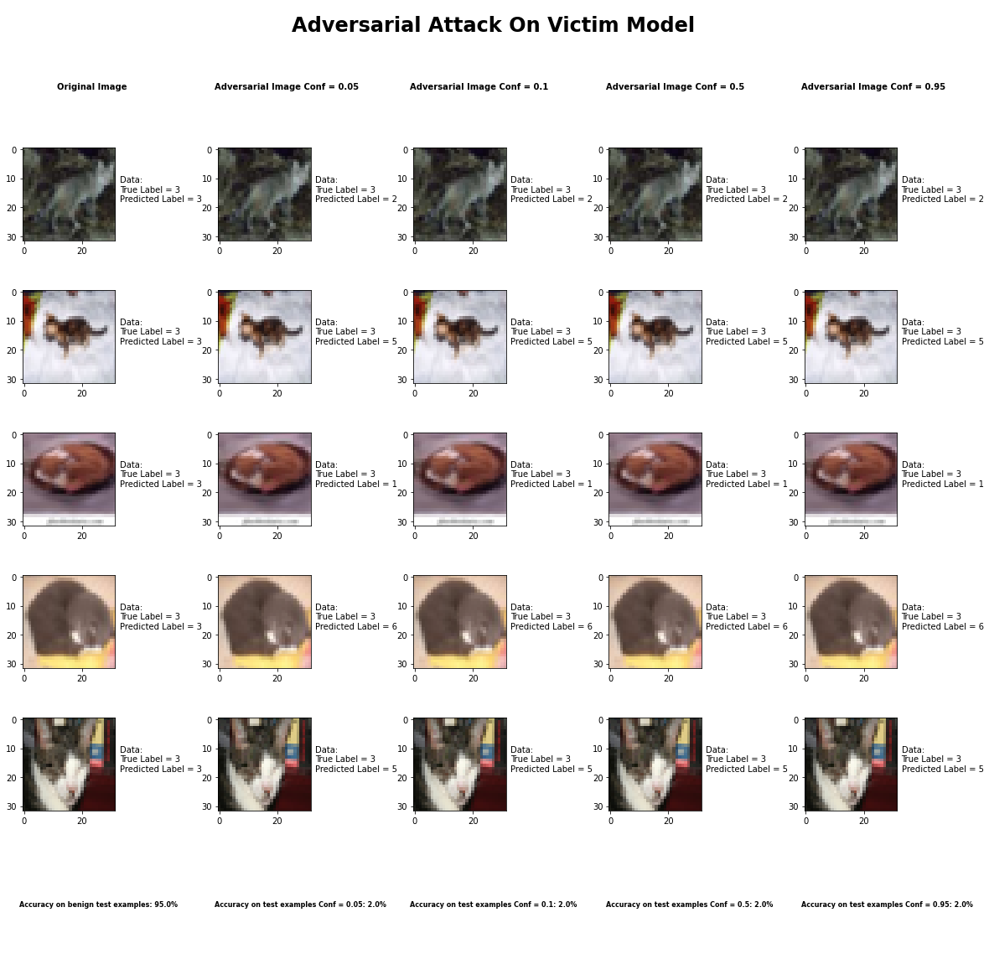

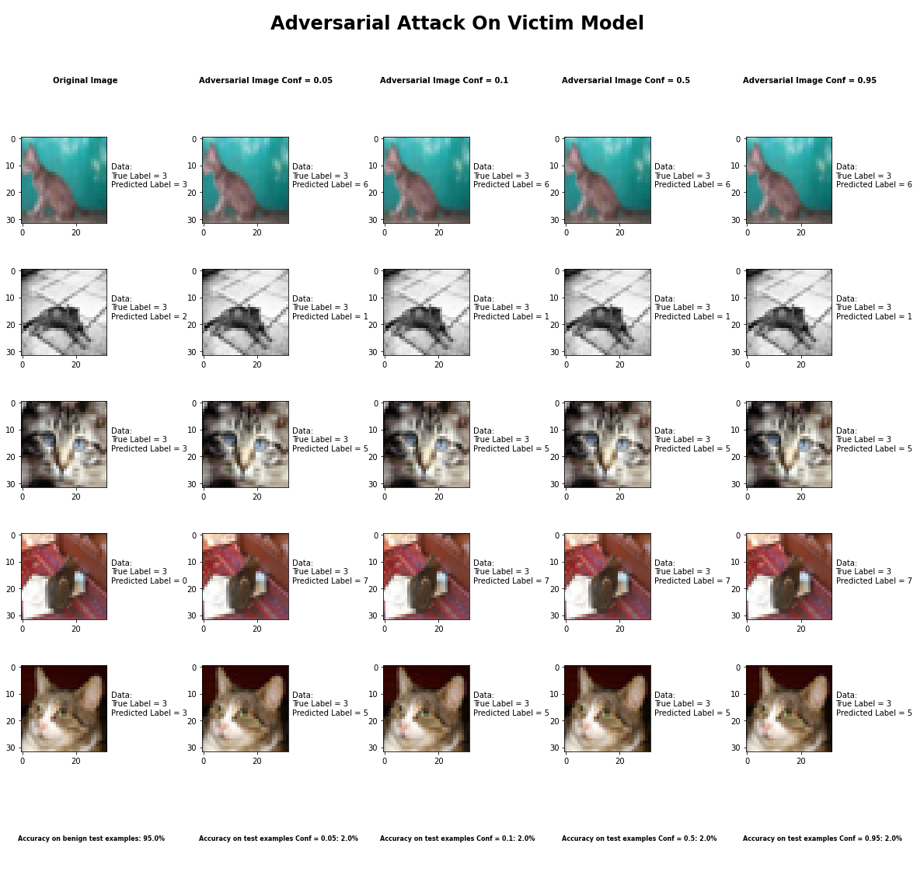

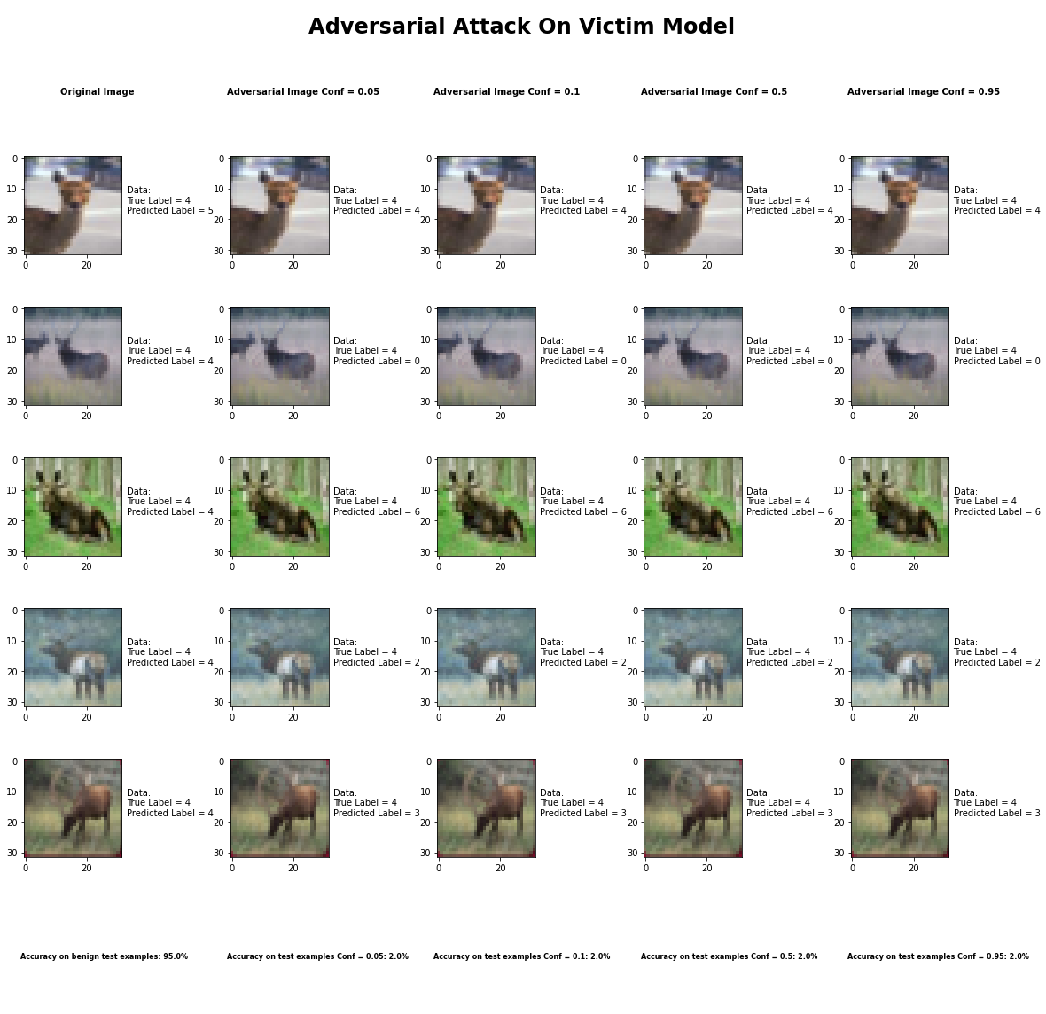

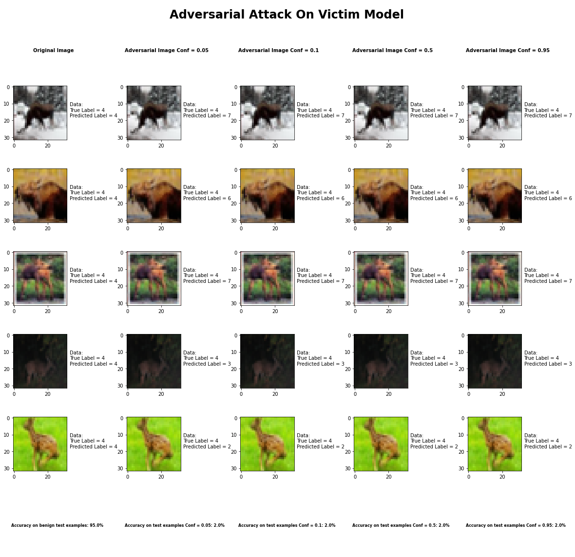

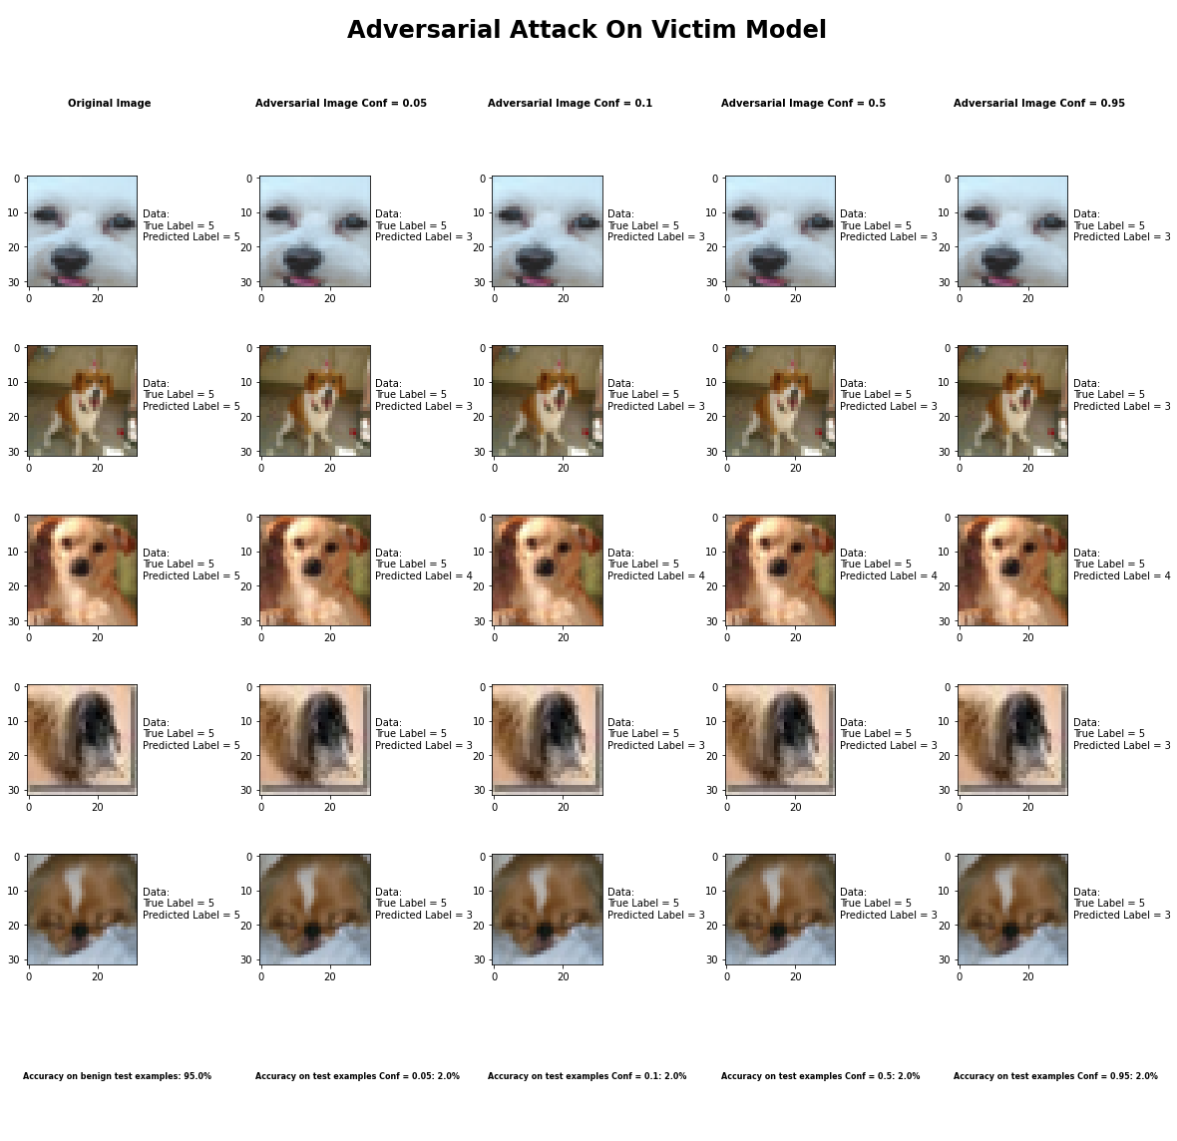

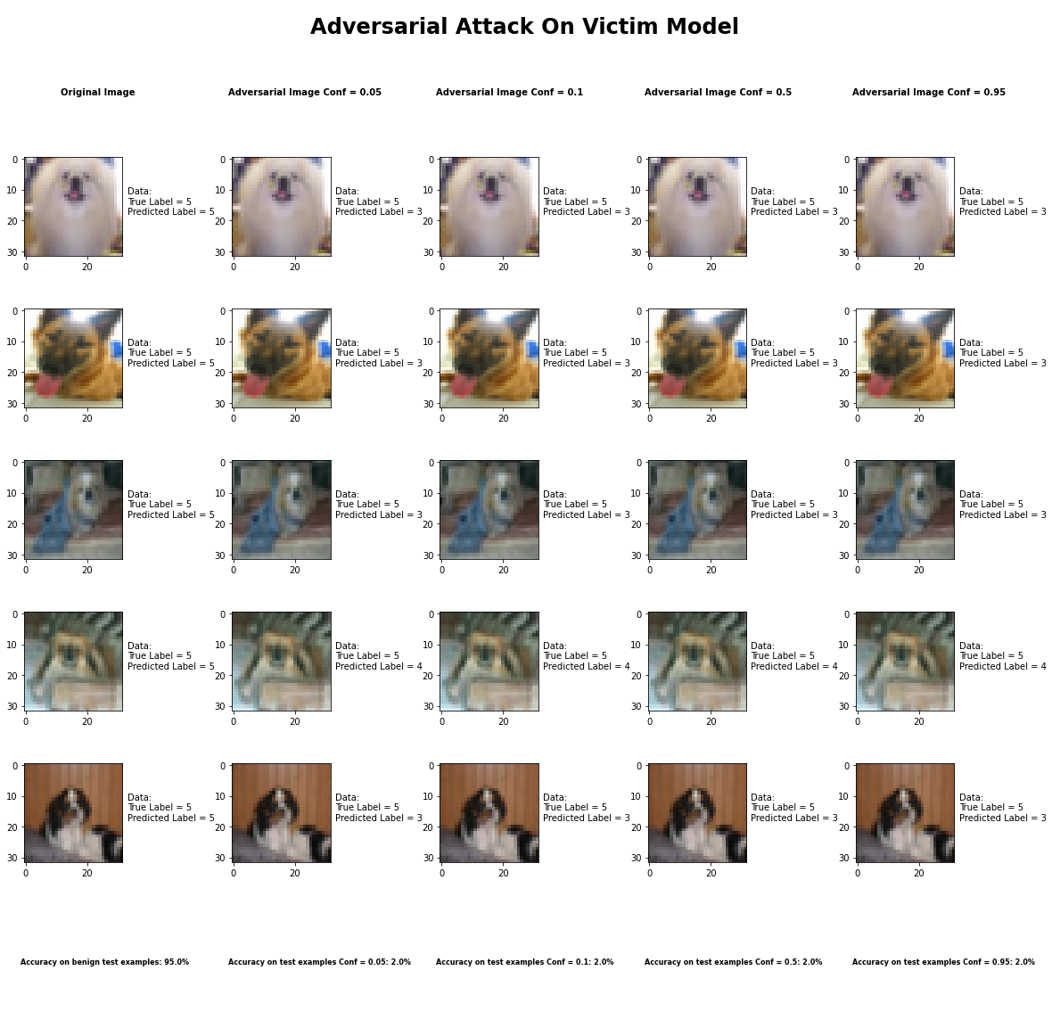

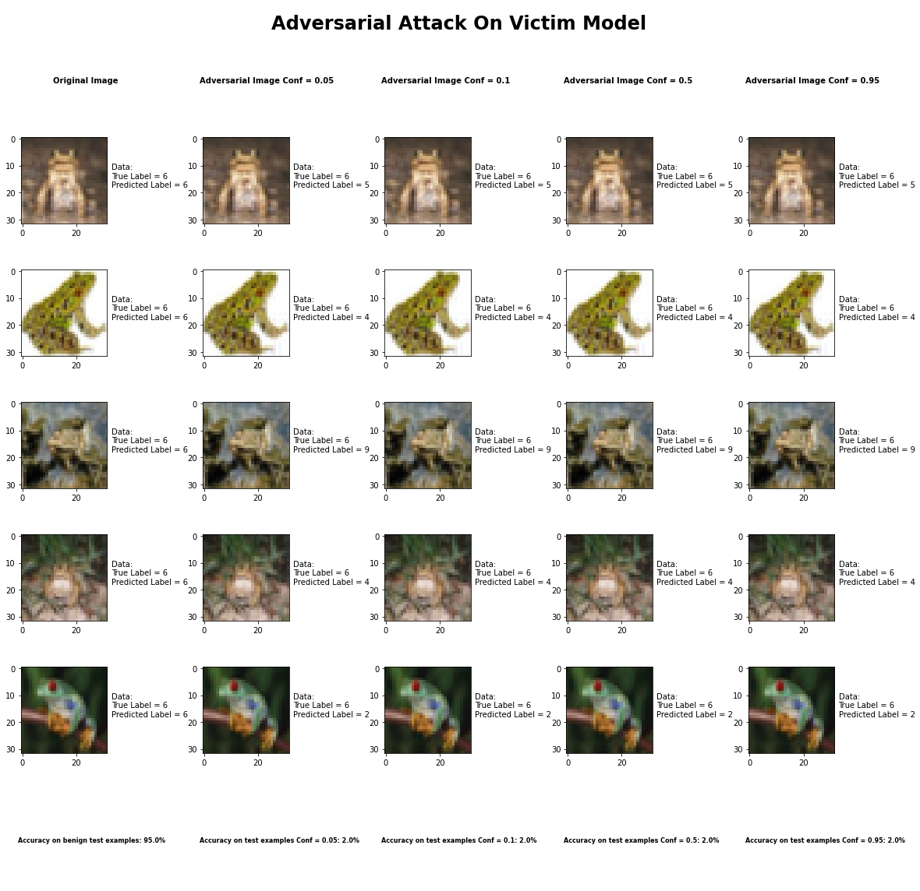

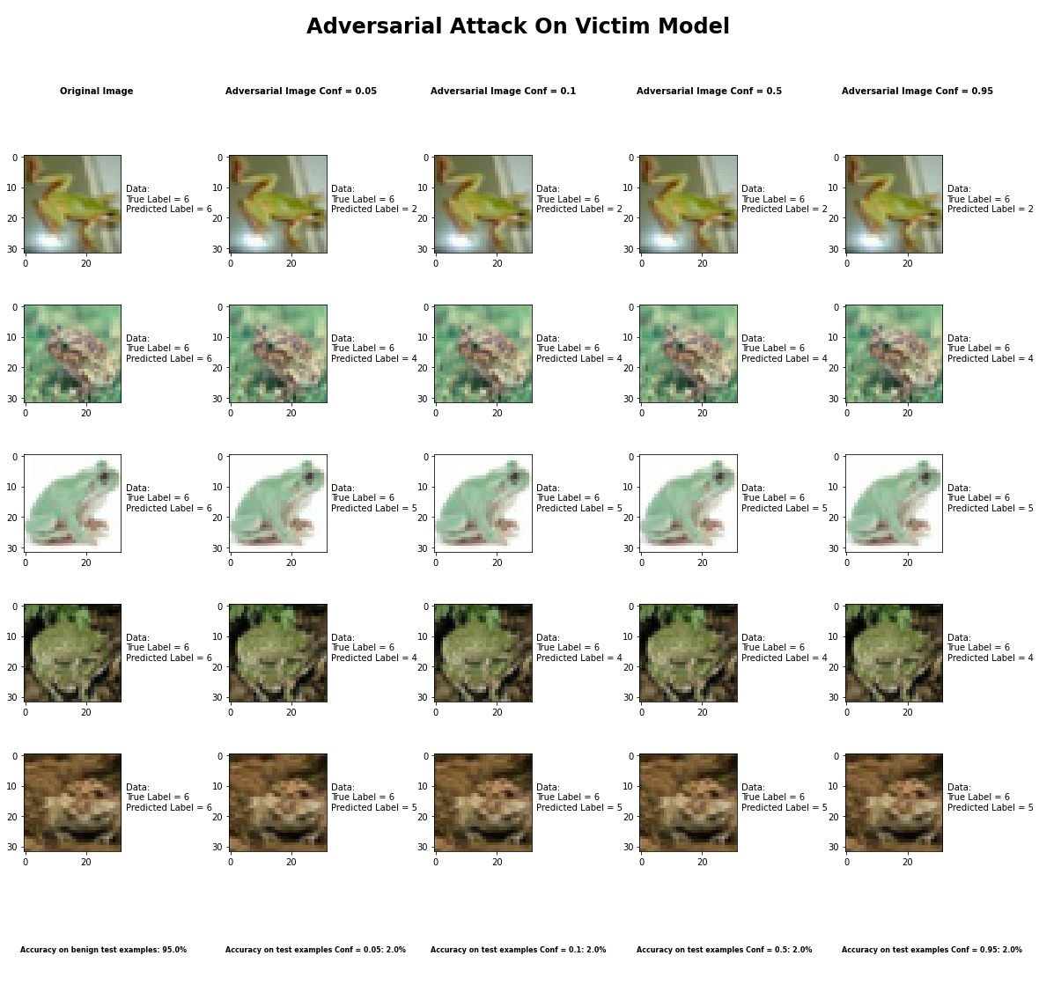

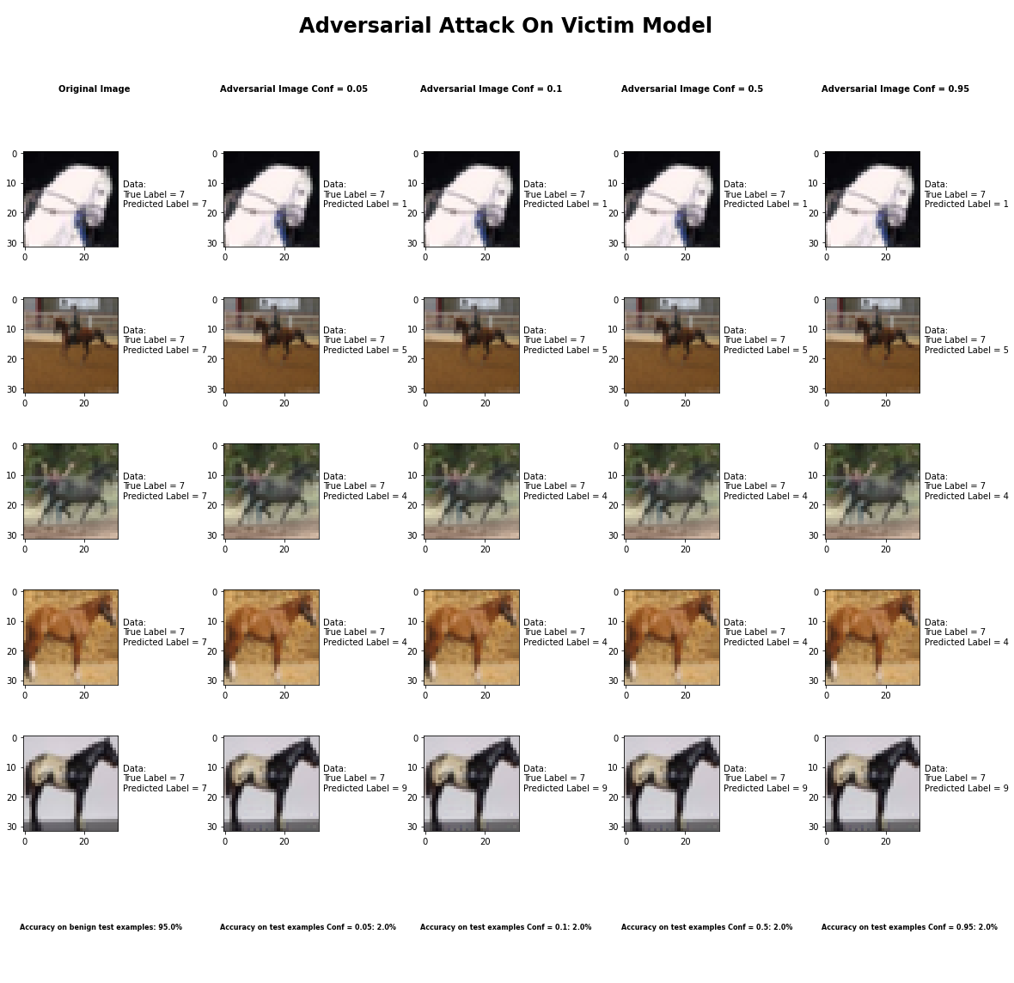

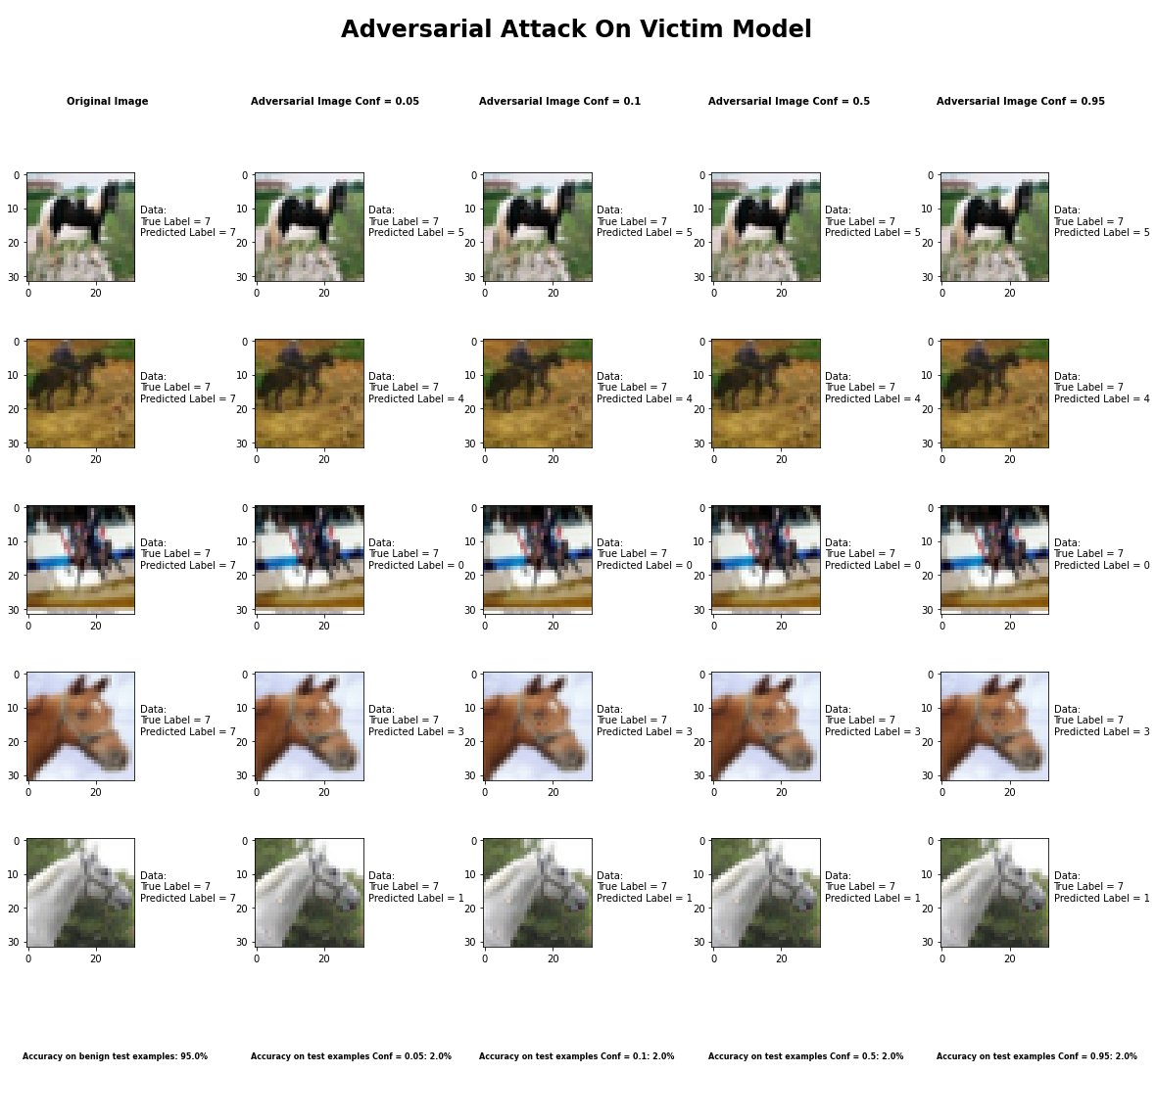



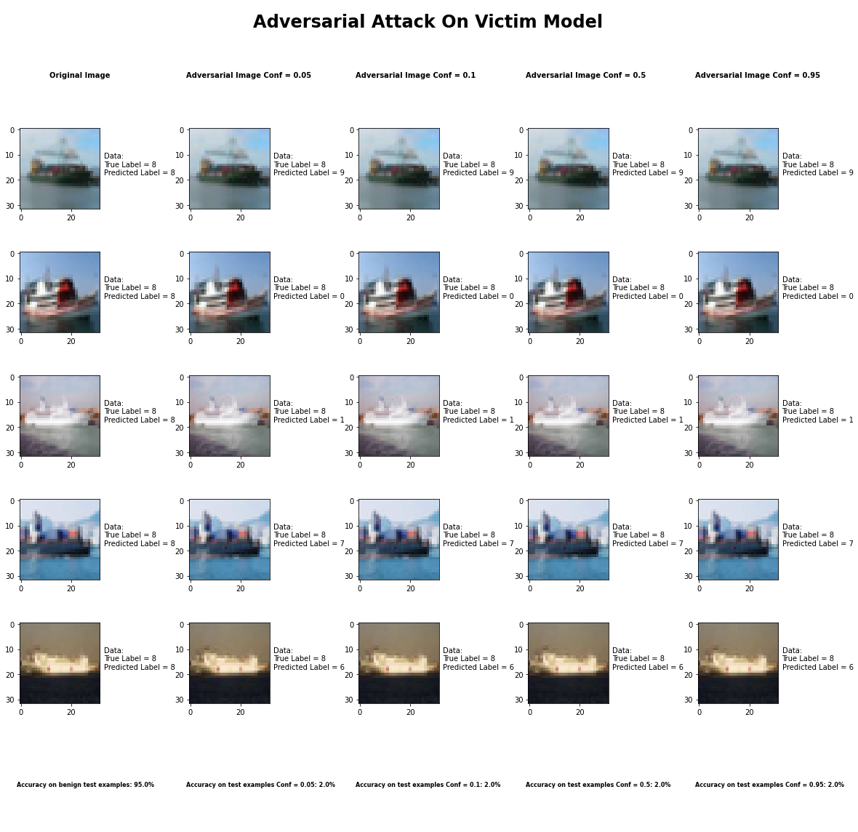

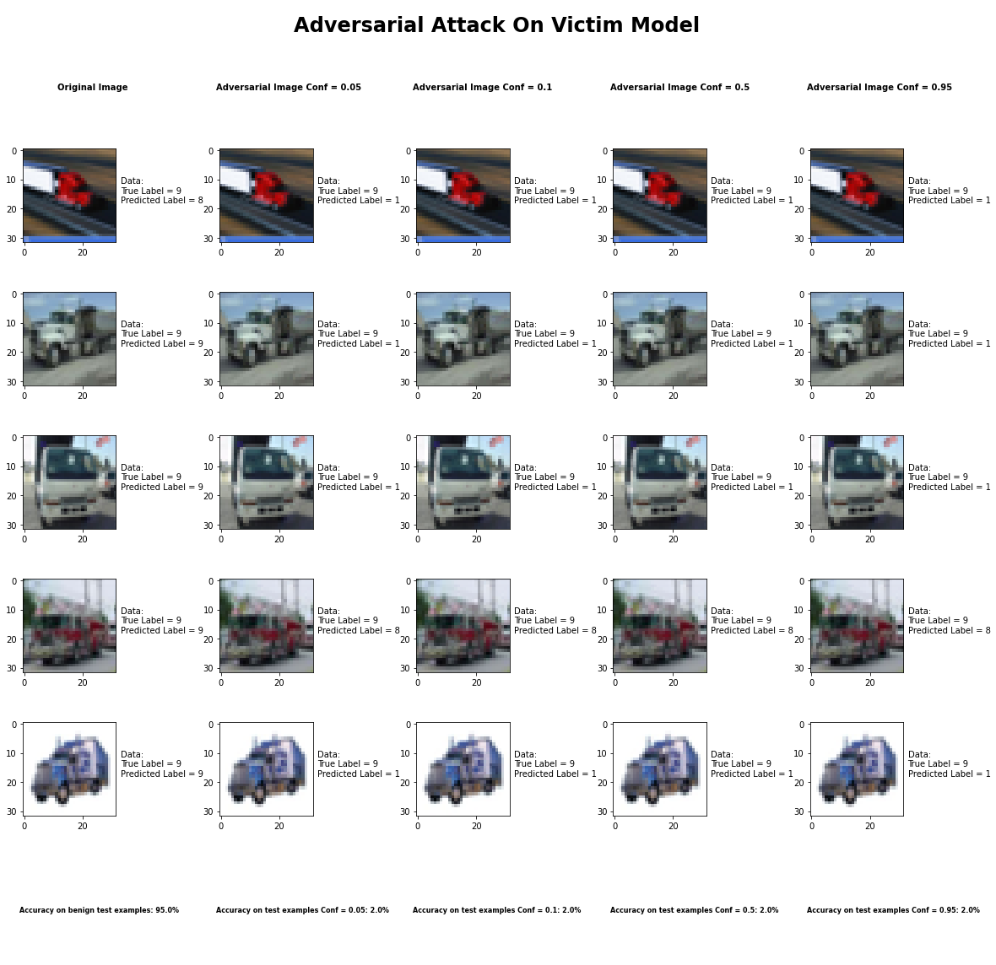

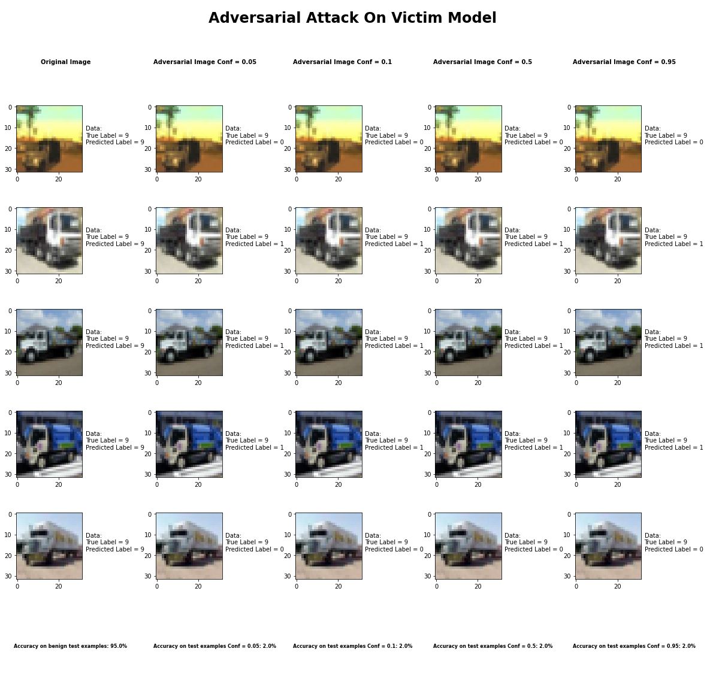

Accuracy on benign test examples: 94.52000000000001%

Accuracy on adversarial test examples with Conf = 0.05: 2.0%

Accuracy on adversarial test examples with Conf = 0.1: 2.0%

Accuracy on adversarial test examples with Conf = 0.5: 2.0%

Accuracy on adversarial test examples with Conf = 0.95: 2.0%

Classifier with benign example has Airplane recognition accuracy of = 100.0%

Elastic Net Method with Conf = 0.05 has Airplane recognition accuracy of = 0.0%

Elastic Net Method with Conf = 0.10 has Airplane recognition accuracy of = 0.0%

Elastic Net Method with Conf = 0.50 has Airplane recognition accuracy of = 0.0%

Elastic Net Method with Conf = 0.95 has Airplane recognition accuracy of = 0.0%

Classifier with benign example has Automobile recognition accuracy of = 100.0%

Elastic Net Method with Conf = 0.05 has Automobile recognition accuracy of = 0.0%

Elastic Net Method with Conf = 0.10 has Automobile recognition accuracy of = 0.0%

Elastic Net Method with Conf = 0.50 has Automobile recognition accuracy of = 0.0%

Elastic Net Method with Conf = 0.95 has Automobile recognition accuracy of = 0.0%

Classifier with benign example has Bird recognition accuracy of = 90.0%

Elastic Net Method with Conf = 0.05 has Bird recognition accuracy of = 10.0%

Elastic Net Method with Conf = 0.10 has Bird recognition accuracy of = 10.0%

Elastic Net Method with Conf = 0.50 has Bird recognition accuracy of = 10.0%

Elastic Net Method with Conf = 0.95 has Bird recognition accuracy of = 10.0%

Classifier with benign example has Cat recognition accuracy of = 80.0%

Elastic Net Method with Conf = 0.05 has Cat recognition accuracy of = 0.0%

Elastic Net Method with Conf = 0.10 has Cat recognition accuracy of = 0.0%

Elastic Net Method with Conf = 0.50 has Cat recognition accuracy of = 0.0%

Elastic Net Method with Conf = 0.95 has Cat recognition accuracy of = 0.0%

Classifier with benign example has Deer recognition accuracy of = 90.0%

Elastic Net Method with Conf = 0.05 has Deer recognition accuracy of = 10.0%

Elastic Net Method with Conf = 0.10 has Deer recognition accuracy of = 10.0%

Elastic Net Method with Conf = 0.50 has Deer recognition accuracy of = 10.0%

Elastic Net Method with Conf = 0.95 has Deer recognition accuracy of = 10.0%

Classifier with benign example has Dog recognition accuracy of = 100.0%

Elastic Net Method with Conf = 0.05 has Dog recognition accuracy of = 0.0%

Elastic Net Method with Conf = 0.10 has Dog recognition accuracy of = 0.0%

Elastic Net Method with Conf = 0.50 has Dog recognition accuracy of = 0.0%

Elastic Net Method with Conf = 0.95 has Dog recognition accuracy of = 0.0%

Classifier with benign example has Frog recognition accuracy of = 100.0%

Elastic Net Method with Conf = 0.05 has Frog recognition accuracy of = 0.0%

Elastic Net Method with Conf = 0.10 has Frog recognition accuracy of = 0.0%

Elastic Net Method with Conf = 0.50 has Frog recognition accuracy of = 0.0%

Elastic Net Method with Conf = 0.95 has Frog recognition accuracy of = 0.0%

Classifier with benign example has Horse recognition accuracy of = 100.0%

Elastic Net Method with Conf = 0.05 has Horse recognition accuracy of = 0.0%

Elastic Net Method with Conf = 0.10 has Horse recognition accuracy of = 0.0%

Elastic Net Method with Conf = 0.50 has Horse recognition accuracy of = 0.0%

Elastic Net Method with Conf = 0.95 has Horse recognition accuracy of = 0.0%

Classifier with benign example has Ship recognition accuracy of = 100.0%

Elastic Net Method with Conf = 0.05 has Ship recognition accuracy of = 0.0%

Elastic Net Method with Conf = 0.10 has Ship recognition accuracy of = 0.0%

Elastic Net Method with Conf = 0.50 has Ship recognition accuracy of = 0.0%

Elastic Net Method with Conf = 0.95 has Ship recognition accuracy of = 0.0%

Classifier with benign example has Truck recognition accuracy of = 90.0%

Elastic Net Method with Conf = 0.05 has Truck recognition accuracy of = 0.0%

Elastic Net Method with Conf = 0.10 has Truck recognition accuracy of = 0.0%

Elastic Net Method with Conf = 0.50 has Truck recognition accuracy of = 0.0%

Elastic Net Method with Conf = 0.95 has Truck recognition accuracy of = 0.0%

## Carlini LInf Method



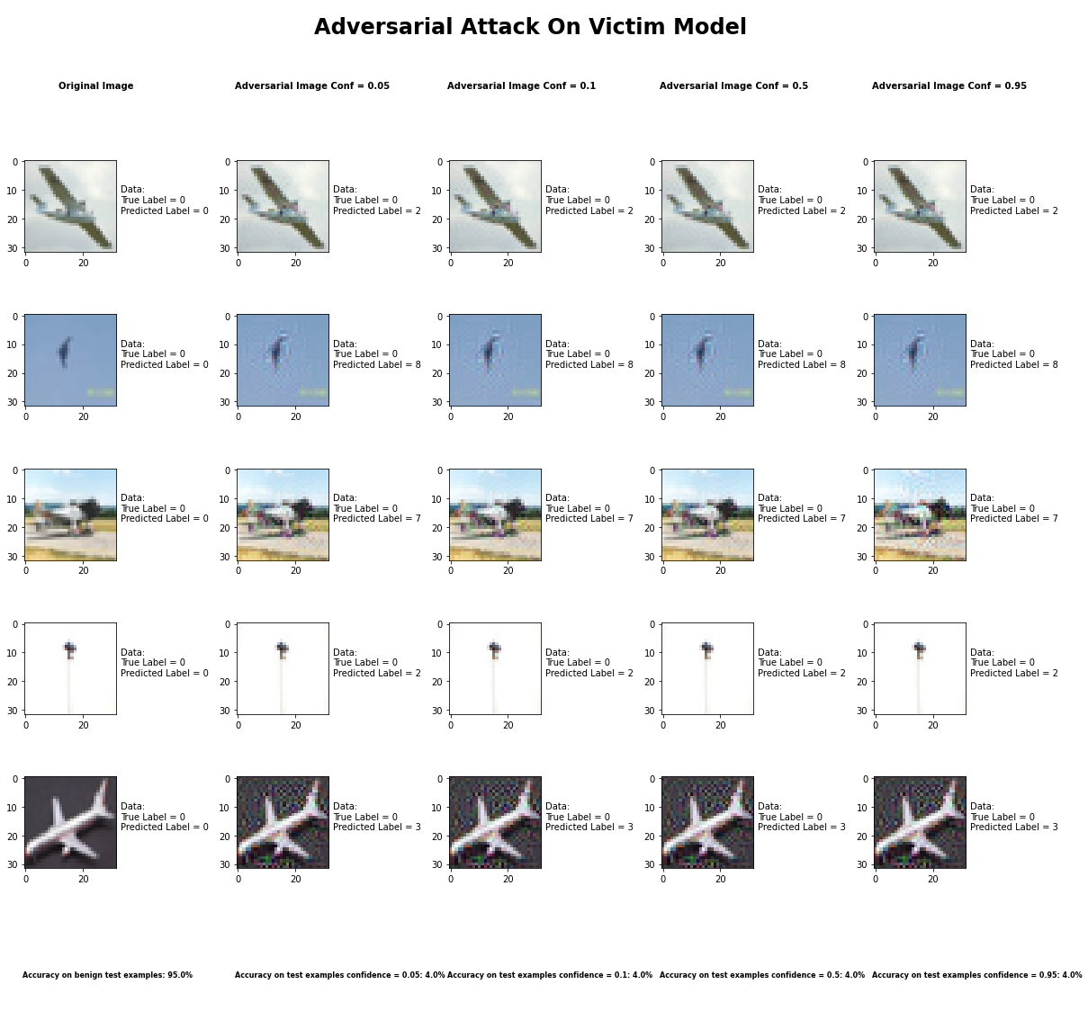

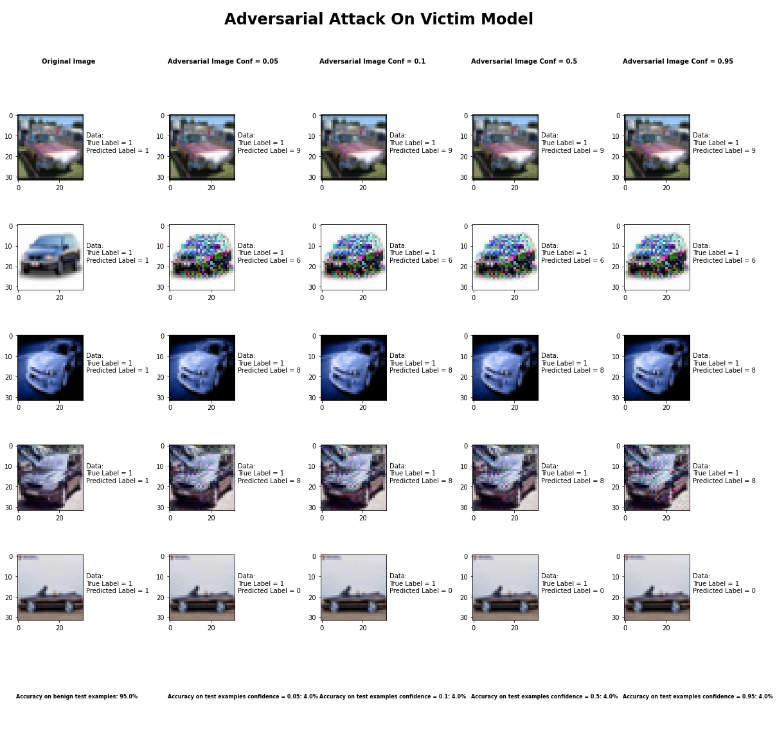

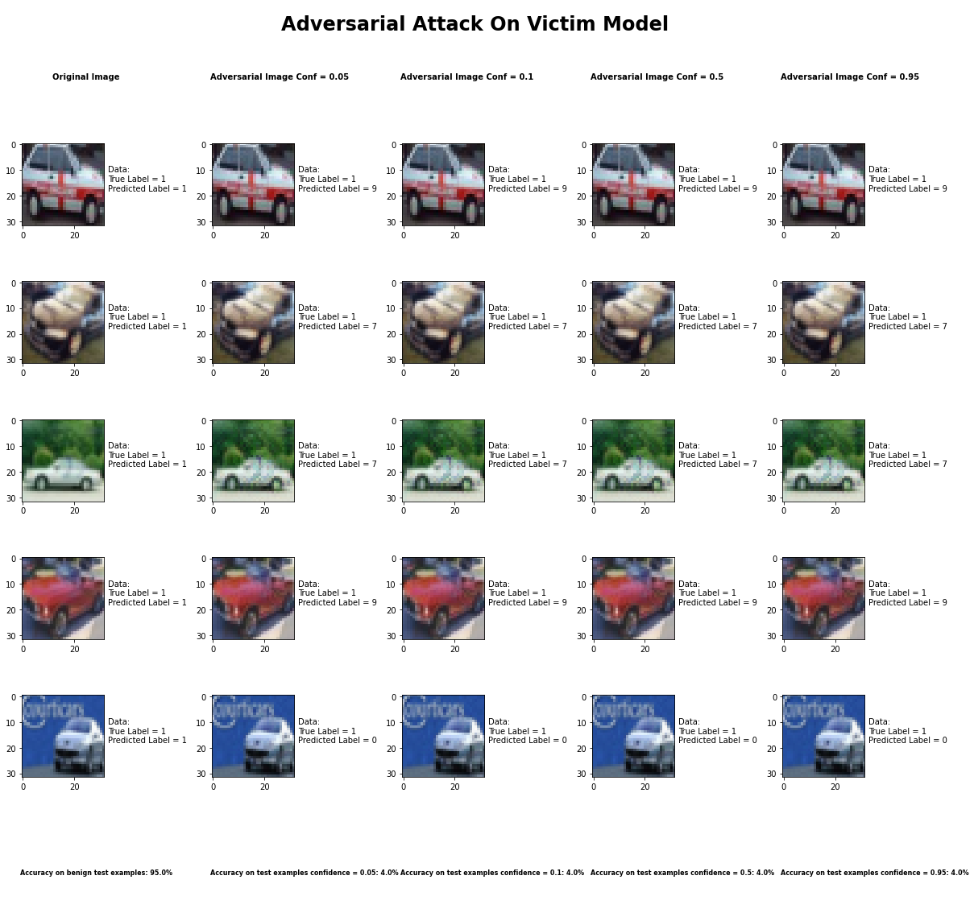

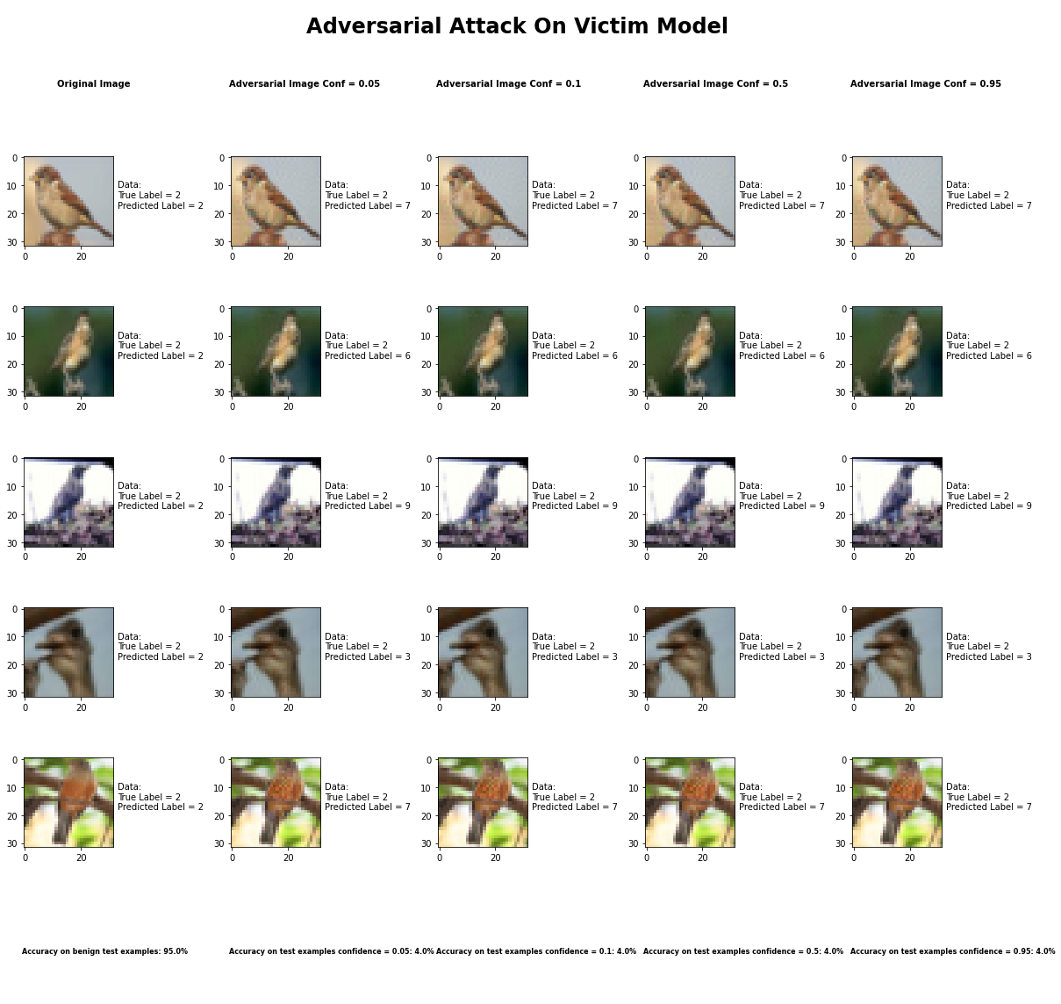

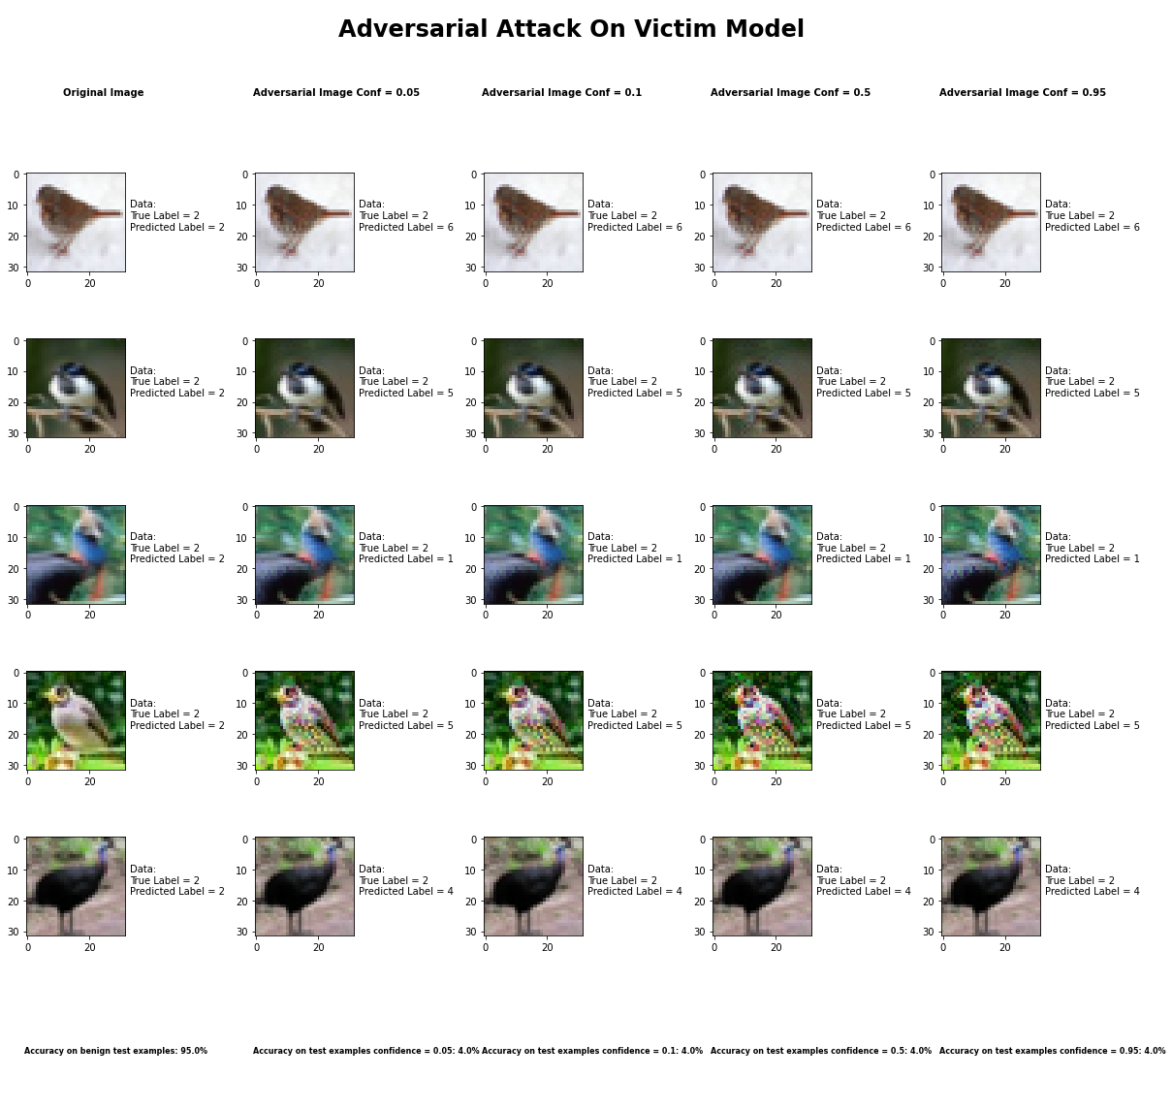

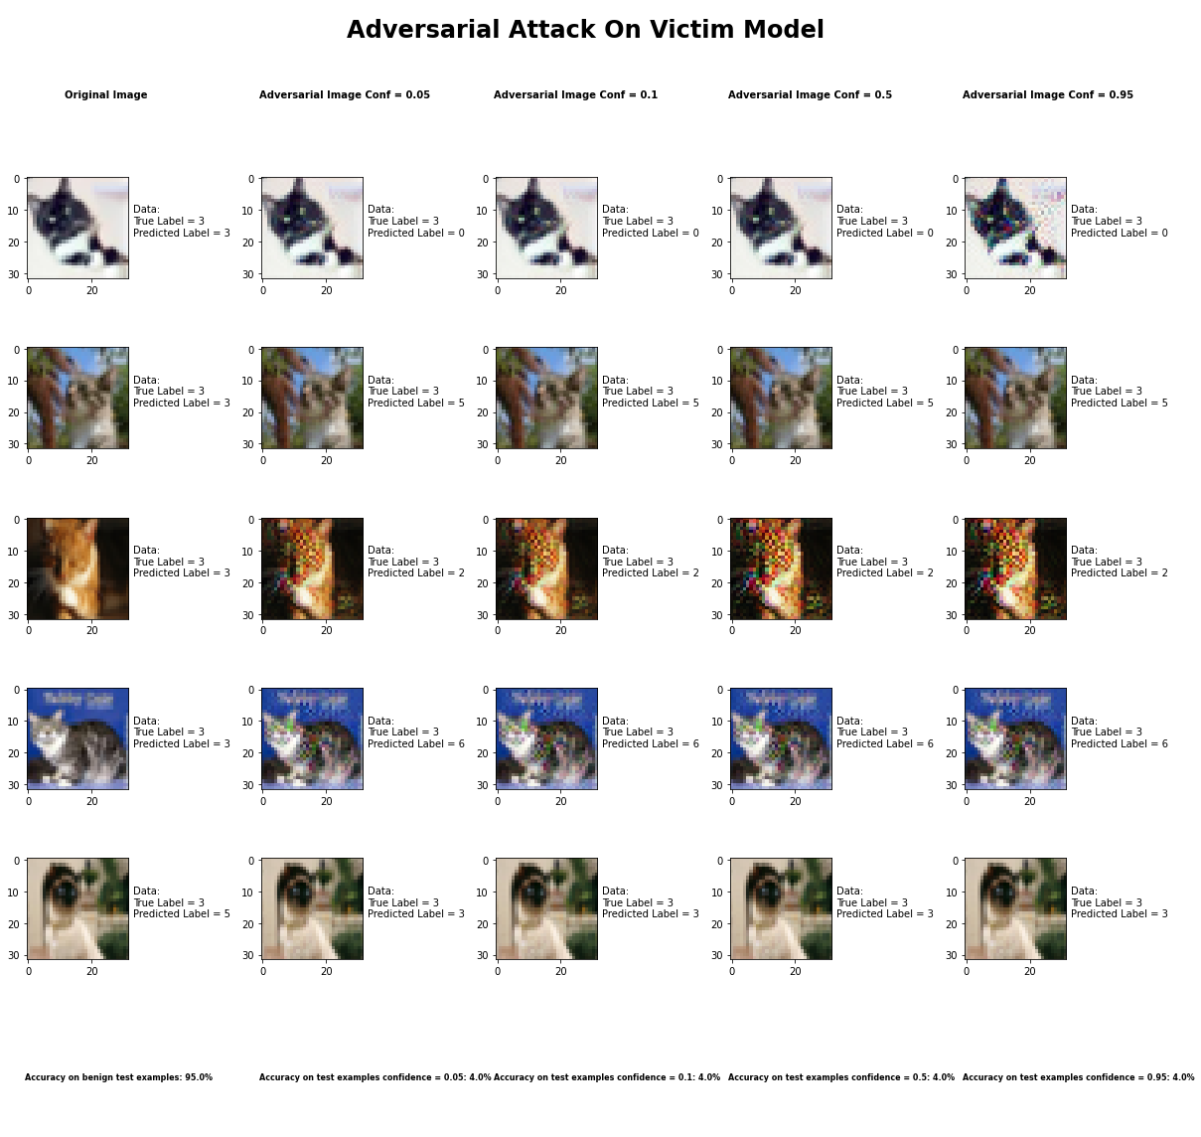

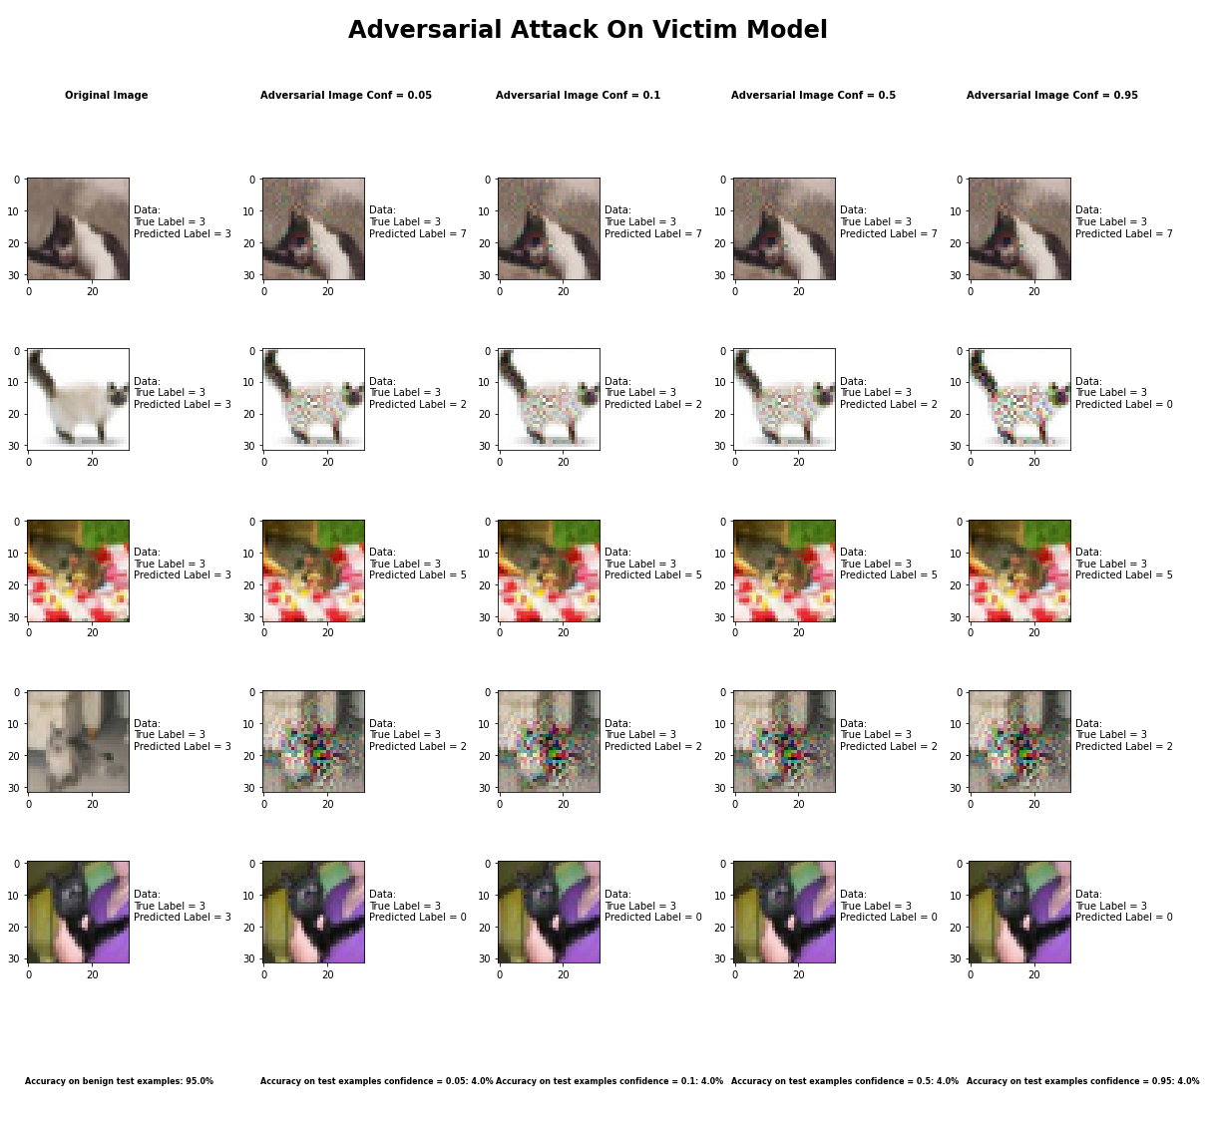

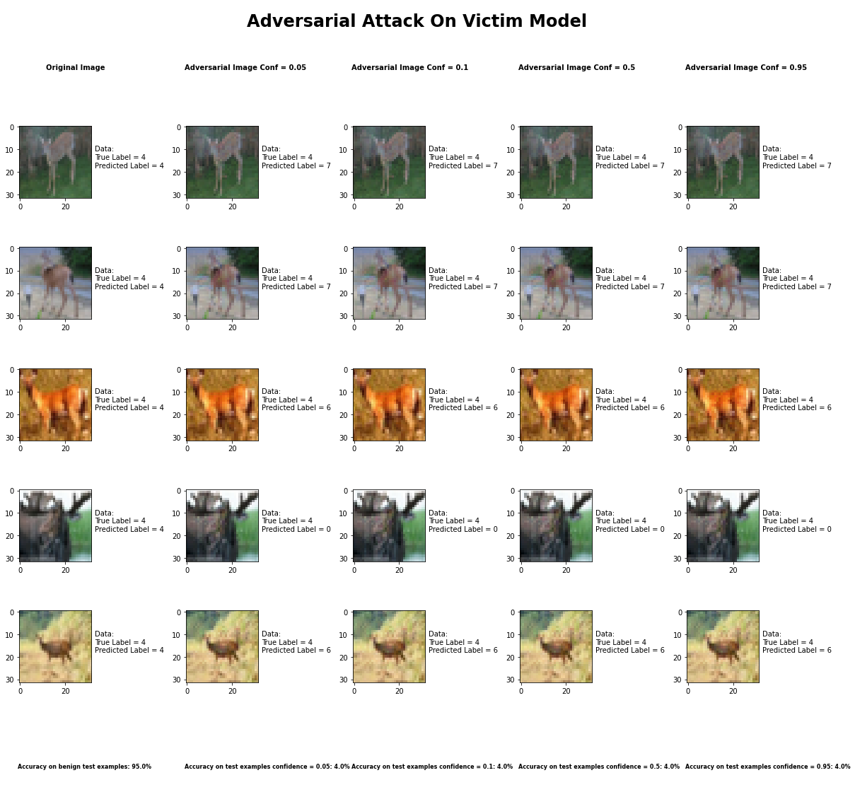

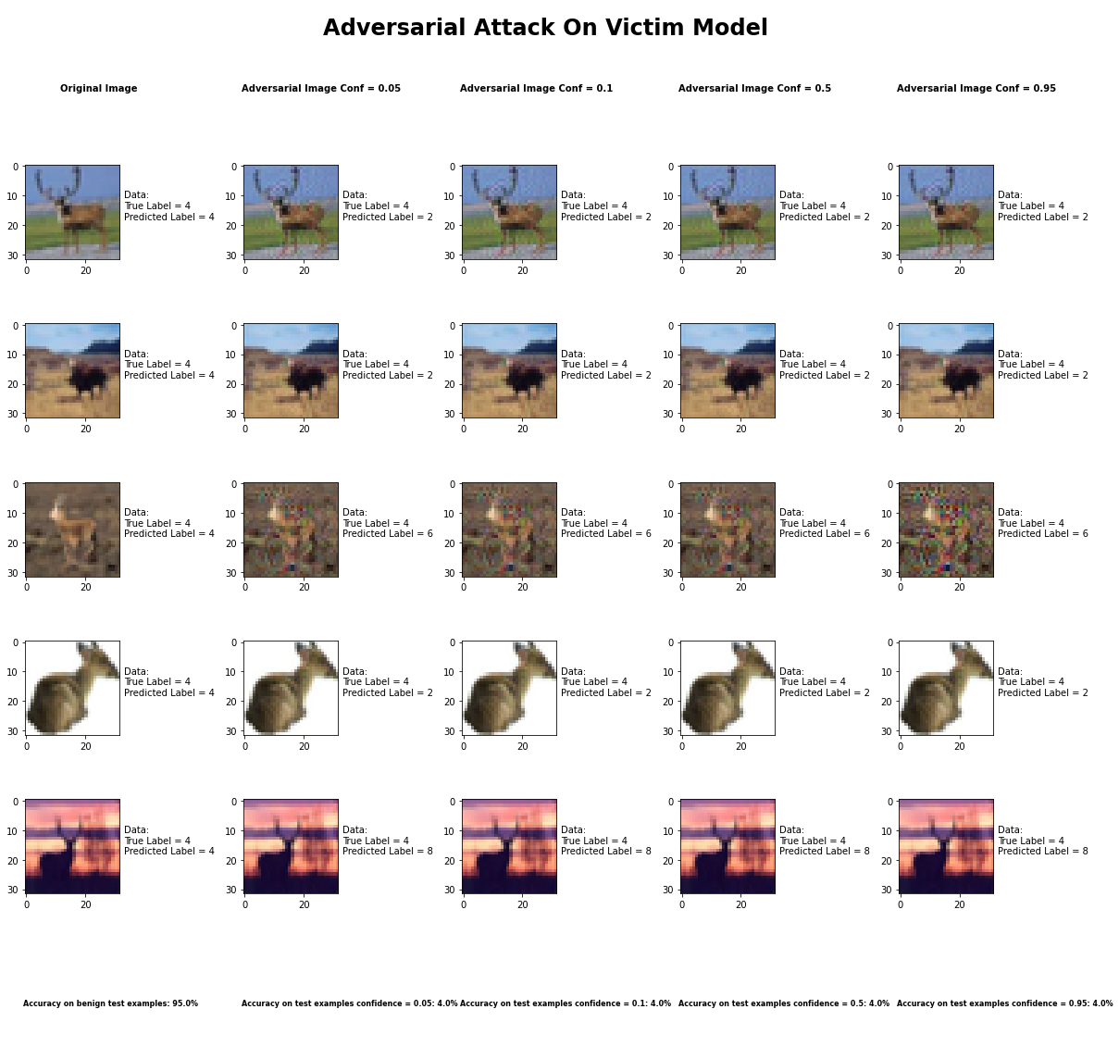

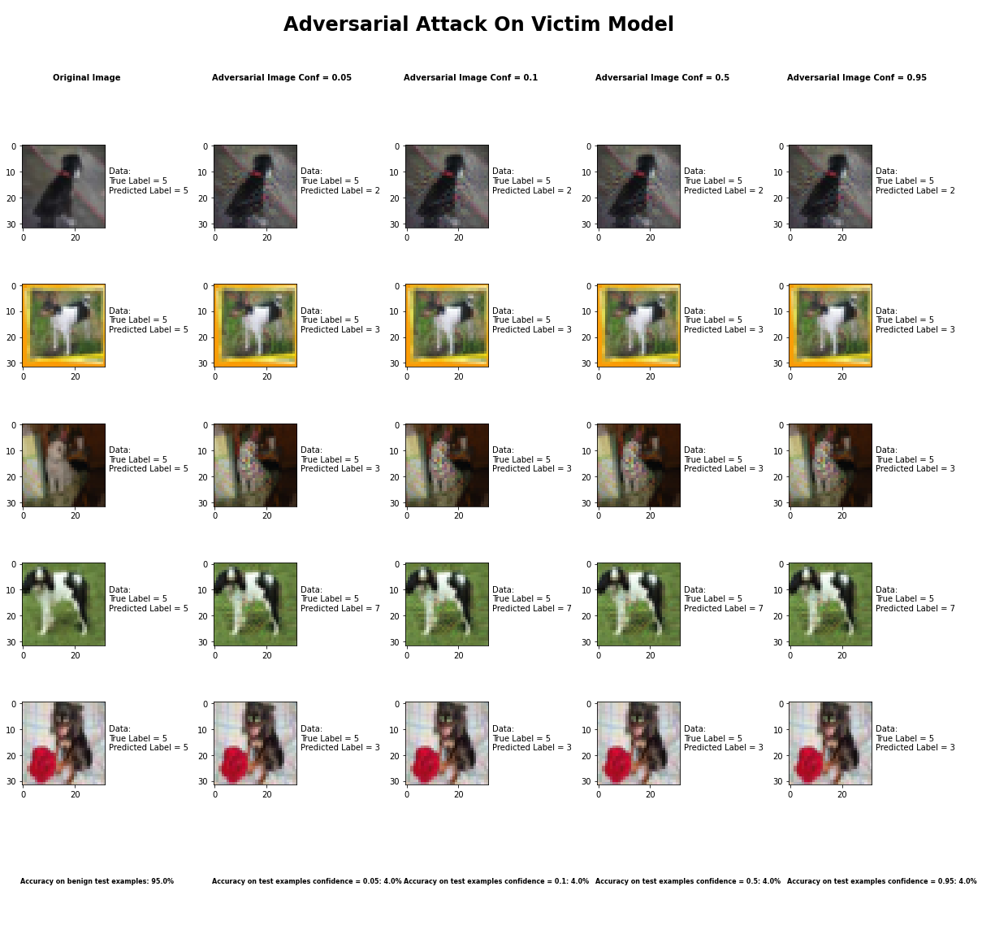

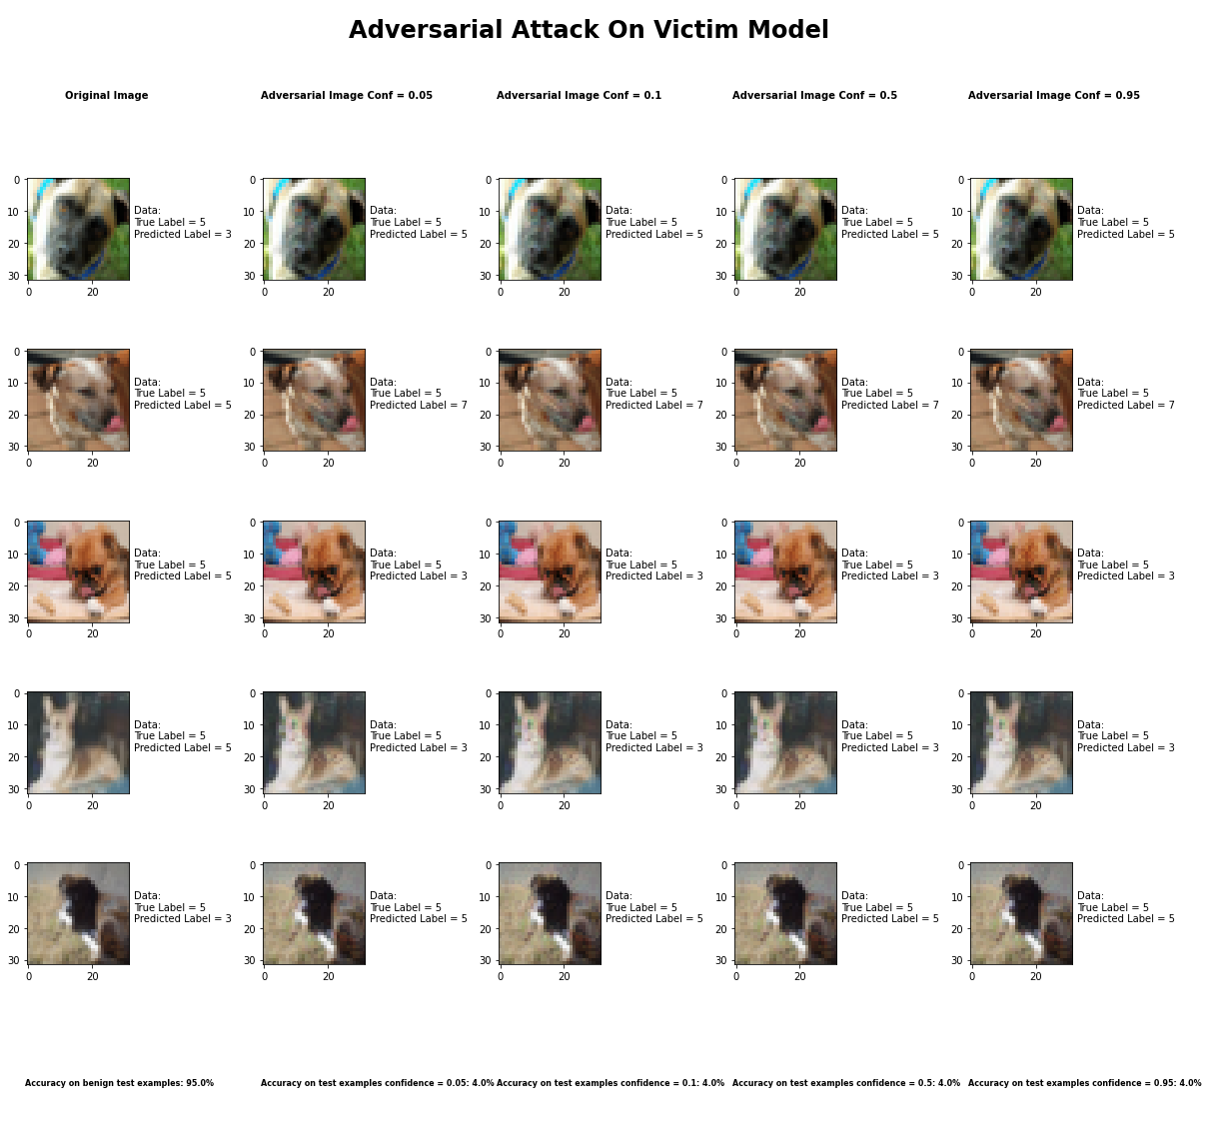

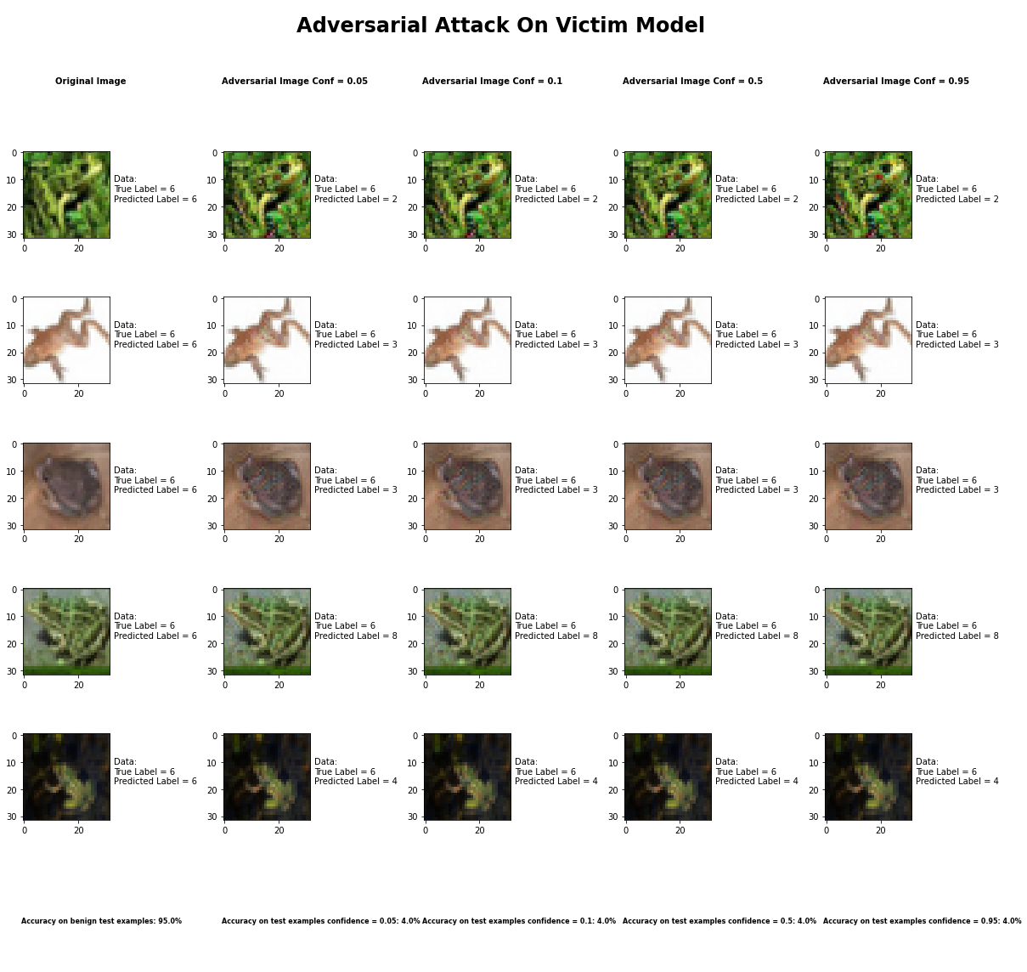

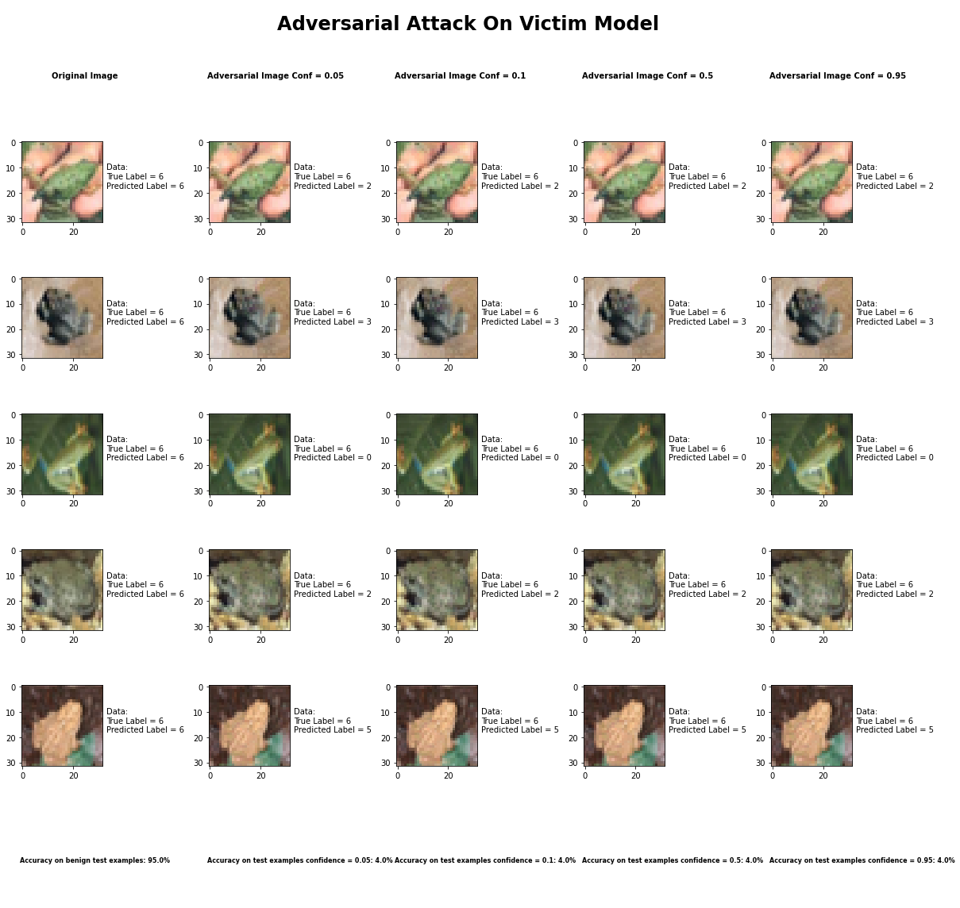

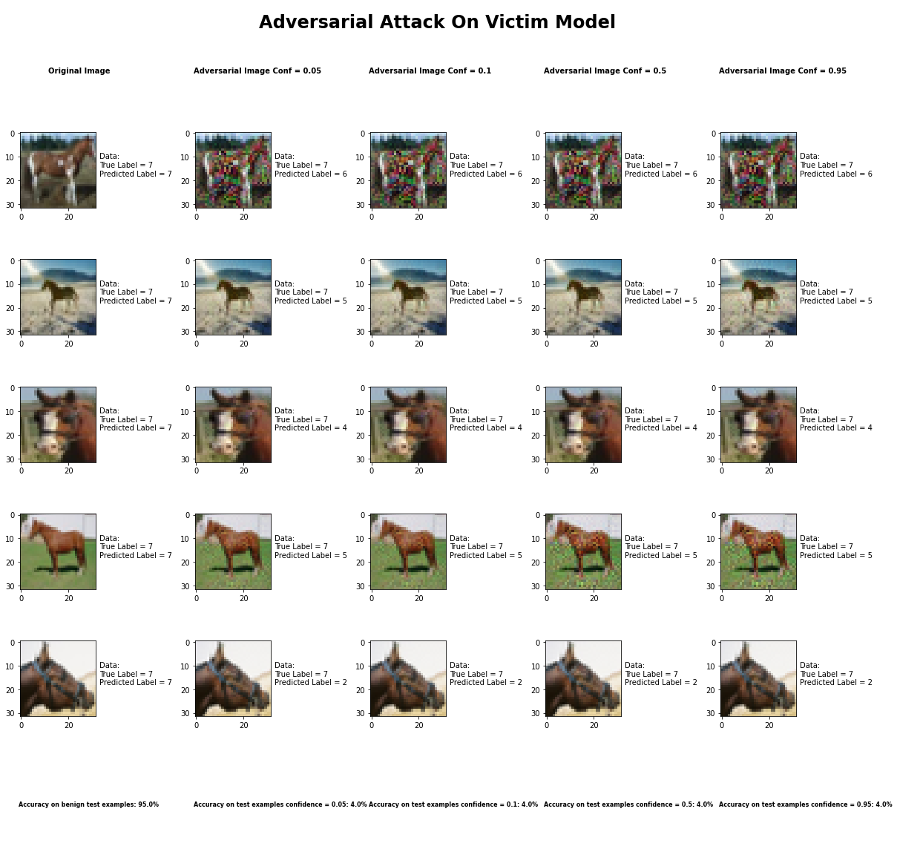

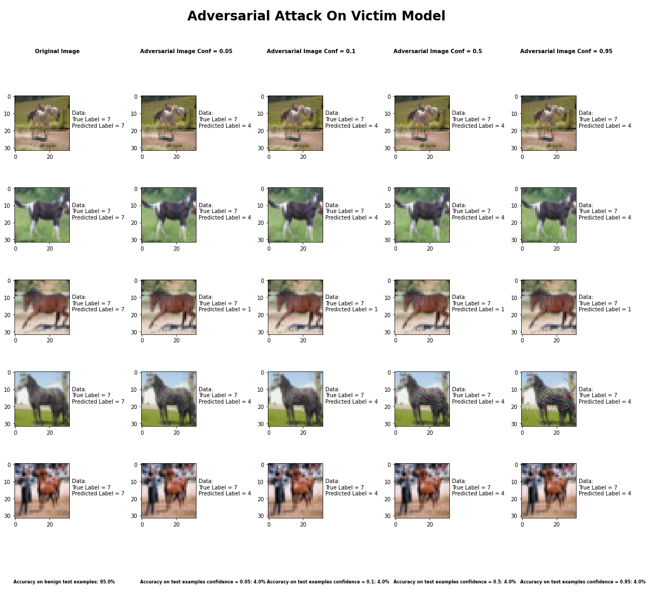

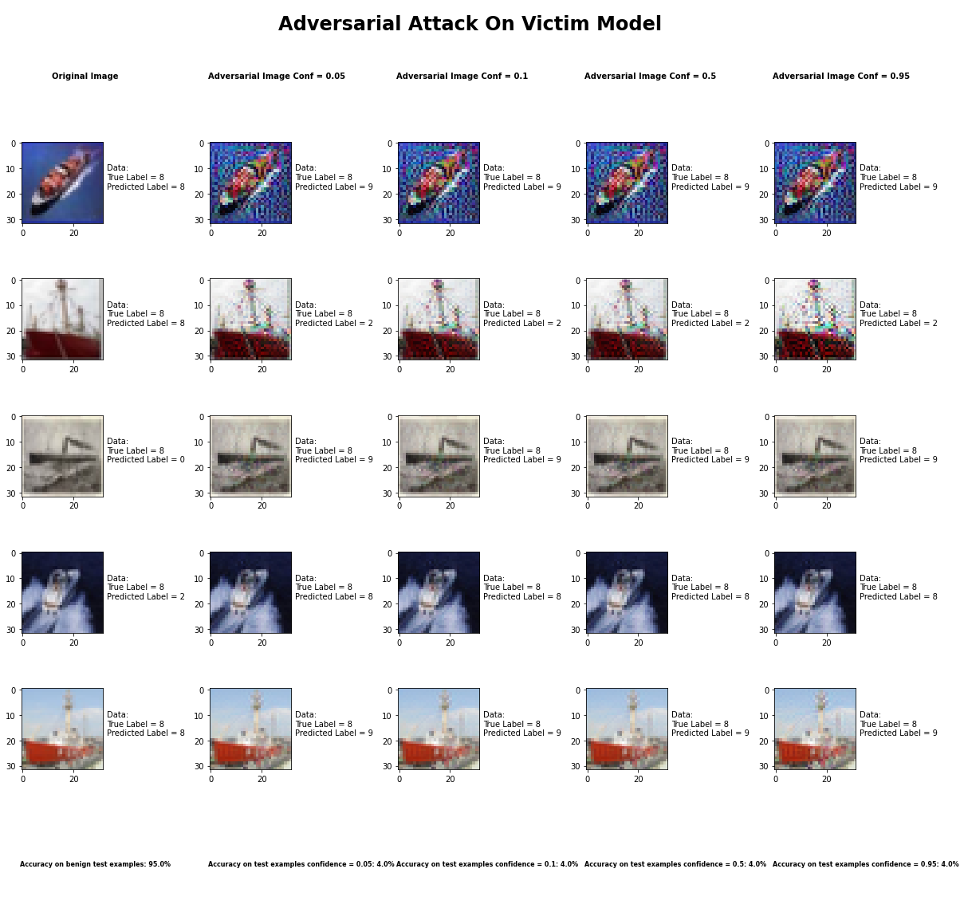

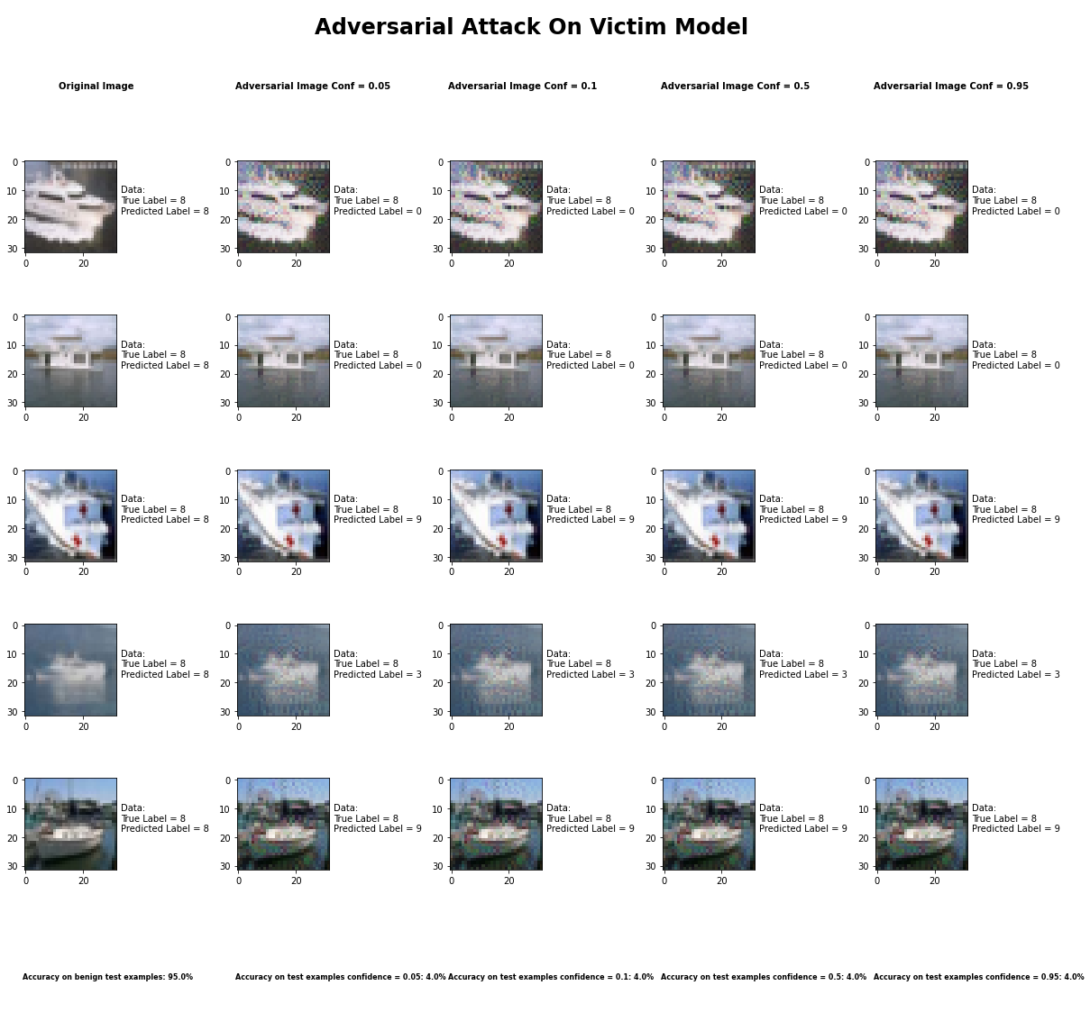

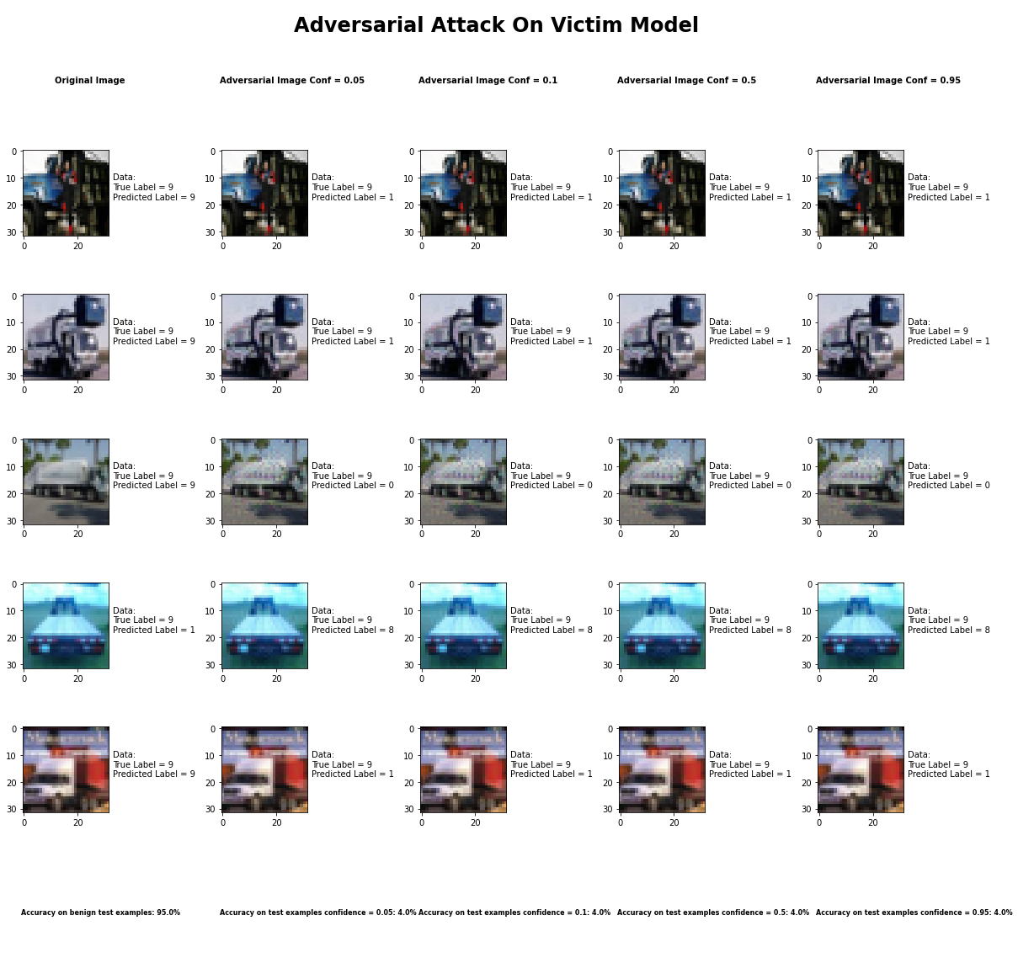

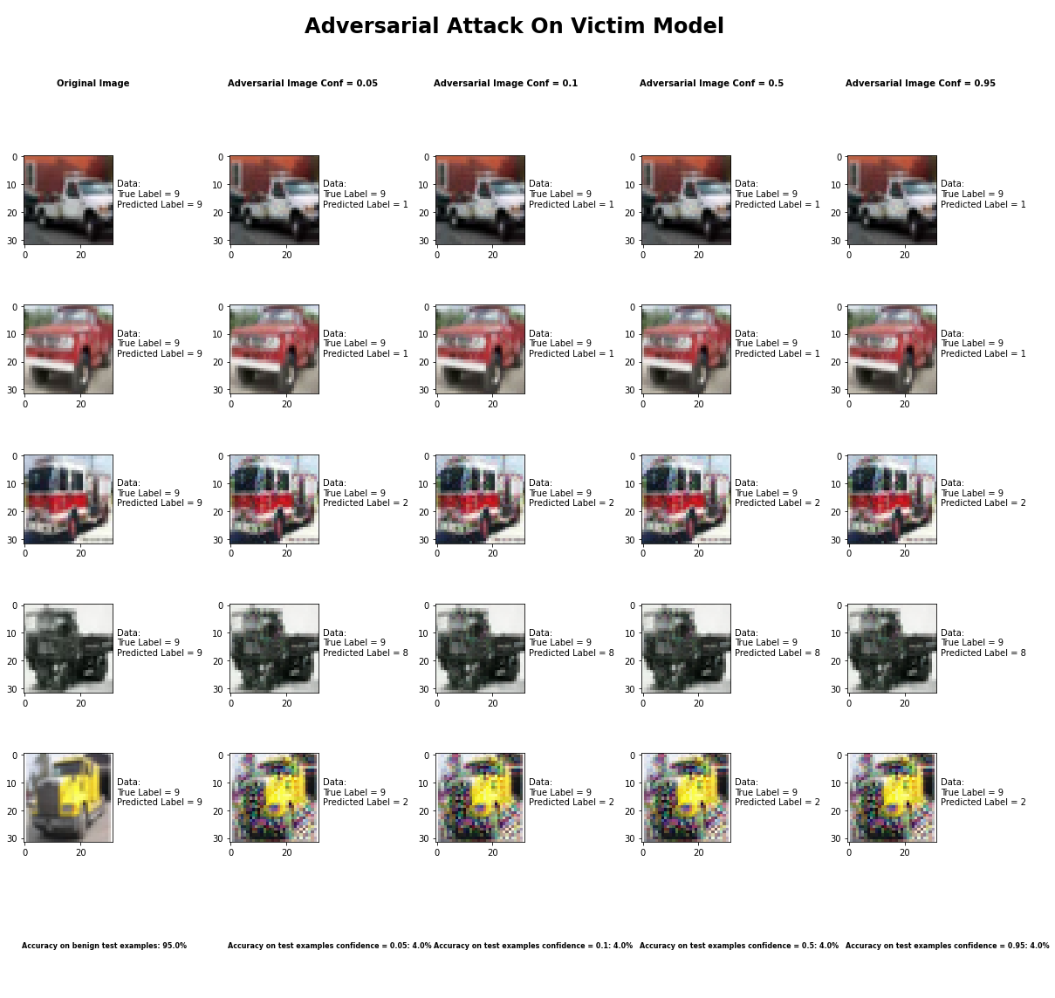

Accuracy on benign test examples: 94.52000000000001%

Average Accuracy on adversarial test examples with confidence = 0.05: 4.5%

Average Accuracy on adversarial test examples with confidence = 0.1: 4.5%

Average Accuracy on adversarial test examples with confidence = 0.5: 4.5%

Average Accuracy on adversarial test examples with confidence = 0.95: 4.5%

Classifier with benign example has Airplane recognition average accuracy of = 96%

Carlini L2 Method with confidence = 0.05 has Airplane recognition average accuracy of = 2%

Carlini L2 Method with confidence = 0.10 has Airplane recognition average accuracy of = 2%

Carlini L2 Method with confidence = 0.50 has Airplane recognition average accuracy of = 2%

Carlini L2 Method with confidence = 0.95 has Airplane recognition average accuracy of = 2%

Classifier with benign example has Automobile recognition average accuracy of = 99%

Carlini L2 Method with confidence = 0.05 has Automobile recognition average accuracy of = 0%

Carlini L2 Method with confidence = 0.10 has Automobile recognition average accuracy of = 0%

Carlini L2 Method with confidence = 0.50 has Automobile recognition average accuracy of = 0%

Carlini L2 Method with confidence = 0.95 has Automobile recognition average accuracy of = 0%

Classifier with benign example has Bird recognition average accuracy of = 93%

Carlini L2 Method with confidence = 0.05 has Bird recognition average accuracy of = 7%

Carlini L2 Method with confidence = 0.10 has Bird recognition average accuracy of = 7%

Carlini L2 Method with confidence = 0.50 has Bird recognition average accuracy of = 7%

Carlini L2 Method with confidence = 0.95 has Bird recognition average accuracy of = 7%

Classifier with benign example has Cat recognition average accuracy of = 83%

Carlini L2 Method with confidence = 0.05 has Cat recognition average accuracy of = 13%

Carlini L2 Method with confidence = 0.10 has Cat recognition average accuracy of = 13%

Carlini L2 Method with confidence = 0.50 has Cat recognition average accuracy of = 13%

Carlini L2 Method with confidence = 0.95 has Cat recognition average accuracy of = 13%

Classifier with benign example has Deer recognition average accuracy of = 97%

Carlini L2 Method with confidence = 0.05 has Deer recognition average accuracy of = 2%

Carlini L2 Method with confidence = 0.10 has Deer recognition average accuracy of = 2%

Carlini L2 Method with confidence = 0.50 has Deer recognition average accuracy of = 2%

Carlini L2 Method with confidence = 0.95 has Deer recognition average accuracy of = 2%

Classifier with benign example has Dog recognition average accuracy of = 89%

Carlini L2 Method with confidence = 0.05 has Dog recognition average accuracy of = 8%

Carlini L2 Method with confidence = 0.10 has Dog recognition average accuracy of = 8%

Carlini L2 Method with confidence = 0.50 has Dog recognition average accuracy of = 8%

Carlini L2 Method with confidence = 0.95 has Dog recognition average accuracy of = 8%

Classifier with benign example has Frog recognition average accuracy of = 100%

Carlini L2 Method with confidence = 0.05 has Frog recognition average accuracy of = 0%

Carlini L2 Method with confidence = 0.10 has Frog recognition average accuracy of = 0%

Carlini L2 Method with confidence = 0.50 has Frog recognition average accuracy of = 0%

Carlini L2 Method with confidence = 0.95 has Frog recognition average accuracy of = 0%

Classifier with benign example has Horse recognition average accuracy of = 95%

Carlini L2 Method with confidence = 0.05 has Horse recognition average accuracy of = 2%

Carlini L2 Method with confidence = 0.10 has Horse recognition average accuracy of = 2%

Carlini L2 Method with confidence = 0.50 has Horse recognition average accuracy of = 2%

Carlini L2 Method with confidence = 0.95 has Horse recognition average accuracy of = 2%

Classifier with benign example has Ship recognition average accuracy of = 93%

Carlini L2 Method with confidence = 0.05 has Ship recognition average accuracy of = 5%

Carlini L2 Method with confidence = 0.10 has Ship recognition average accuracy of = 5%

Carlini L2 Method with confidence = 0.50 has Ship recognition average accuracy of = 5%

Carlini L2 Method with confidence = 0.95 has Ship recognition average accuracy of = 5%

Classifier with benign example has Truck recognition average accuracy of = 92%

Carlini L2 Method with confidence = 0.05 has Truck recognition average accuracy of = 6%

Carlini L2 Method with confidence = 0.10 has Truck recognition average accuracy of = 6%

Carlini L2 Method with confidence = 0.50 has Truck recognition average accuracy of = 6%

Carlini L2 Method with confidence = 0.95 has Truck recognition average accuracy of = 6%

## Carlini L2 Method



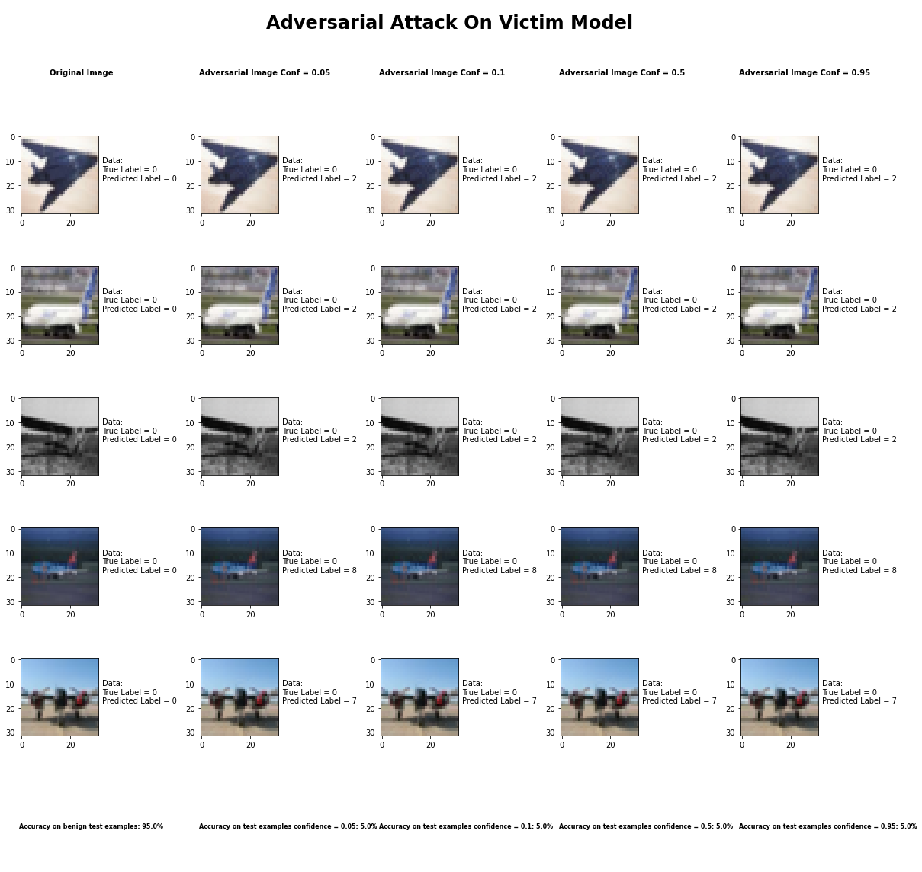

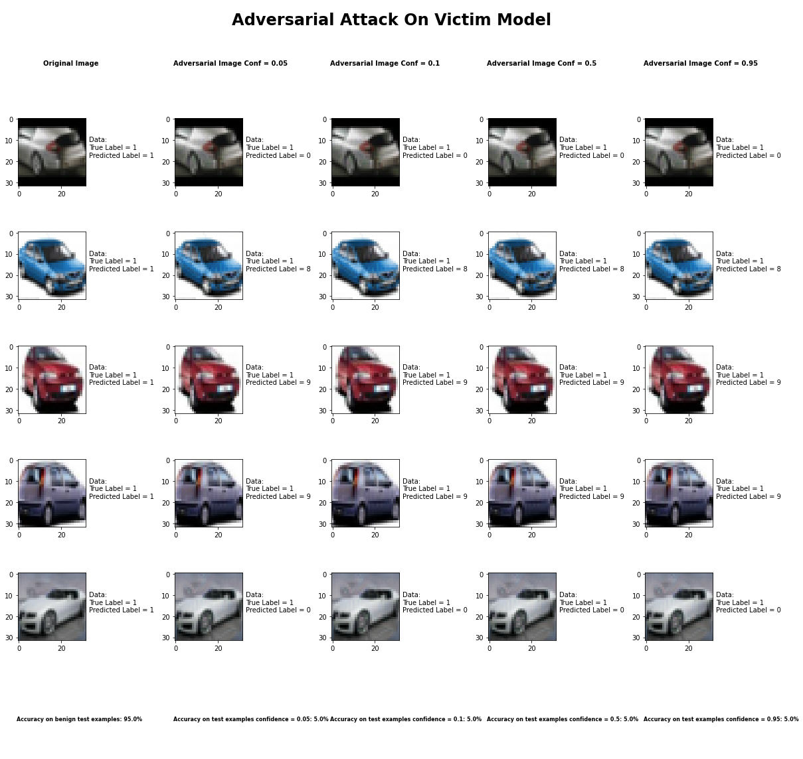

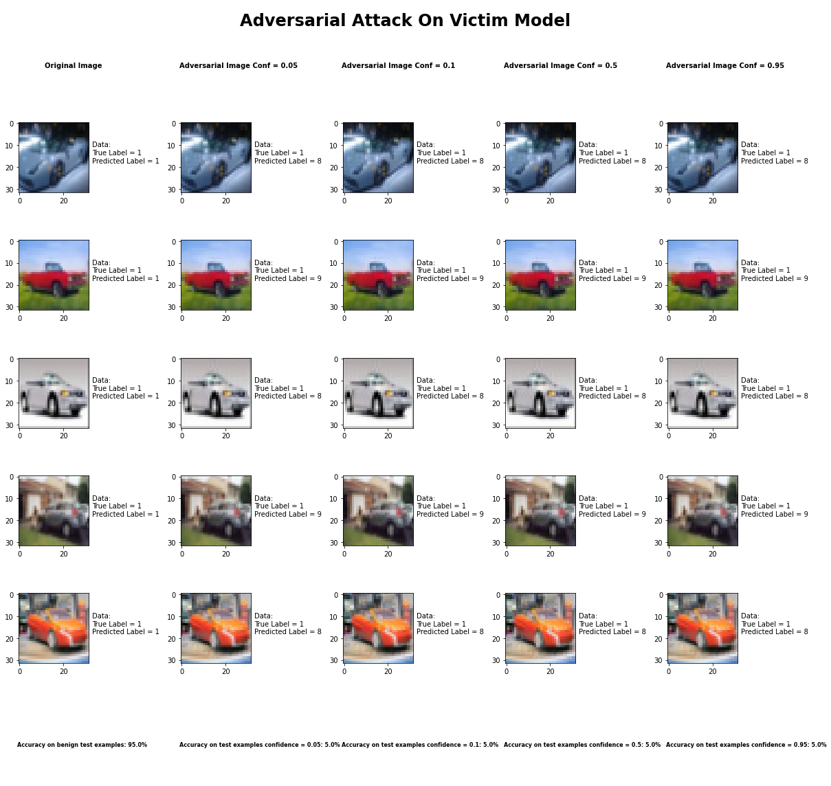

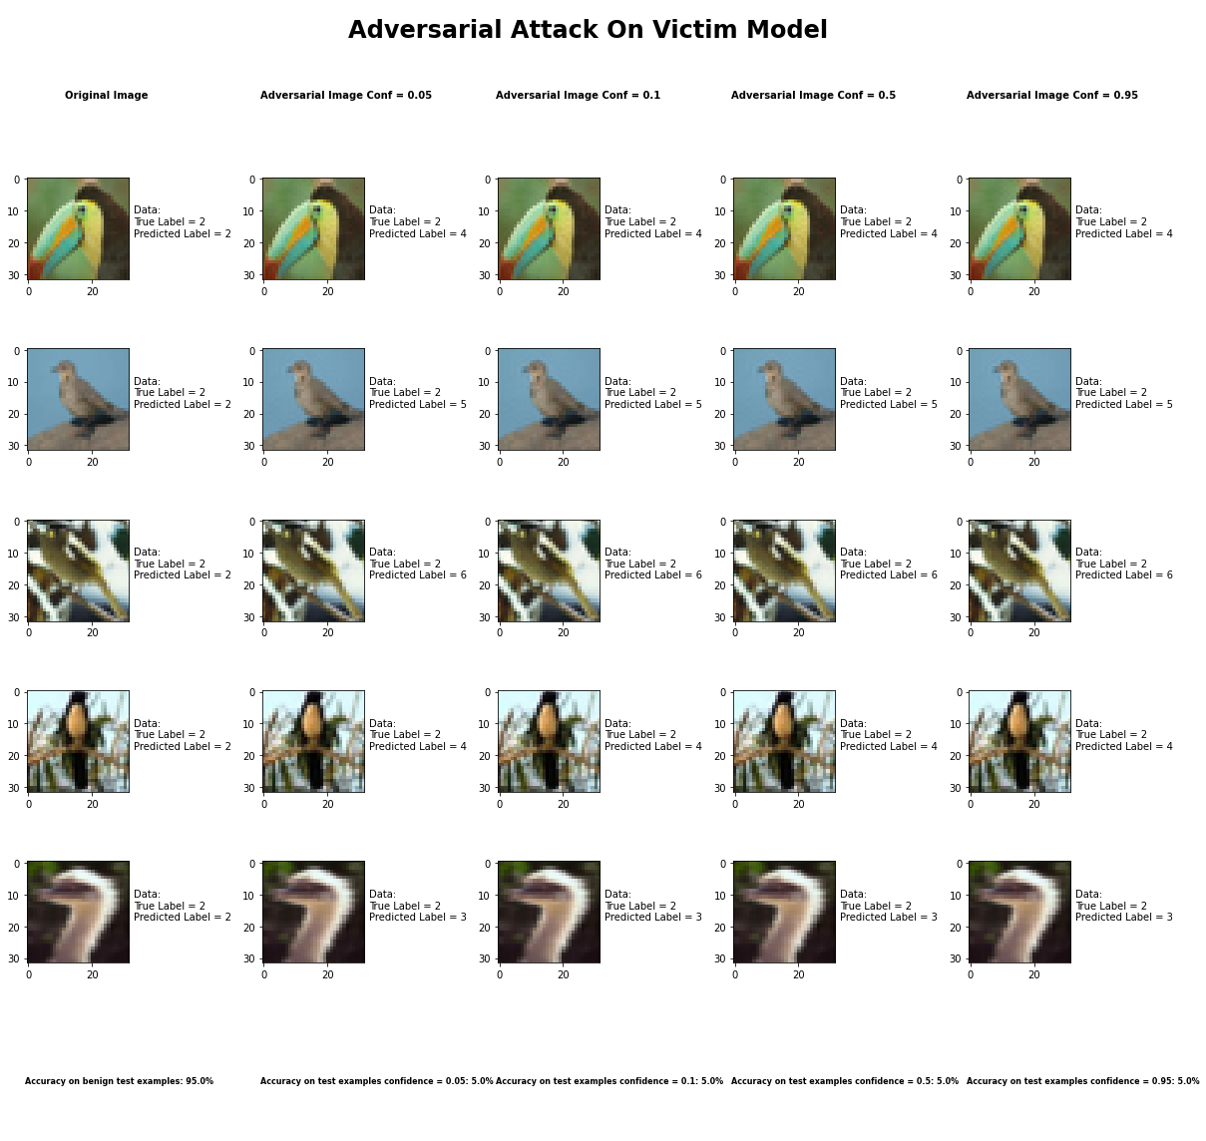

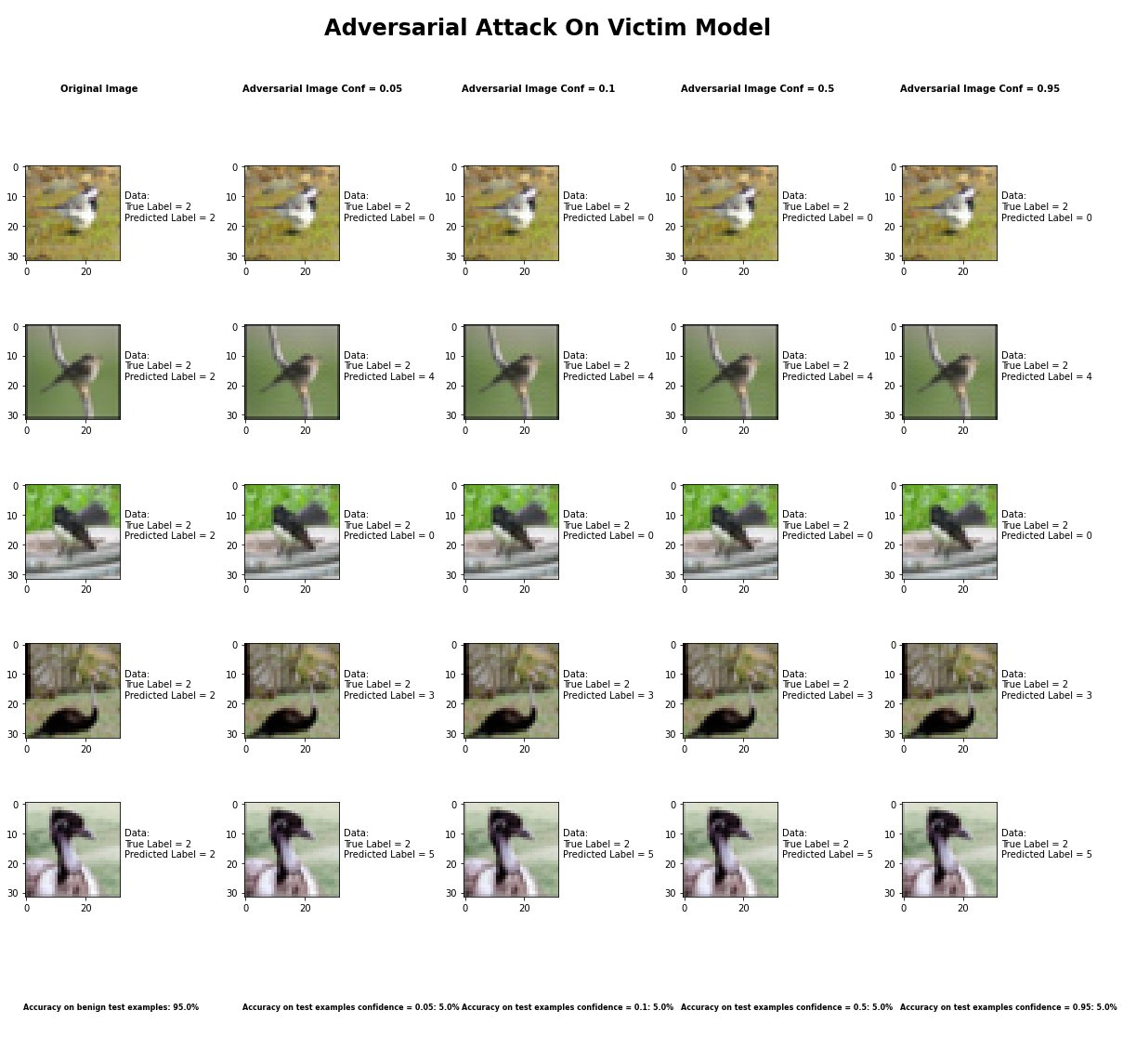

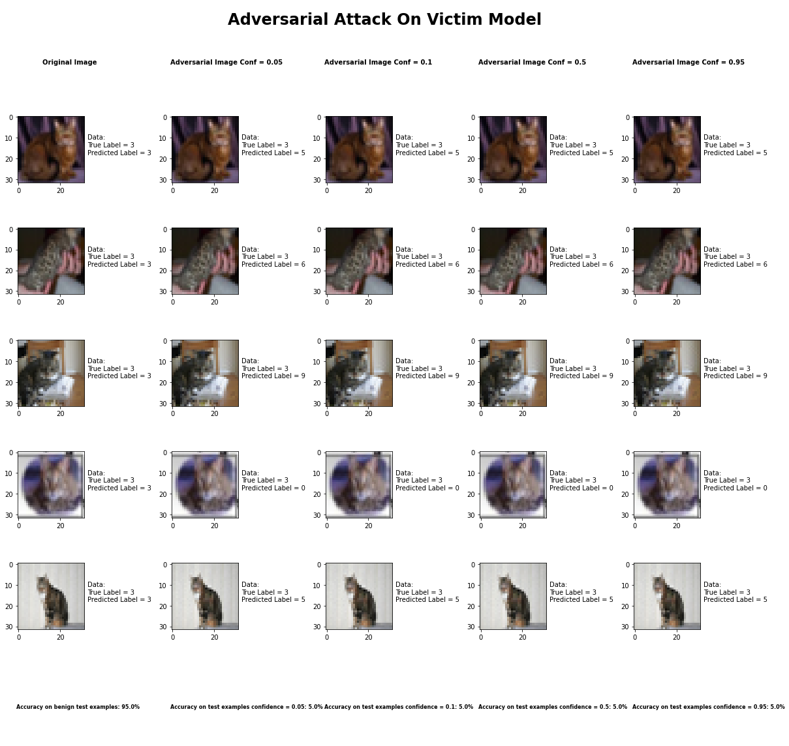

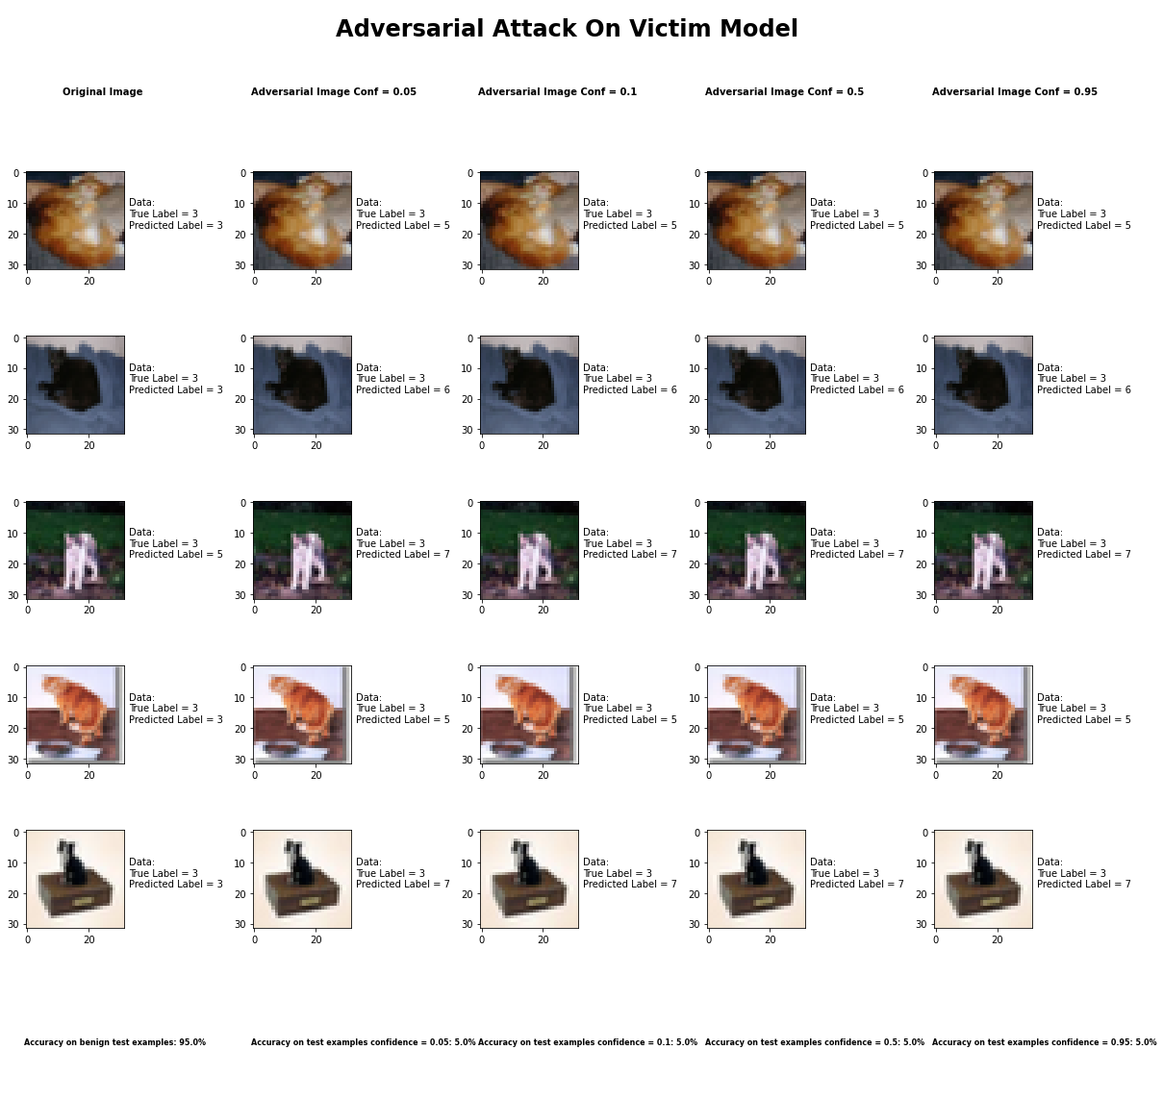

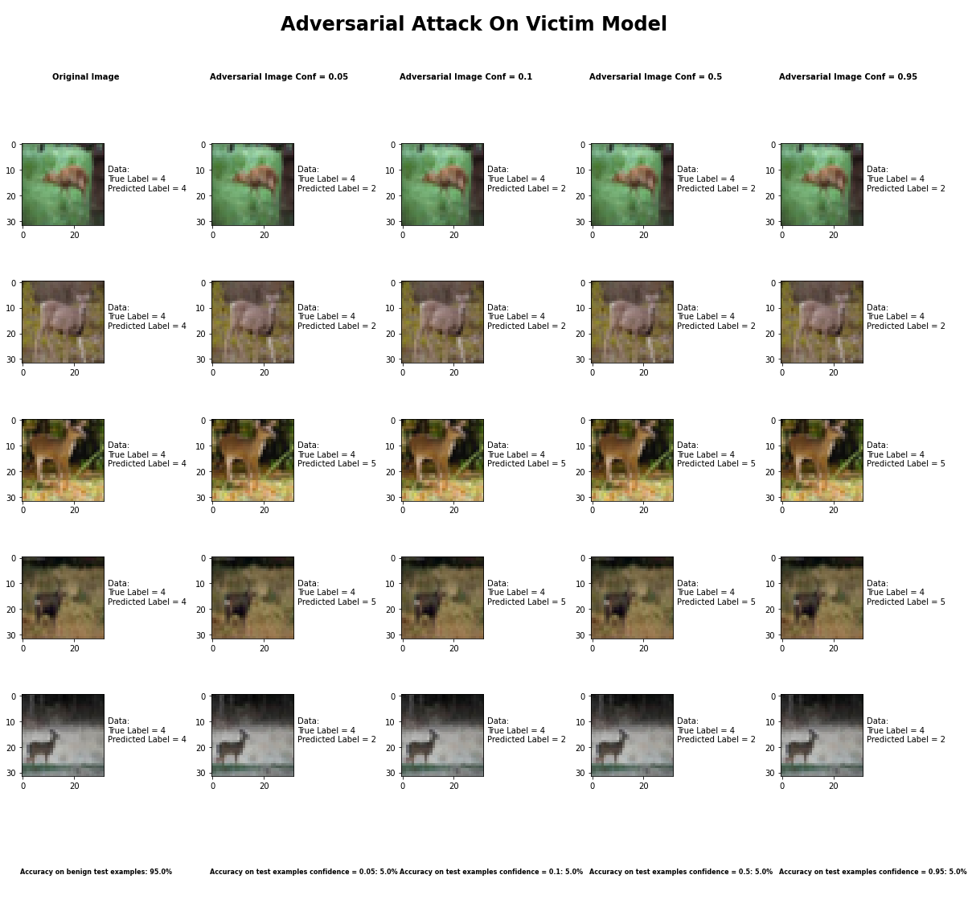

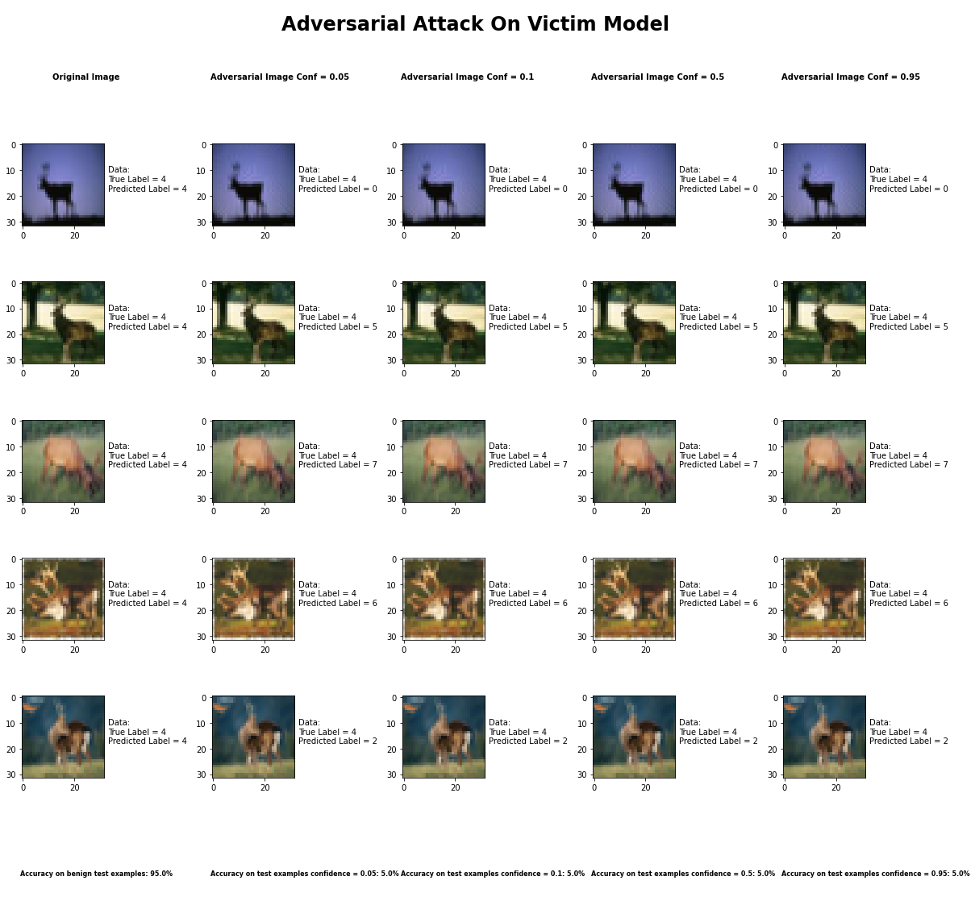

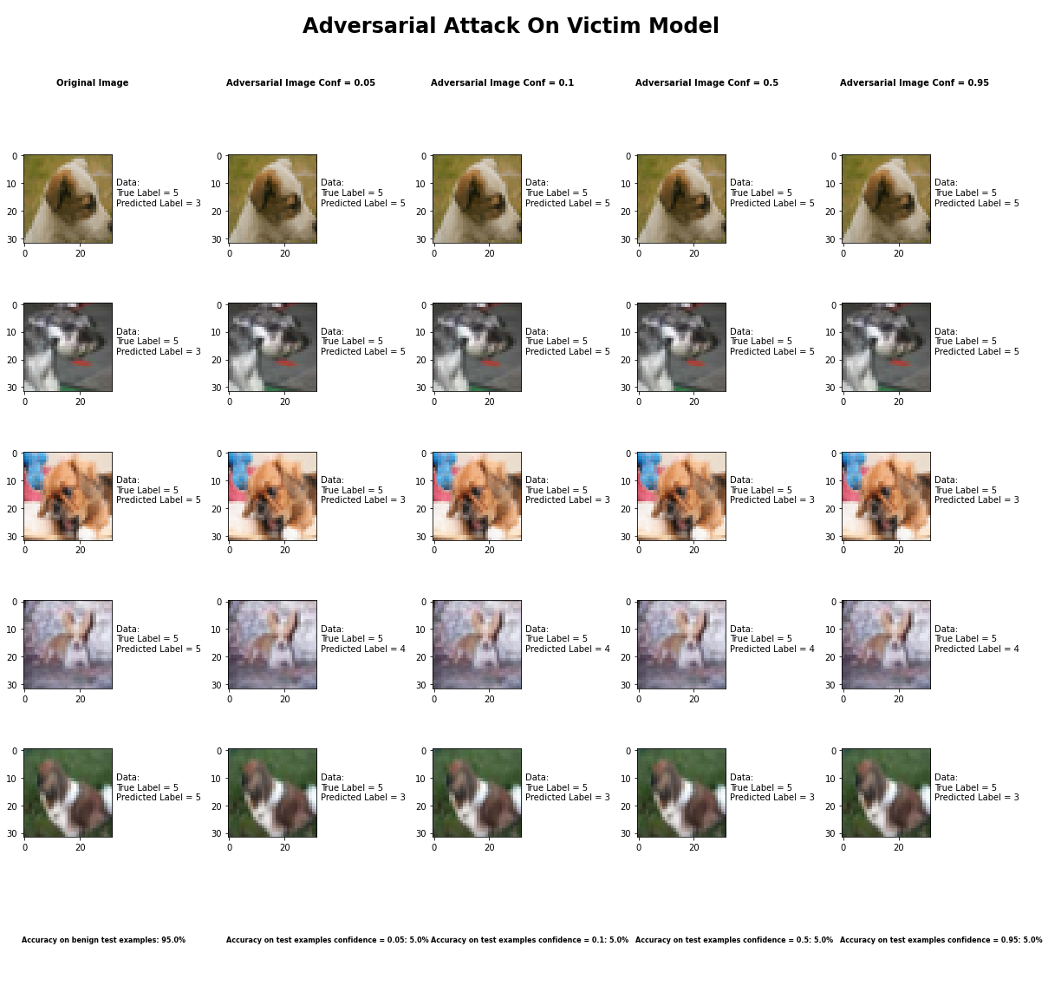

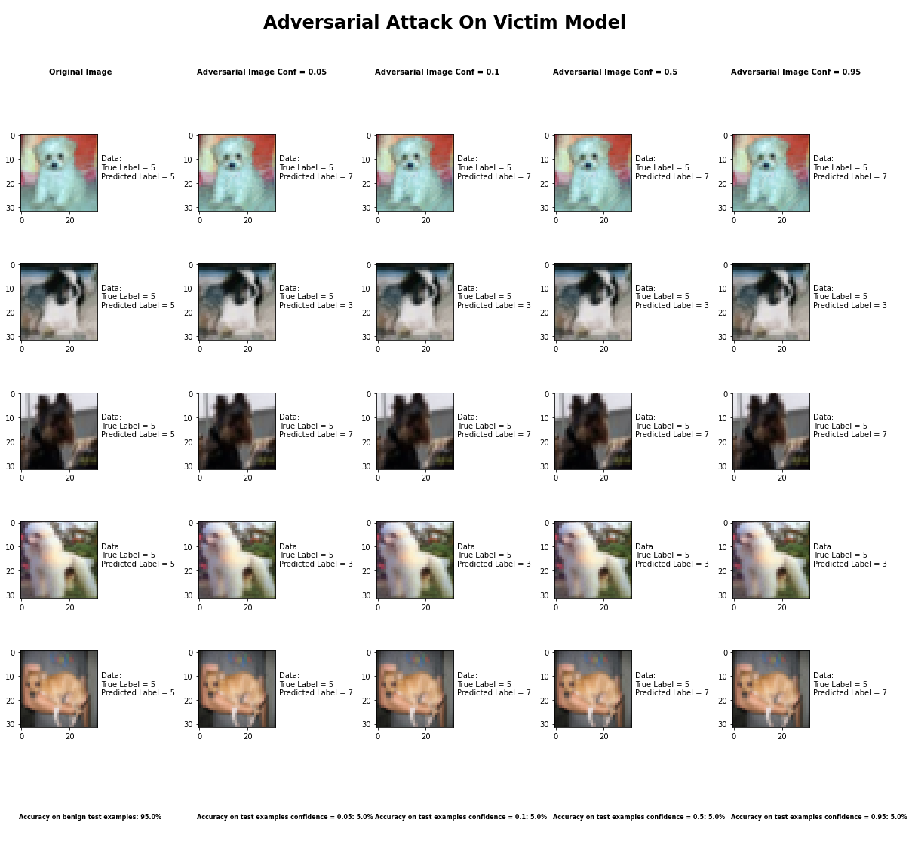

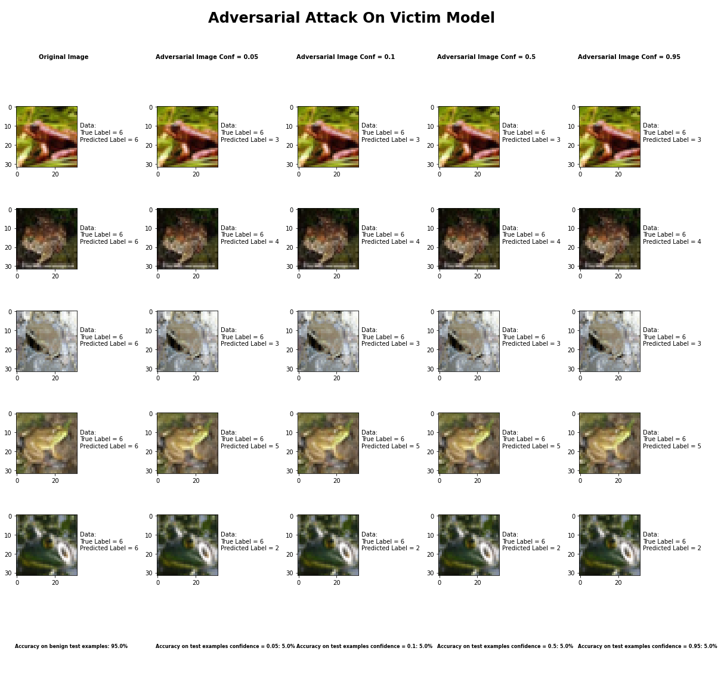

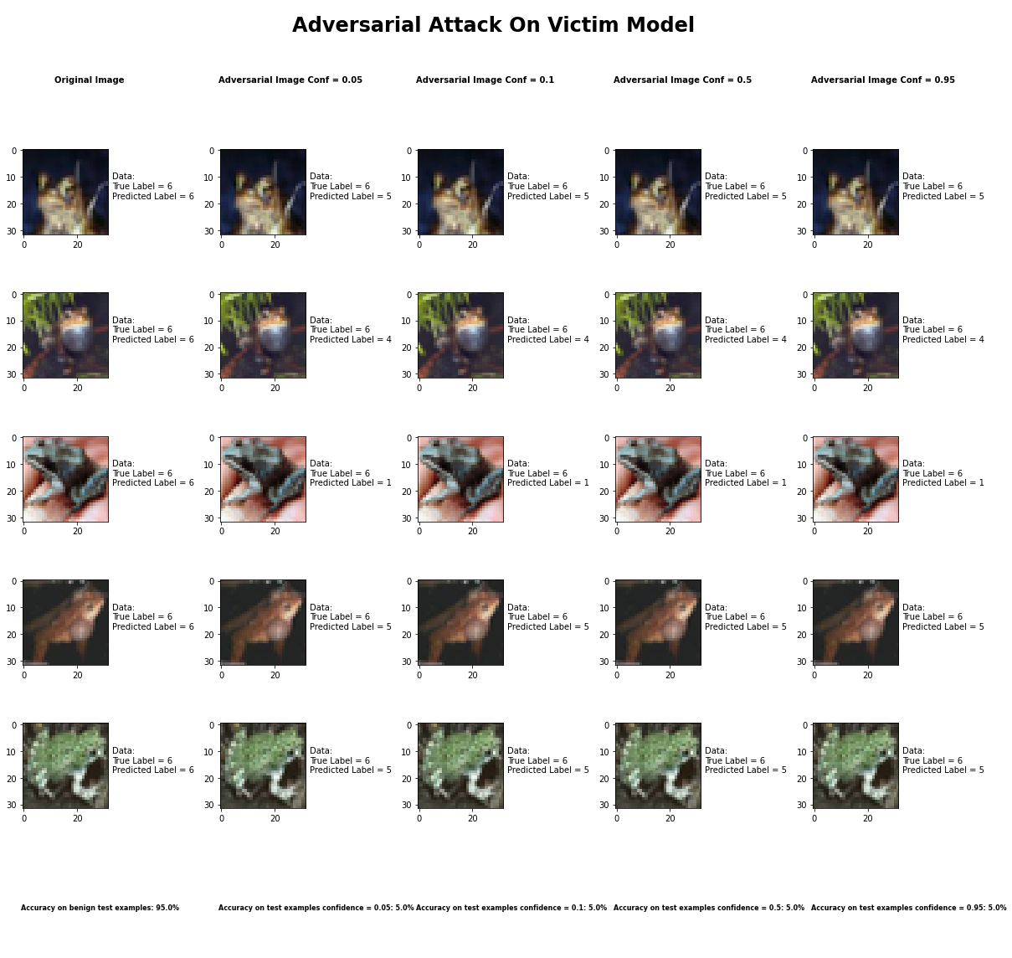

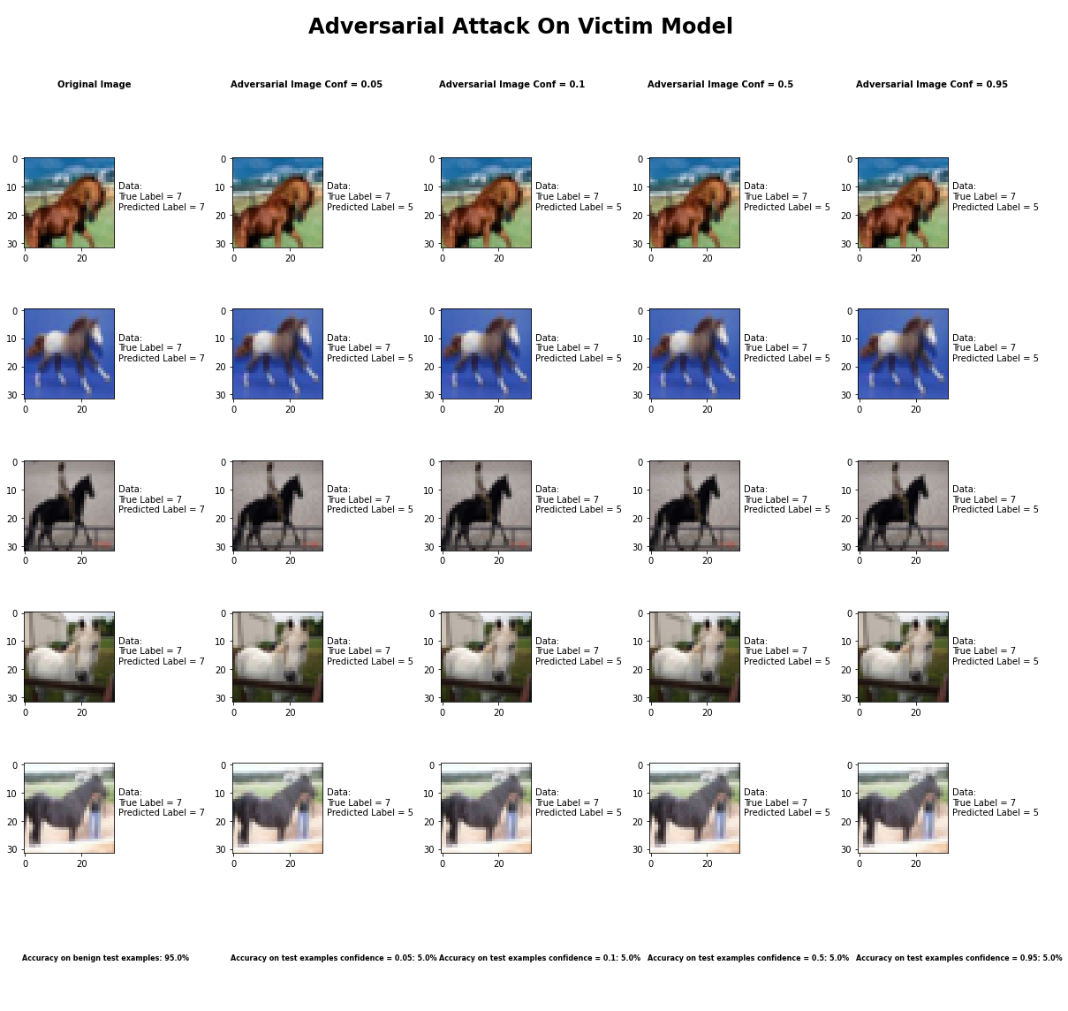

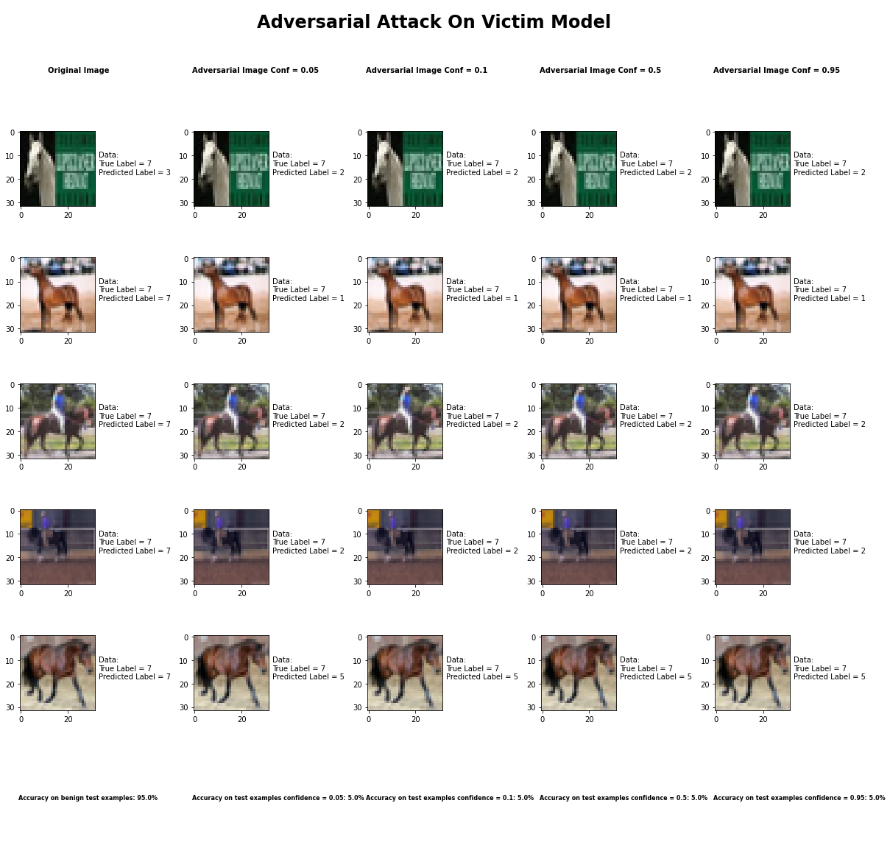

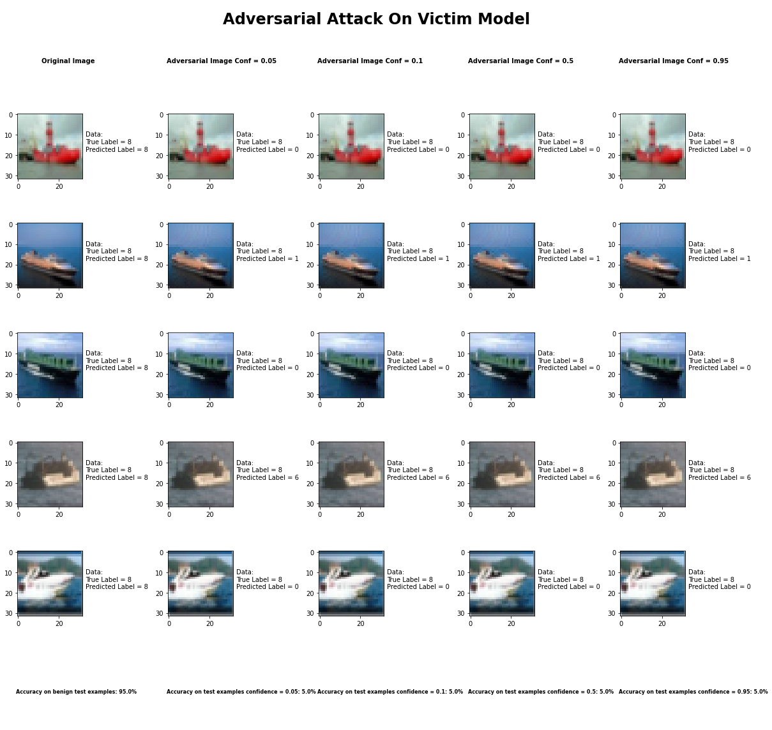

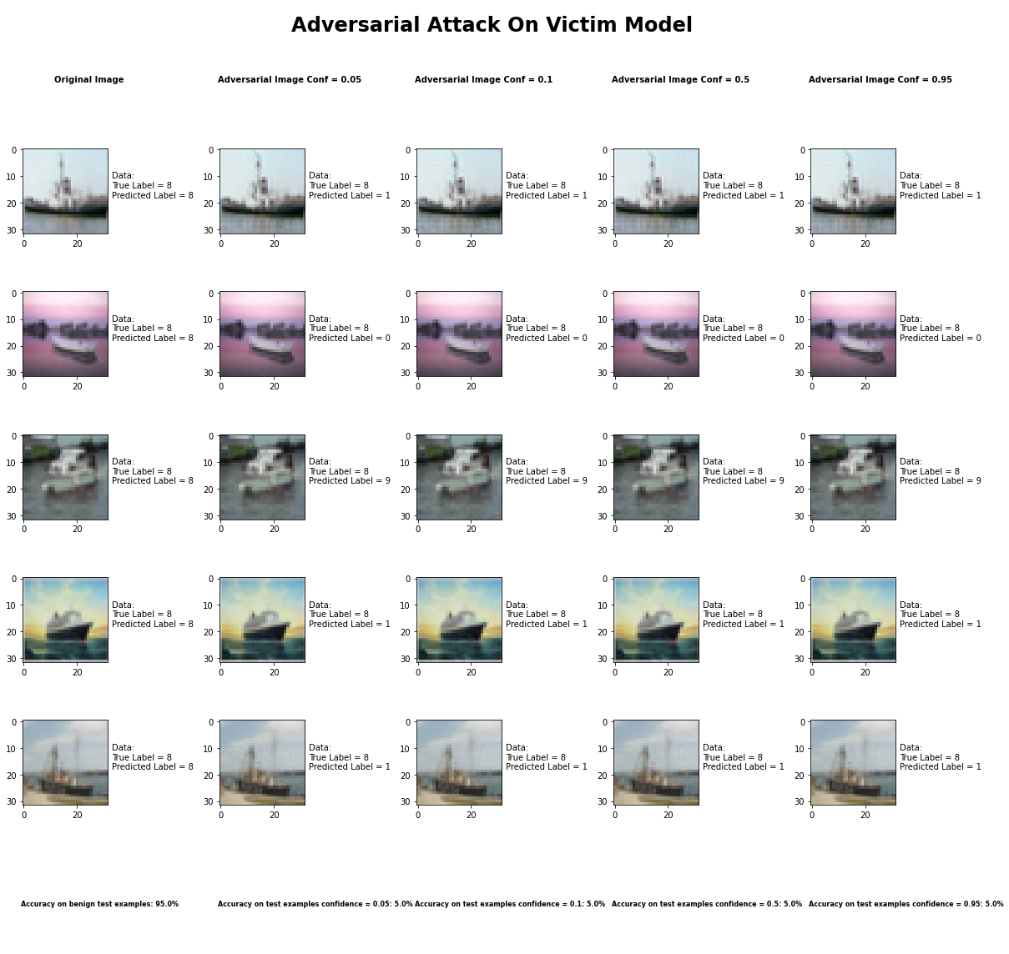

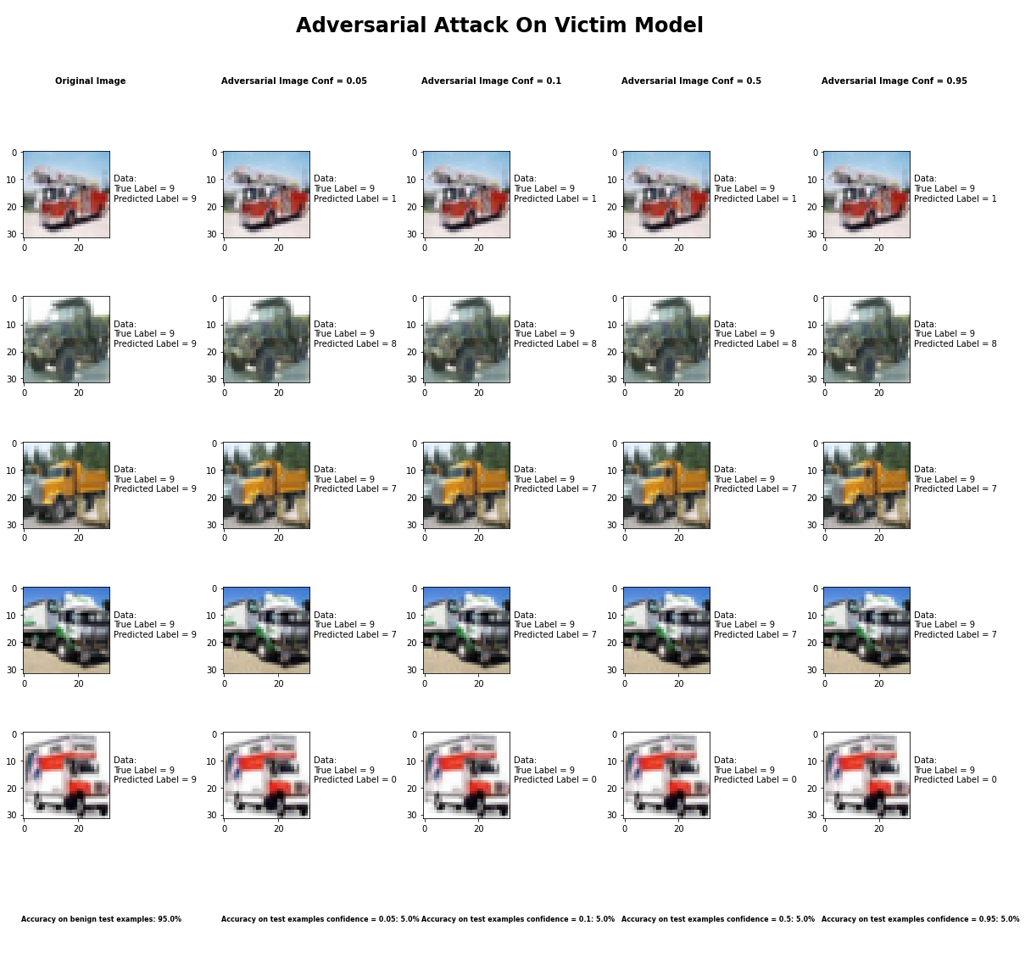

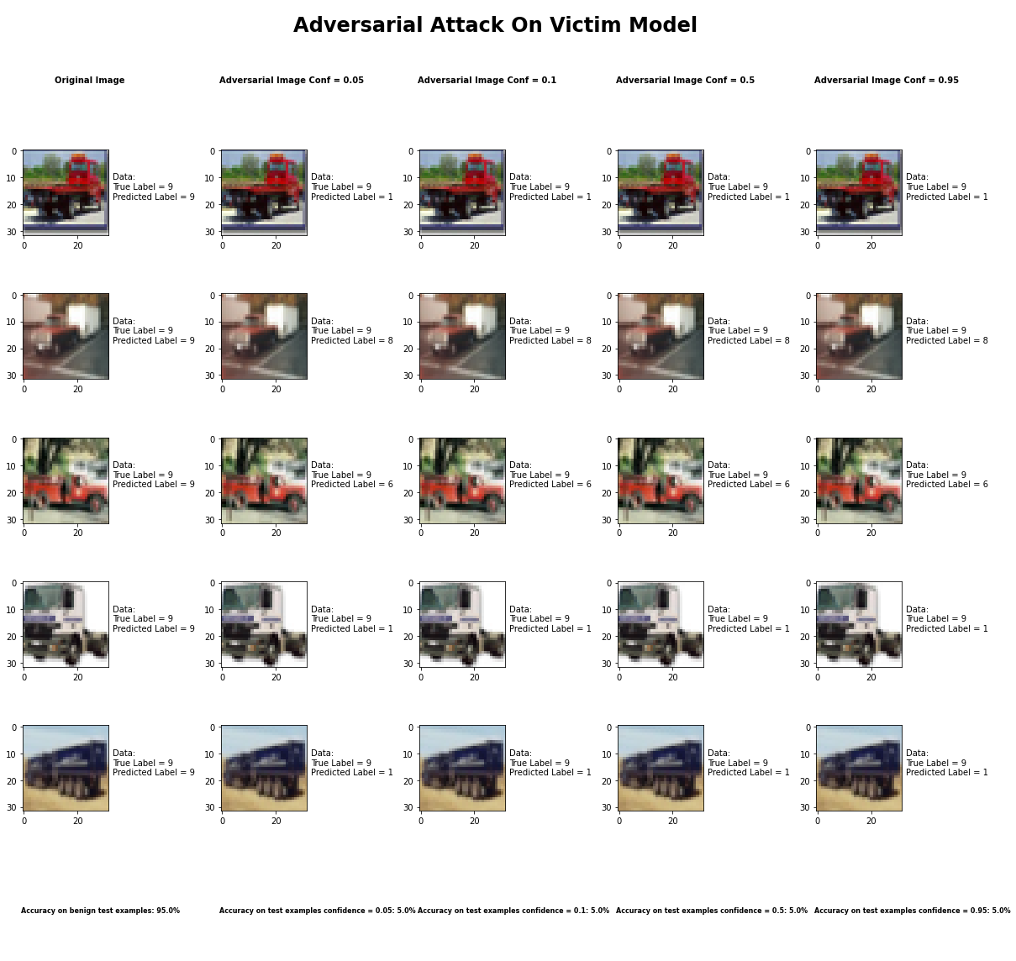

Accuracy on benign test examples: 94.52000000000001%

Average Accuracy on adversarial test examples with confidence = 0.05: 4.8%

Average Accuracy on adversarial test examples with confidence = 0.1: 4.8%

Average Accuracy on adversarial test examples with confidence = 0.5: 4.8%

Average Accuracy on adversarial test examples with confidence = 0.95: 4.8%

Classifier with benign example has Airplane recognition average accuracy of = 97%

Carlini L2 Method with confidence = 0.05 has Airplane recognition average accuracy of = 1%

Carlini L2 Method with confidence = 0.10 has Airplane recognition average accuracy of = 1%

Carlini L2 Method with confidence = 0.50 has Airplane recognition average accuracy of = 1%

Carlini L2 Method with confidence = 0.95 has Airplane recognition average accuracy of = 1%

Classifier with benign example has Automobile recognition average accuracy of = 97%

Carlini L2 Method with confidence = 0.05 has Automobile recognition average accuracy of = 2%

Carlini L2 Method with confidence = 0.10 has Automobile recognition average accuracy of = 2%

Carlini L2 Method with confidence = 0.50 has Automobile recognition average accuracy of = 2%

Carlini L2 Method with confidence = 0.95 has Automobile recognition average accuracy of = 2%

Classifier with benign example has Bird recognition average accuracy of = 91%

Carlini L2 Method with confidence = 0.05 has Bird recognition average accuracy of = 6%

Carlini L2 Method with confidence = 0.10 has Bird recognition average accuracy of = 6%

Carlini L2 Method with confidence = 0.50 has Bird recognition average accuracy of = 6%

Carlini L2 Method with confidence = 0.95 has Bird recognition average accuracy of = 6%

Classifier with benign example has Cat recognition average accuracy of = 83%

Carlini L2 Method with confidence = 0.05 has Cat recognition average accuracy of = 8%

Carlini L2 Method with confidence = 0.10 has Cat recognition average accuracy of = 8%

Carlini L2 Method with confidence = 0.50 has Cat recognition average accuracy of = 8%

Carlini L2 Method with confidence = 0.95 has Cat recognition average accuracy of = 8%

Classifier with benign example has Deer recognition average accuracy of = 89%

Carlini L2 Method with confidence = 0.05 has Deer recognition average accuracy of = 9%

Carlini L2 Method with confidence = 0.10 has Deer recognition average accuracy of = 9%

Carlini L2 Method with confidence = 0.50 has Deer recognition average accuracy of = 9%

Carlini L2 Method with confidence = 0.95 has Deer recognition average accuracy of = 9%

Classifier with benign example has Dog recognition average accuracy of = 84%

Carlini L2 Method with confidence = 0.05 has Dog recognition average accuracy of = 12%

Carlini L2 Method with confidence = 0.10 has Dog recognition average accuracy of = 12%

Carlini L2 Method with confidence = 0.50 has Dog recognition average accuracy of = 12%

Carlini L2 Method with confidence = 0.95 has Dog recognition average accuracy of = 12%

Classifier with benign example has Frog recognition average accuracy of = 97%

Carlini L2 Method with confidence = 0.05 has Frog recognition average accuracy of = 3%

Carlini L2 Method with confidence = 0.10 has Frog recognition average accuracy of = 3%

Carlini L2 Method with confidence = 0.50 has Frog recognition average accuracy of = 3%

Carlini L2 Method with confidence = 0.95 has Frog recognition average accuracy of = 3%

Classifier with benign example has Horse recognition average accuracy of = 94%

Carlini L2 Method with confidence = 0.05 has Horse recognition average accuracy of = 1%

Carlini L2 Method with confidence = 0.10 has Horse recognition average accuracy of = 1%

Carlini L2 Method with confidence = 0.50 has Horse recognition average accuracy of = 1%

Carlini L2 Method with confidence = 0.95 has Horse recognition average accuracy of = 1%

Classifier with benign example has Ship recognition average accuracy of = 96%

Carlini L2 Method with confidence = 0.05 has Ship recognition average accuracy of = 4%

Carlini L2 Method with confidence = 0.10 has Ship recognition average accuracy of = 4%

Carlini L2 Method with confidence = 0.50 has Ship recognition average accuracy of = 4%

Carlini L2 Method with confidence = 0.95 has Ship recognition average accuracy of = 4%

Classifier with benign example has Truck recognition average accuracy of = 98%

Carlini L2 Method with confidence = 0.05 has Truck recognition average accuracy of = 2%

Carlini L2 Method with confidence = 0.10 has Truck recognition average accuracy of = 2%

Carlini L2 Method with confidence = 0.50 has Truck recognition average accuracy of = 2%

Carlini L2 Method with confidence = 0.95 has Truck recognition average accuracy of = 2%

## Basic Iterative Method



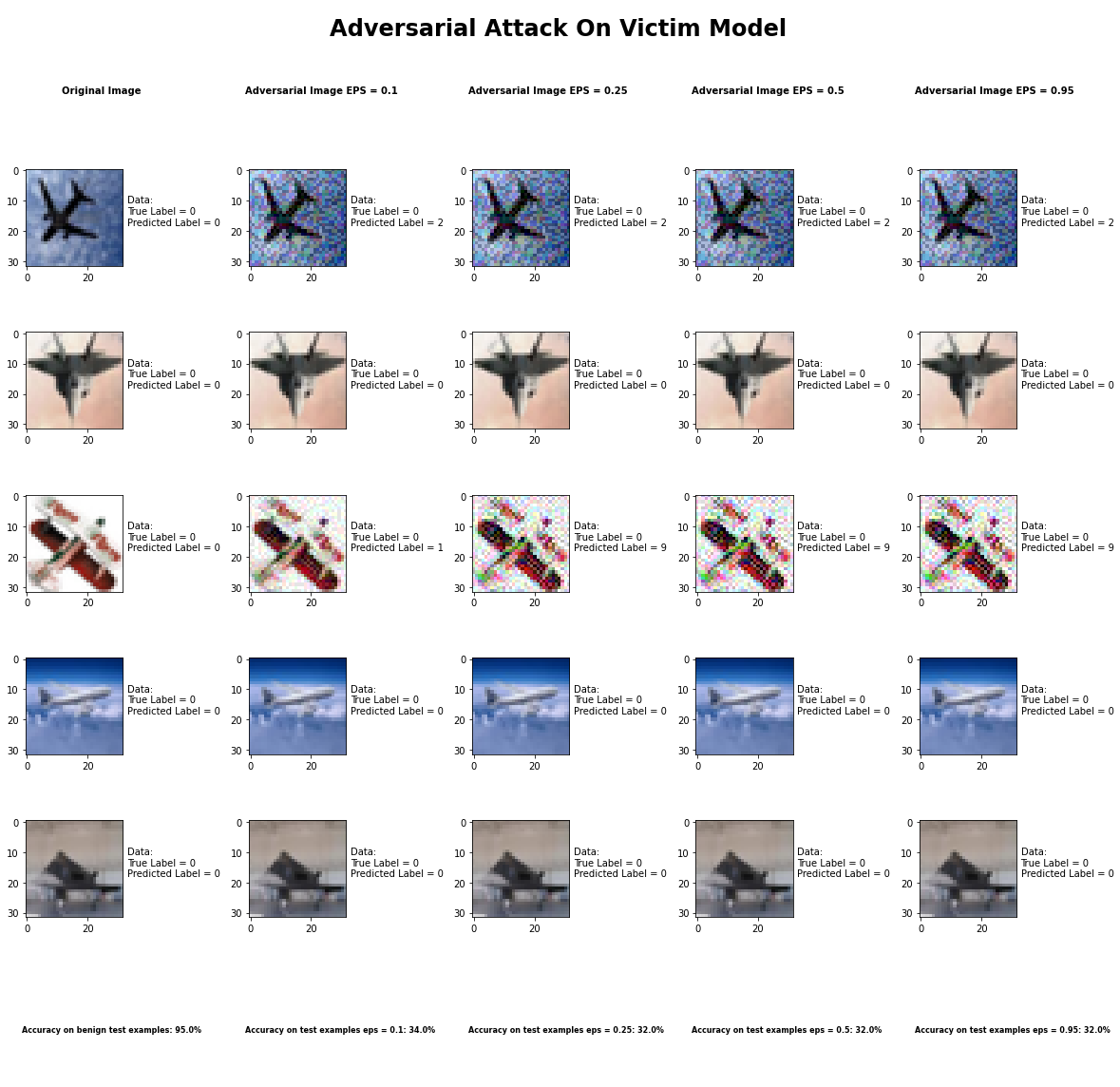

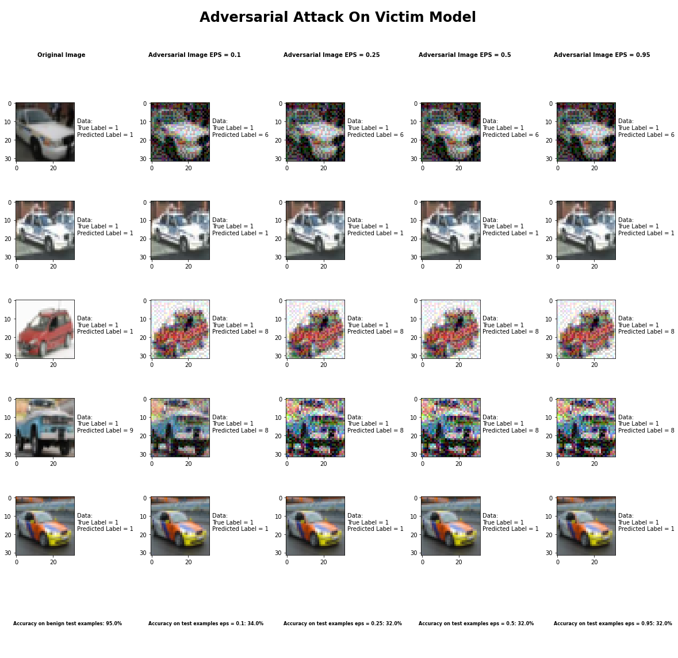

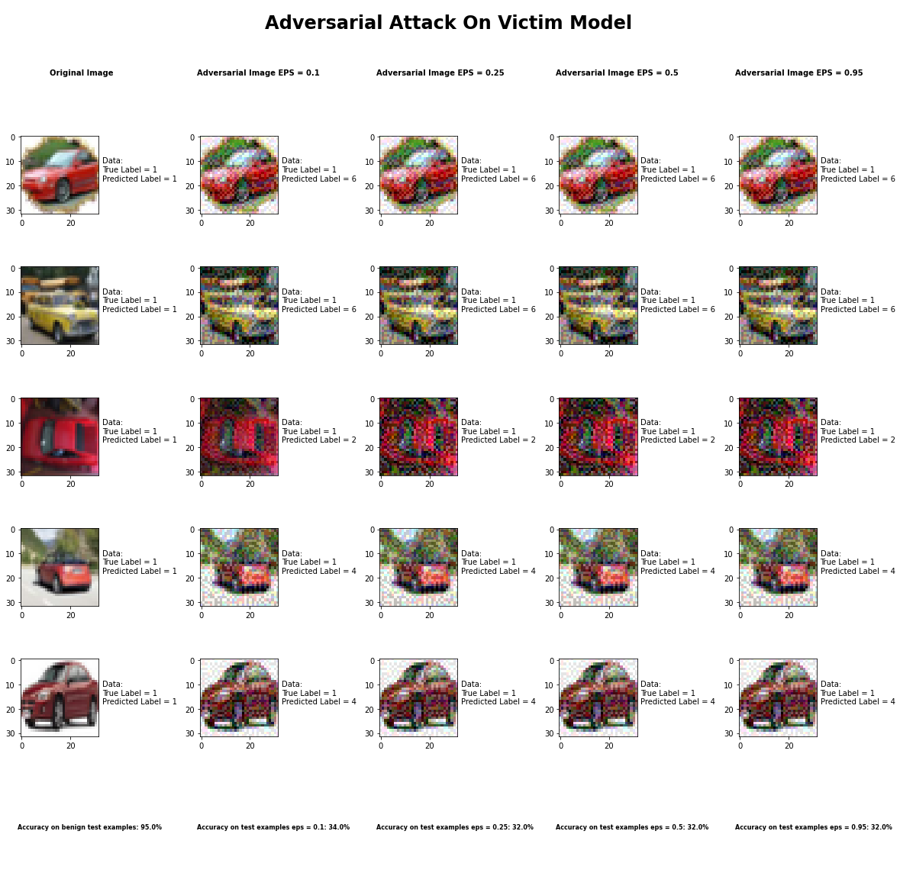

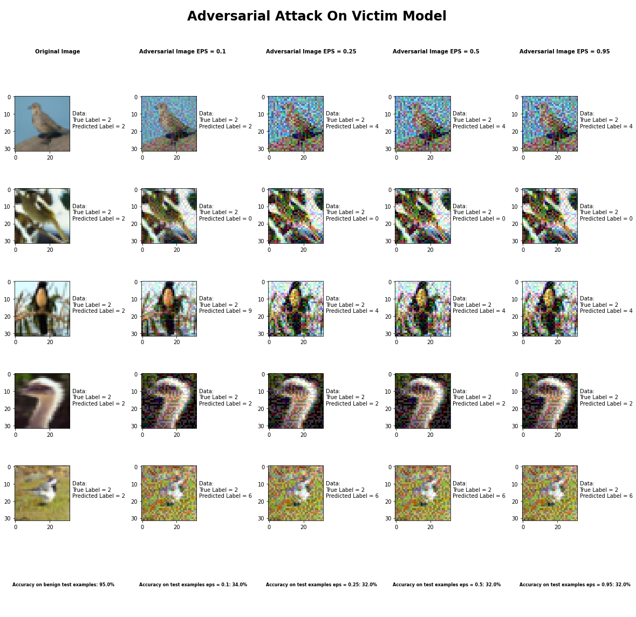

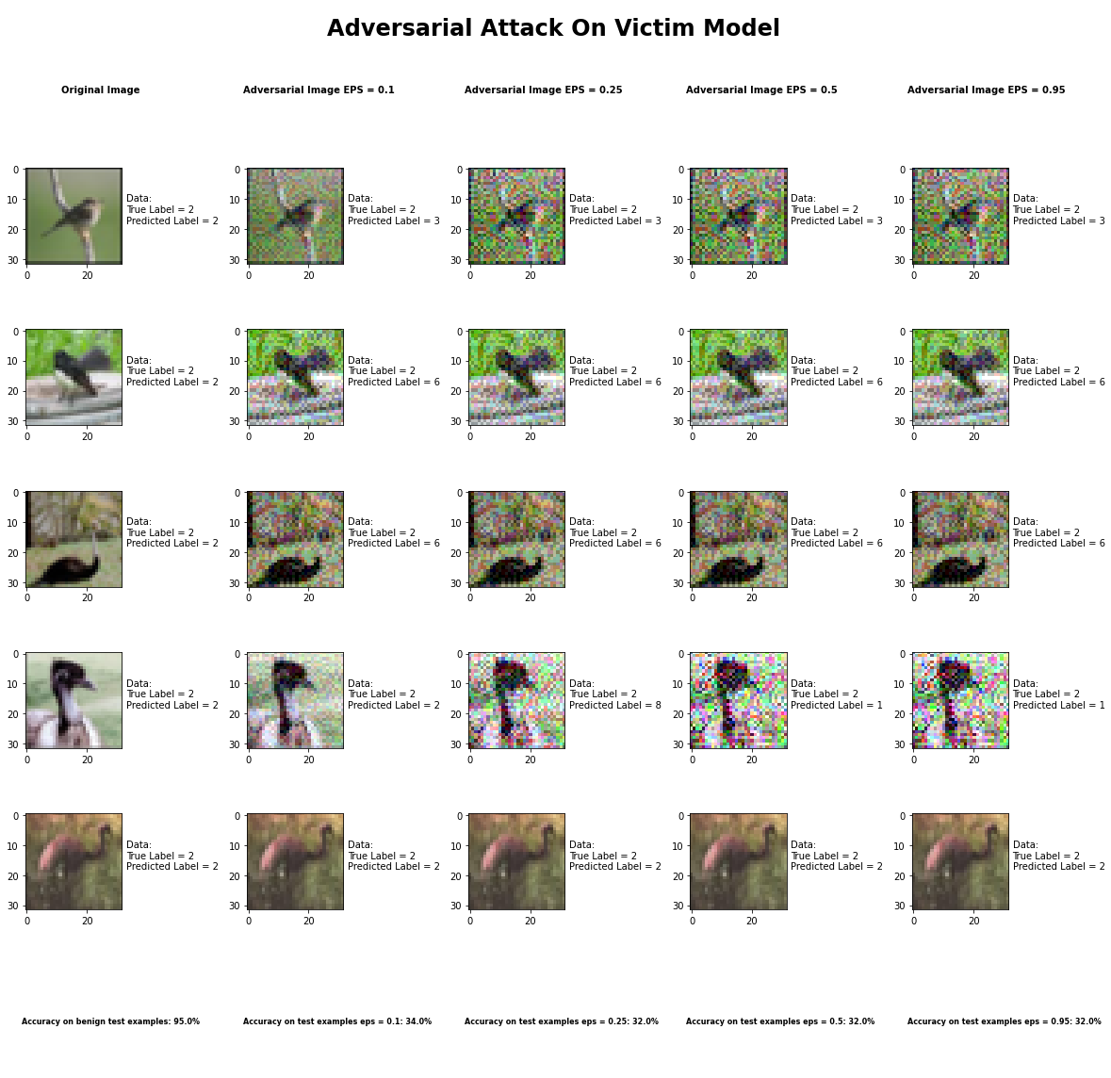

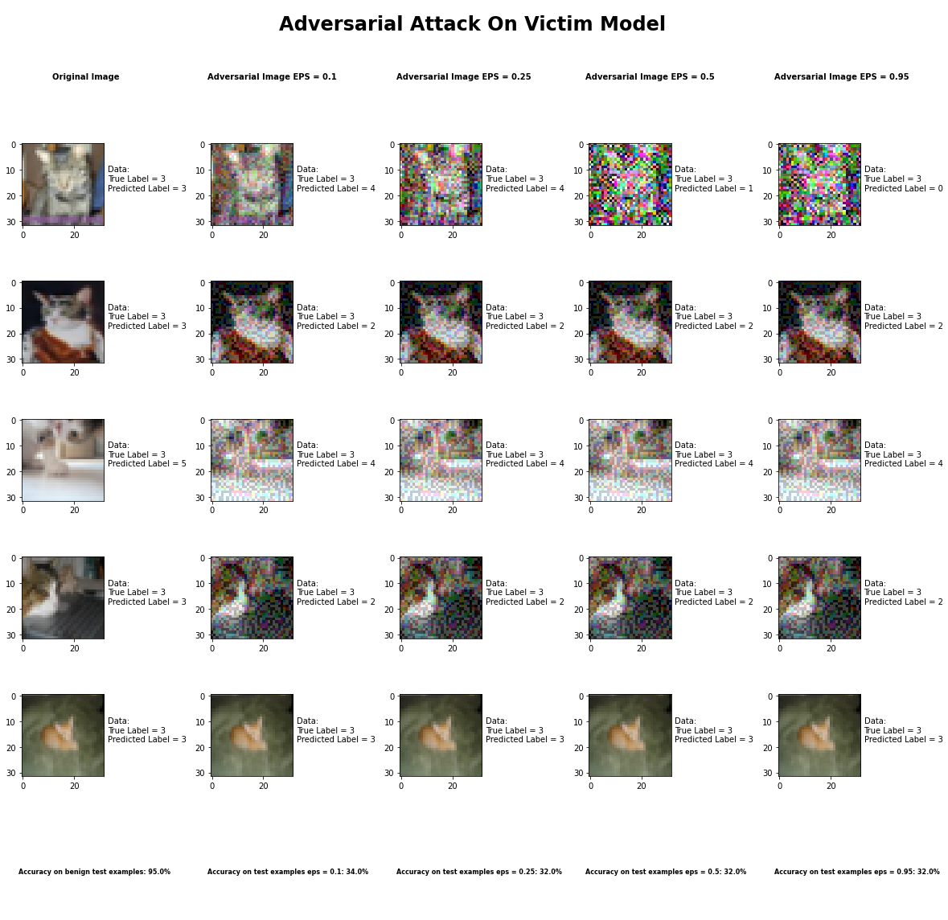

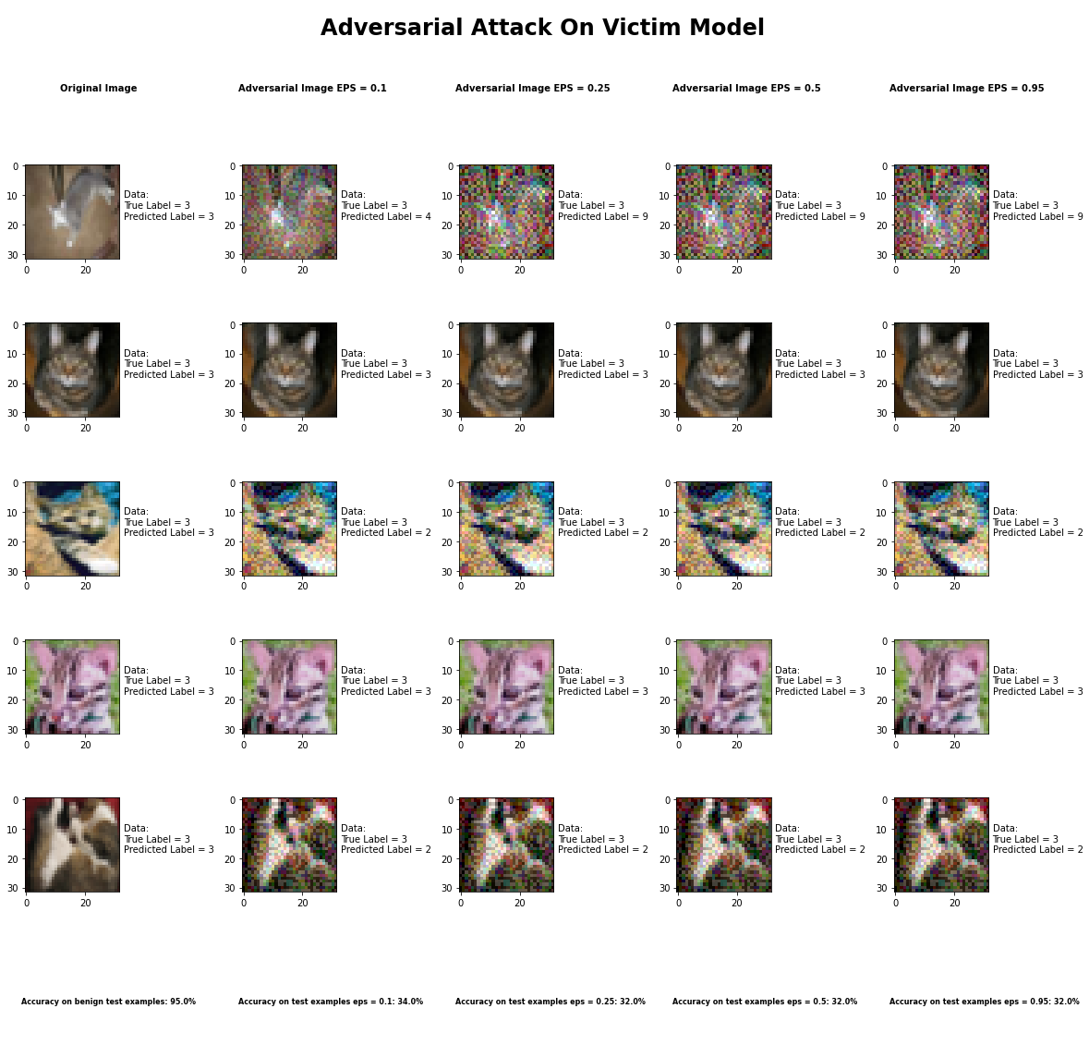

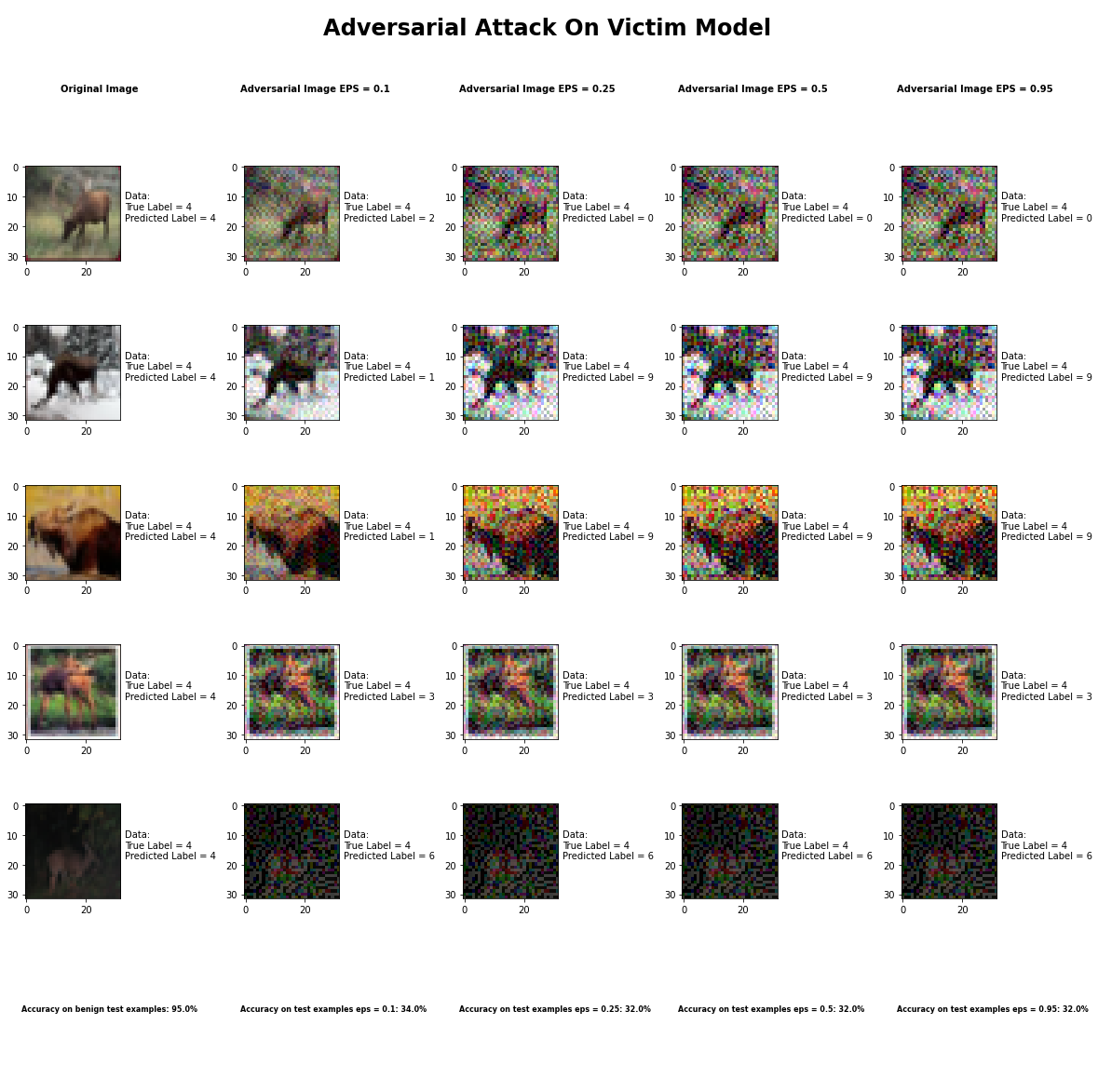

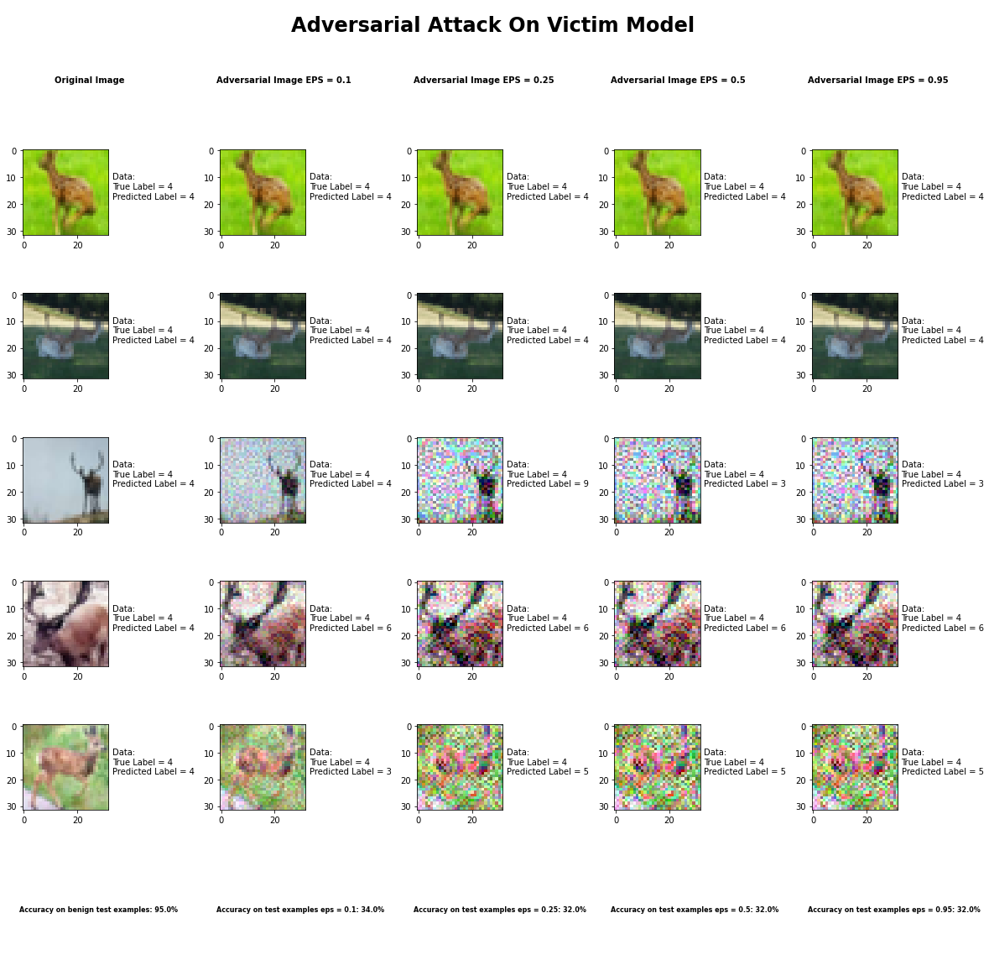

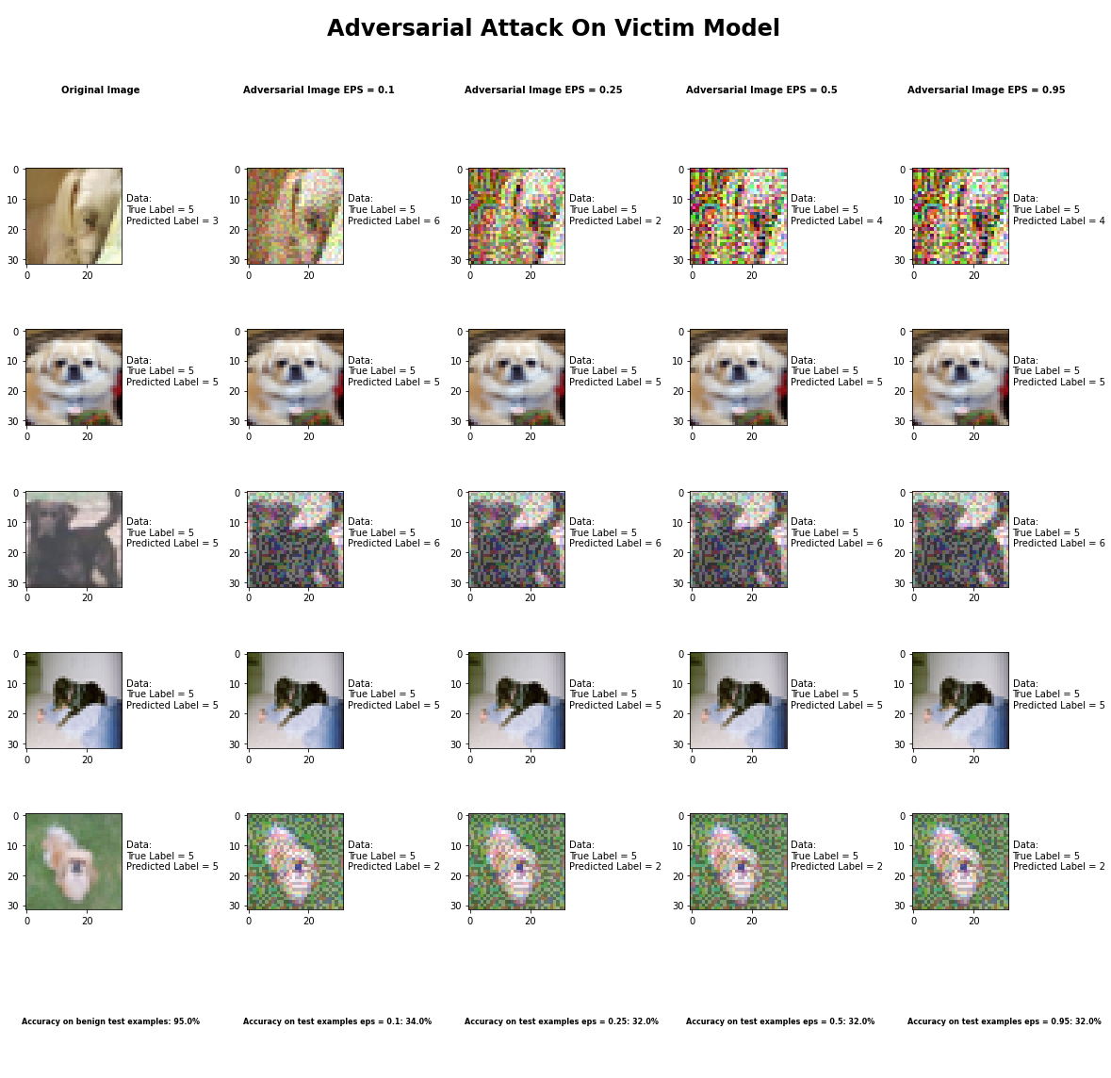

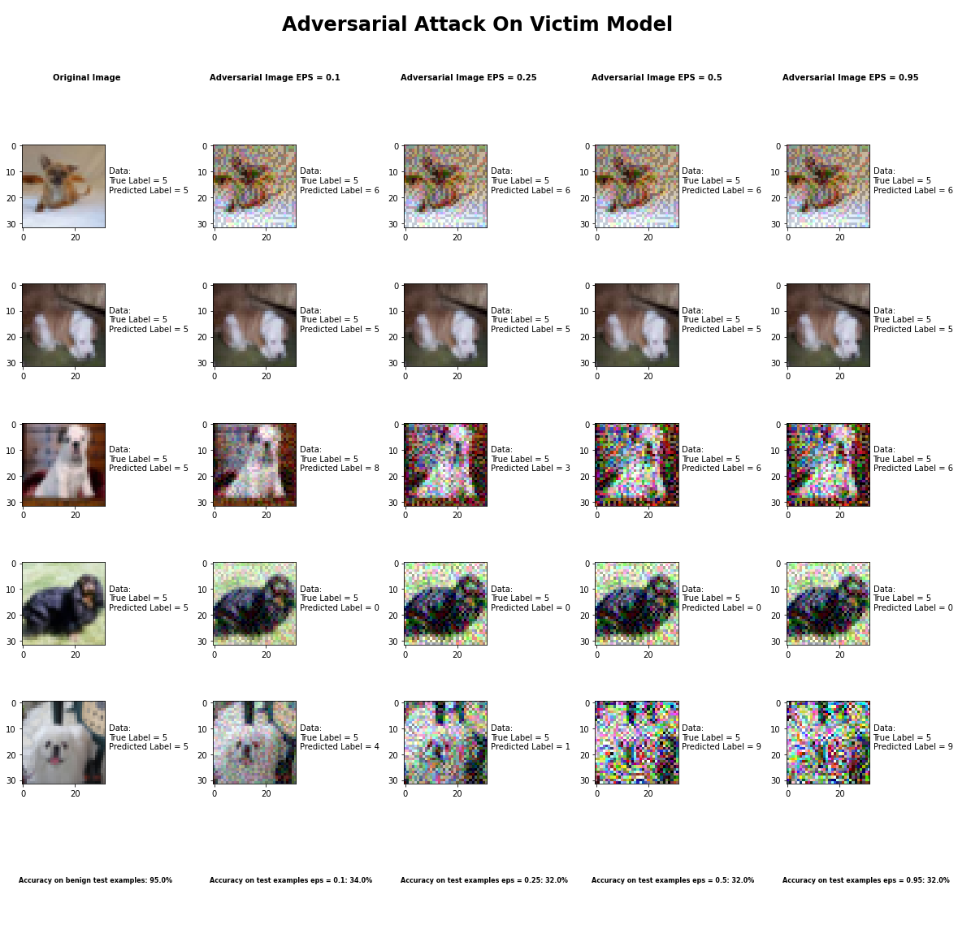

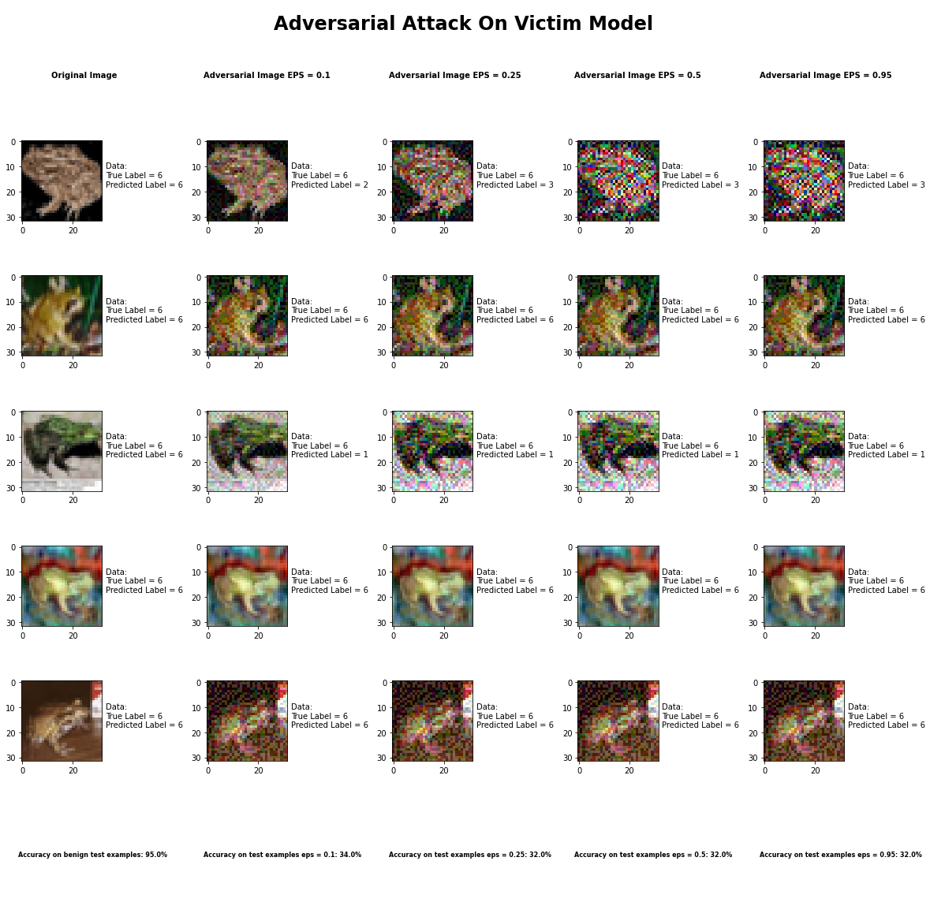

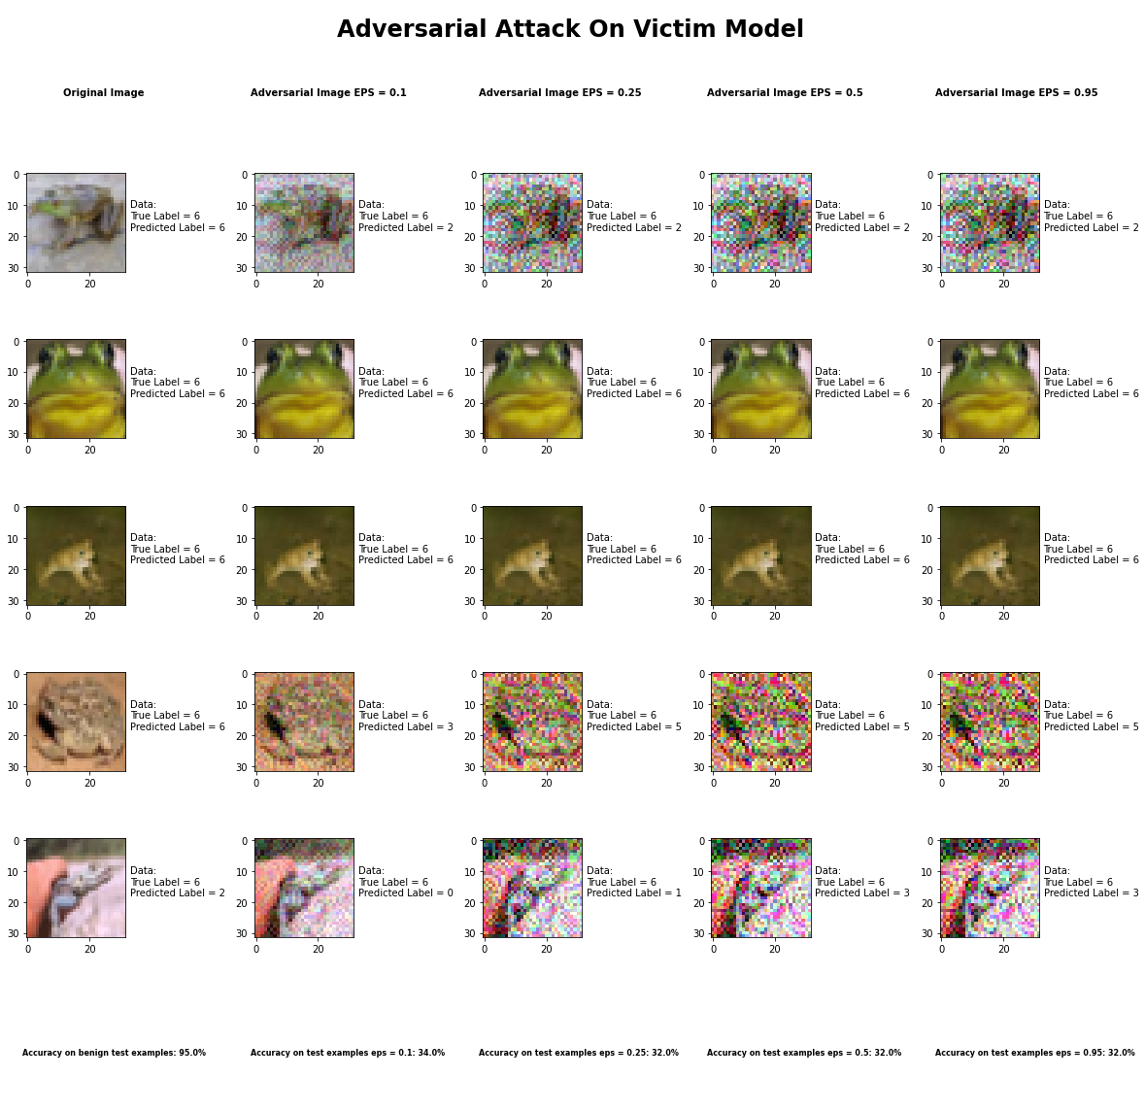

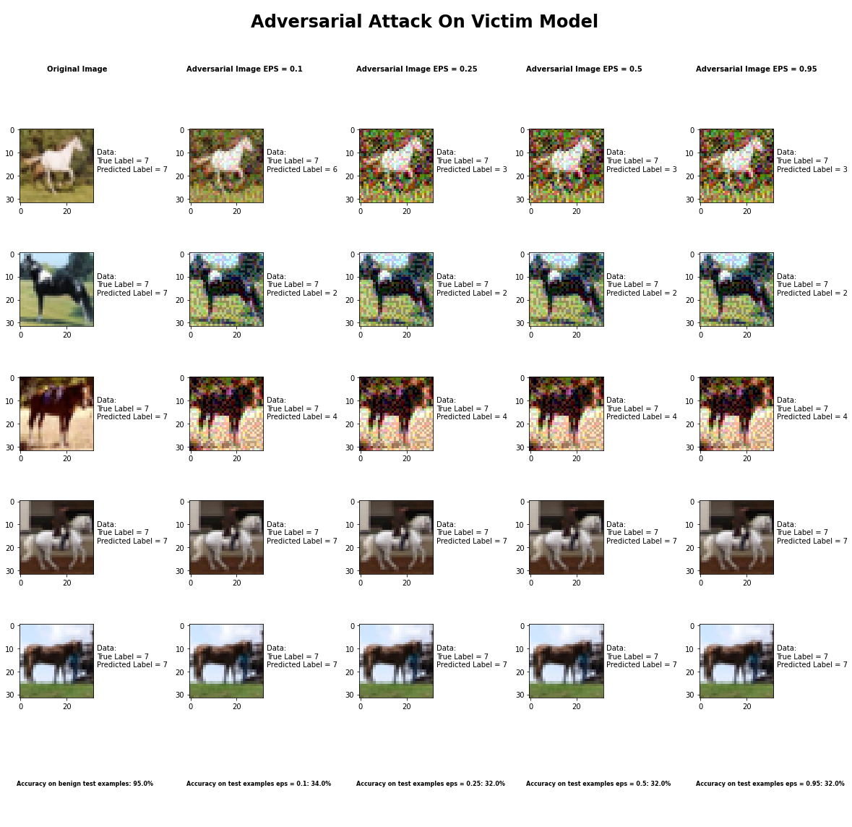

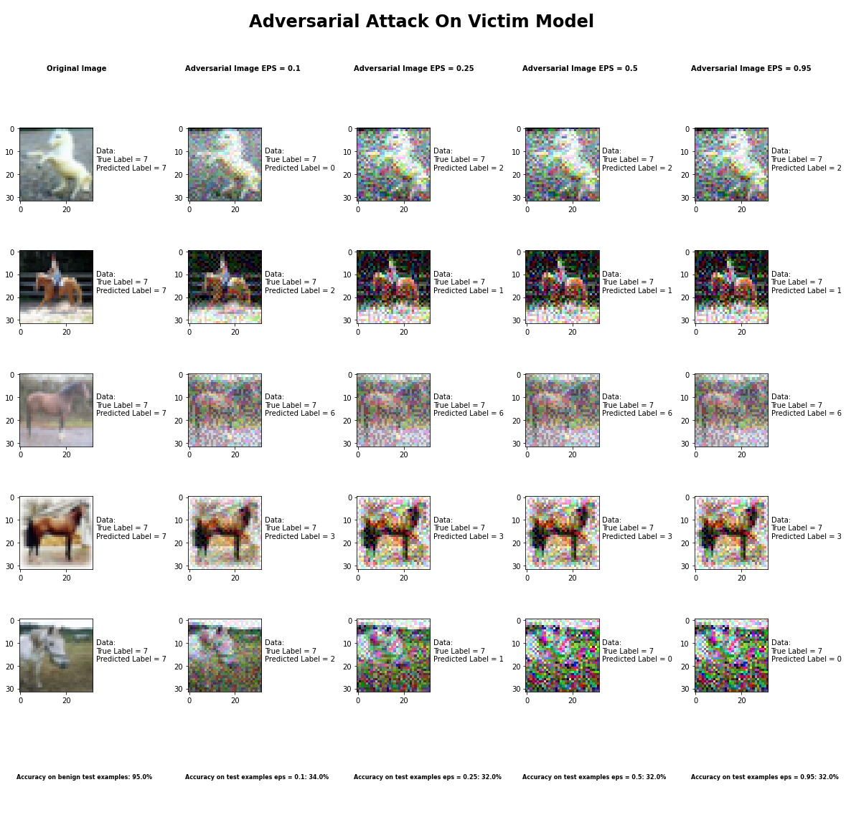

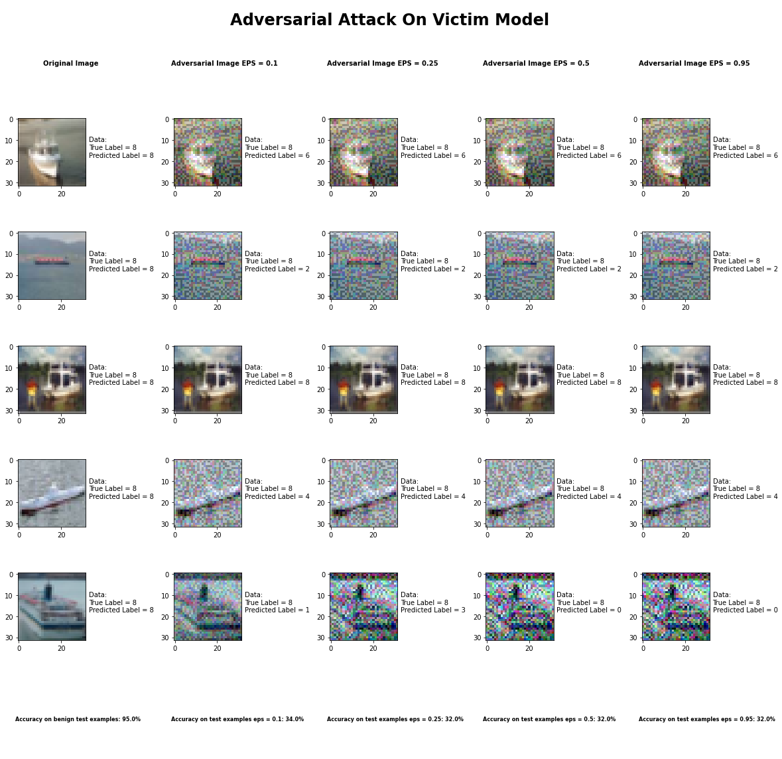

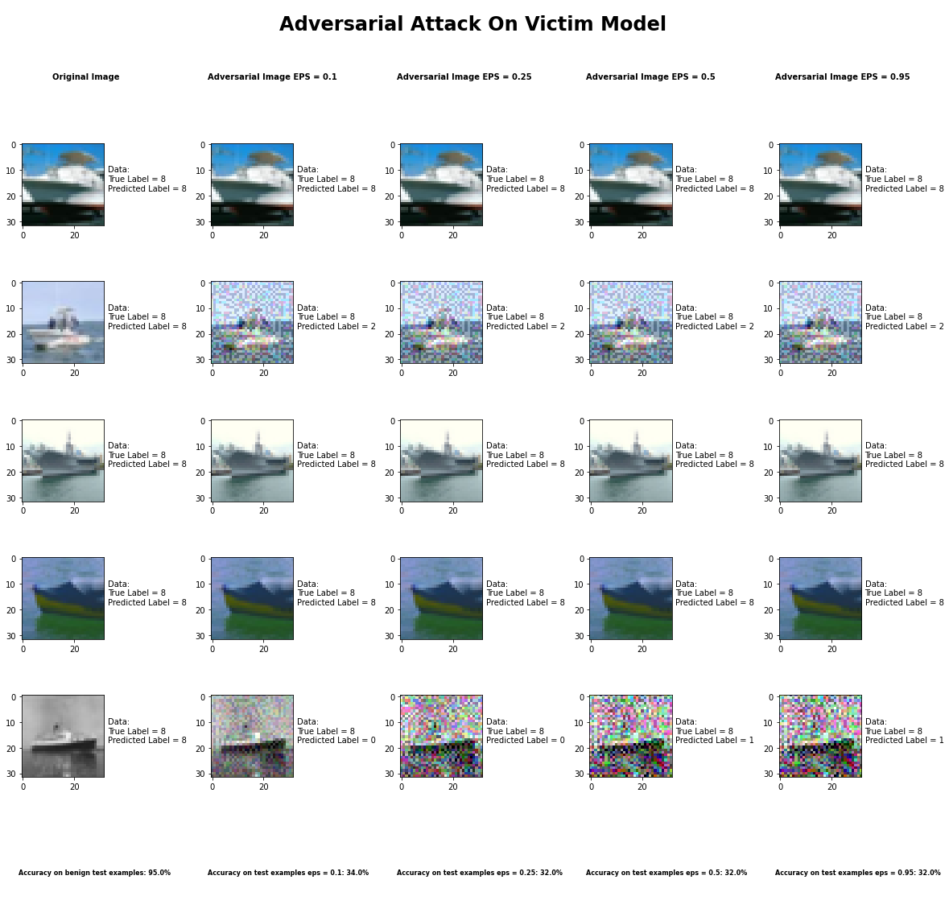

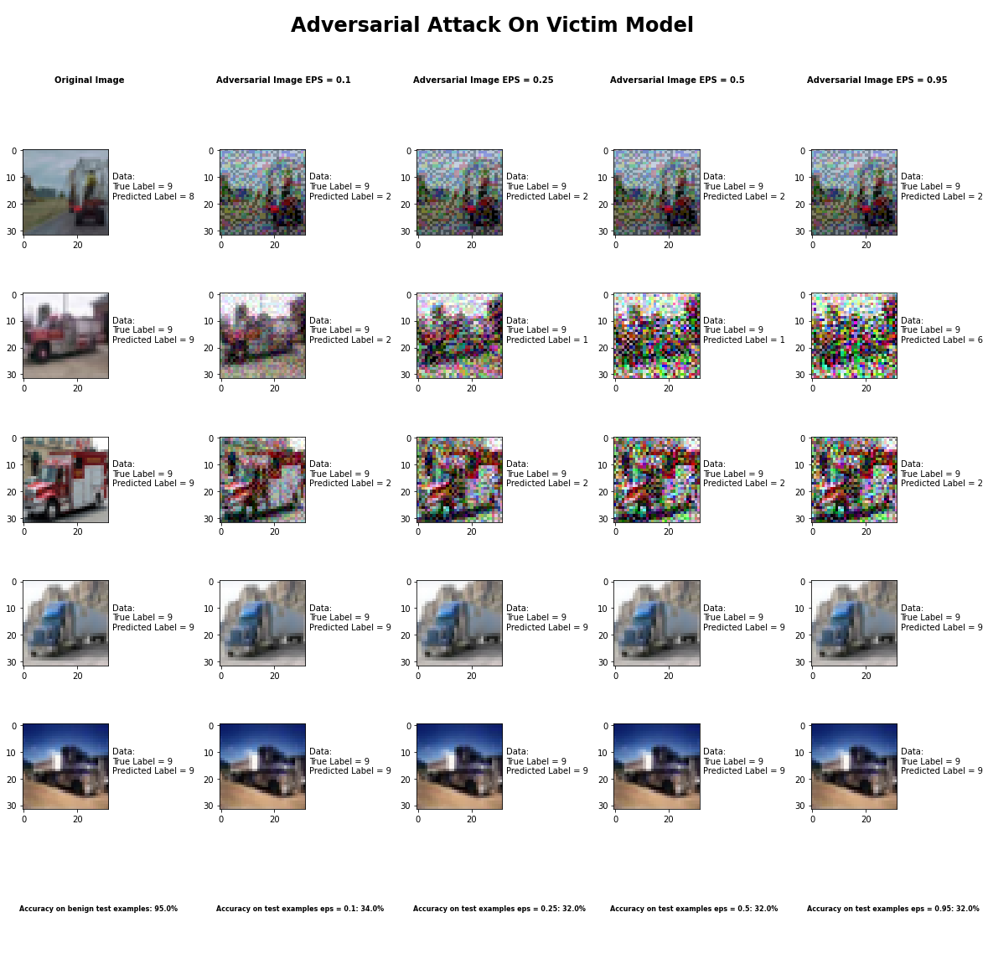

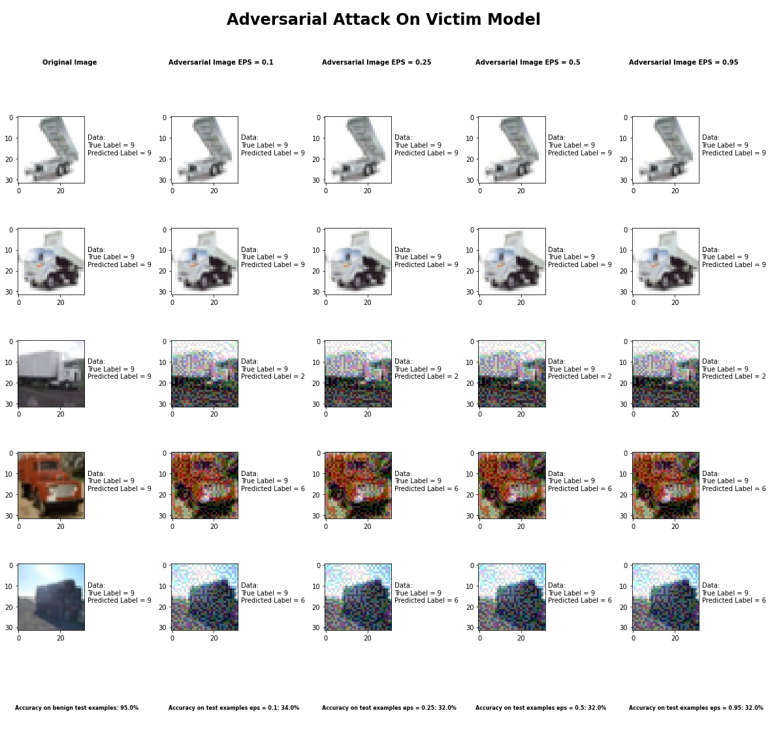 Accuracy on benign test examples: 94.52000000000001%

Average Accuracy on adversarial test examples with eps = 0.10: 34.0%

Average Accuracy on adversarial test examples with eps = 0.25: 32.3%

Average Accuracy on adversarial test examples with eps = 0.50: 32.0%

Average Accuracy on adversarial test examples with eps = 0.95: 32.1%

Classifier with benign example has Airplane recognition average accuracy of = 99%

Basic Iterative Method with eps = 0.10 has Airplane recognition average accuracy of = 35%

Basic Iterative Method with eps = 0.25 has Airplane recognition average accuracy of = 35%

Basic Iterative Method with eps = 0.50 has Airplane recognition average accuracy of = 35%

Basic Iterative Method with eps = 0.95 has Airplane recognition average accuracy of = 36%

Classifier with benign example has Automobile recognition average accuracy of = 96%

Basic Iterative Method with eps = 0.10 has Automobile recognition average accuracy of = 30%

Basic Iterative Method with eps = 0.25 has Automobile recognition average accuracy of = 28%

Basic Iterative Method with eps = 0.50 has Automobile recognition average accuracy of = 28%

Basic Iterative Method with eps = 0.95 has Automobile recognition average accuracy of = 28%

Classifier with benign example has Bird recognition average accuracy of = 94%

Basic Iterative Method with eps = 0.10 has Bird recognition average accuracy of = 44%

Basic Iterative Method with eps = 0.25 has Bird recognition average accuracy of = 41%

Basic Iterative Method with eps = 0.50 has Bird recognition average accuracy of = 40%

Basic Iterative Method with eps = 0.95 has Bird recognition average accuracy of = 40%

Classifier with benign example has Cat recognition average accuracy of = 87%

Basic Iterative Method with eps = 0.10 has Cat recognition average accuracy of = 27%

Basic Iterative Method with eps = 0.25 has Cat recognition average accuracy of = 27%

Basic Iterative Method with eps = 0.50 has Cat recognition average accuracy of = 25%

Basic Iterative Method with eps = 0.95 has Cat recognition average accuracy of = 25%

Classifier with benign example has Deer recognition average accuracy of = 97%

Basic Iterative Method with eps = 0.10 has Deer recognition average accuracy of = 29%

Basic Iterative Method with eps = 0.25 has Deer recognition average accuracy of = 28%

Basic Iterative Method with eps = 0.50 has Deer recognition average accuracy of = 28%

Basic Iterative Method with eps = 0.95 has Deer recognition average accuracy of = 28%

Classifier with benign example has Dog recognition average accuracy of = 88%

Basic Iterative Method with eps = 0.10 has Dog recognition average accuracy of = 22%

Basic Iterative Method with eps = 0.25 has Dog recognition average accuracy of = 22%

Basic Iterative Method with eps = 0.50 has Dog recognition average accuracy of = 22%

Basic Iterative Method with eps = 0.95 has Dog recognition average accuracy of = 22%

Classifier with benign example has Frog recognition average accuracy of = 95%

Basic Iterative Method with eps = 0.10 has Frog recognition average accuracy of = 54%

Basic Iterative Method with eps = 0.25 has Frog recognition average accuracy of = 47%

Basic Iterative Method with eps = 0.50 has Frog recognition average accuracy of = 47%

Basic Iterative Method with eps = 0.95 has Frog recognition average accuracy of = 47%

Classifier with benign example has Horse recognition average accuracy of = 97%

Basic Iterative Method with eps = 0.10 has Horse recognition average accuracy of = 30%

Basic Iterative Method with eps = 0.25 has Horse recognition average accuracy of = 30%

Basic Iterative Method with eps = 0.50 has Horse recognition average accuracy of = 30%

Basic Iterative Method with eps = 0.95 has Horse recognition average accuracy of = 30%

Classifier with benign example has Ship recognition average accuracy of = 93%

Basic Iterative Method with eps = 0.10 has Ship recognition average accuracy of = 33%

Basic Iterative Method with eps = 0.25 has Ship recognition average accuracy of = 31%

Basic Iterative Method with eps = 0.50 has Ship recognition average accuracy of = 31%

Basic Iterative Method with eps = 0.95 has Ship recognition average accuracy of = 31%

Classifier with benign example has Truck recognition average accuracy of = 93%

Basic Iterative Method with eps = 0.10 has Truck recognition average accuracy of = 36%

Basic Iterative Method with eps = 0.25 has Truck recognition average accuracy of = 34%

Basic Iterative Method with eps = 0.50 has Truck recognition average accuracy of = 34%

Basic Iterative Method with eps = 0.95 has Truck recognition average accuracy of = 34%

## Universal Perturbation Method



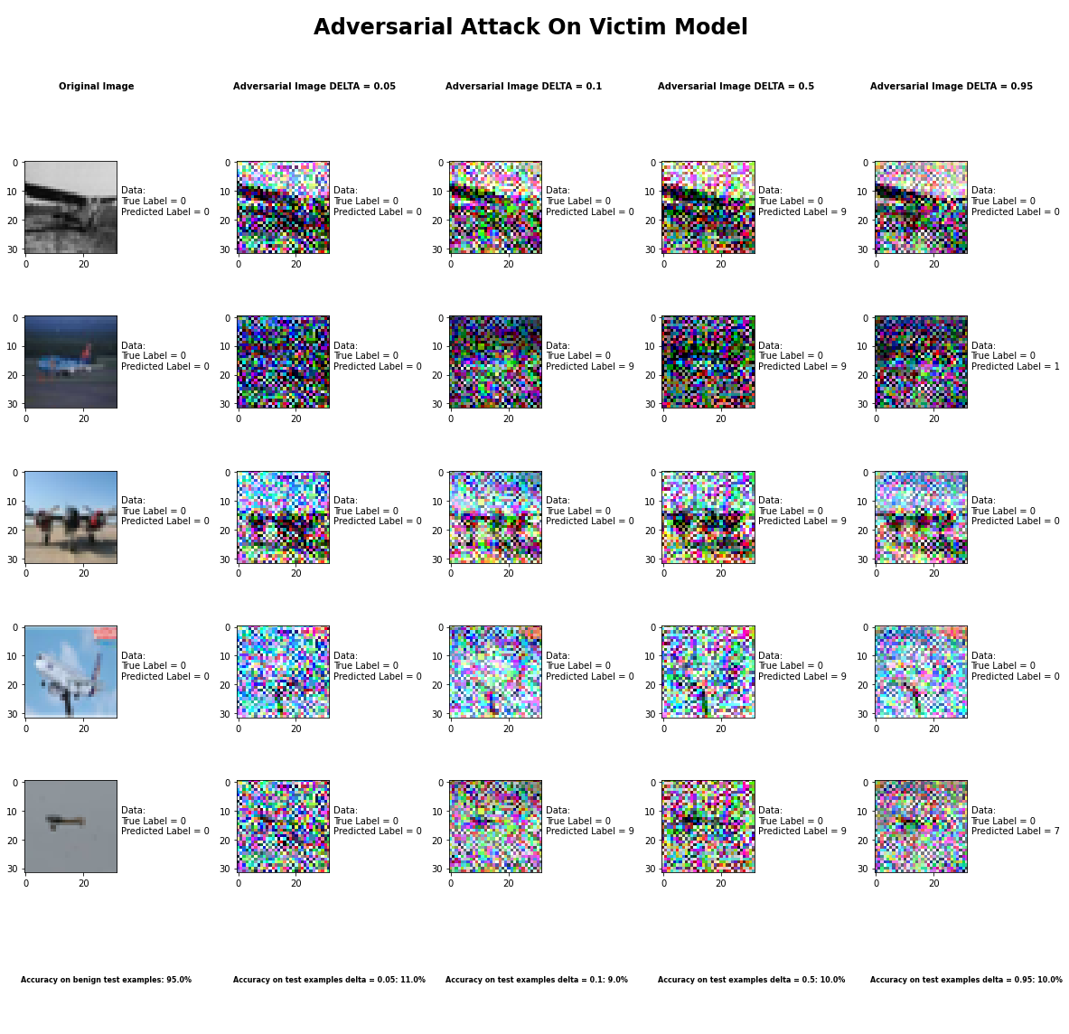

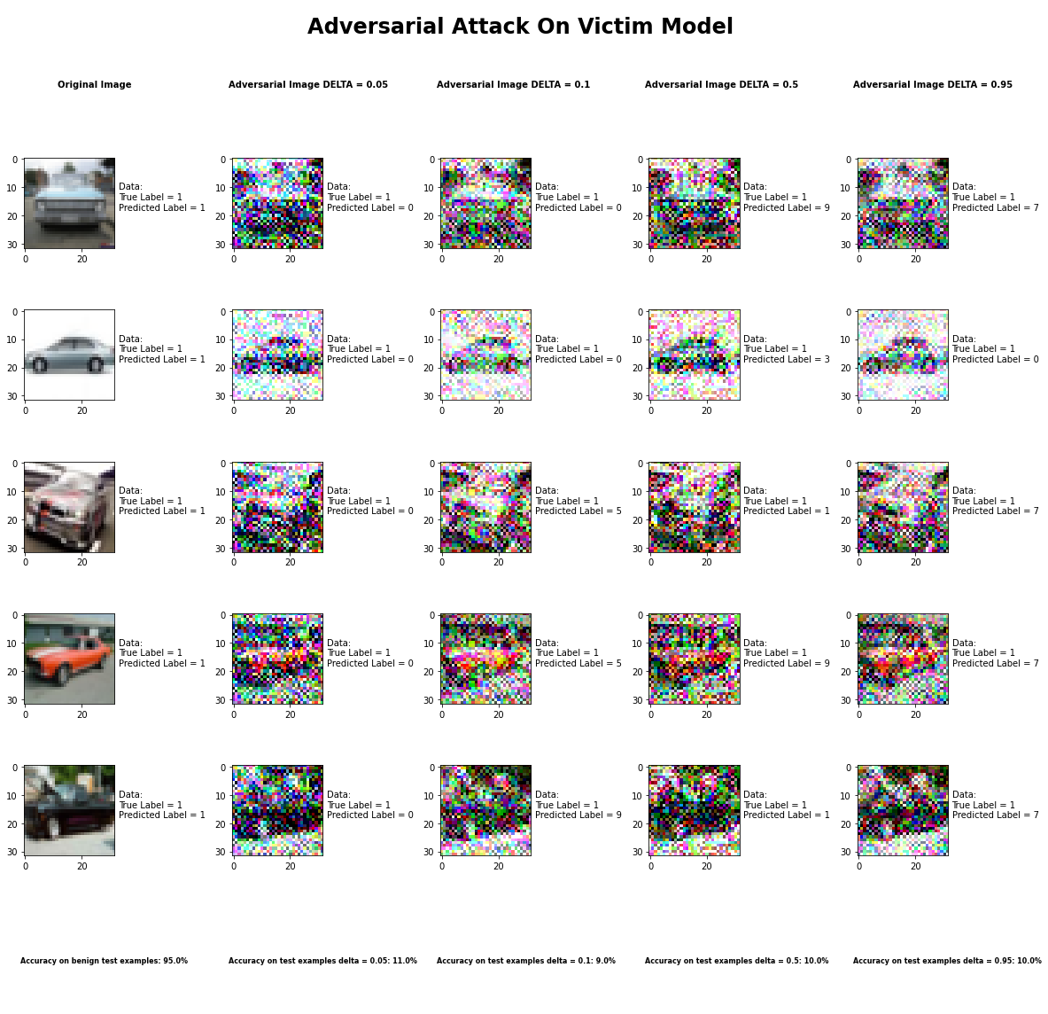

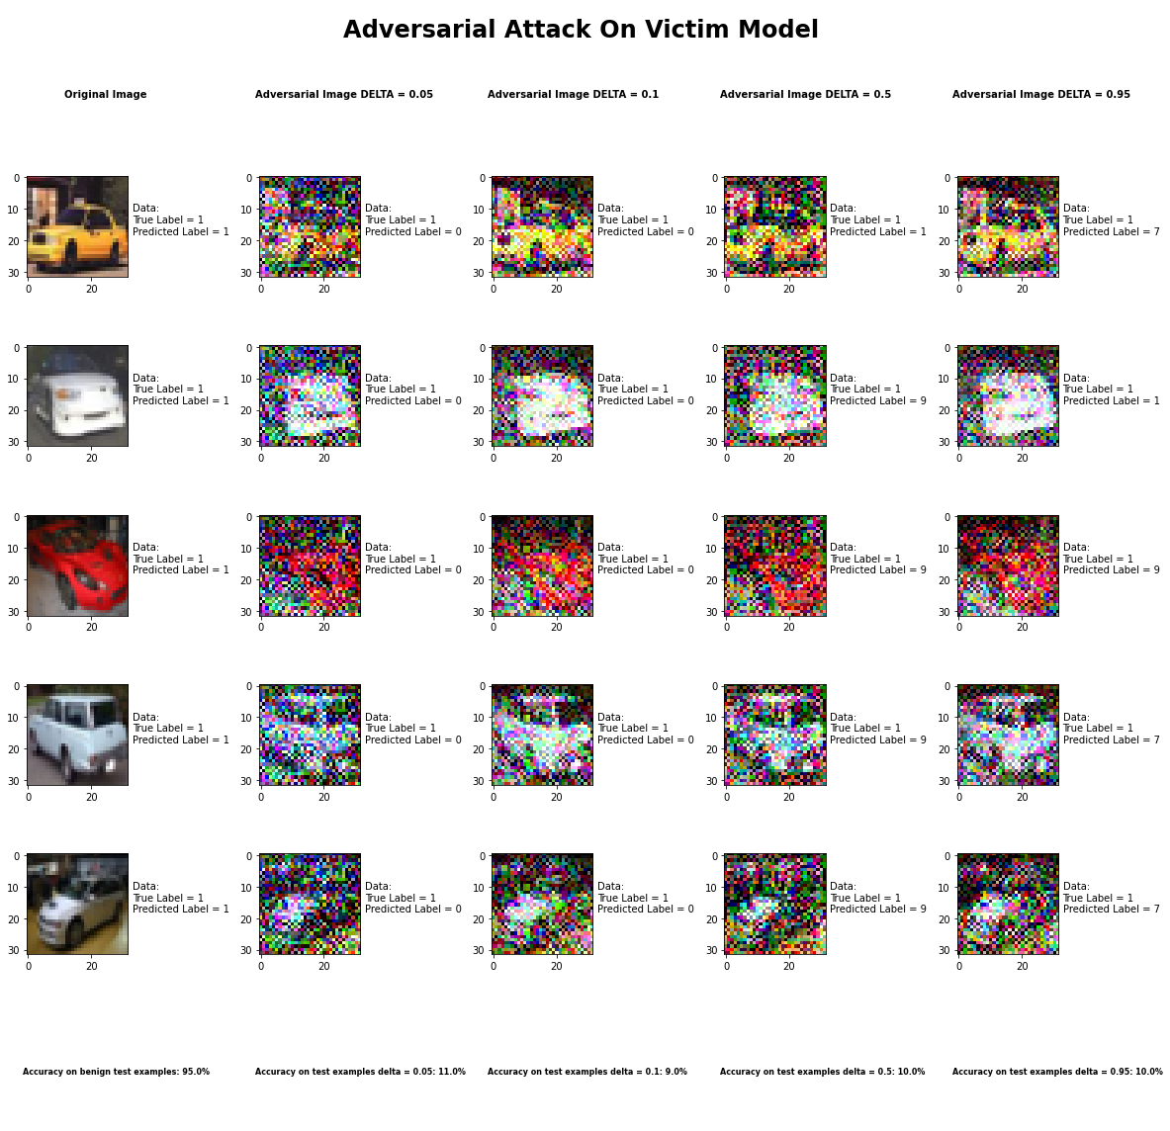

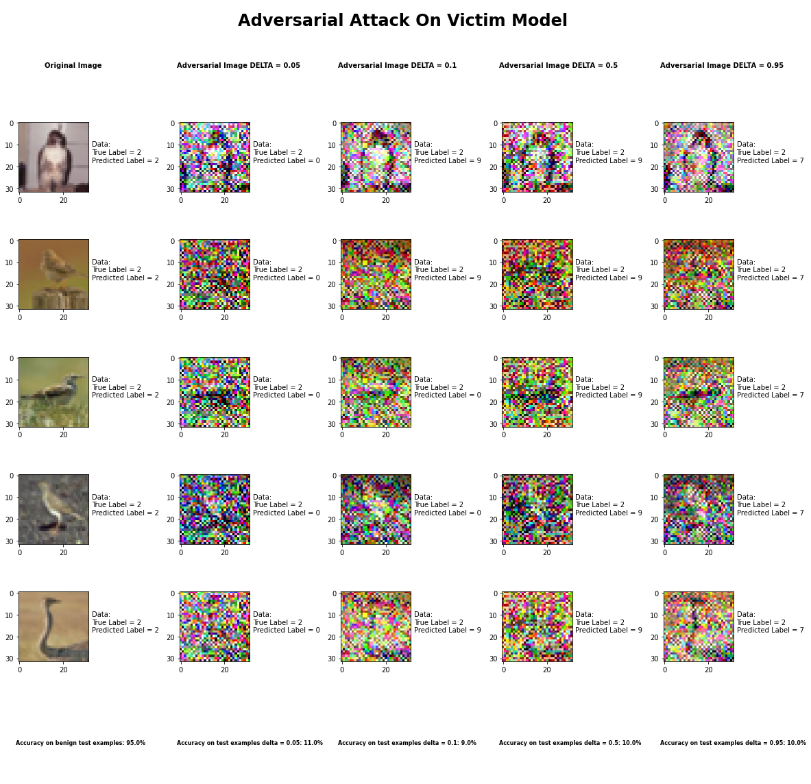

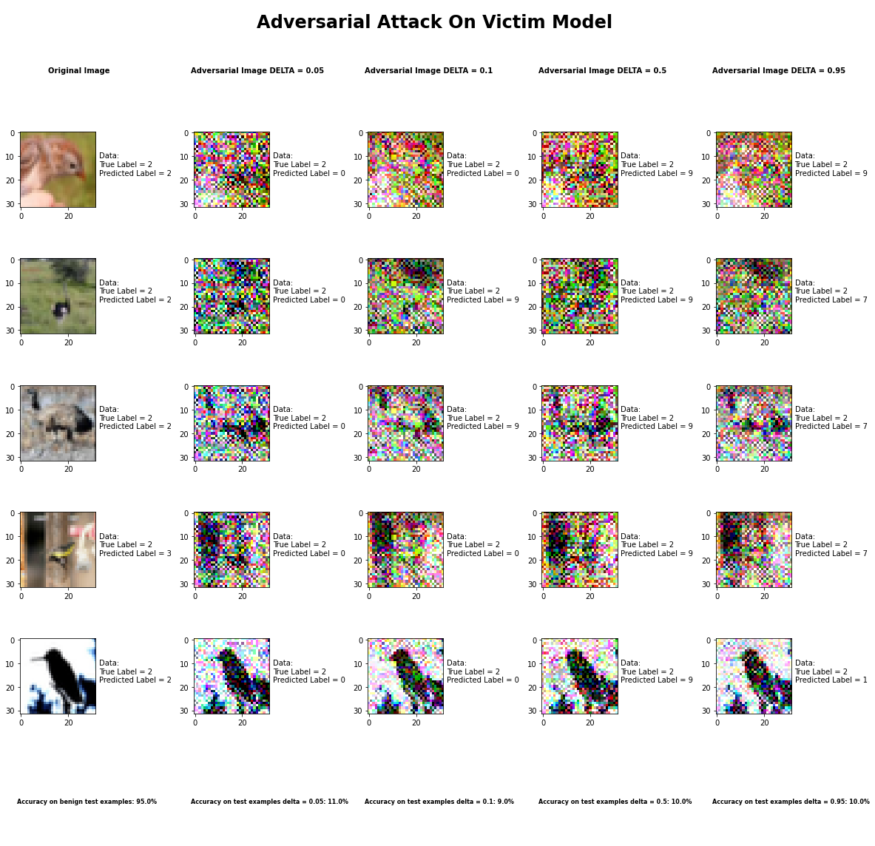

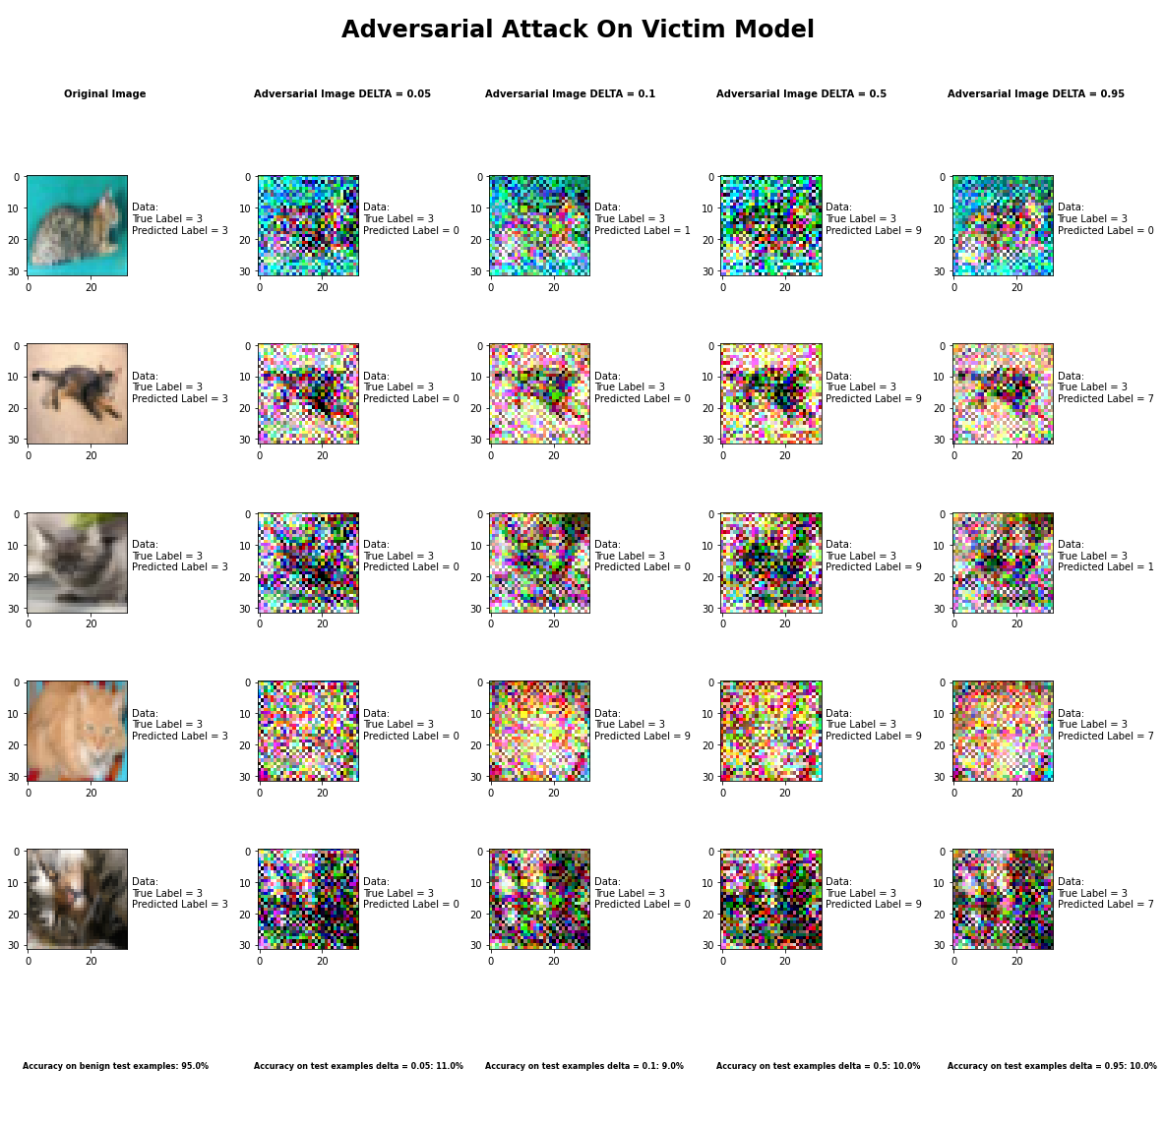

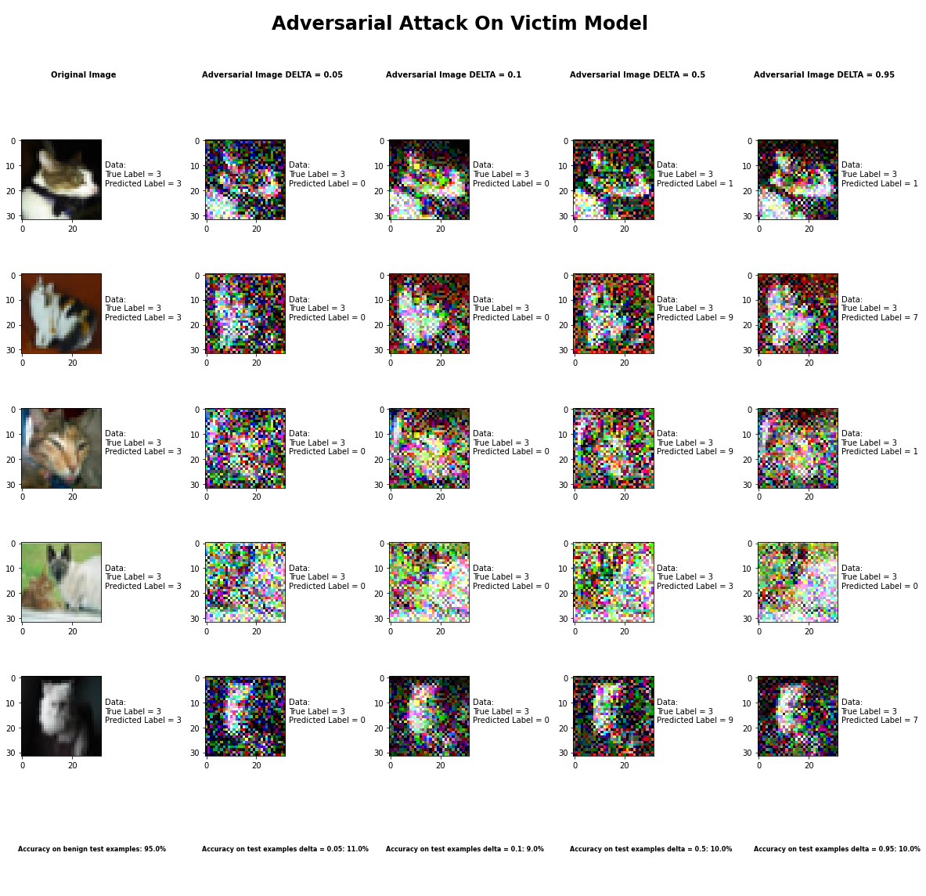

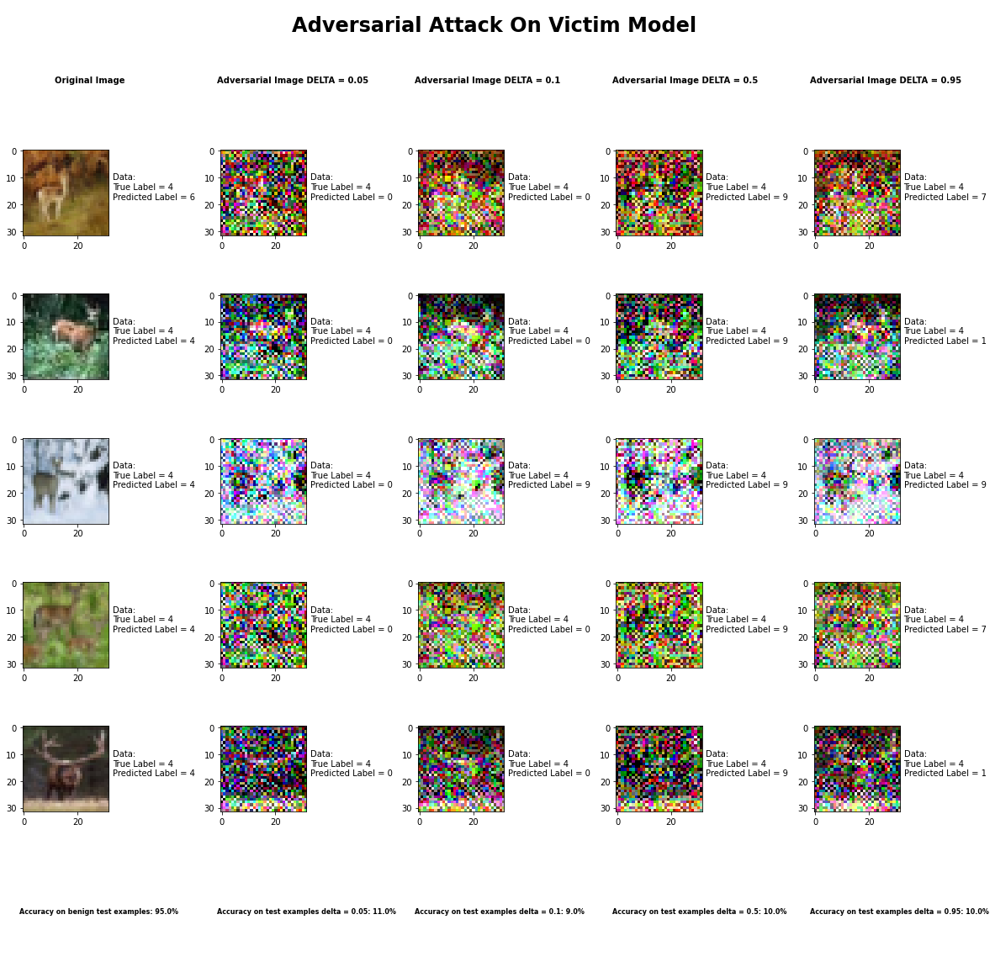

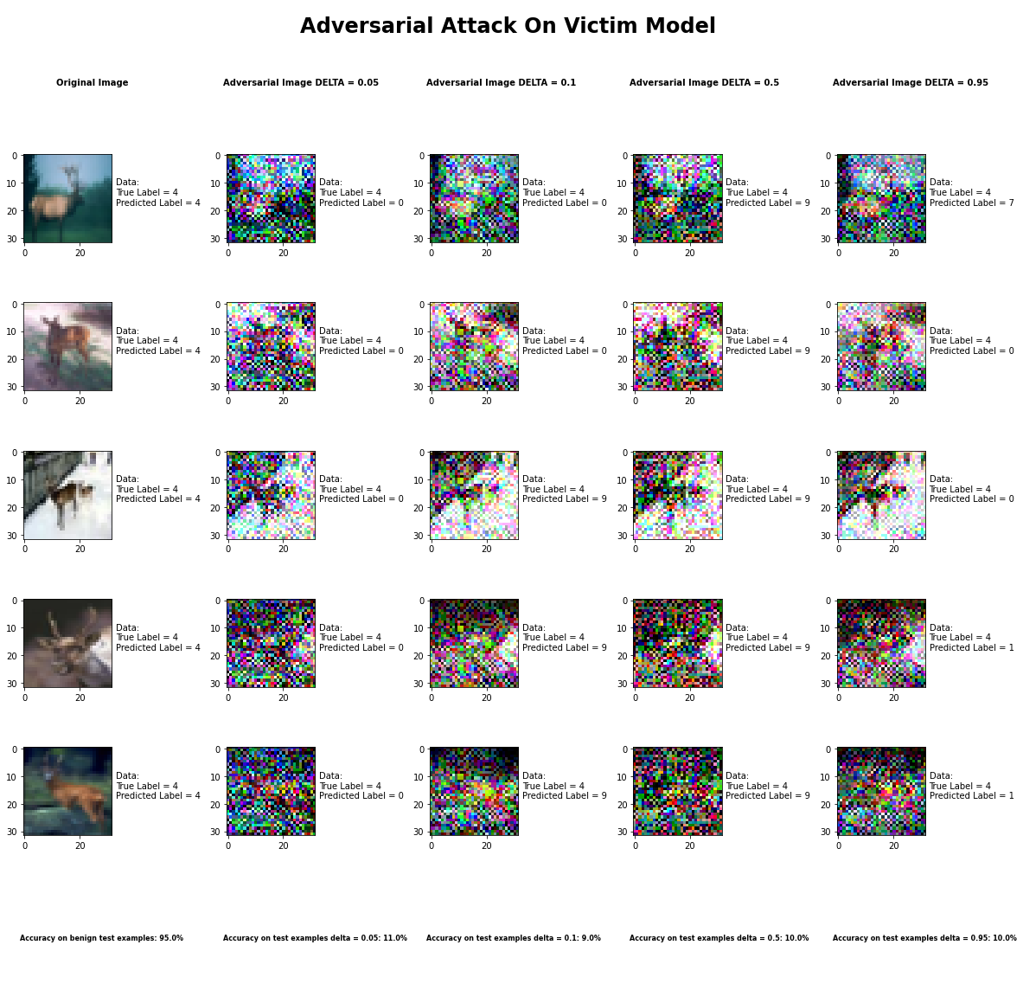

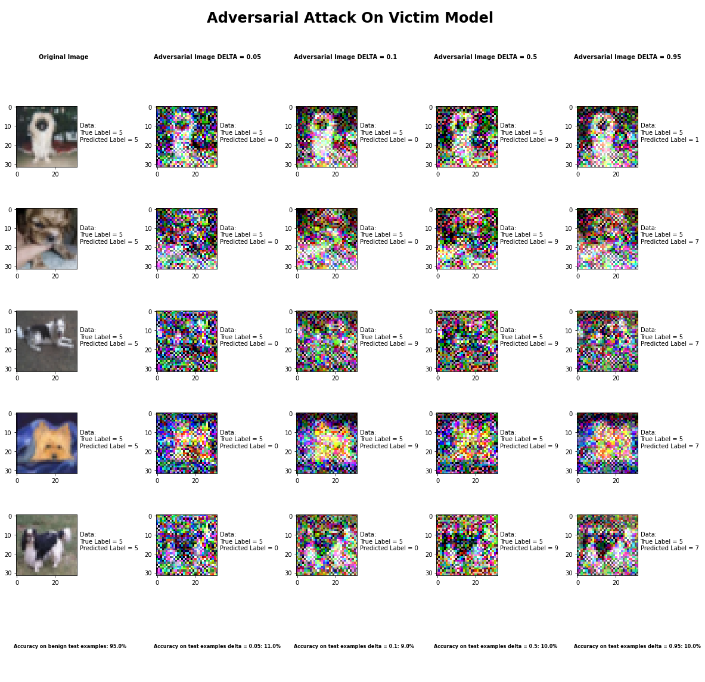

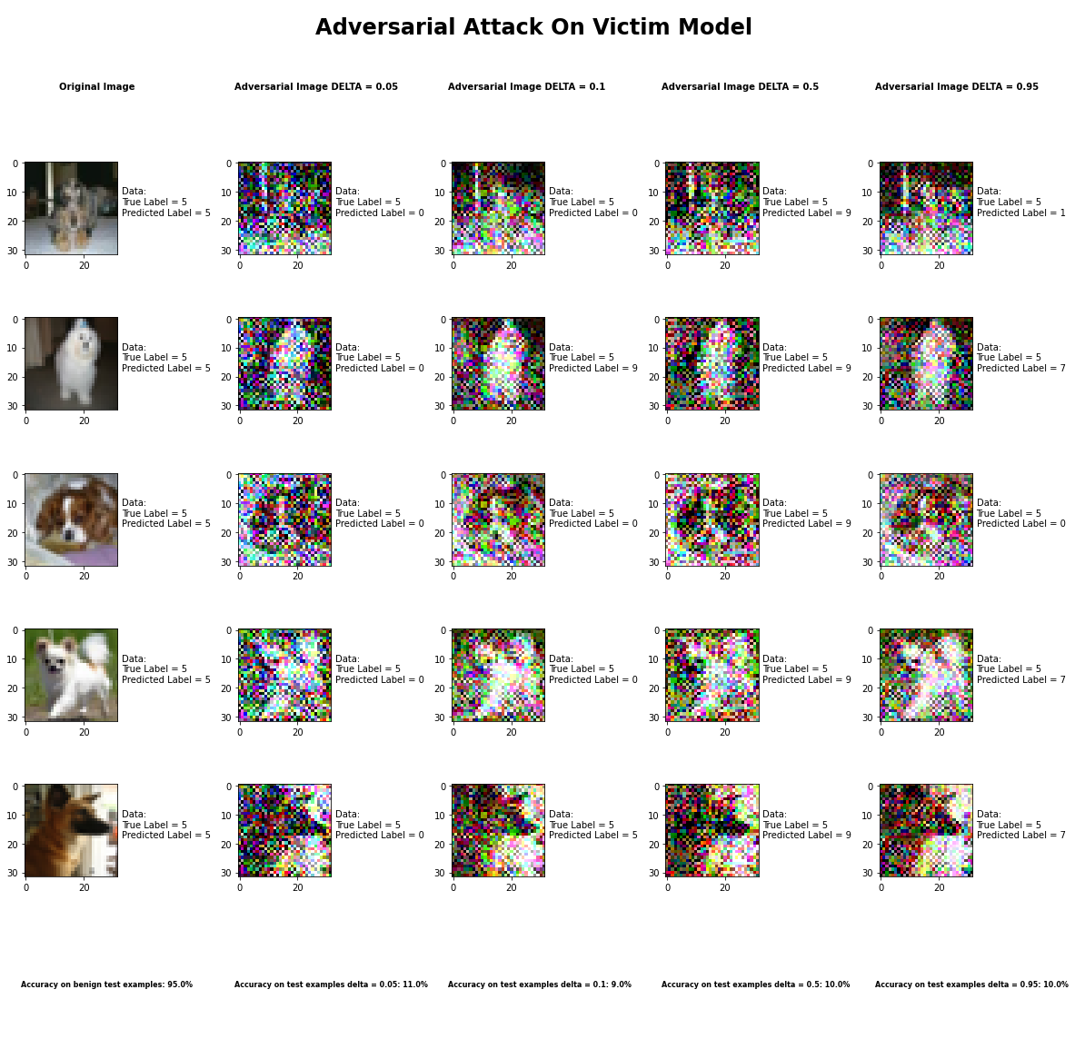

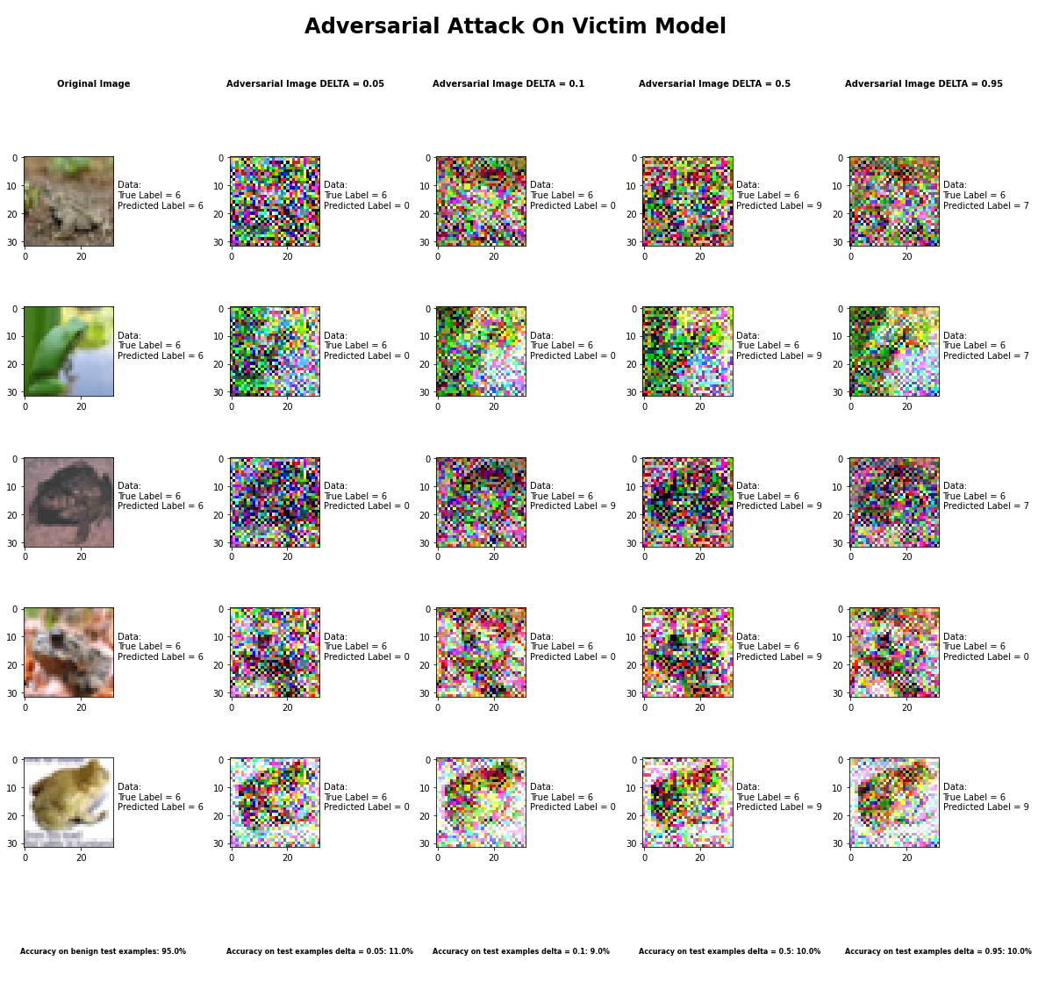

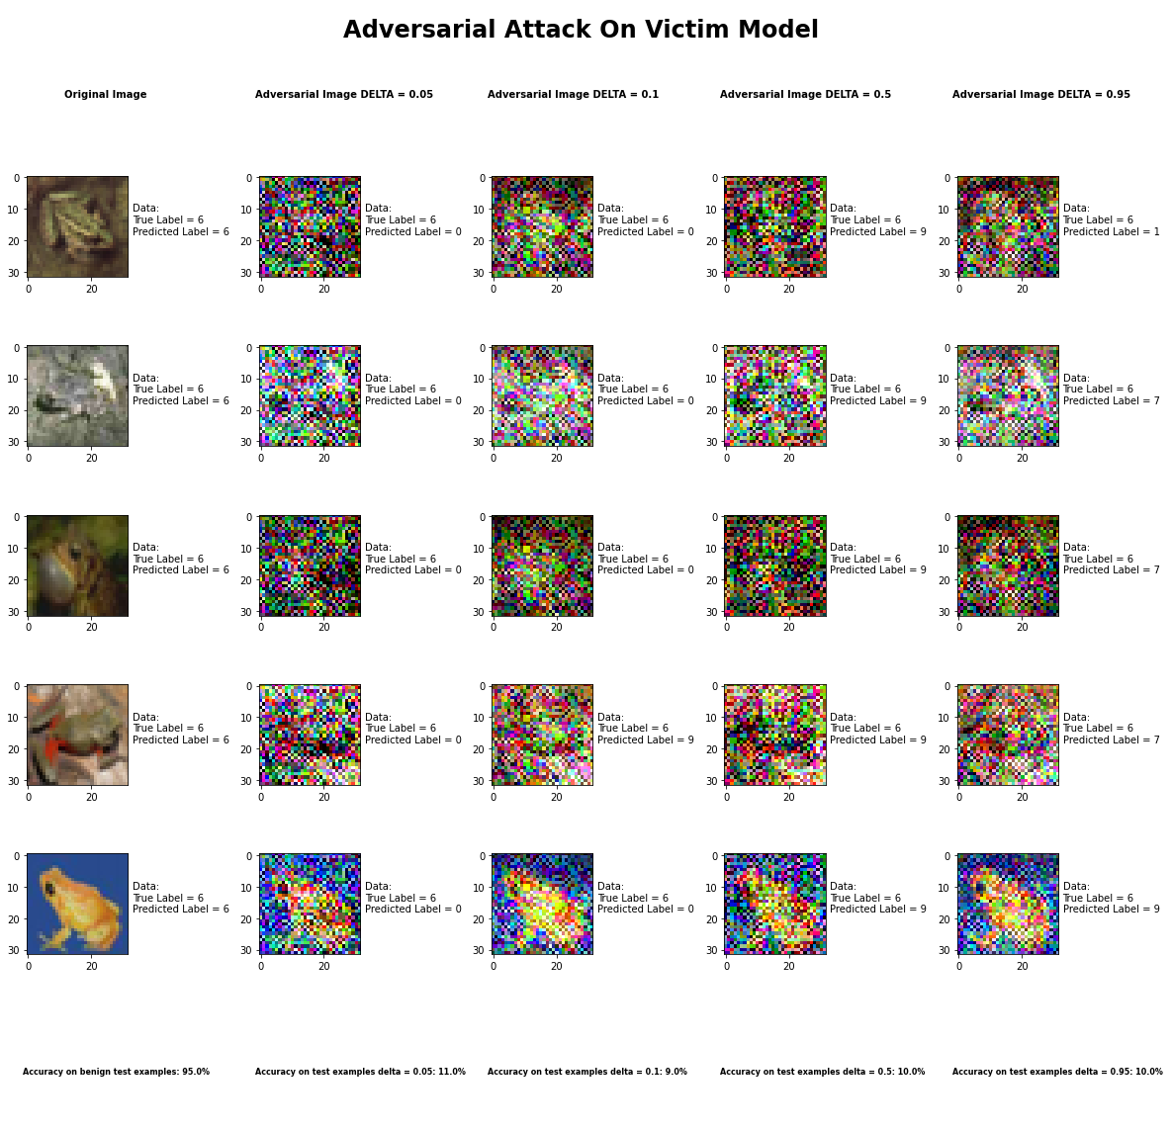

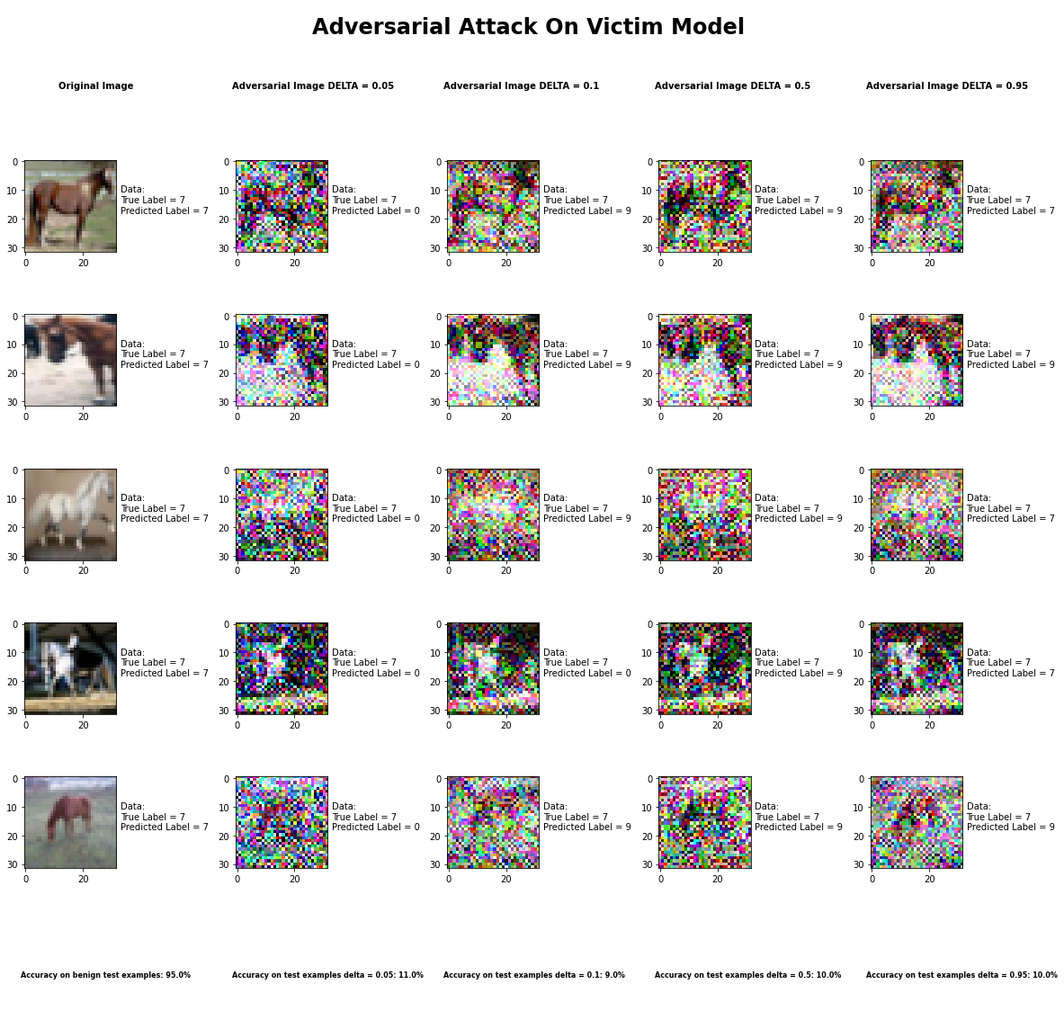

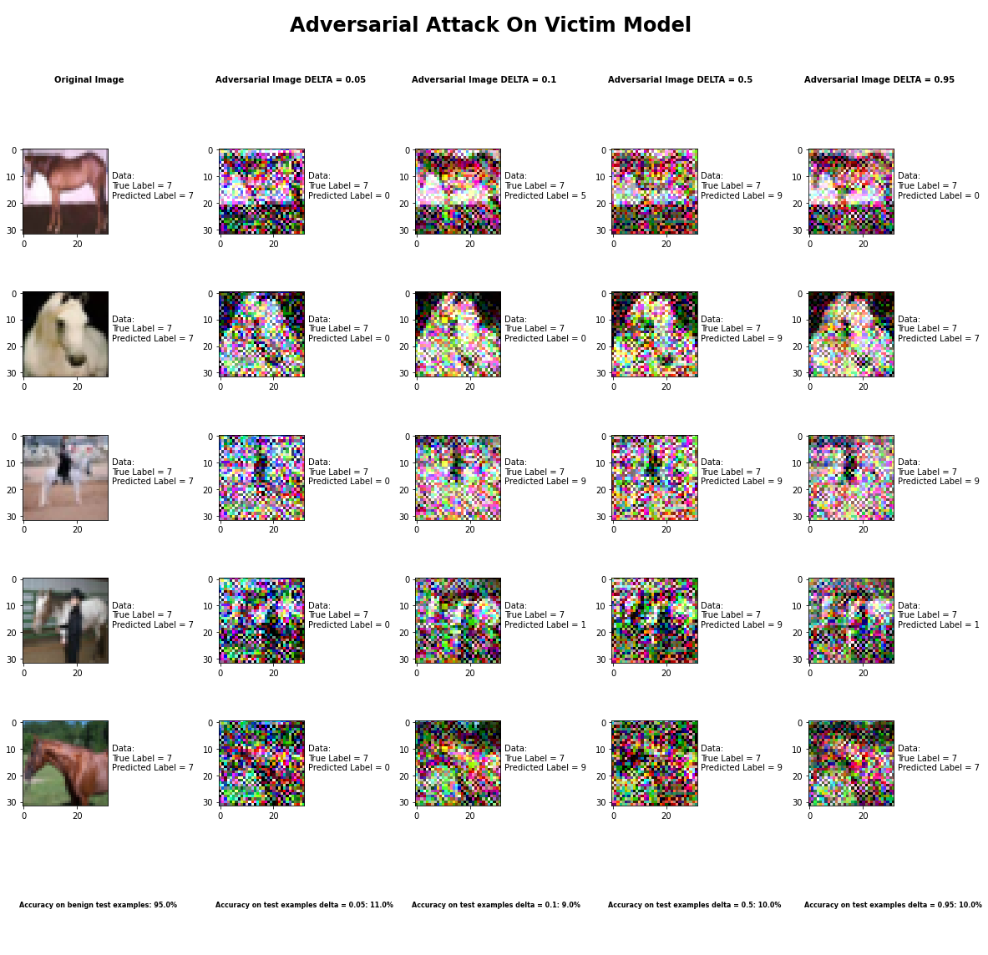

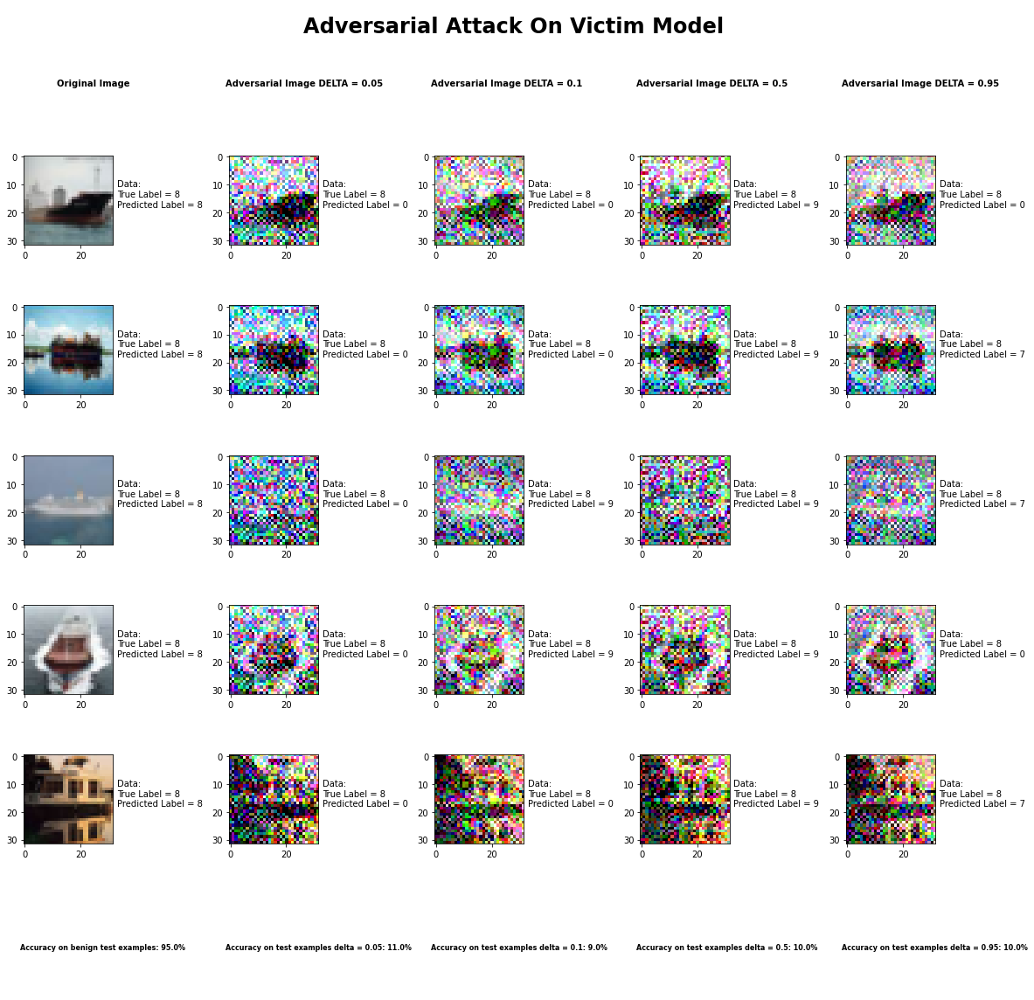

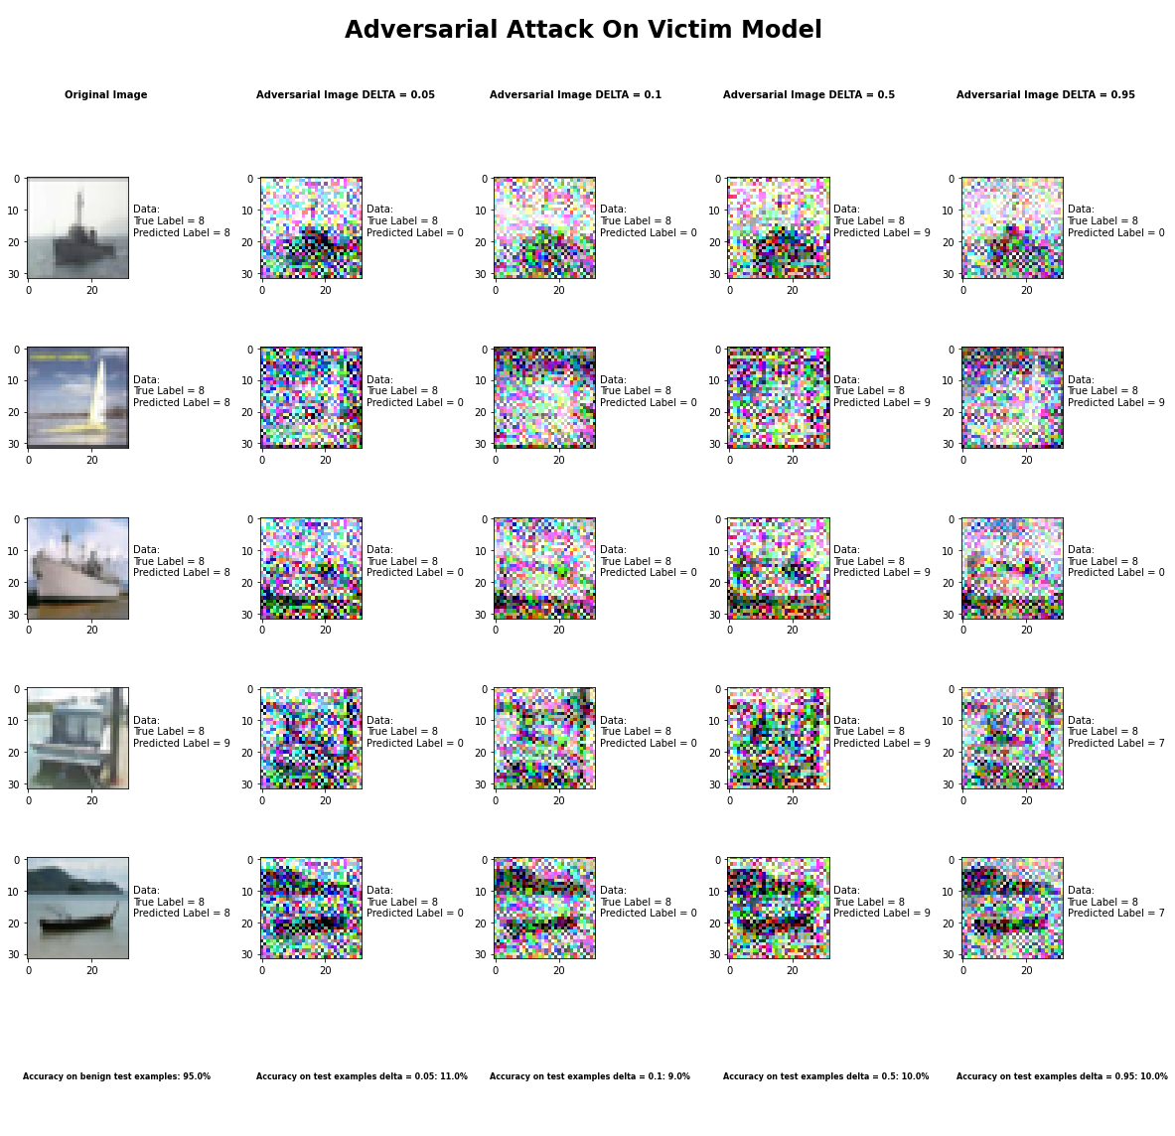

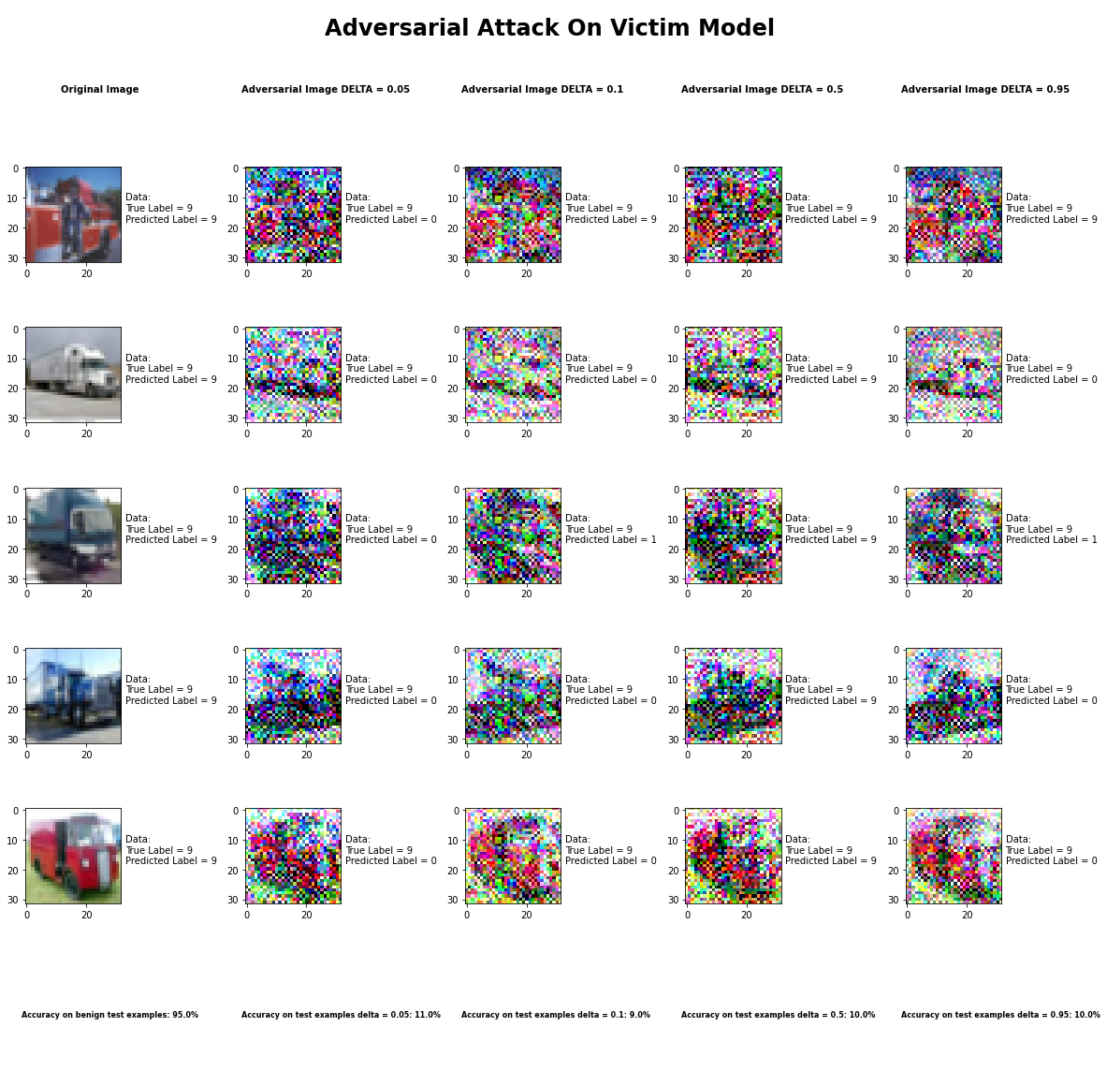

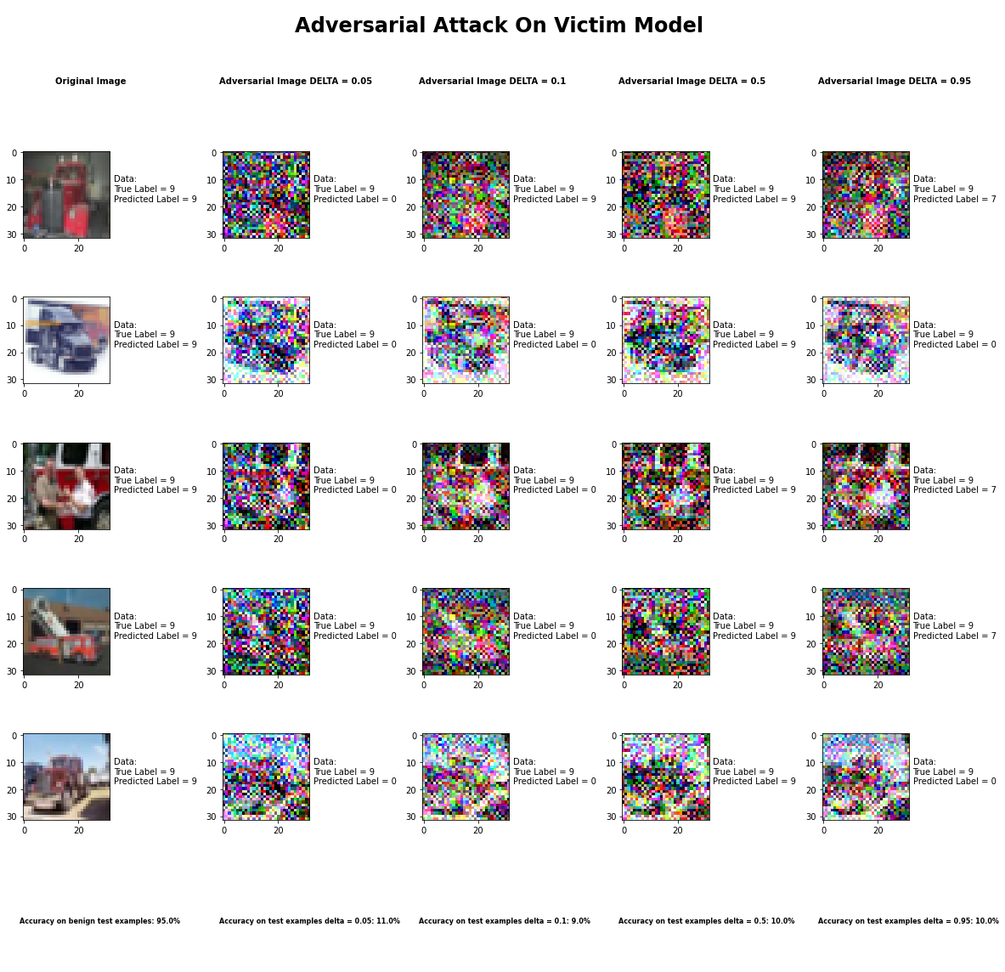

Accuracy on benign test examples: 94.52000000000001%

Average Accuracy on adversarial test examples with delta = 0.05: 10.6%

Average Accuracy on adversarial test examples with delta = 0.1: 9.1%

Average Accuracy on adversarial test examples with delta = 0.5: 10.5%

Average Accuracy on adversarial test examples with delta = 0.95: 10.4%

Classifier with benign example has Airplane recognition average accuracy of = 94%

Universal Perturbation Method with delta = 0.05 has Airplane recognition average accuracy of = 54%

Universal Perturbation Method with delta = 0.1 has Airplane recognition average accuracy of = 36%

Universal Perturbation Method with delta = 0.5 has Airplane recognition average accuracy of = 37%

Universal Perturbation Method with delta = 0.95 has Airplane recognition average accuracy of = 56%

Classifier with benign example has Automobile recognition average accuracy of = 97%

Universal Perturbation Method with delta = 0.05 has Automobile recognition average accuracy of = 1%

Universal Perturbation Method with delta = 0.1 has Automobile recognition average accuracy of = 2%

Universal Perturbation Method with delta = 0.5 has Automobile recognition average accuracy of = 21%

Universal Perturbation Method with delta = 0.95 has Automobile recognition average accuracy of = 5%

Classifier with benign example has Bird recognition average accuracy of = 93%

Universal Perturbation Method with delta = 0.05 has Bird recognition average accuracy of = 0%

Universal Perturbation Method with delta = 0.1 has Bird recognition average accuracy of = 0%

Universal Perturbation Method with delta = 0.5 has Bird recognition average accuracy of = 0%

Universal Perturbation Method with delta = 0.95 has Bird recognition average accuracy of = 0%

Classifier with benign example has Cat recognition average accuracy of = 95%

Universal Perturbation Method with delta = 0.05 has Cat recognition average accuracy of = 0%

Universal Perturbation Method with delta = 0.1 has Cat recognition average accuracy of = 11%

Universal Perturbation Method with delta = 0.5 has Cat recognition average accuracy of = 1%

Universal Perturbation Method with delta = 0.95 has Cat recognition average accuracy of = 2%

Classifier with benign example has Deer recognition average accuracy of = 97%

Universal Perturbation Method with delta = 0.05 has Deer recognition average accuracy of = 0%

Universal Perturbation Method with delta = 0.1 has Deer recognition average accuracy of = 0%

Universal Perturbation Method with delta = 0.5 has Deer recognition average accuracy of = 0%

Universal Perturbation Method with delta = 0.95 has Deer recognition average accuracy of = 0%

Classifier with benign example has Dog recognition average accuracy of = 90%

Universal Perturbation Method with delta = 0.05 has Dog recognition average accuracy of = 0%

Universal Perturbation Method with delta = 0.1 has Dog recognition average accuracy of = 1%

Universal Perturbation Method with delta = 0.5 has Dog recognition average accuracy of = 1%

Universal Perturbation Method with delta = 0.95 has Dog recognition average accuracy of = 1%

Classifier with benign example has Frog recognition average accuracy of = 96%

Universal Perturbation Method with delta = 0.05 has Frog recognition average accuracy of = 2%

Universal Perturbation Method with delta = 0.1 has Frog recognition average accuracy of = 0%

Universal Perturbation Method with delta = 0.5 has Frog recognition average accuracy of = 10%

Universal Perturbation Method with delta = 0.95 has Frog recognition average accuracy of = 3%

Classifier with benign example has Horse recognition average accuracy of = 98%

Universal Perturbation Method with delta = 0.05 has Horse recognition average accuracy of = 0%

Universal Perturbation Method with delta = 0.1 has Horse recognition average accuracy of = 0%

Universal Perturbation Method with delta = 0.5 has Horse recognition average accuracy of = 0%

Universal Perturbation Method with delta = 0.95 has Horse recognition average accuracy of = 9%

Classifier with benign example has Ship recognition average accuracy of = 94%

Universal Perturbation Method with delta = 0.05 has Ship recognition average accuracy of = 0%

Universal Perturbation Method with delta = 0.1 has Ship recognition average accuracy of = 0%

Universal Perturbation Method with delta = 0.5 has Ship recognition average accuracy of = 0%

Universal Perturbation Method with delta = 0.95 has Ship recognition average accuracy of = 0%

Classifier with benign example has Truck recognition average accuracy of = 96%

Universal Perturbation Method with delta = 0.05 has Truck recognition average accuracy of = 49%

Universal Perturbation Method with delta = 0.1 has Truck recognition average accuracy of = 41%

Universal Perturbation Method with delta = 0.5 has Truck recognition average accuracy of = 35%

Universal Perturbation Method with delta = 0.95 has Truck recognition average accuracy of = 28%

## Jacobian Saliency Method



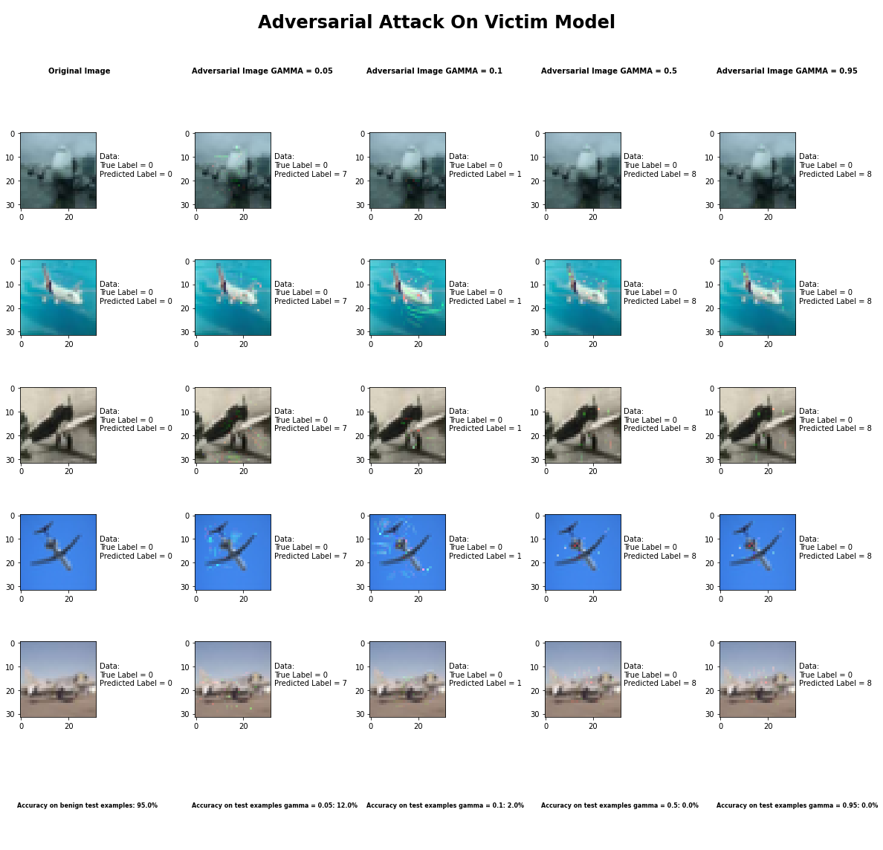

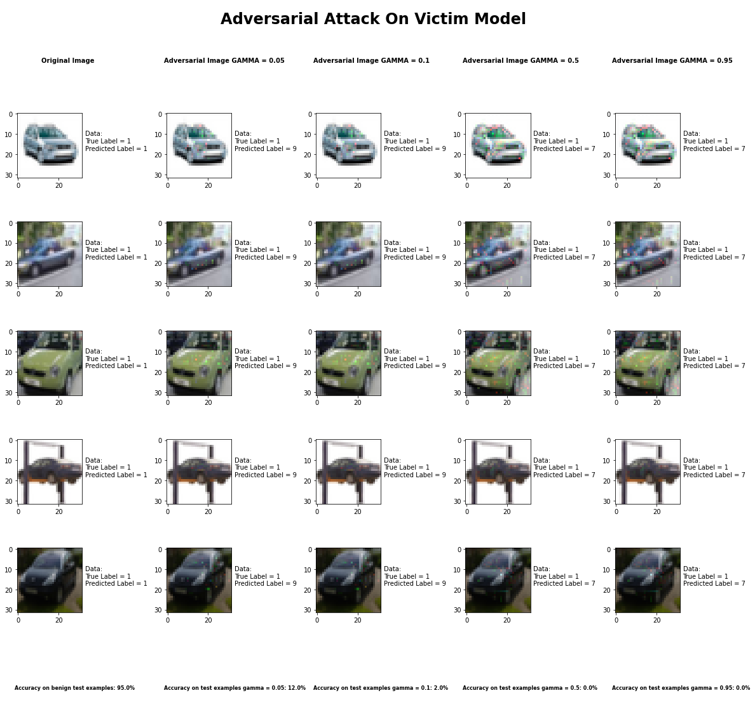

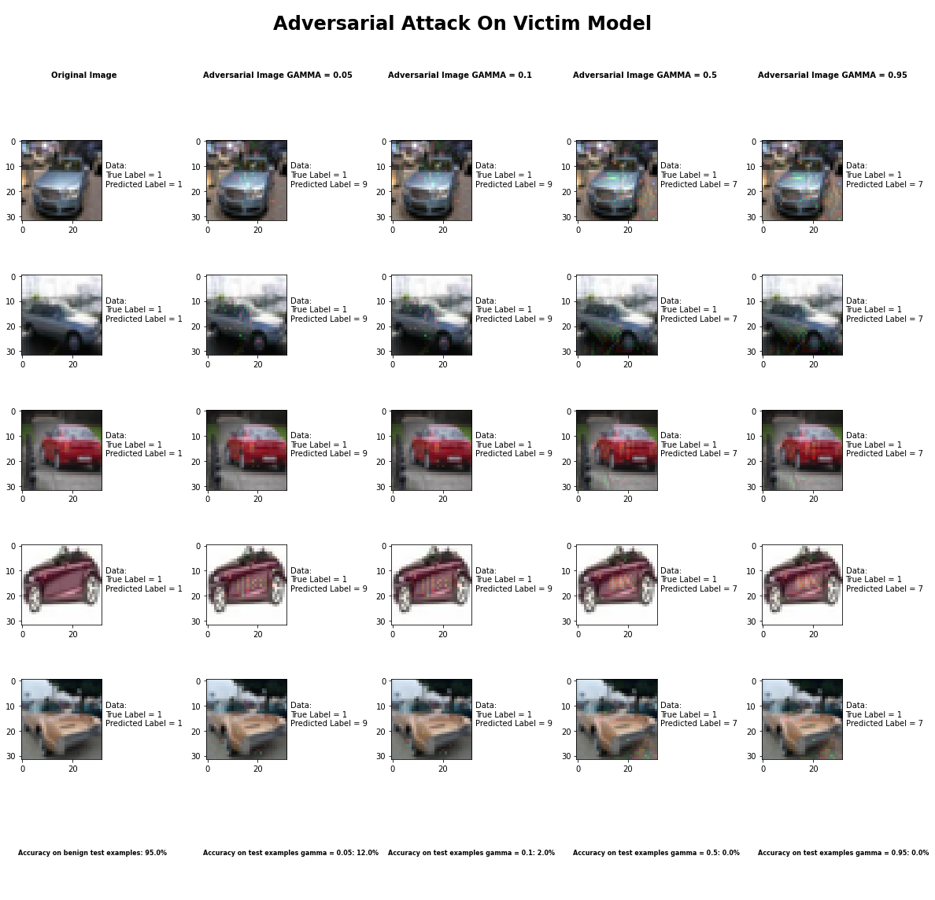

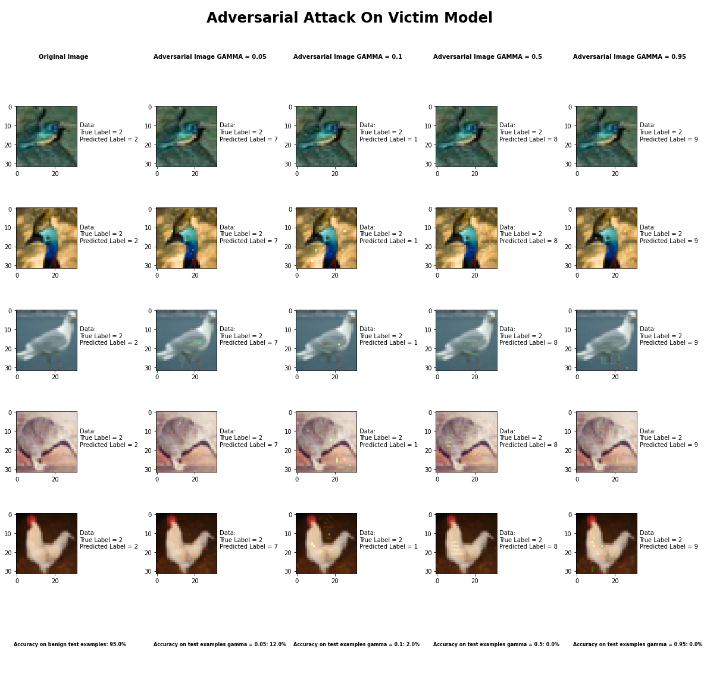

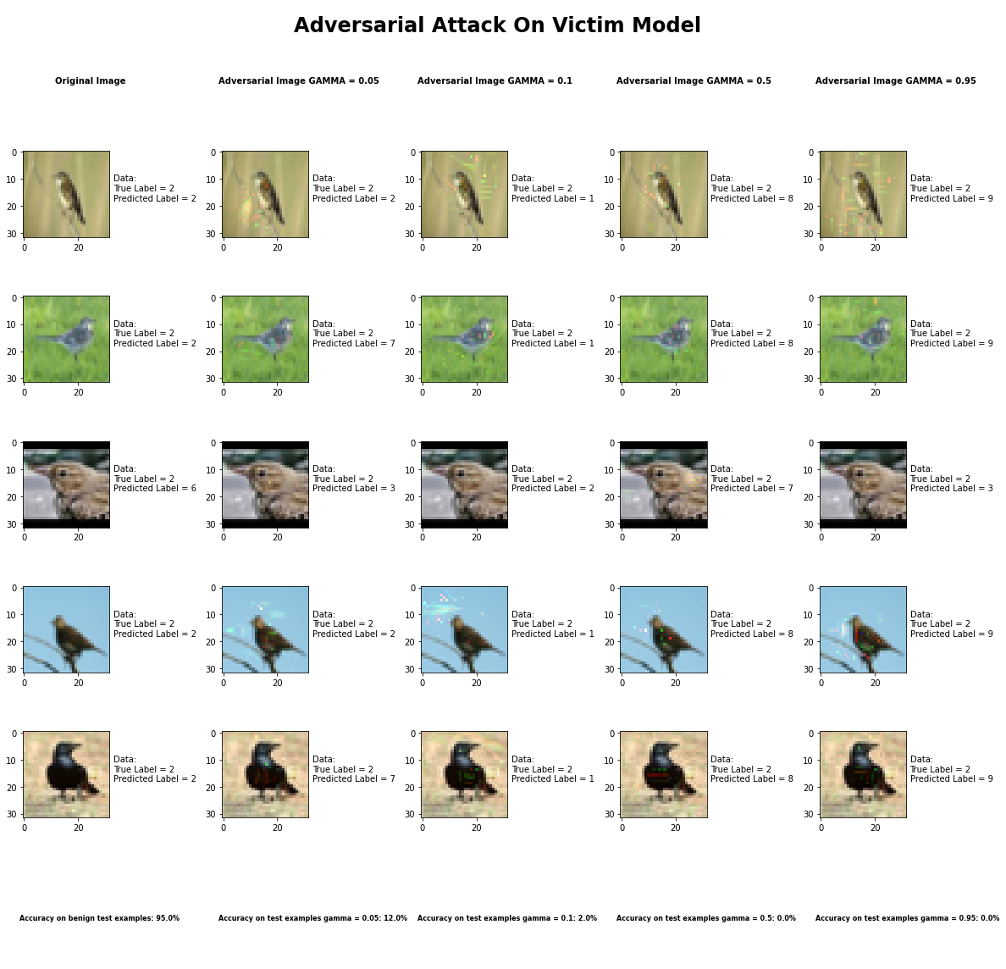

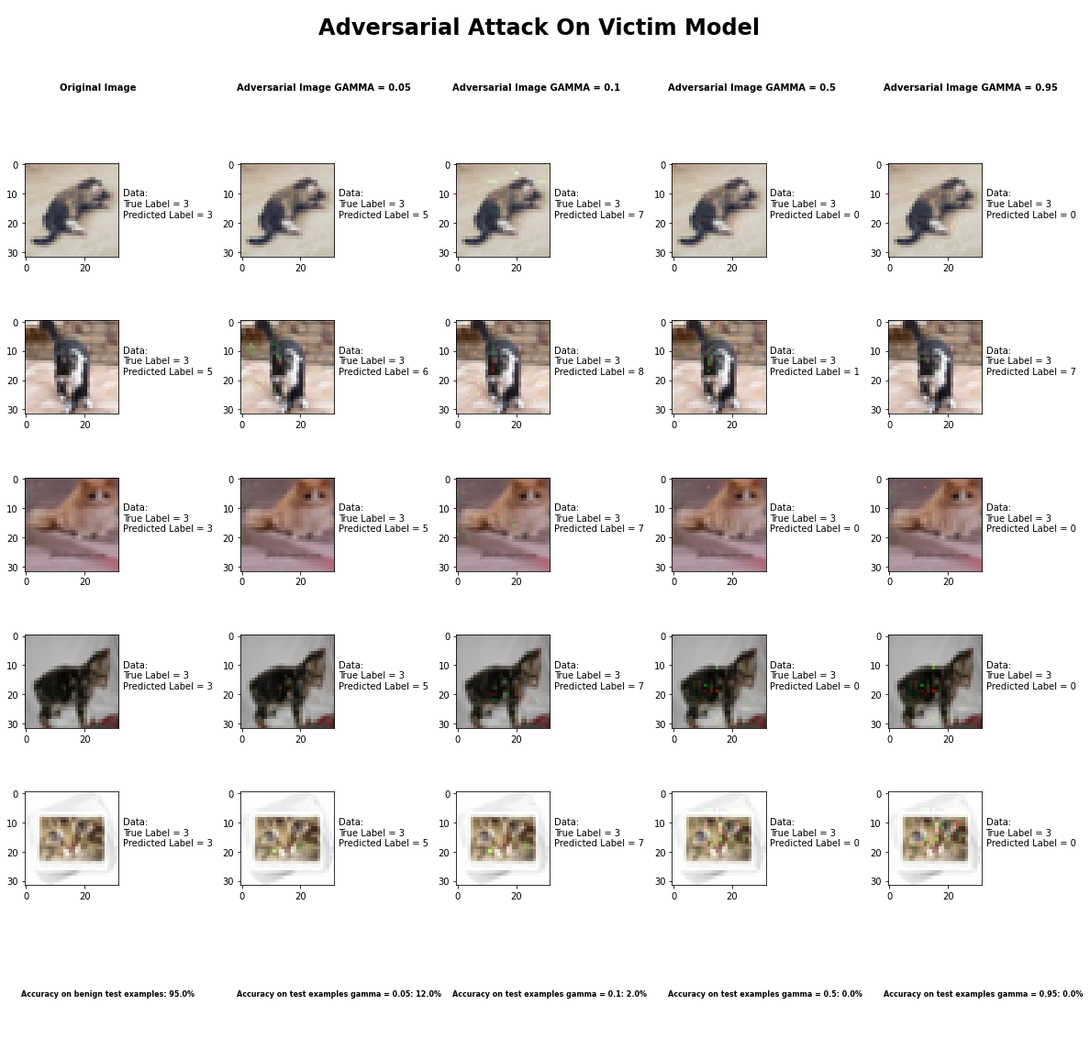

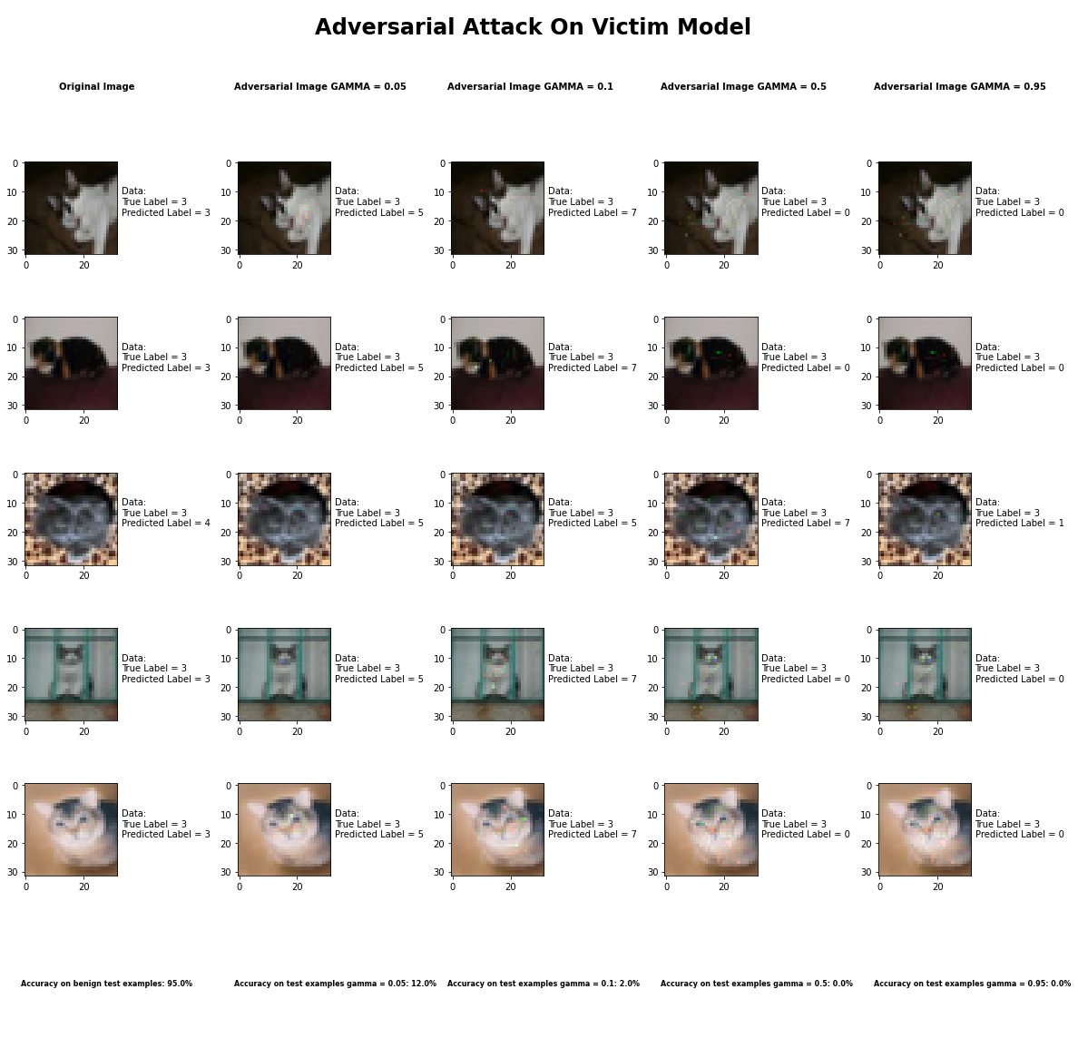

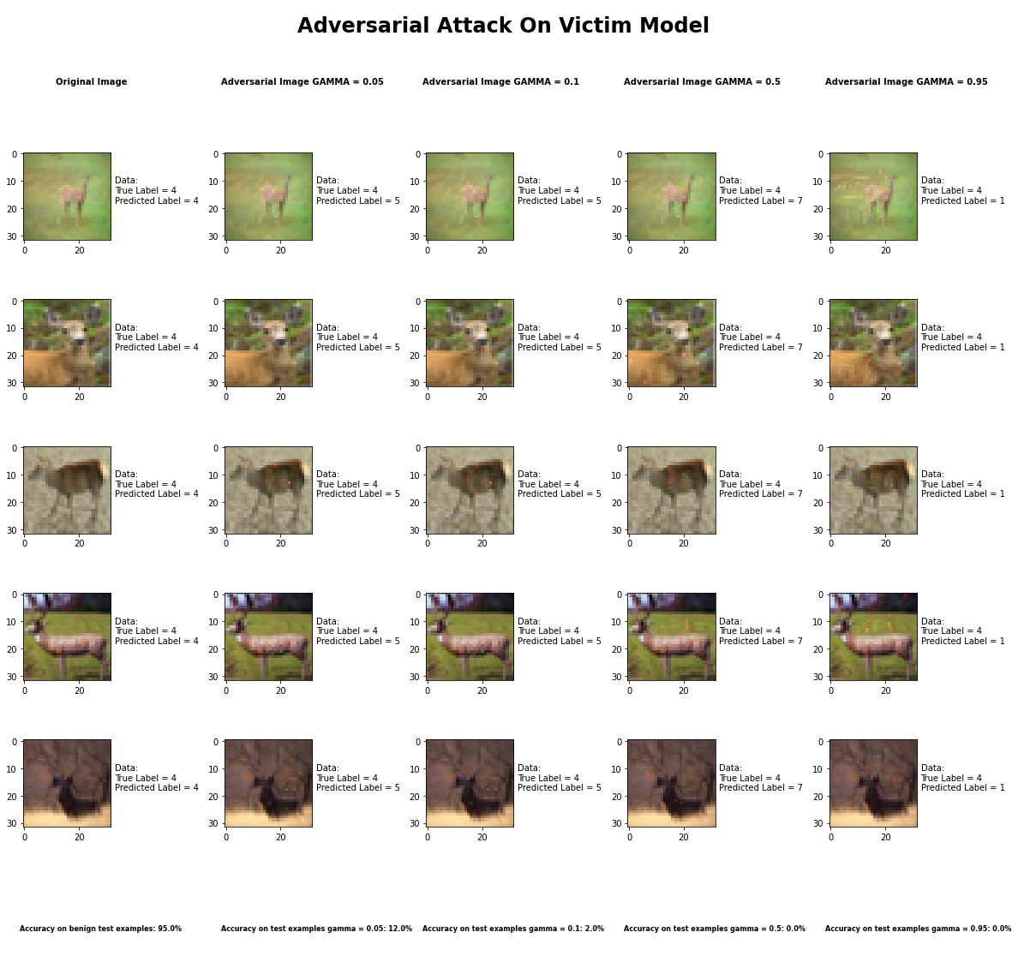

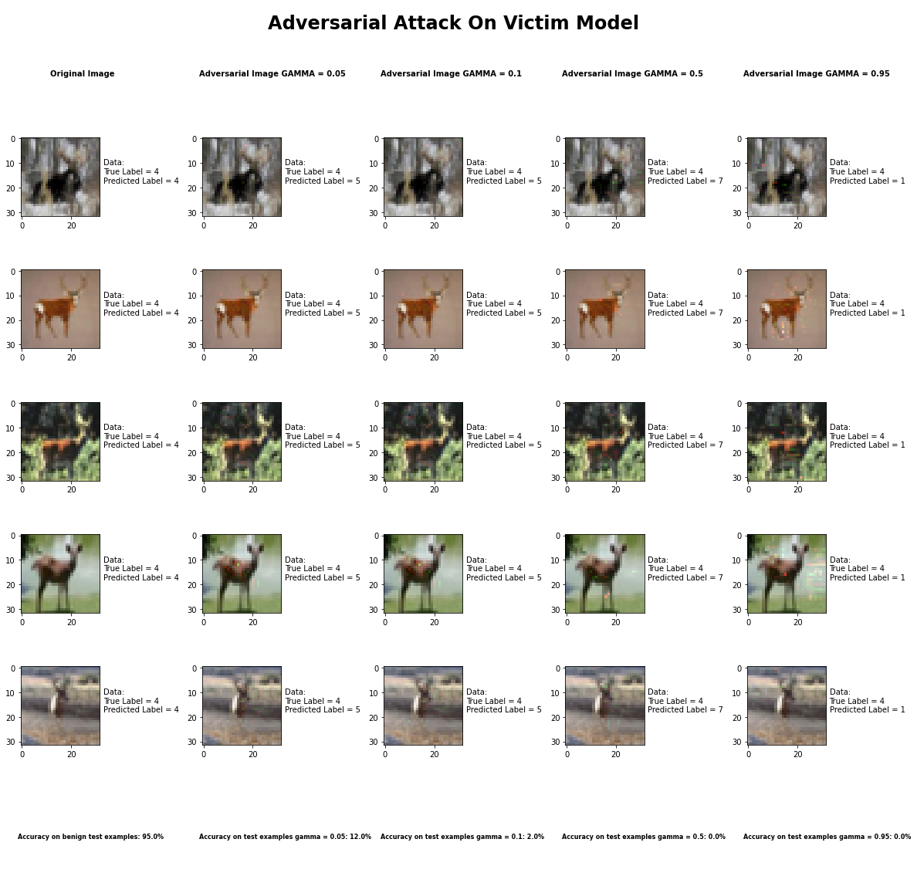

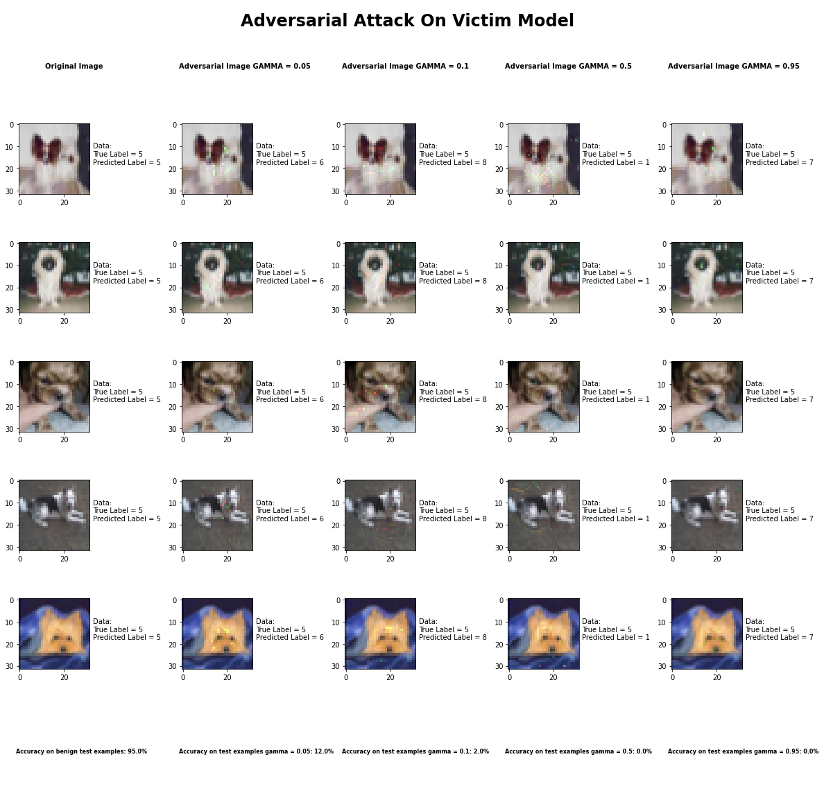

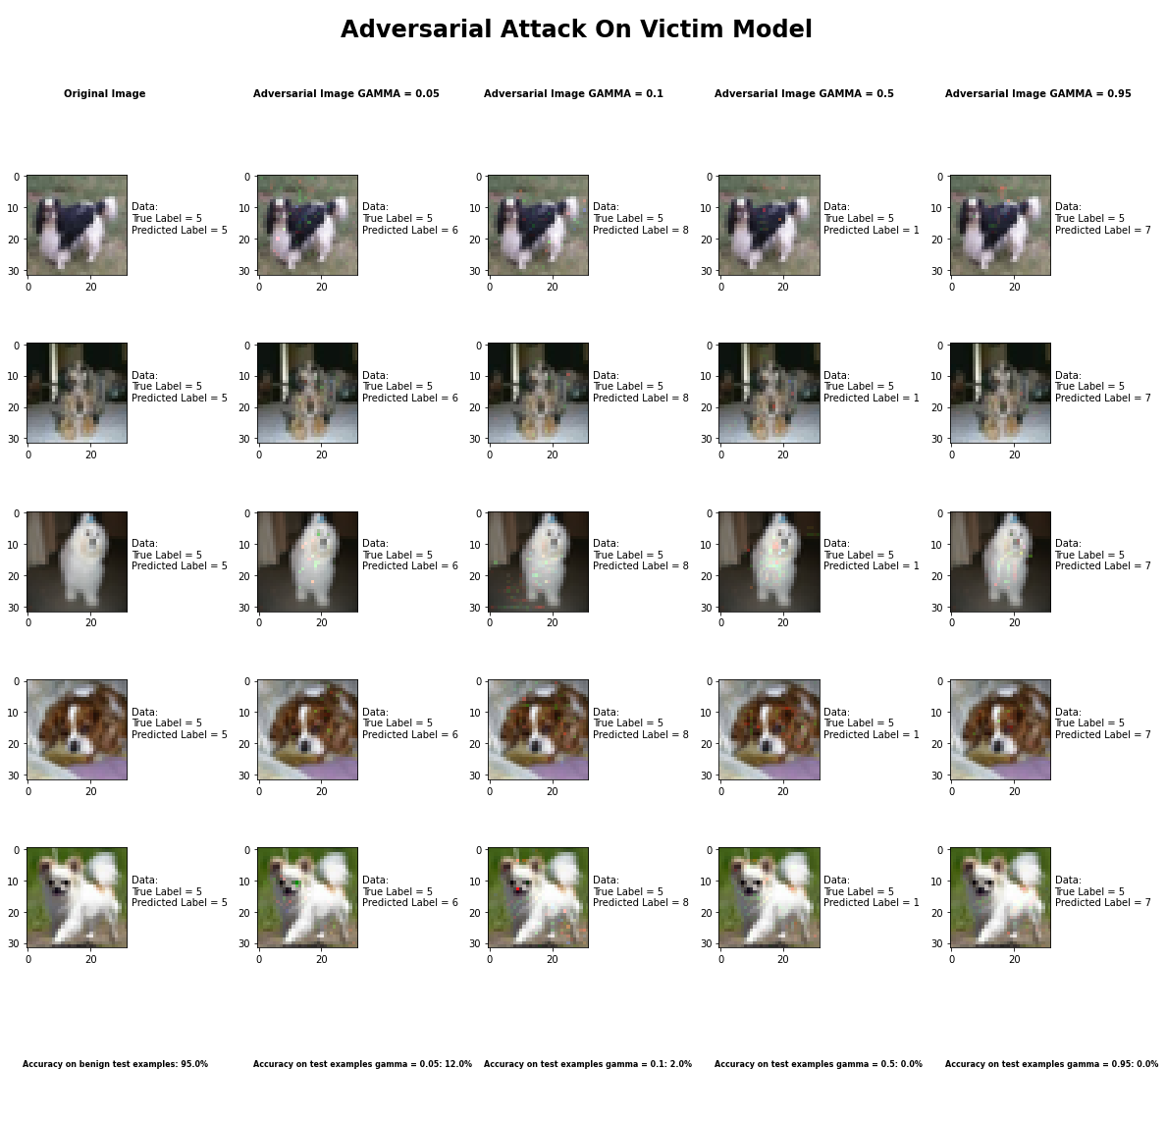

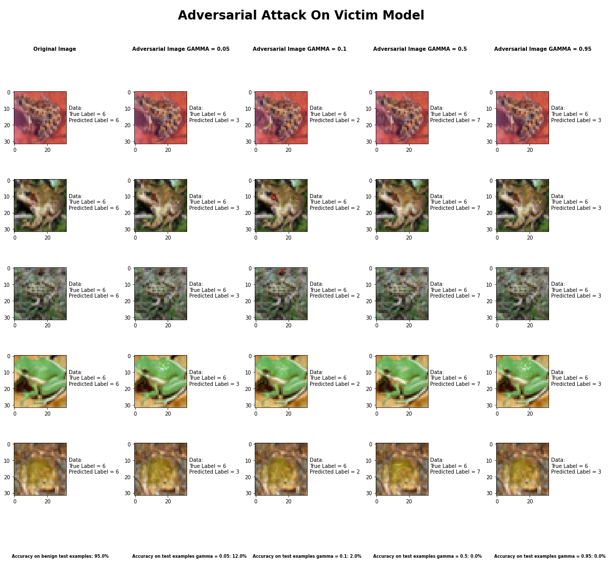

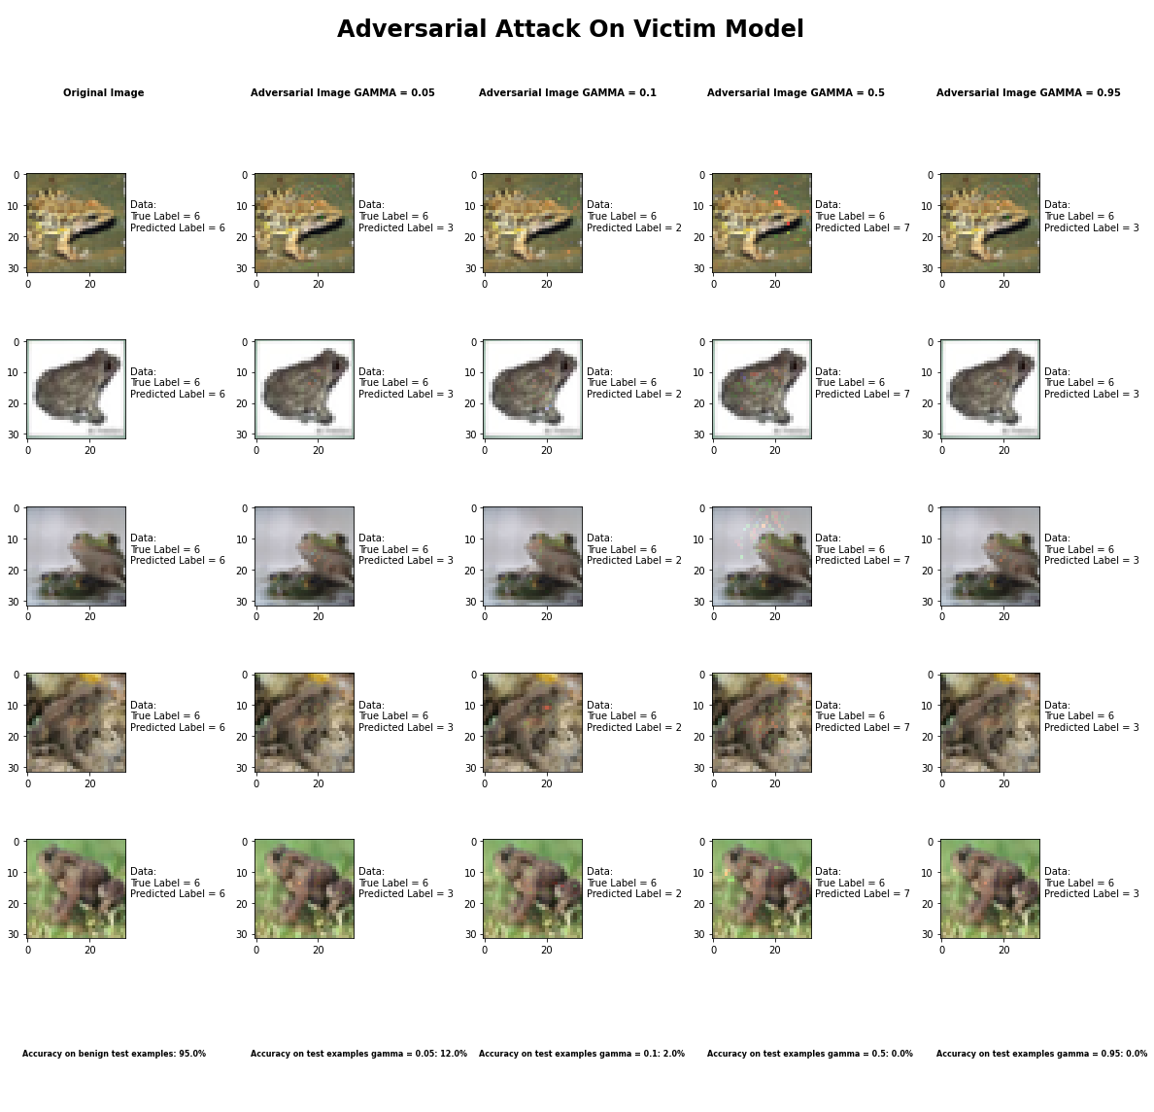

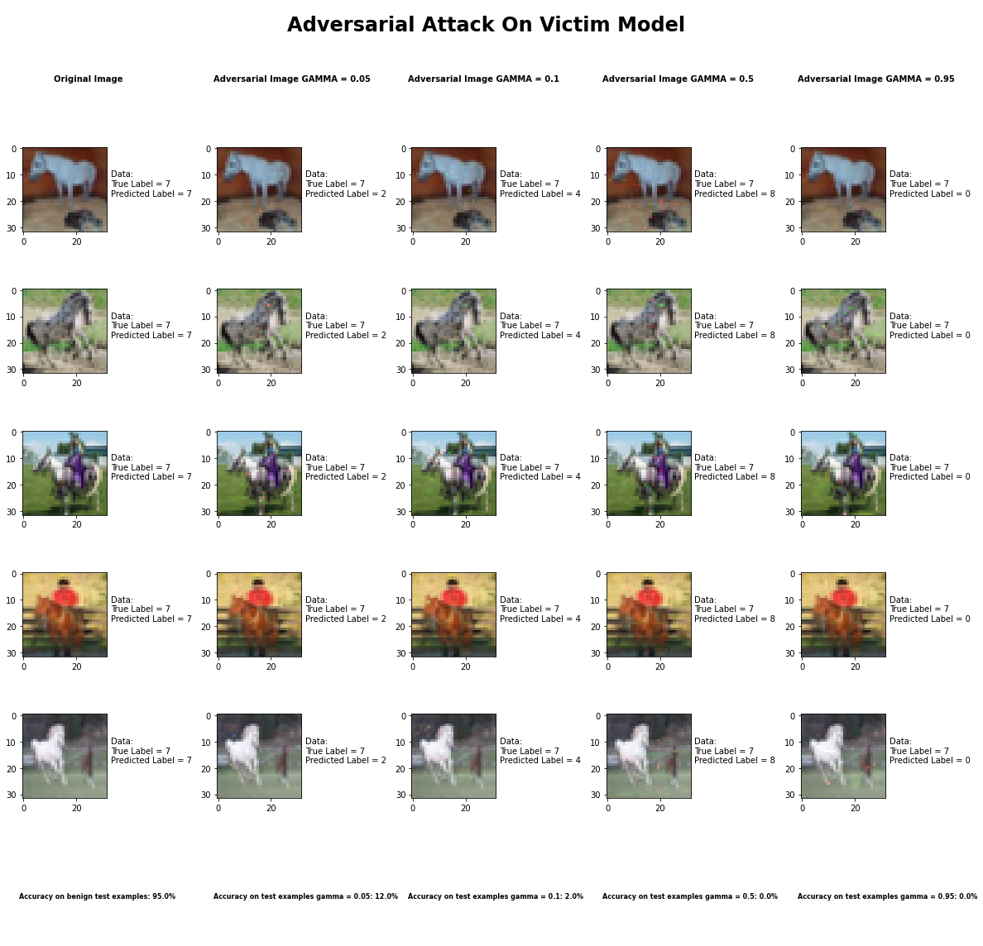

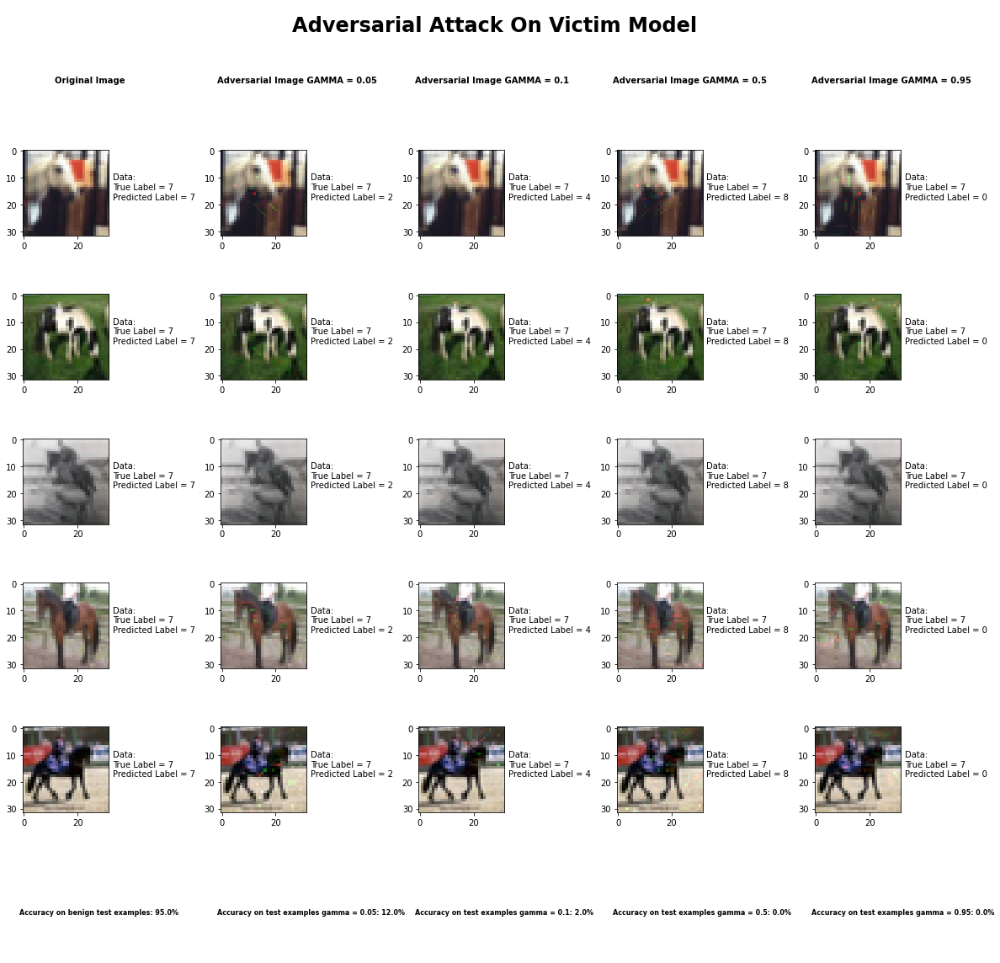

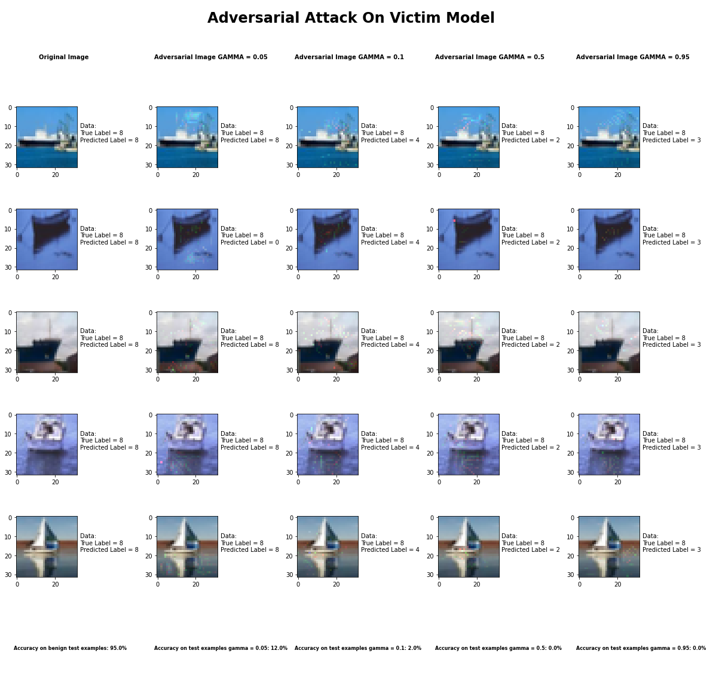

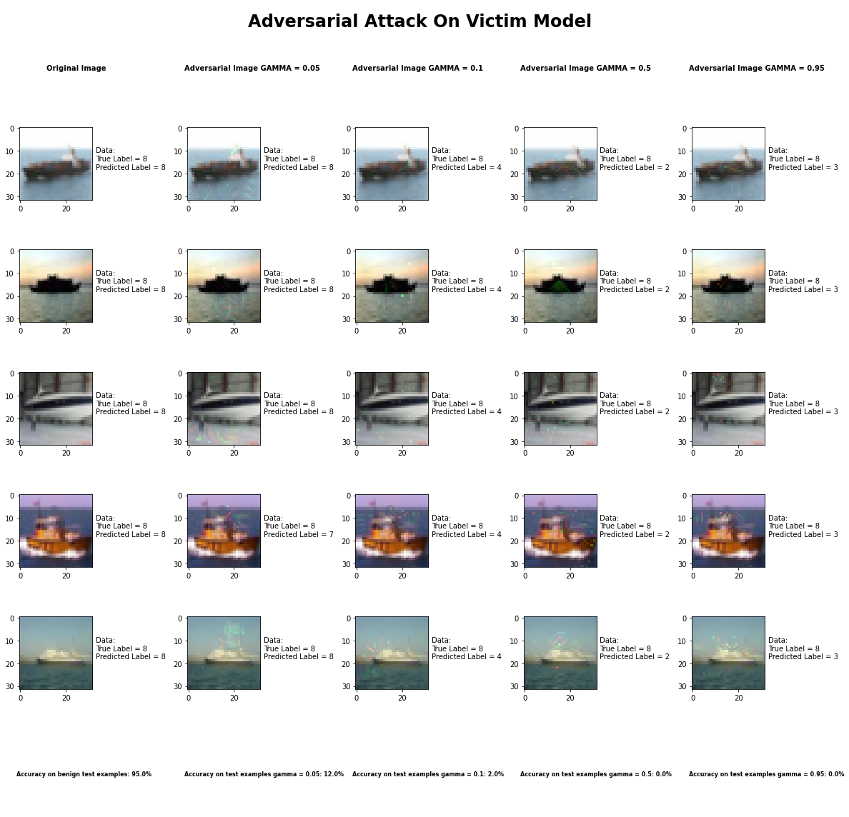

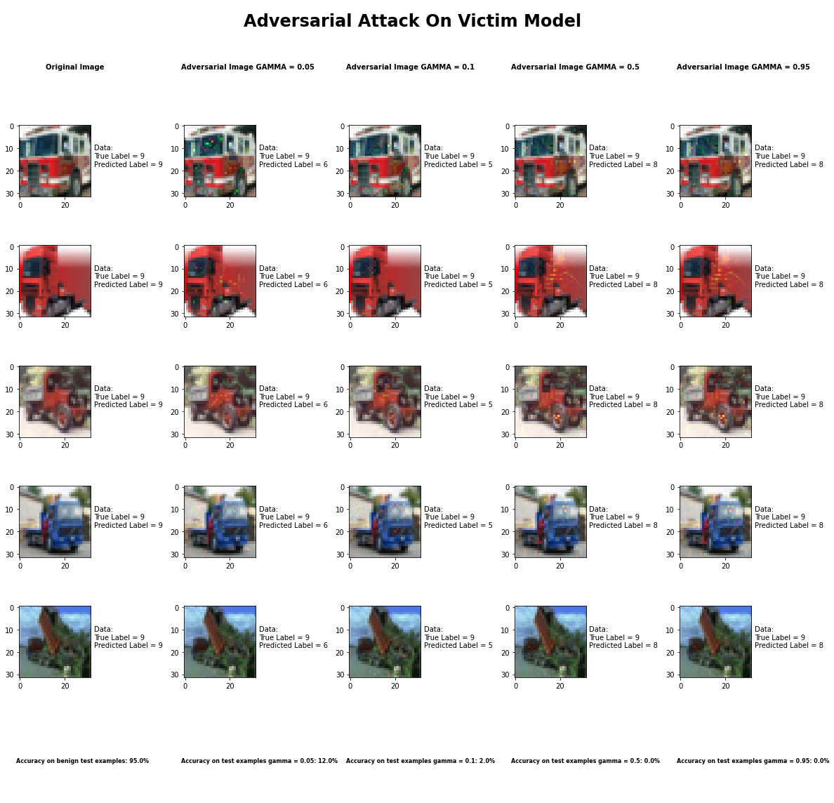

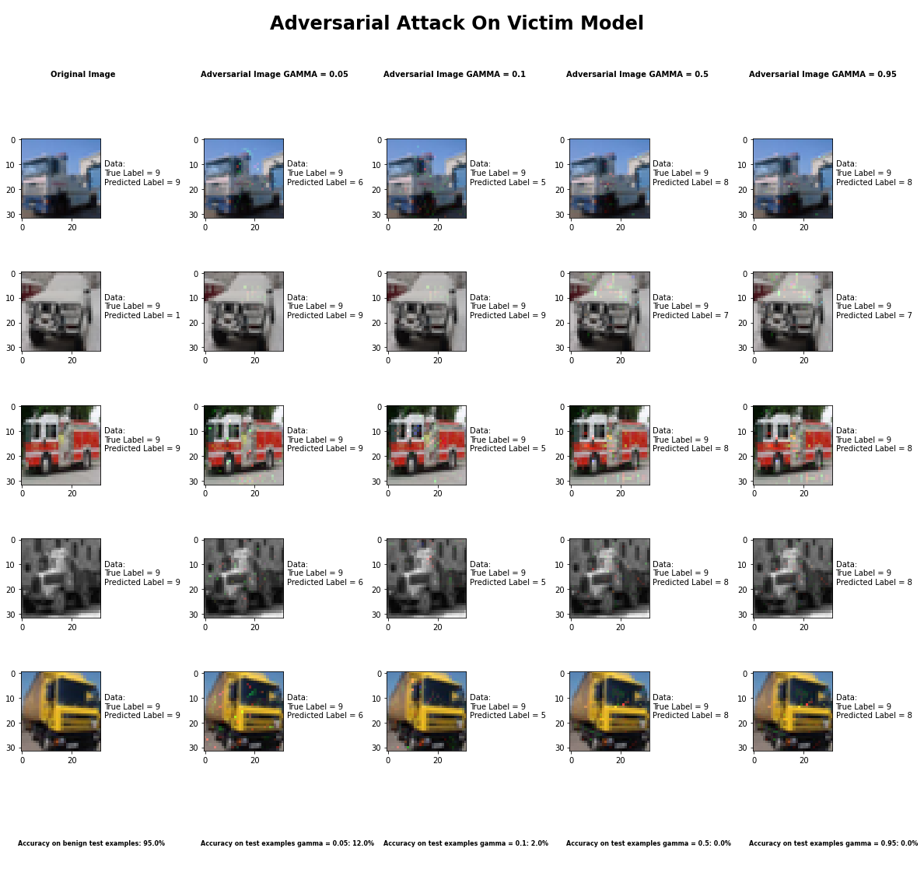

Accuracy on benign test examples: 94.52000000000001%

Average Accuracy on adversarial test examples with gamma = 0.05: 12.5%

Average Accuracy on adversarial test examples with gamma = 0.1: 2.1%

Average Accuracy on adversarial test examples with gamma = 0.5: 0.2%

Average Accuracy on adversarial test examples with gamma = 0.95: 0.1%

Classifier with benign example has Airplane recognition average accuracy of = 97%

Jacobian Saliency Map Method with gamma = 0.05 has Airplane recognition average accuracy of = 19%

Jacobian Saliency Map Method with gamma = 0.1 has Airplane recognition average accuracy of = 2%

Jacobian Saliency Map Method with gamma = 0.5 has Airplane recognition average accuracy of = 0%

Jacobian Saliency Map Method with gamma = 0.95 has Airplane recognition average accuracy of = 0%

Classifier with benign example has Automobile recognition average accuracy of = 99%

Jacobian Saliency Map Method with gamma = 0.05 has Automobile recognition average accuracy of = 34%

Jacobian Saliency Map Method with gamma = 0.1 has Automobile recognition average accuracy of = 6%

Jacobian Saliency Map Method with gamma = 0.5 has Automobile recognition average accuracy of = 0%

Jacobian Saliency Map Method with gamma = 0.95 has Automobile recognition average accuracy of = 0%

Classifier with benign example has Bird recognition average accuracy of = 92%

Jacobian Saliency Map Method with gamma = 0.05 has Bird recognition average accuracy of = 7%

Jacobian Saliency Map Method with gamma = 0.1 has Bird recognition average accuracy of = 1%

Jacobian Saliency Map Method with gamma = 0.5 has Bird recognition average accuracy of = 0%

Jacobian Saliency Map Method with gamma = 0.95 has Bird recognition average accuracy of = 0%

Classifier with benign example has Cat recognition average accuracy of = 87%

Jacobian Saliency Map Method with gamma = 0.05 has Cat recognition average accuracy of = 4%

Jacobian Saliency Map Method with gamma = 0.1 has Cat recognition average accuracy of = 4%

Jacobian Saliency Map Method with gamma = 0.5 has Cat recognition average accuracy of = 1%

Jacobian Saliency Map Method with gamma = 0.95 has Cat recognition average accuracy of = 1%

Classifier with benign example has Deer recognition average accuracy of = 94%

Jacobian Saliency Map Method with gamma = 0.05 has Deer recognition average accuracy of = 2%

Jacobian Saliency Map Method with gamma = 0.1 has Deer recognition average accuracy of = 0%

Jacobian Saliency Map Method with gamma = 0.5 has Deer recognition average accuracy of = 1%

Jacobian Saliency Map Method with gamma = 0.95 has Deer recognition average accuracy of = 0%

Classifier with benign example has Dog recognition average accuracy of = 84%

Jacobian Saliency Map Method with gamma = 0.05 has Dog recognition average accuracy of = 5%

Jacobian Saliency Map Method with gamma = 0.1 has Dog recognition average accuracy of = 3%

Jacobian Saliency Map Method with gamma = 0.5 has Dog recognition average accuracy of = 0%

Jacobian Saliency Map Method with gamma = 0.95 has Dog recognition average accuracy of = 0%

Classifier with benign example has Frog recognition average accuracy of = 98%

Jacobian Saliency Map Method with gamma = 0.05 has Frog recognition average accuracy of = 7%

Jacobian Saliency Map Method with gamma = 0.1 has Frog recognition average accuracy of = 0%

Jacobian Saliency Map Method with gamma = 0.5 has Frog recognition average accuracy of = 0%

Jacobian Saliency Map Method with gamma = 0.95 has Frog recognition average accuracy of = 0%

Classifier with benign example has Horse recognition average accuracy of = 97%

Jacobian Saliency Map Method with gamma = 0.05 has Horse recognition average accuracy of = 10%

Jacobian Saliency Map Method with gamma = 0.1 has Horse recognition average accuracy of = 1%

Jacobian Saliency Map Method with gamma = 0.5 has Horse recognition average accuracy of = 0%

Jacobian Saliency Map Method with gamma = 0.95 has Horse recognition average accuracy of = 0%

Classifier with benign example has Ship recognition average accuracy of = 99%

Jacobian Saliency Map Method with gamma = 0.05 has Ship recognition average accuracy of = 20%

Jacobian Saliency Map Method with gamma = 0.1 has Ship recognition average accuracy of = 1%

Jacobian Saliency Map Method with gamma = 0.5 has Ship recognition average accuracy of = 0%

Jacobian Saliency Map Method with gamma = 0.95 has Ship recognition average accuracy of = 0%

Classifier with benign example has Truck recognition average accuracy of = 96%

Jacobian Saliency Map Method with gamma = 0.05 has Truck recognition average accuracy of = 17%

Jacobian Saliency Map Method with gamma = 0.1 has Truck recognition average accuracy of = 3%

Jacobian Saliency Map Method with gamma = 0.5 has Truck recognition average accuracy of = 0%

Jacobian Saliency Map Method with gamma = 0.95 has Truck recognition average accuracy of = 0%

## DeepFool Method



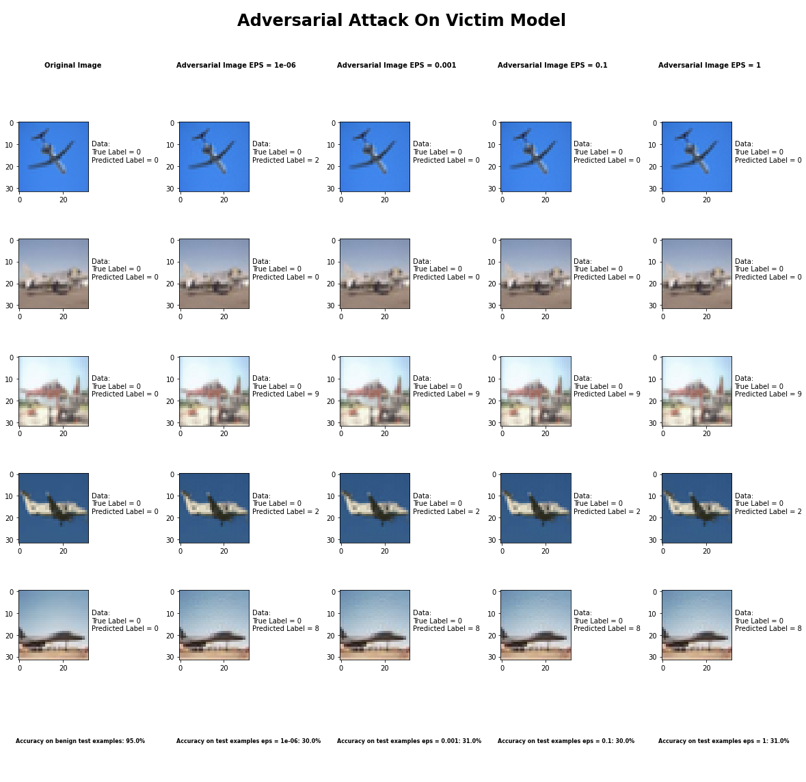

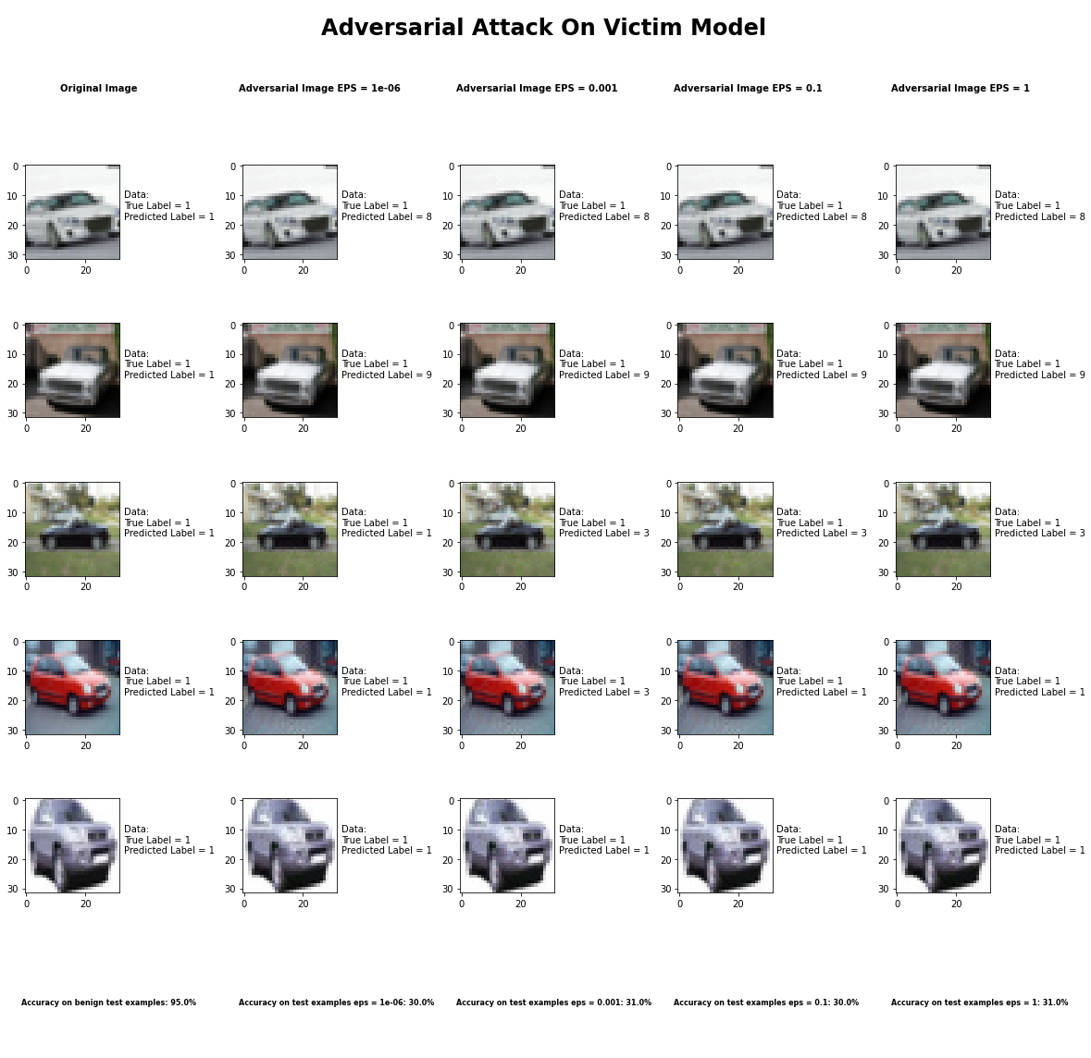

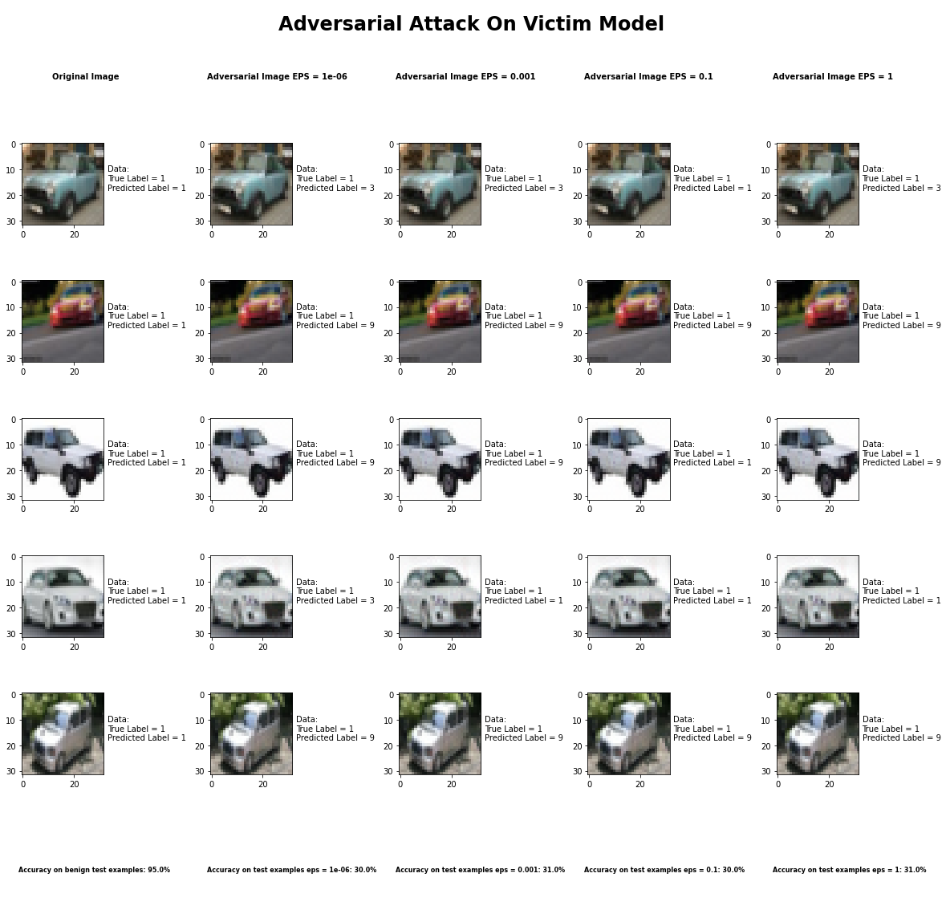

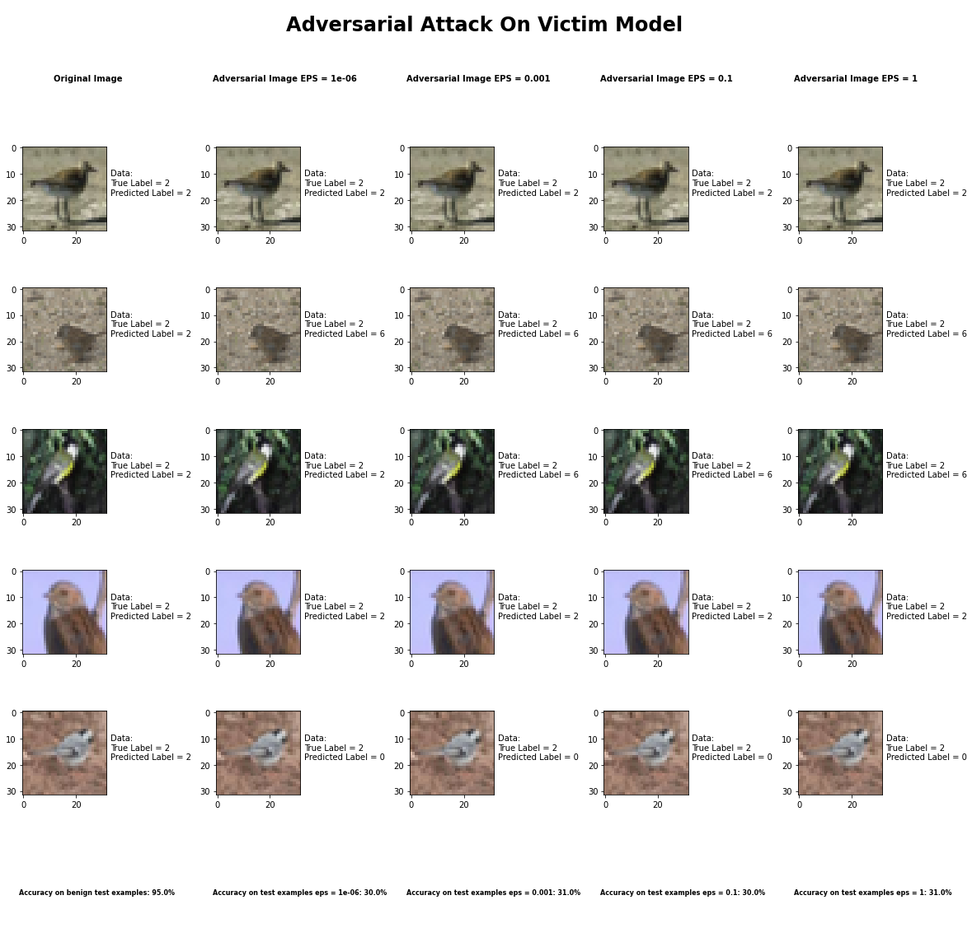

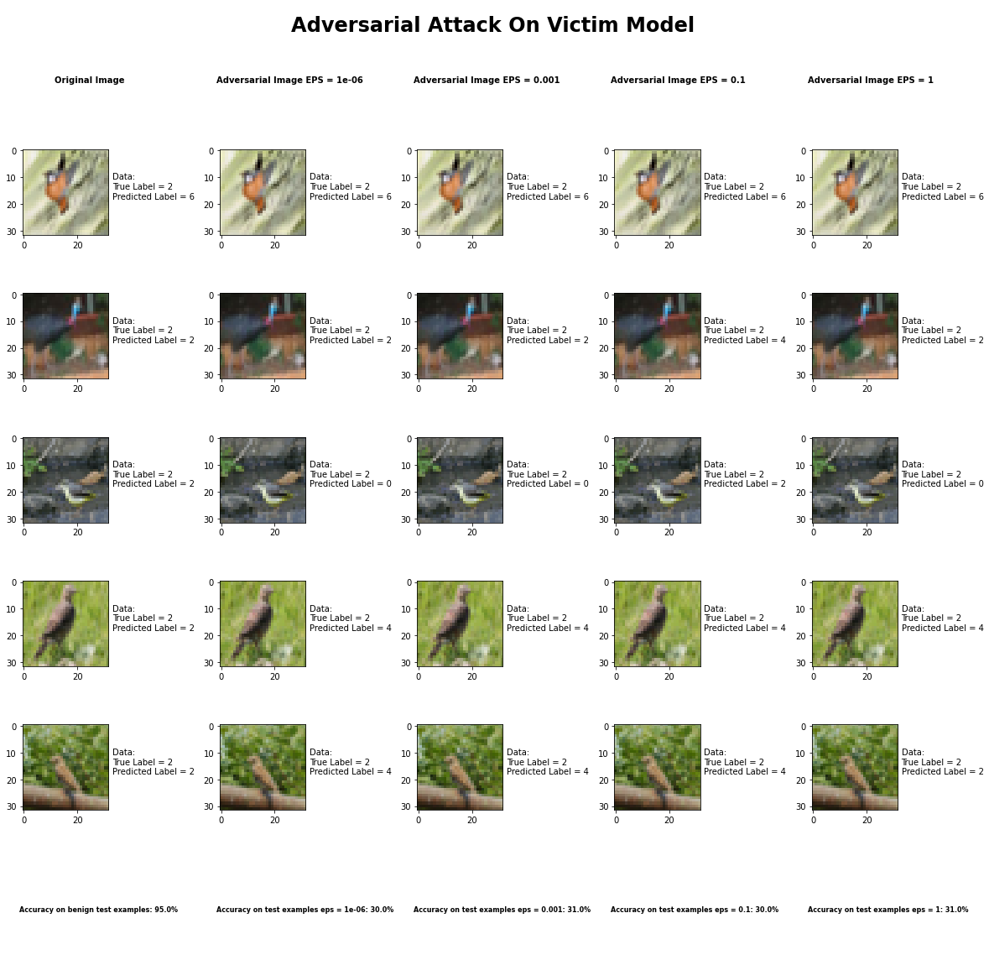

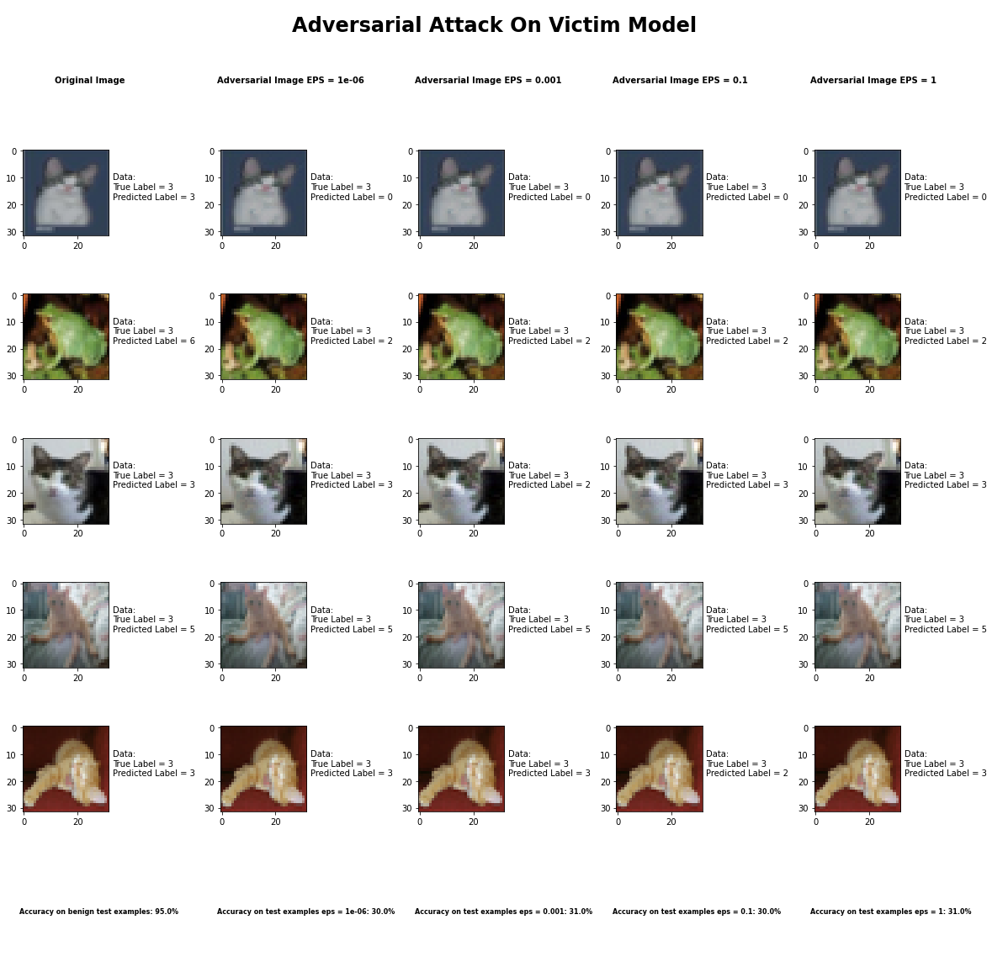

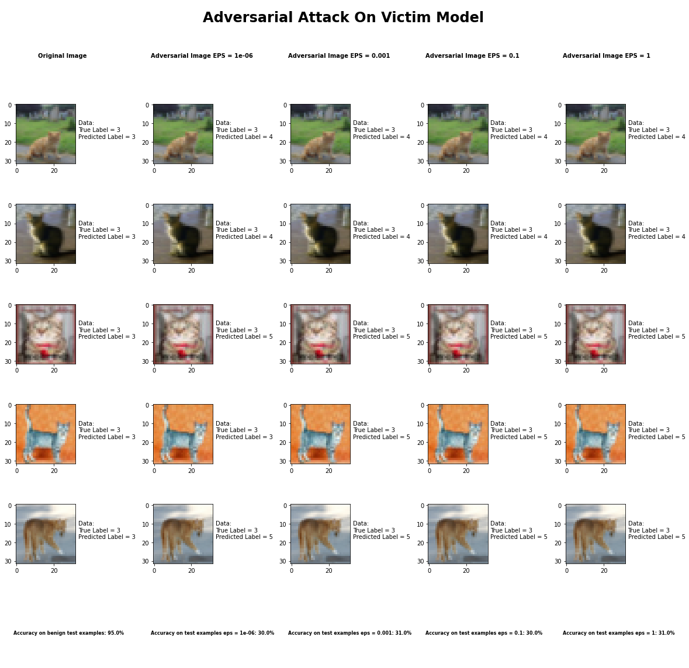

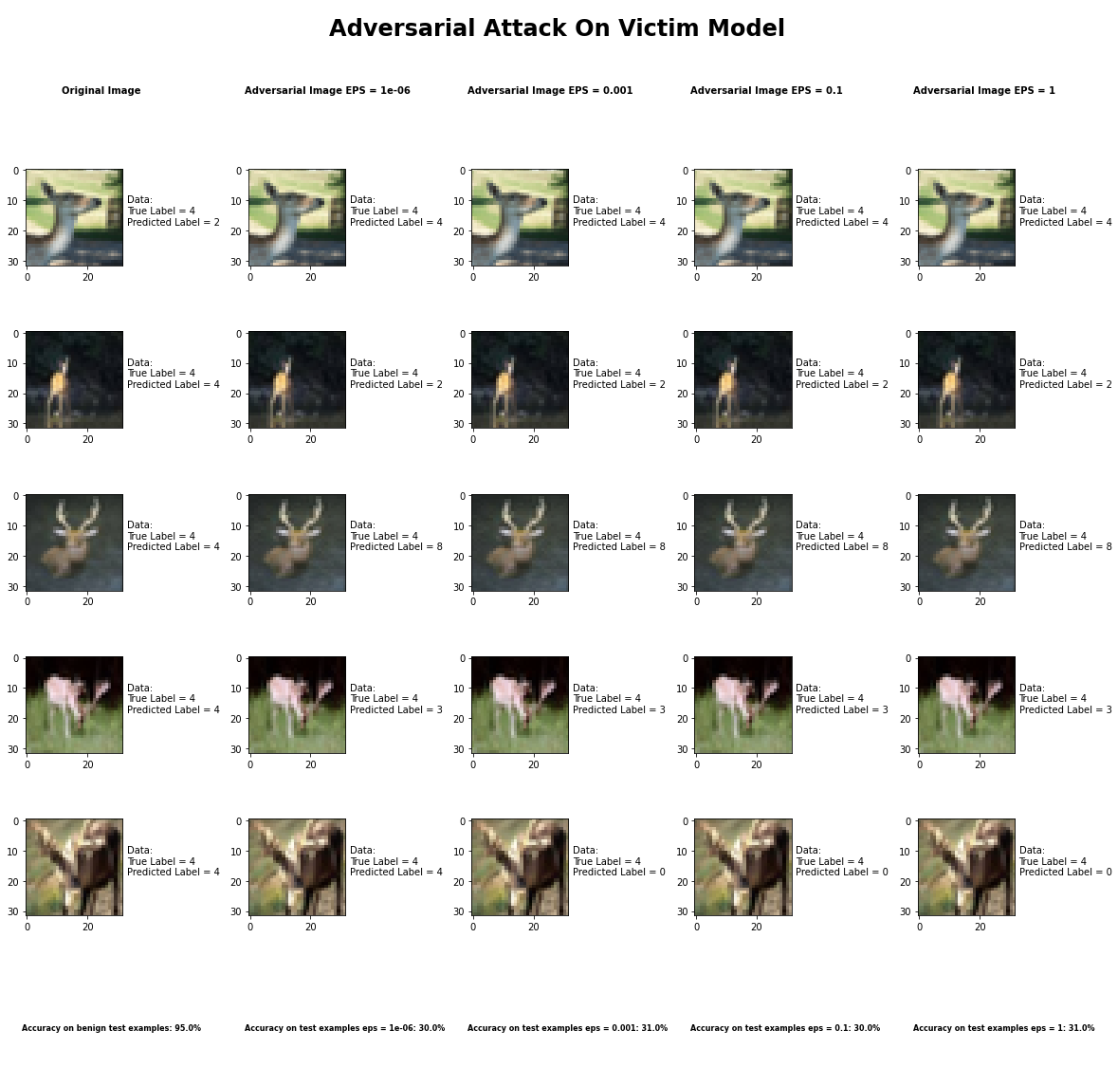

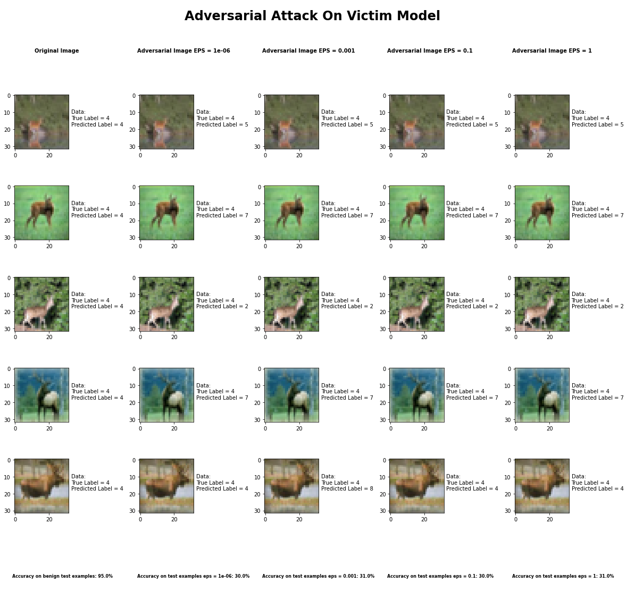

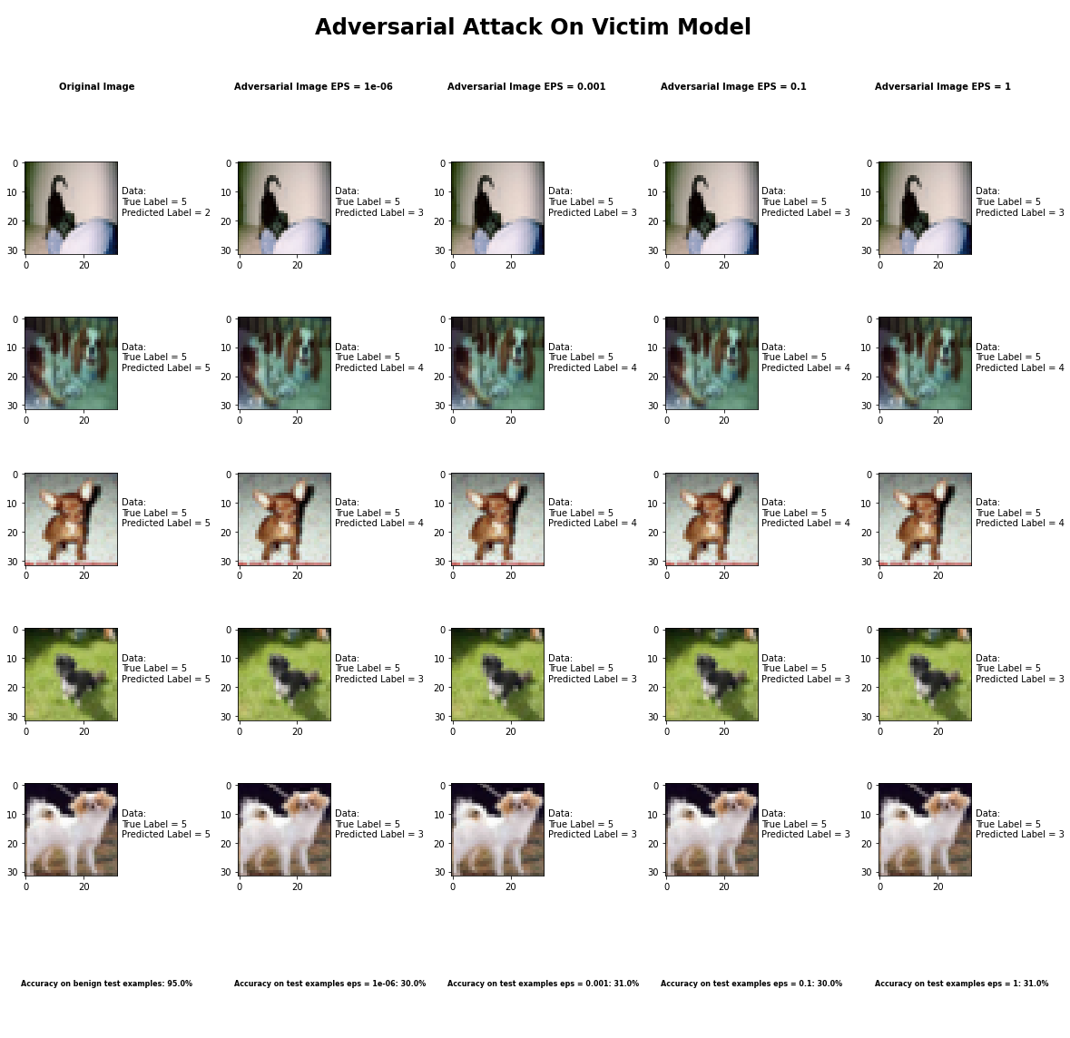

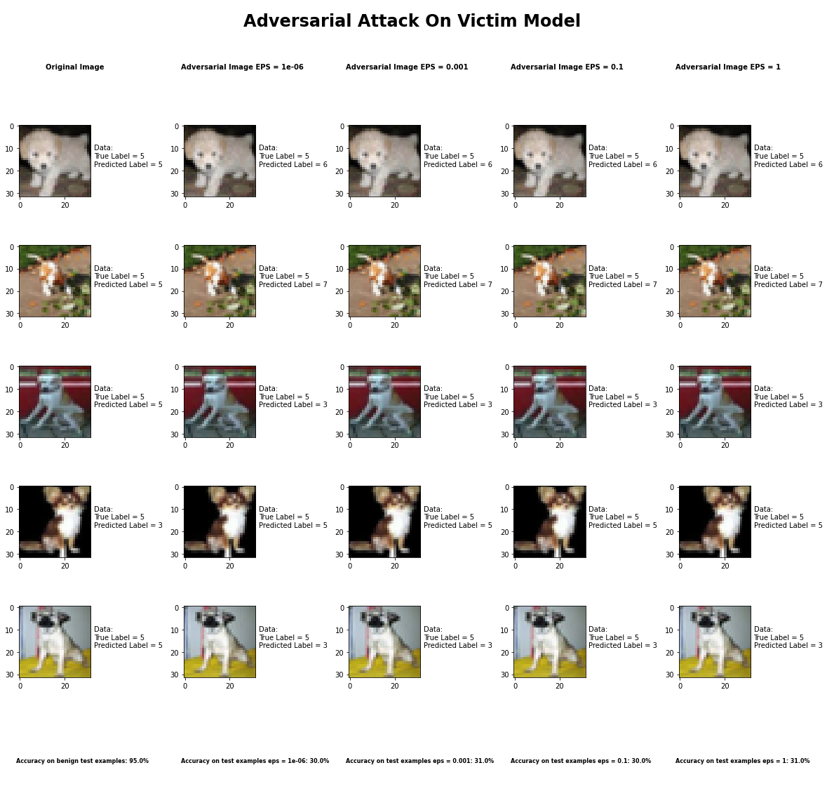

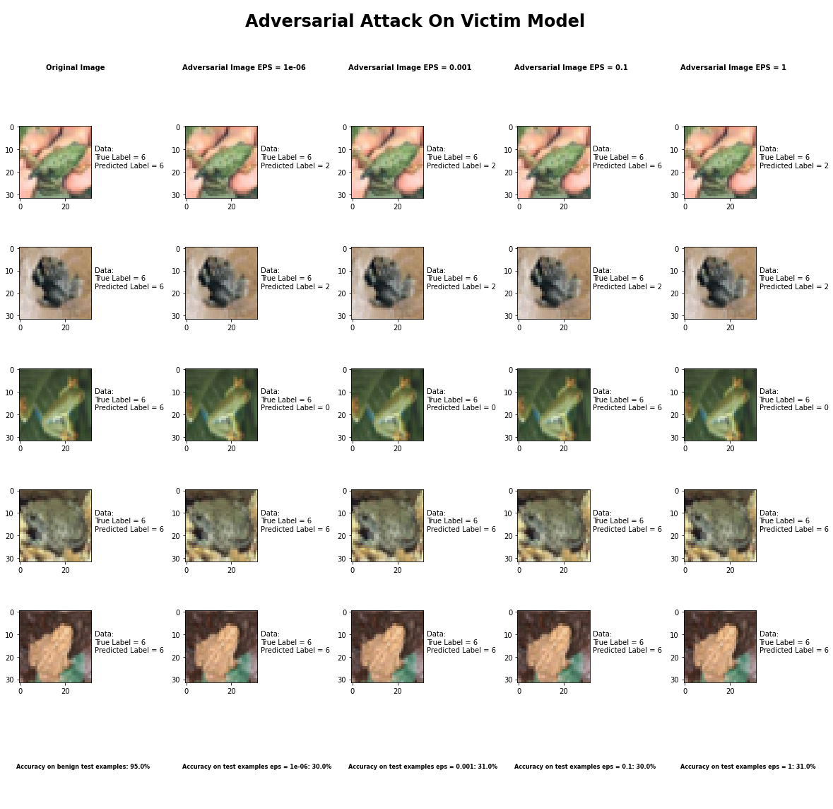

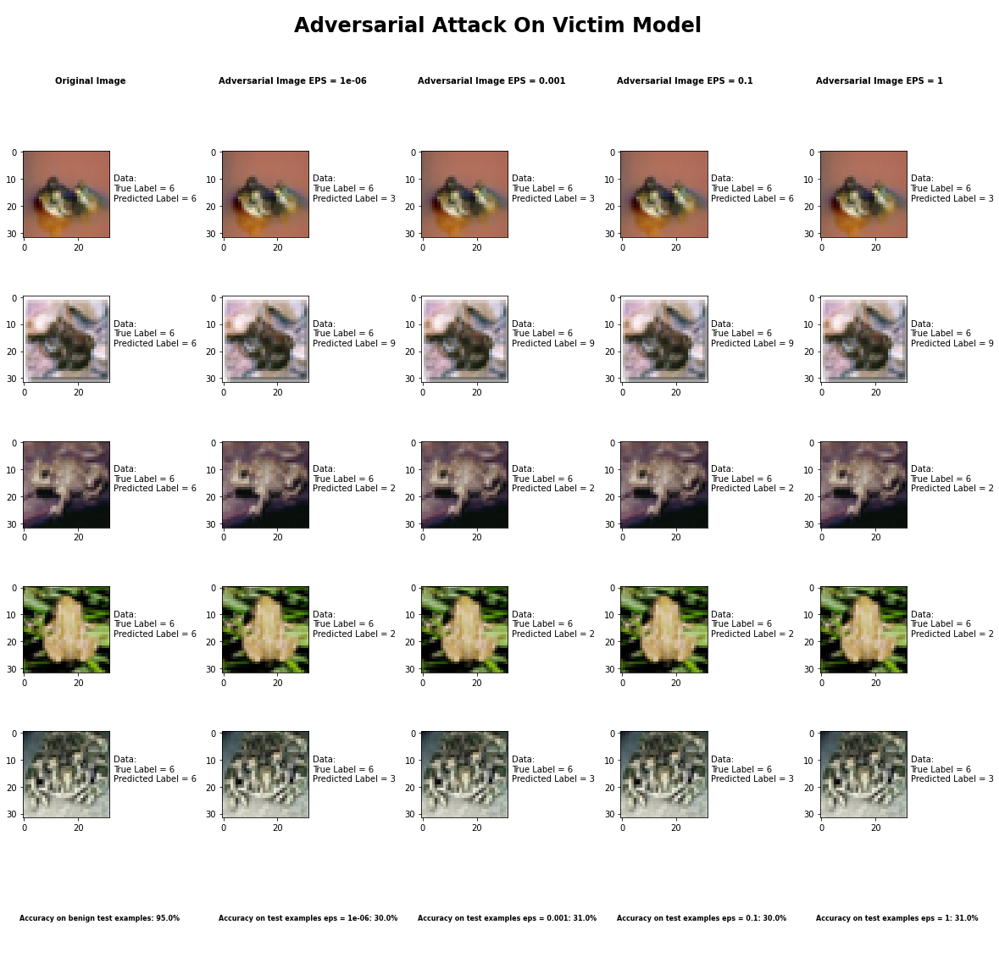

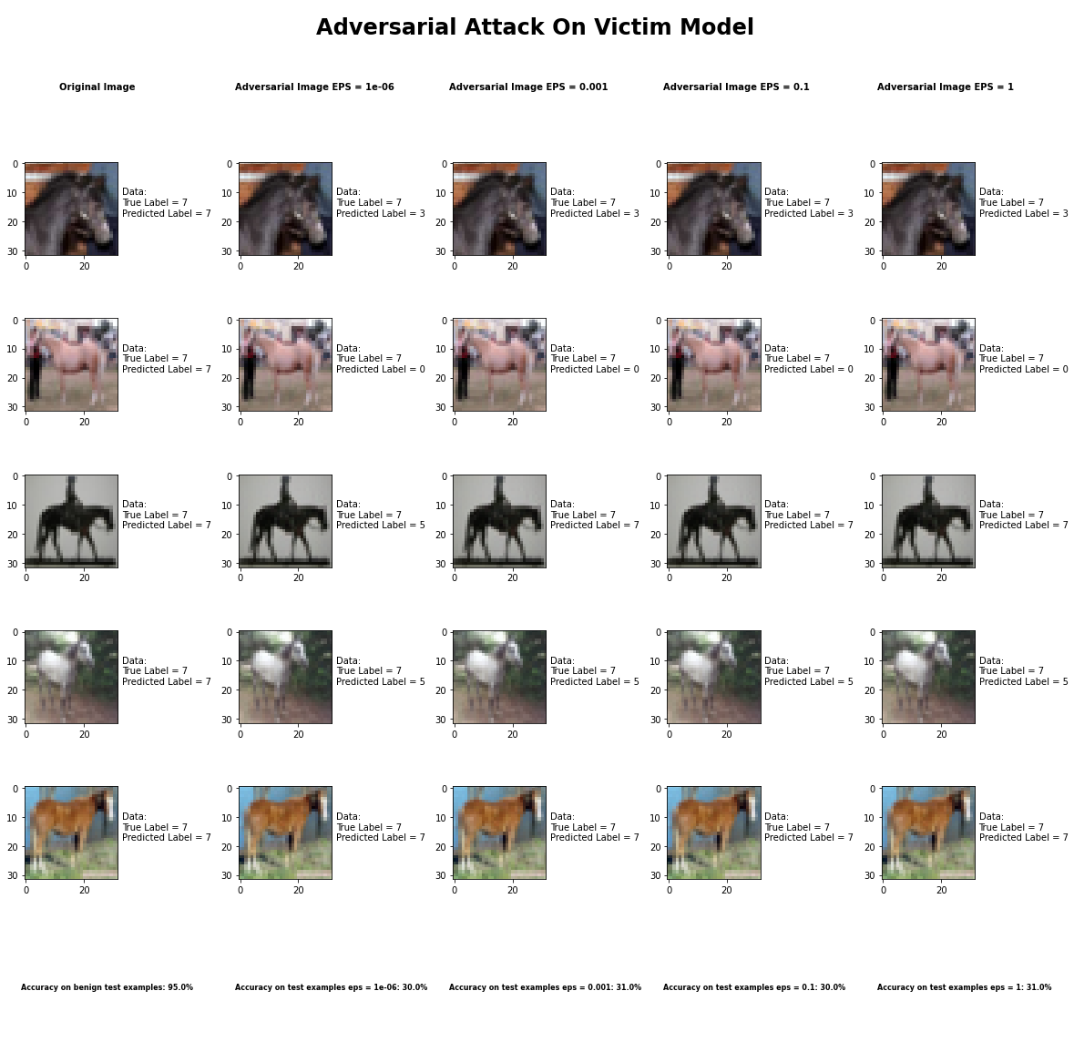

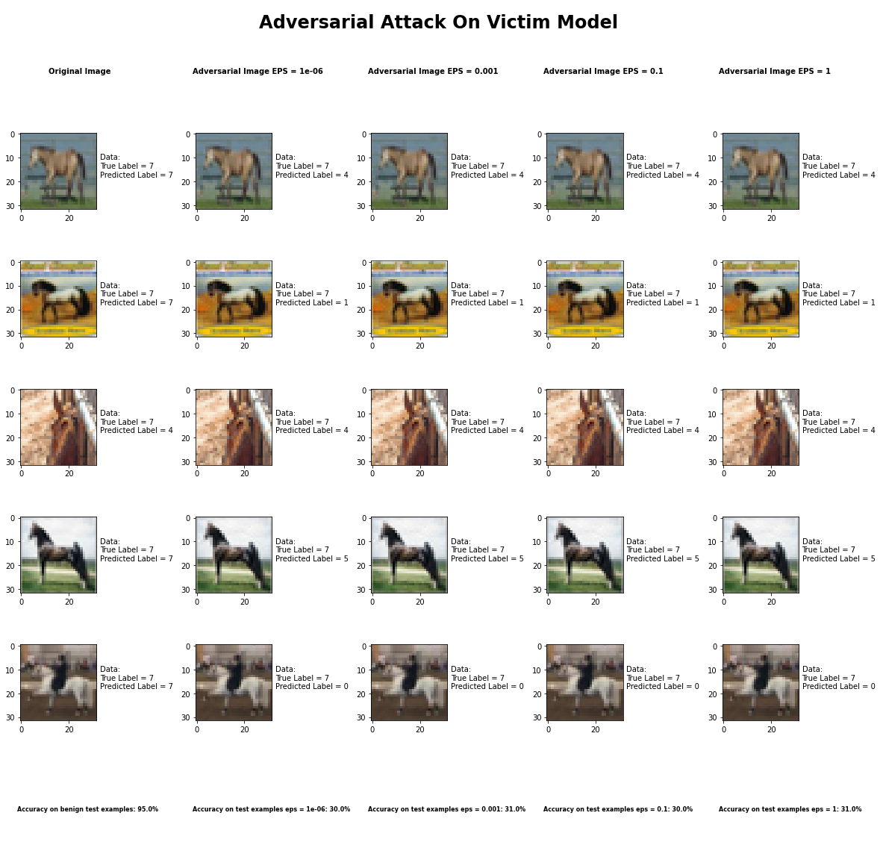

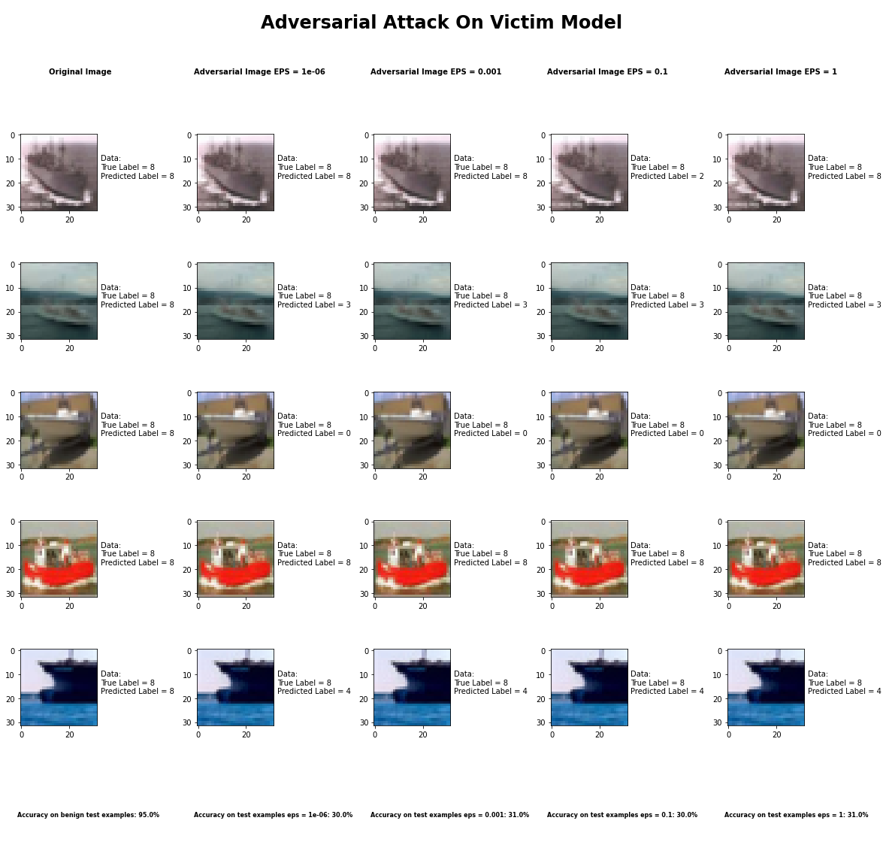

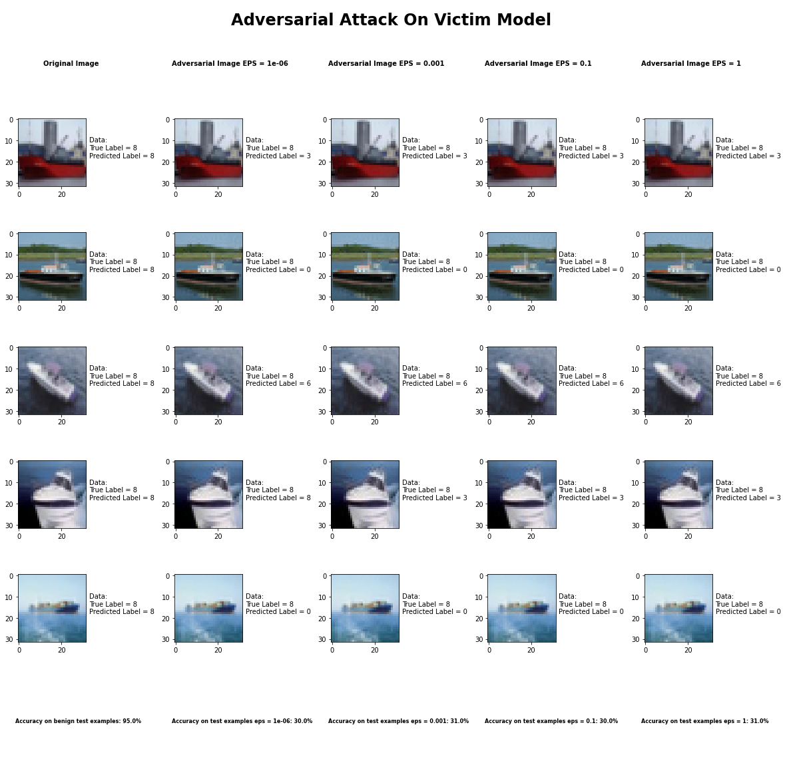

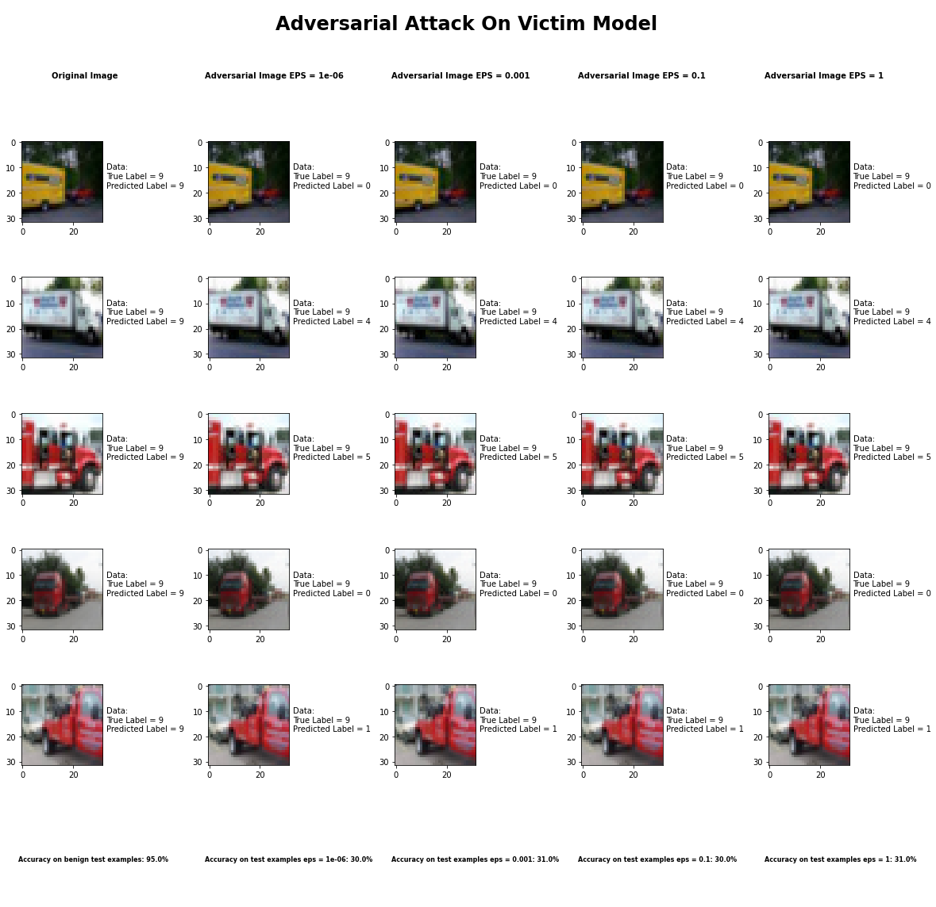

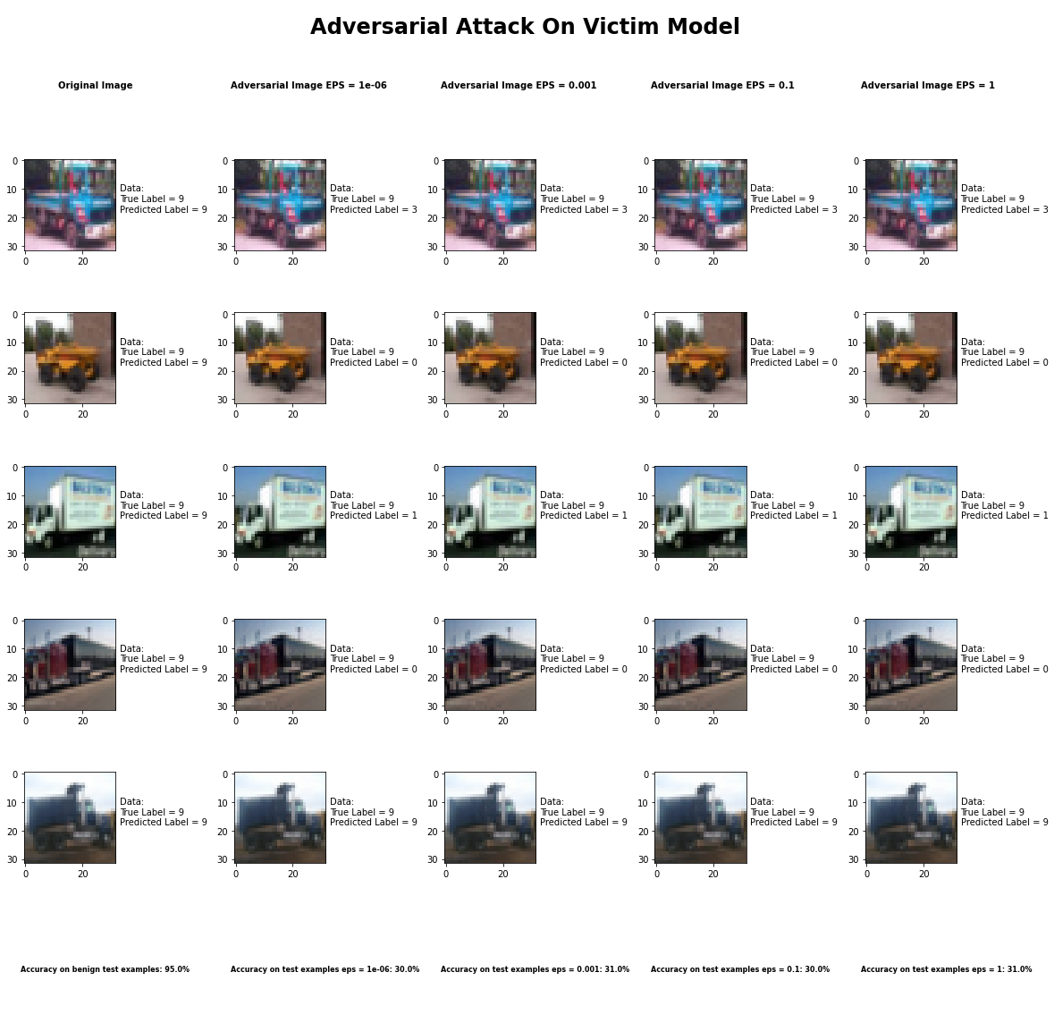

Accuracy on benign test examples: 94.52000000000001%

Average Accuracy on adversarial test examples with eps = 0.05: 30.2%

Average Accuracy on adversarial test examples with eps = 0.1: 31.3%

Average Accuracy on adversarial test examples with eps = 0.5: 30.1%

Average Accuracy on adversarial test examples with eps = 0.95: 31.0%

Classifier with benign example has Airplane recognition average accuracy of = 95%

DeepFool Method with eps = 1e-6 has Airplane recognition average accuracy of = 42%

DeepFool Method with eps = 1e-3 has Airplane recognition average accuracy of = 46%

DeepFool Method with eps = 1e-1 has Airplane recognition average accuracy of = 46%

DeepFool Method with eps = 1 has Airplane recognition average accuracy of = 46%

Classifier with benign example has Automobile recognition average accuracy of = 92%

DeepFool Method with eps = 1e-6 has Automobile recognition average accuracy of = 45%

DeepFool Method with eps = 1e-3 has Automobile recognition average accuracy of = 51%

DeepFool Method with eps = 1e-1 has Automobile recognition average accuracy of = 48%

DeepFool Method with eps = 1 has Automobile recognition average accuracy of = 41%

Classifier with benign example has Bird recognition average accuracy of = 96%

DeepFool Method with eps = 1e-6 has Bird recognition average accuracy of = 27%

DeepFool Method with eps = 1e-3 has Bird recognition average accuracy of = 31%

DeepFool Method with eps = 1e-1 has Bird recognition average accuracy of = 24%

DeepFool Method with eps = 1 has Bird recognition average accuracy of = 28%

Classifier with benign example has Cat recognition average accuracy of = 86%

DeepFool Method with eps = 1e-6 has Cat recognition average accuracy of = 29%

DeepFool Method with eps = 1e-3 has Cat recognition average accuracy of = 26%

DeepFool Method with eps = 1e-1 has Cat recognition average accuracy of = 22%

DeepFool Method with eps = 1 has Cat recognition average accuracy of = 24%

Classifier with benign example has Deer recognition average accuracy of = 95%

DeepFool Method with eps = 1e-6 has Deer recognition average accuracy of = 37%

DeepFool Method with eps = 1e-3 has Deer recognition average accuracy of = 33%

DeepFool Method with eps = 1e-1 has Deer recognition average accuracy of = 38%

DeepFool Method with eps = 1 has Deer recognition average accuracy of = 35%

Classifier with benign example has Dog recognition average accuracy of = 88%

DeepFool Method with eps = 1e-6 has Dog recognition average accuracy of = 20%

DeepFool Method with eps = 1e-3 has Dog recognition average accuracy of = 22%

DeepFool Method with eps = 1e-1 has Dog recognition average accuracy of = 23%

DeepFool Method with eps = 1 has Dog recognition average accuracy of = 22%

Classifier with benign example has Frog recognition average accuracy of = 99%

DeepFool Method with eps = 1e-6 has Frog recognition average accuracy of = 26%

DeepFool Method with eps = 1e-3 has Frog recognition average accuracy of = 24%

DeepFool Method with eps = 1e-1 has Frog recognition average accuracy of = 29%

DeepFool Method with eps = 1 has Frog recognition average accuracy of = 25%

Classifier with benign example has Horse recognition average accuracy of = 93%

DeepFool Method with eps = 1e-6 has Horse recognition average accuracy of = 21%

DeepFool Method with eps = 1e-3 has Horse recognition average accuracy of = 25%

DeepFool Method with eps = 1e-1 has Horse recognition average accuracy of = 24%

DeepFool Method with eps = 1 has Horse recognition average accuracy of = 26%

Classifier with benign example has Ship recognition average accuracy of = 94%

DeepFool Method with eps = 1e-6 has Ship recognition average accuracy of = 32%

DeepFool Method with eps = 1e-3 has Ship recognition average accuracy of = 30%

DeepFool Method with eps = 1e-1 has Ship recognition average accuracy of = 28%

DeepFool Method with eps = 1 has Ship recognition average accuracy of = 32%

Classifier with benign example has Truck recognition average accuracy of = 98%

DeepFool Method with eps = 1e-6 has Truck recognition average accuracy of = 26%

DeepFool Method with eps = 1e-3 has Truck recognition average accuracy of = 24%

DeepFool Method with eps = 1e-1 has Truck recognition average accuracy of = 21%

DeepFool Method with eps = 1 has Truck recognition average accuracy of = 18%

## Fast Gradient Sign Method



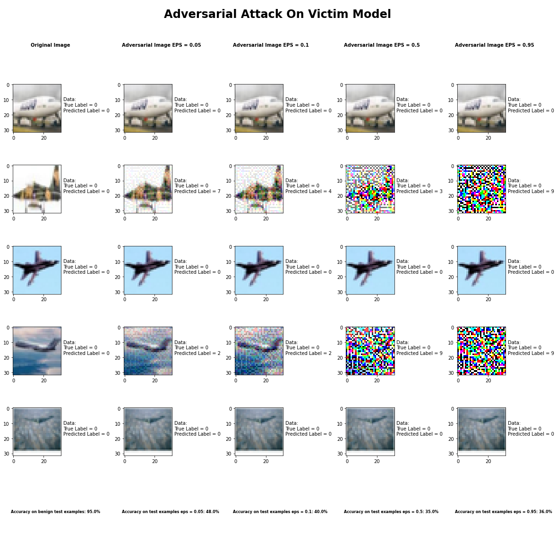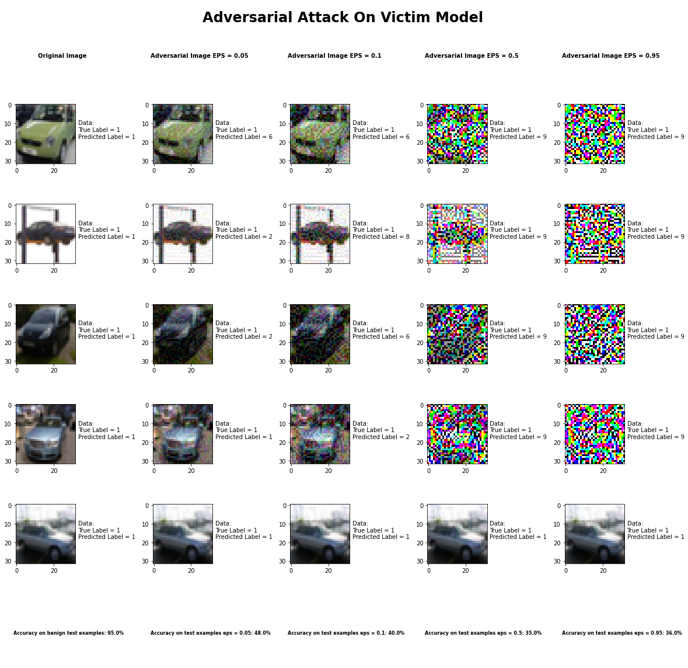

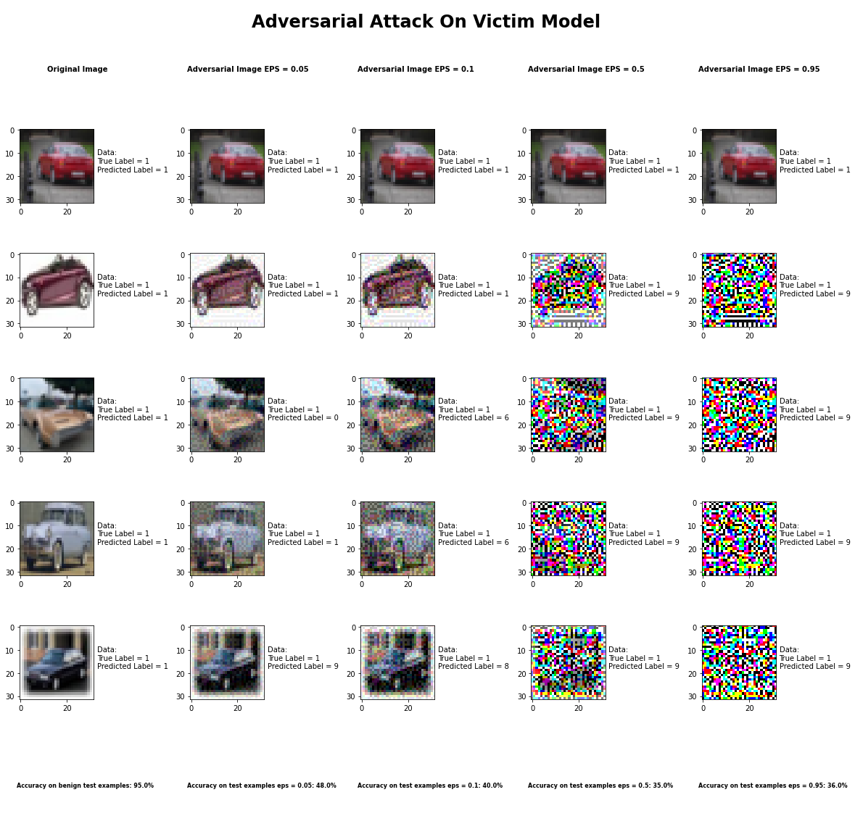

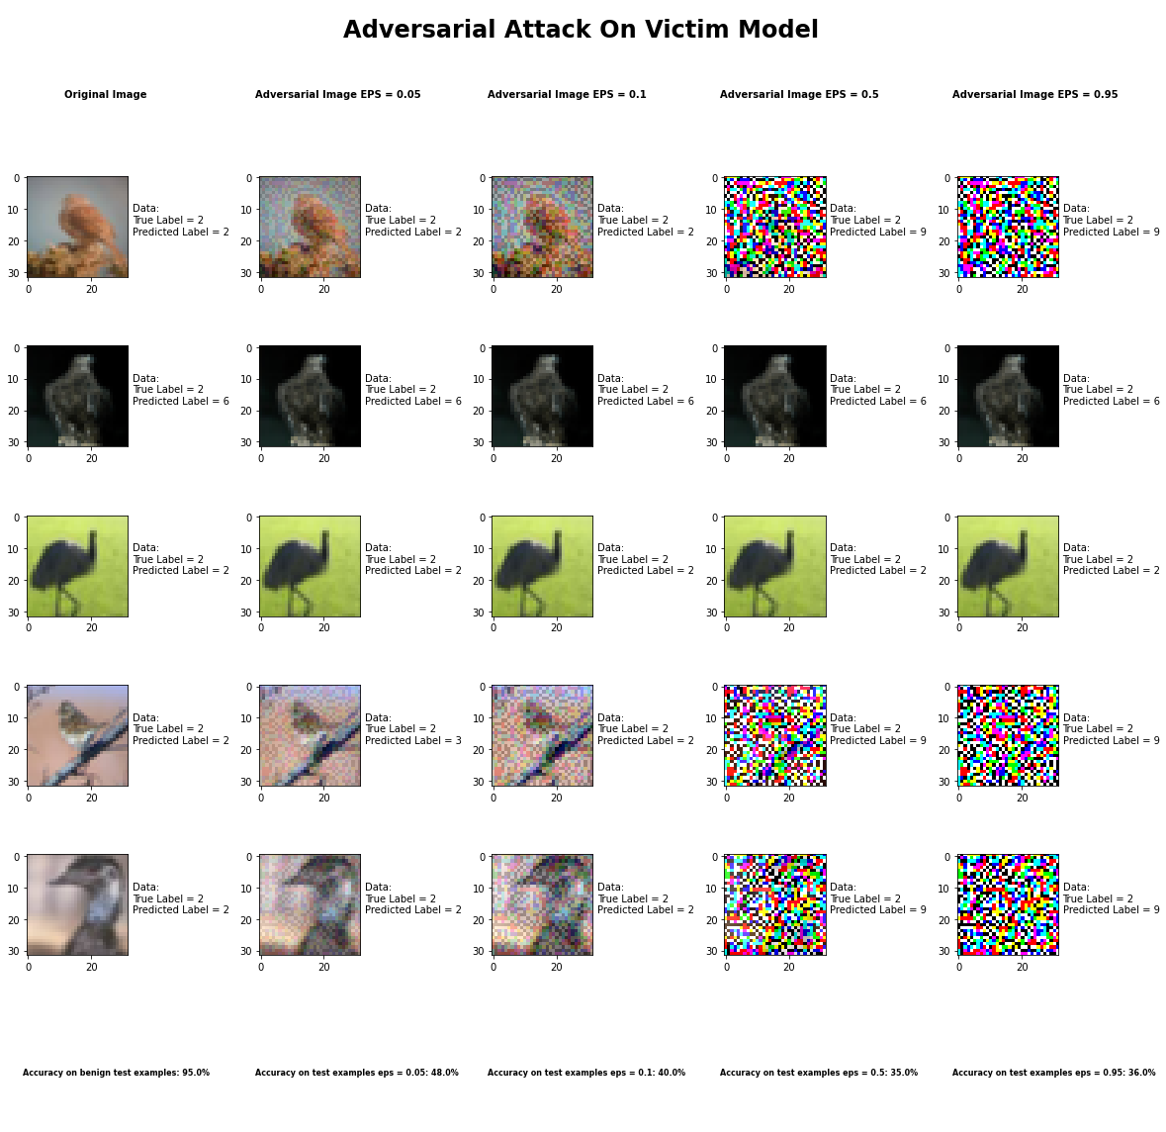

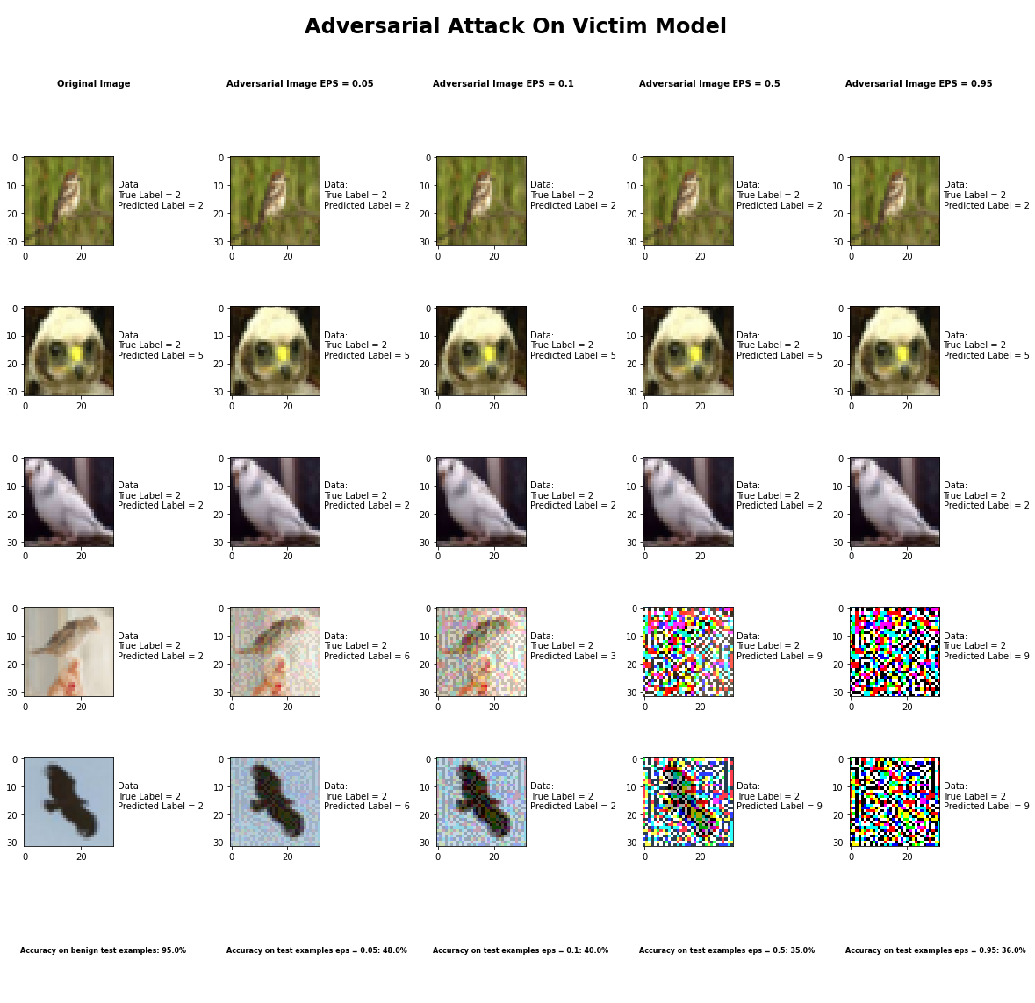

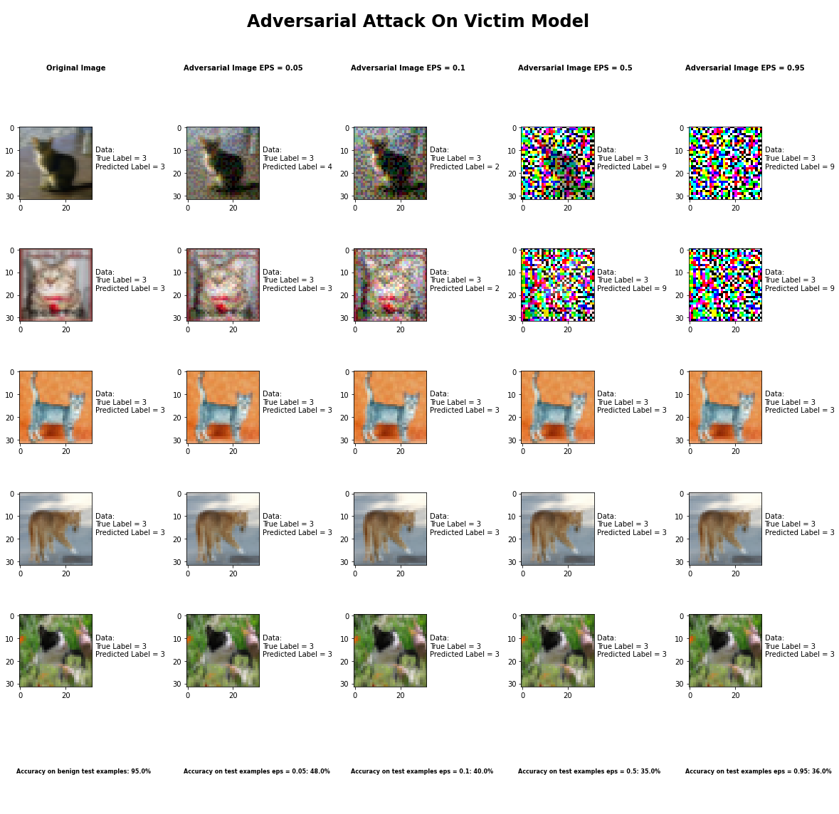

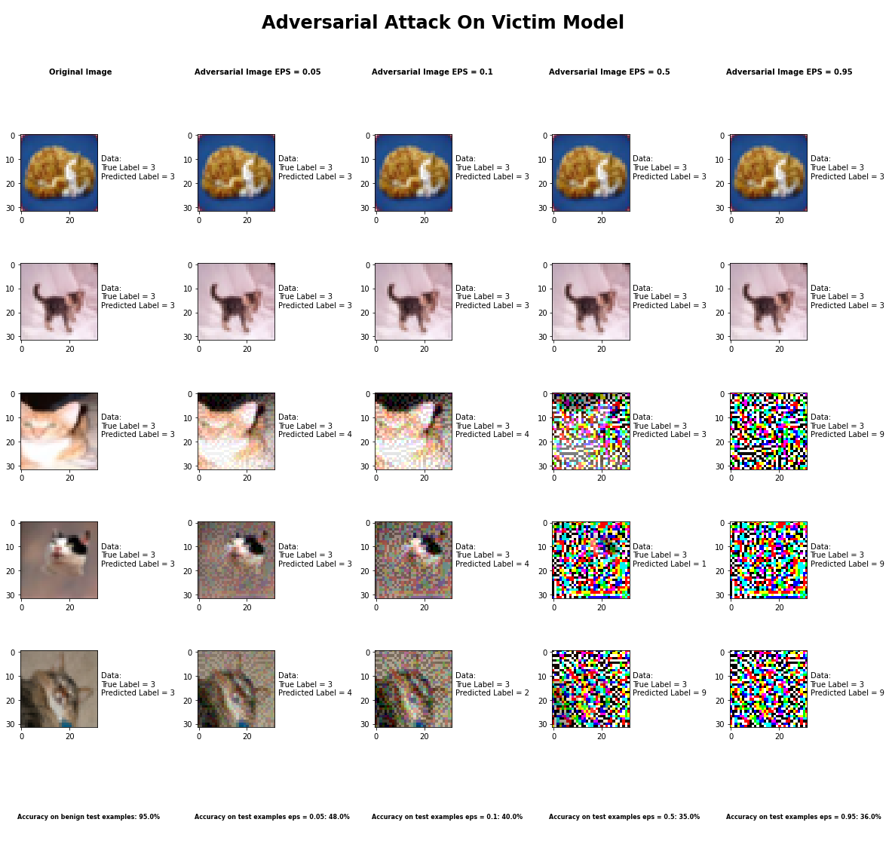

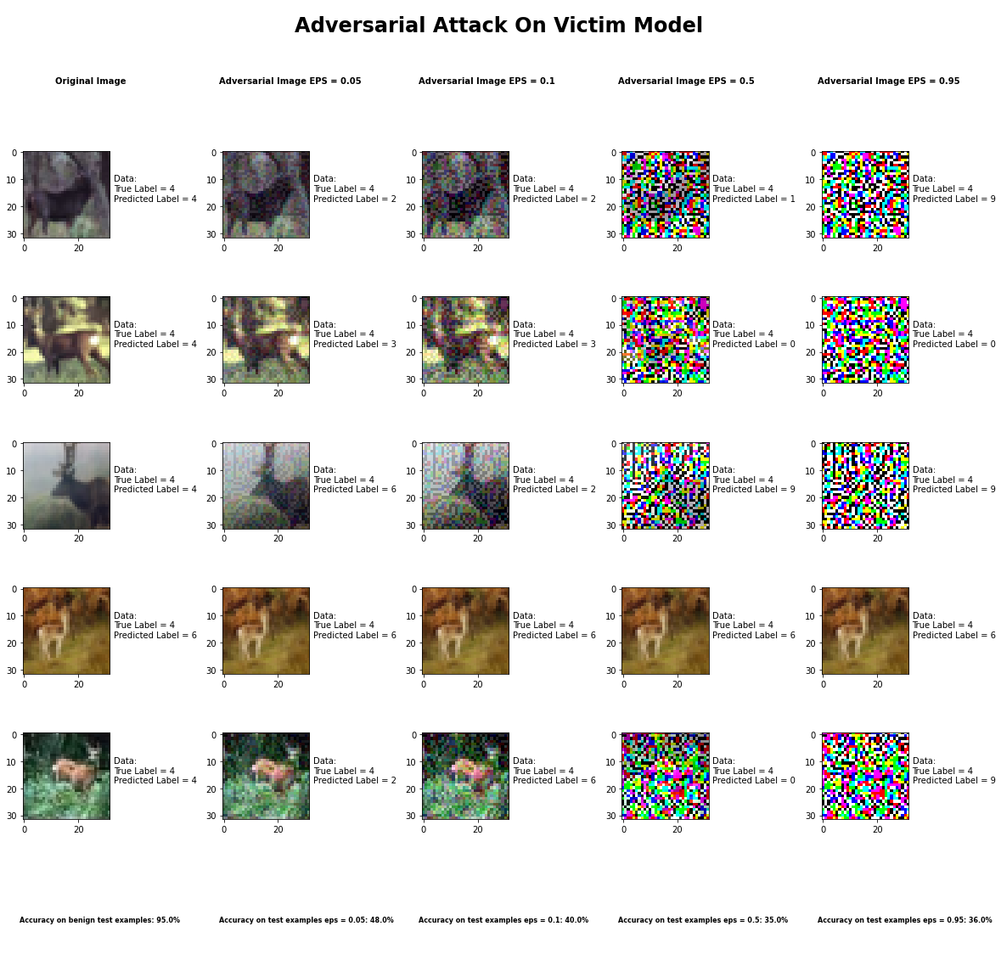

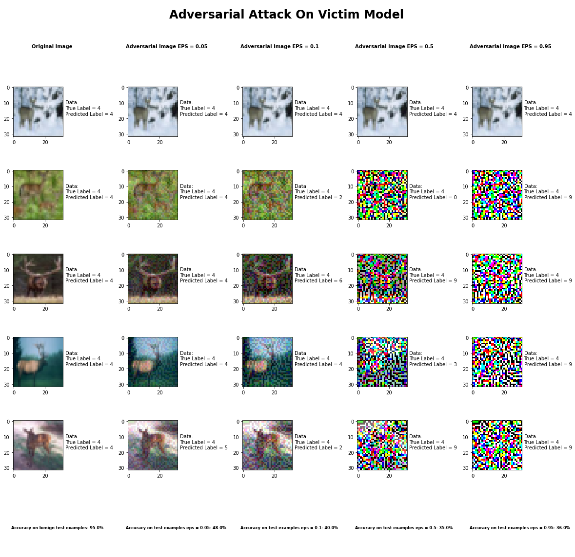

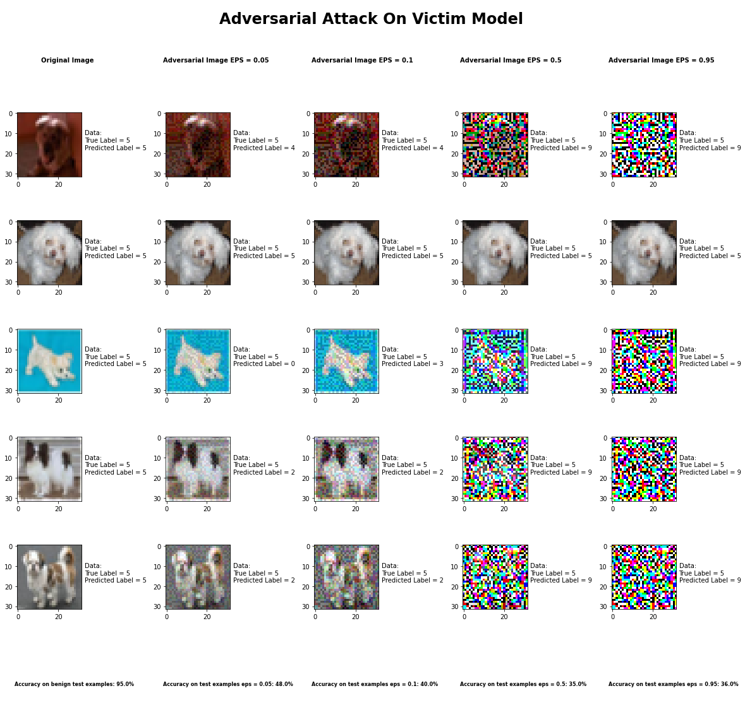

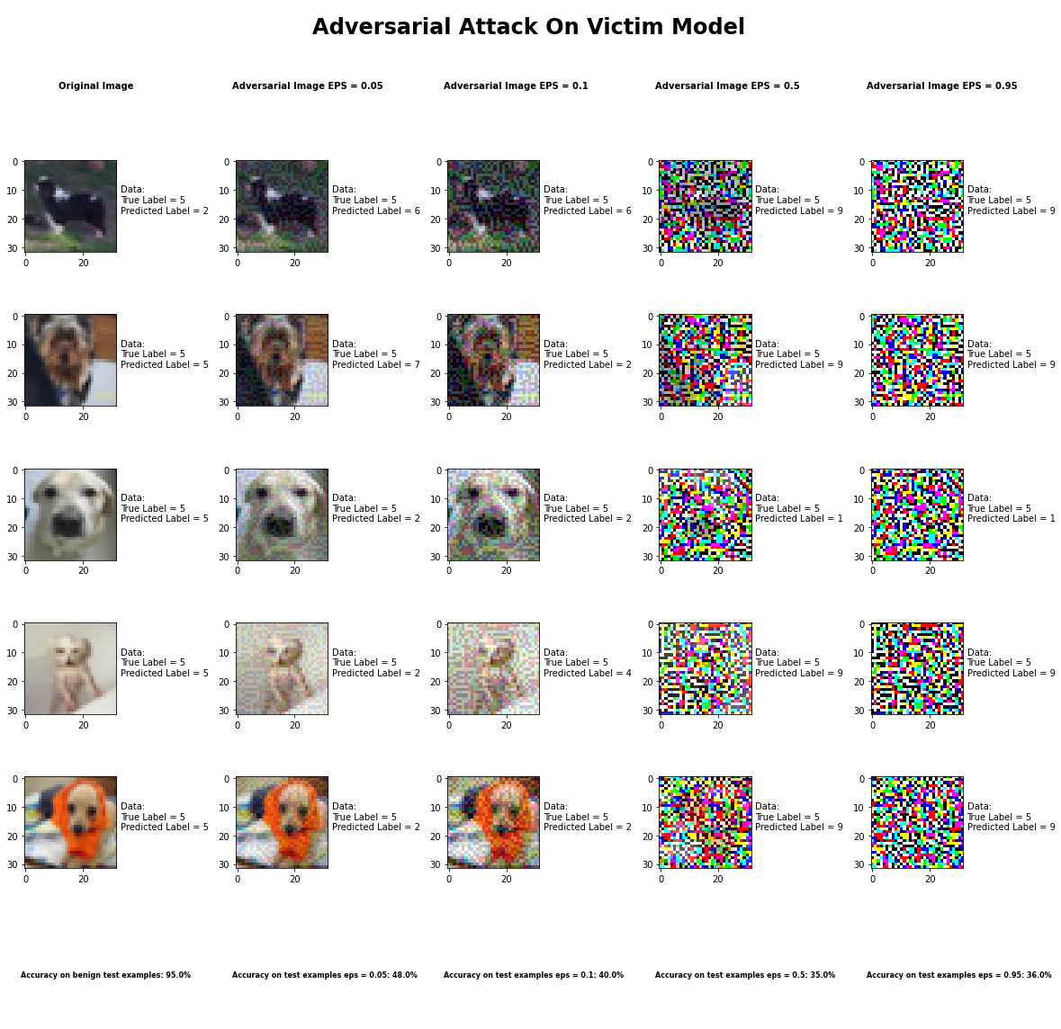

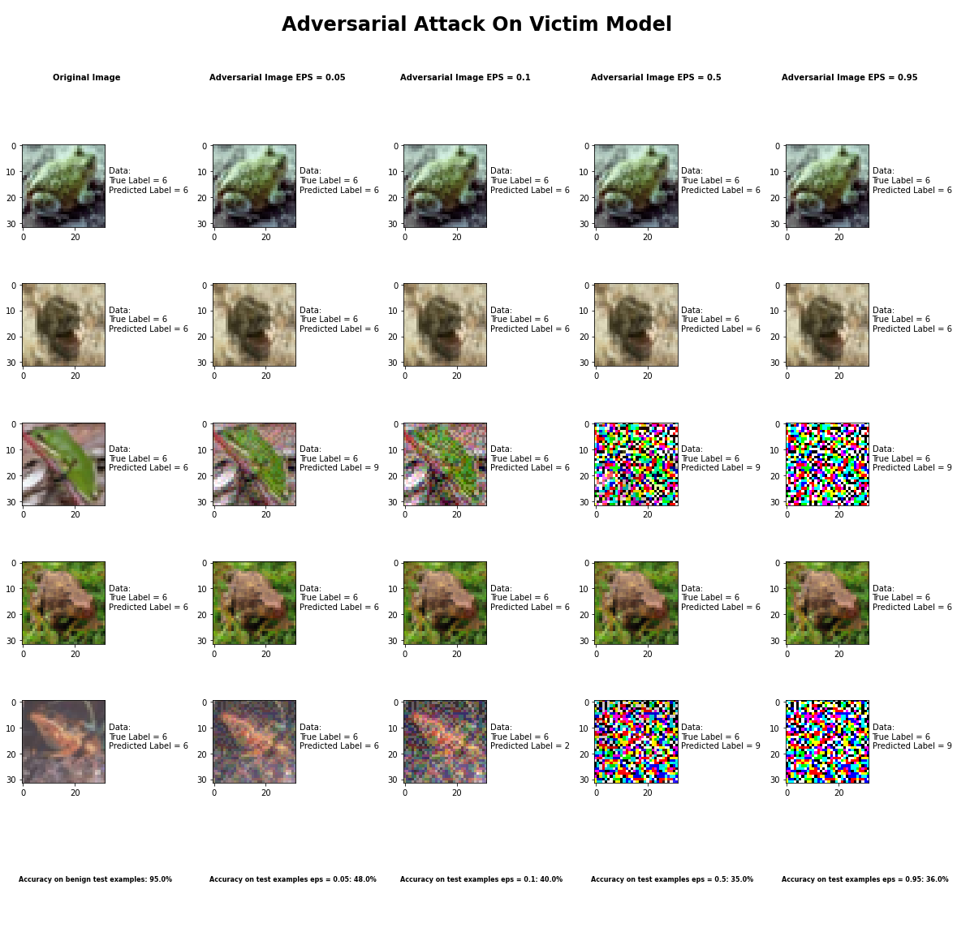

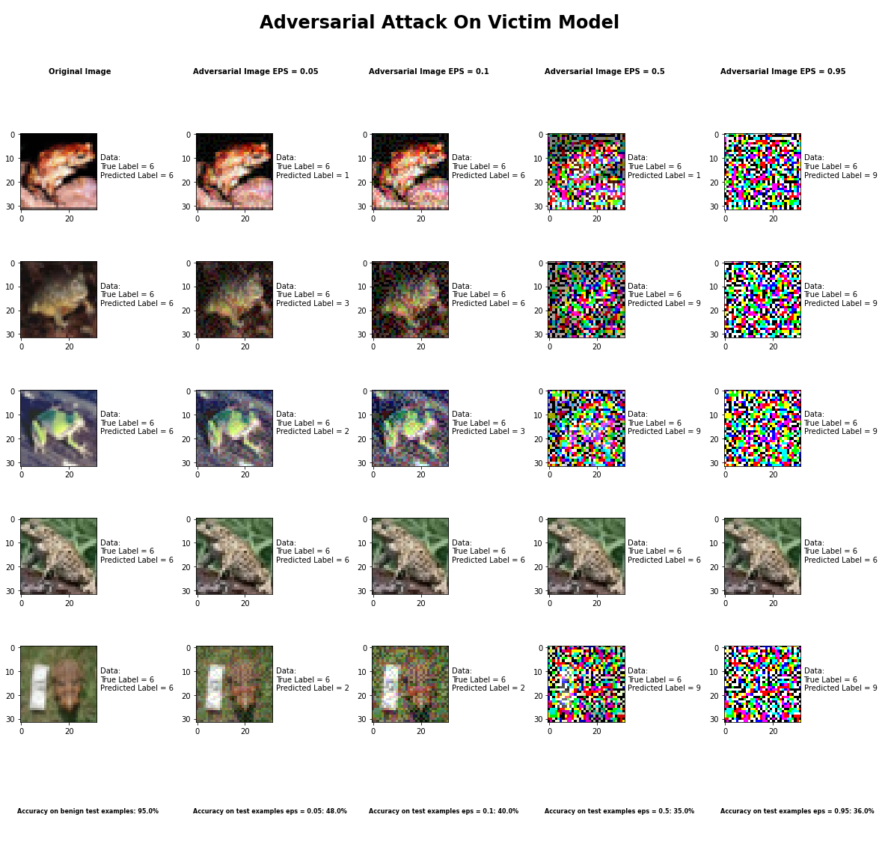

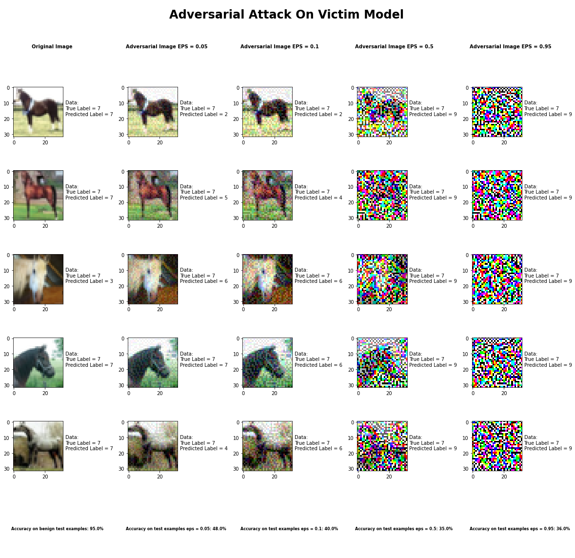

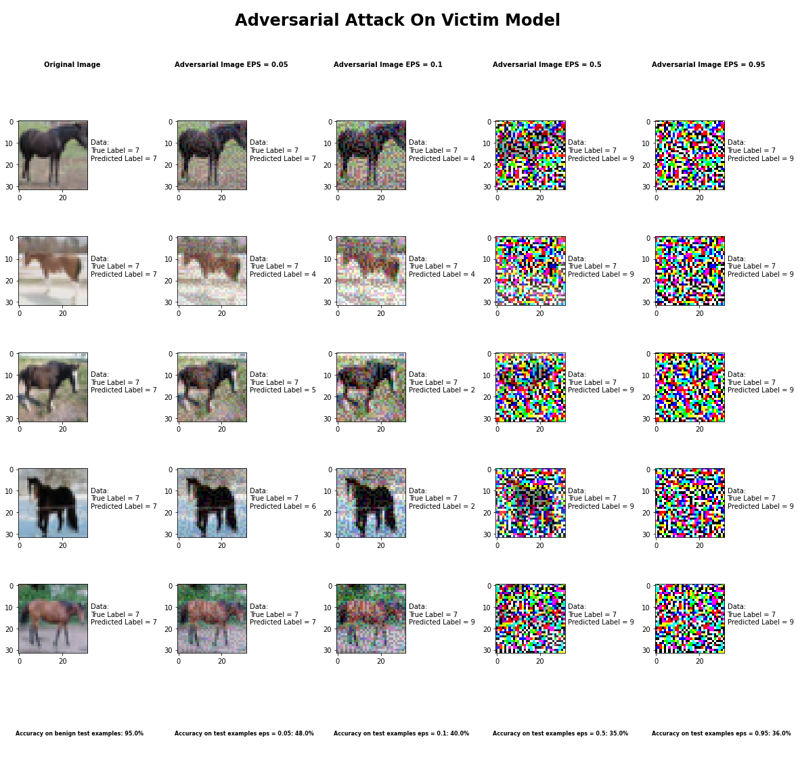

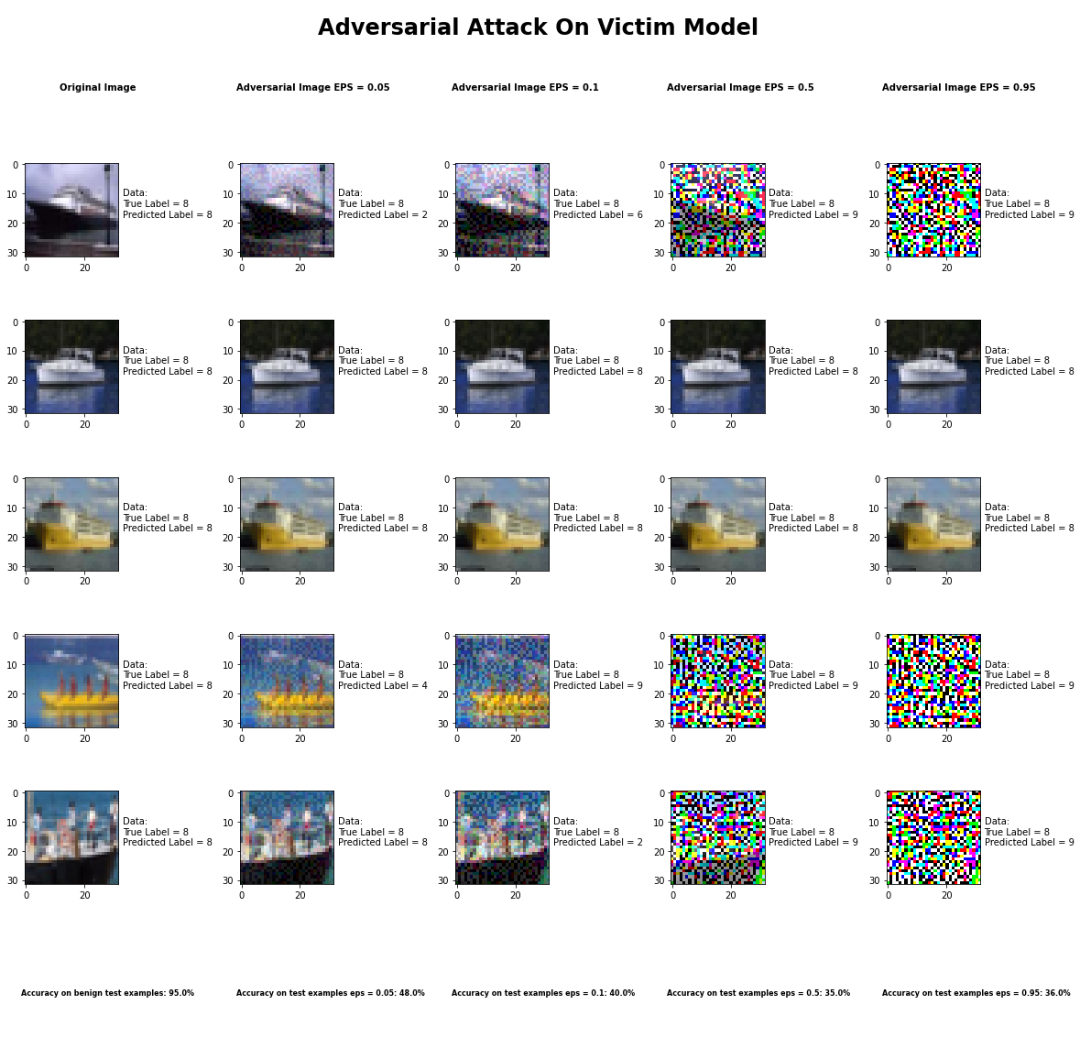

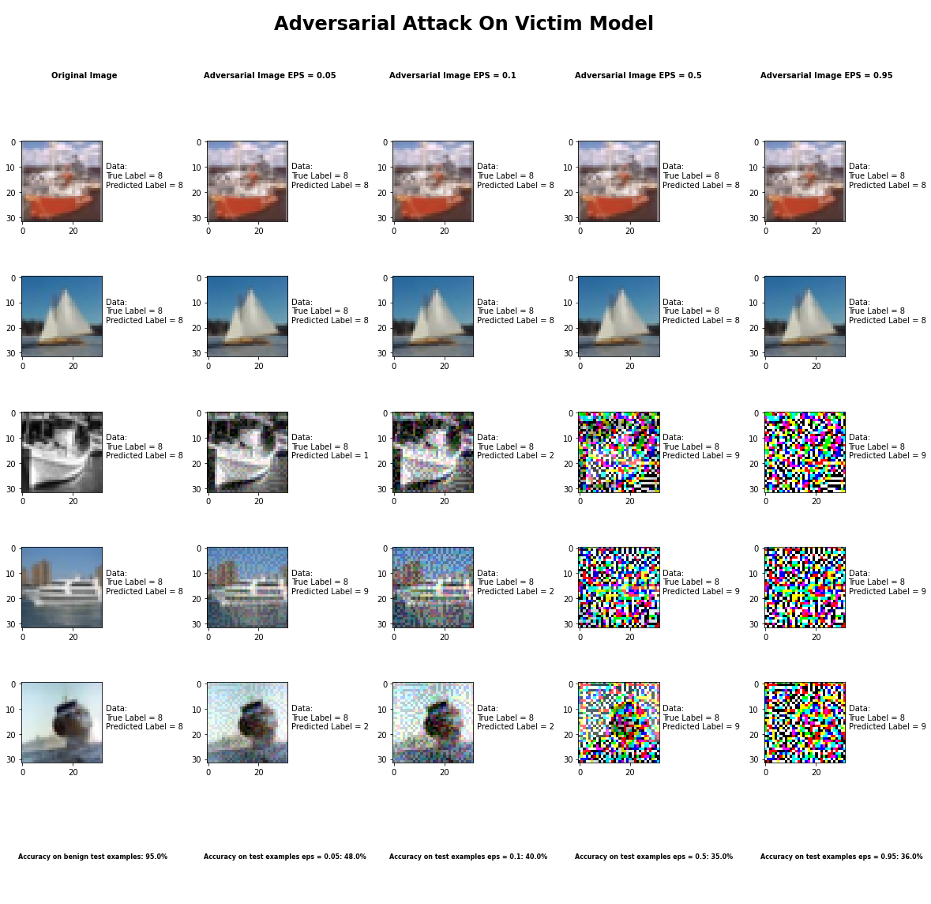

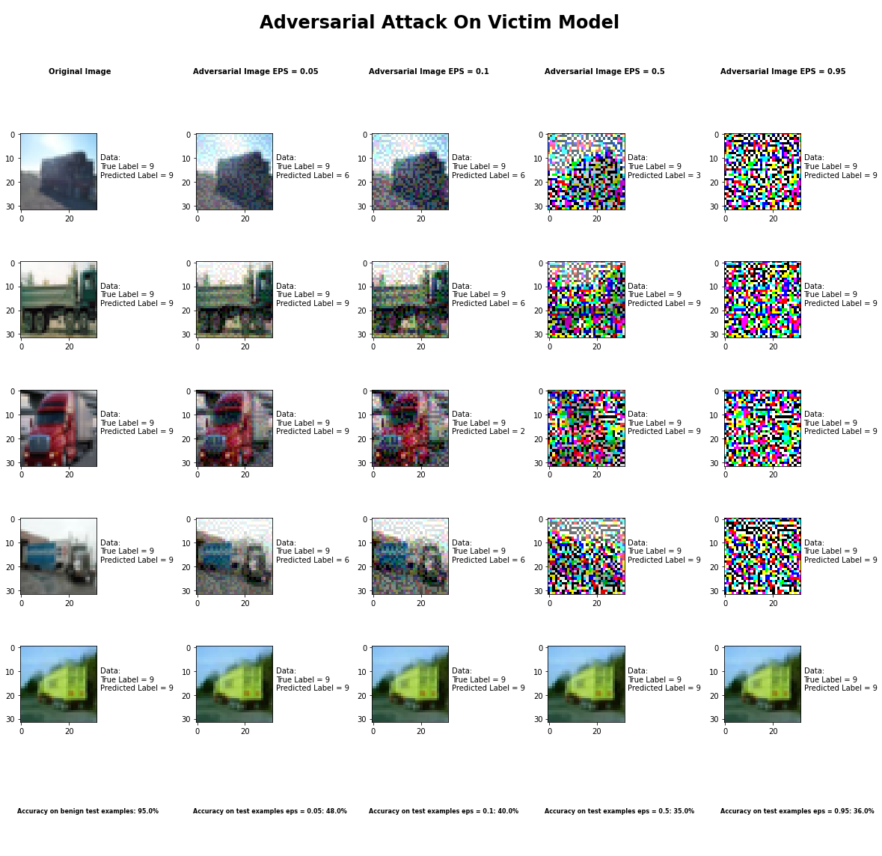

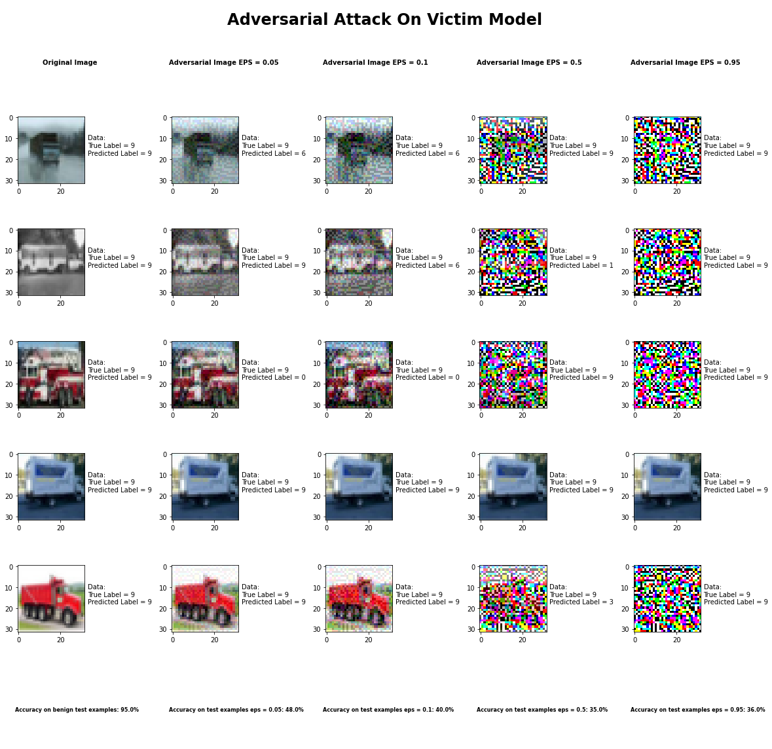

Accuracy on benign test examples: 94.52000000000001%

Average Accuracy on adversarial test examples with eps = 0.05: 48.4%

Average Accuracy on adversarial test examples with eps = 0.1: 39.9%

Average Accuracy on adversarial test examples with eps = 0.5: 35.3%

Average Accuracy on adversarial test examples with eps = 0.95: 35.5%

Classifier with benign example has Airplane recognition average accuracy of = 98%

Fast Gradient Method with eps = 0.05 has Airplane recognition average accuracy of = 32%

Fast Gradient Method with eps = 0.10 has Airplane recognition average accuracy of = 30%

Fast Gradient Method with eps = 0.50 has Airplane recognition average accuracy of = 33%

Fast Gradient Method with eps = 0.95 has Airplane recognition average accuracy of = 30%

Classifier with benign example has Automobile recognition average accuracy of = 96%

Fast Gradient Method with eps = 0.05 has Automobile recognition average accuracy of = 60%

Fast Gradient Method with eps = 0.10 has Automobile recognition average accuracy of = 40%

Fast Gradient Method with eps = 0.50 has Automobile recognition average accuracy of = 40%

Fast Gradient Method with eps = 0.95 has Automobile recognition average accuracy of = 35%

Classifier with benign example has Bird recognition average accuracy of = 95%

Fast Gradient Method with eps = 0.05 has Bird recognition average accuracy of = 68%

Fast Gradient Method with eps = 0.10 has Bird recognition average accuracy of = 70%

Fast Gradient Method with eps = 0.50 has Bird recognition average accuracy of = 34%

Fast Gradient Method with eps = 0.95 has Bird recognition average accuracy of = 34%

Classifier with benign example has Cat recognition average accuracy of = 86%

Fast Gradient Method with eps = 0.05 has Cat recognition average accuracy of = 42%

Fast Gradient Method with eps = 0.10 has Cat recognition average accuracy of = 34%

Fast Gradient Method with eps = 0.50 has Cat recognition average accuracy of = 37%

Fast Gradient Method with eps = 0.95 has Cat recognition average accuracy of = 32%

Classifier with benign example has Deer recognition average accuracy of = 96%

Fast Gradient Method with eps = 0.05 has Deer recognition average accuracy of = 43%

Fast Gradient Method with eps = 0.10 has Deer recognition average accuracy of = 28%

Fast Gradient Method with eps = 0.50 has Deer recognition average accuracy of = 20%

Fast Gradient Method with eps = 0.95 has Deer recognition average accuracy of = 20%

Classifier with benign example has Dog recognition average accuracy of = 84%

Fast Gradient Method with eps = 0.05 has Dog recognition average accuracy of = 31%

Fast Gradient Method with eps = 0.10 has Dog recognition average accuracy of = 23%

Fast Gradient Method with eps = 0.50 has Dog recognition average accuracy of = 23%

Fast Gradient Method with eps = 0.95 has Dog recognition average accuracy of = 23%

Classifier with benign example has Frog recognition average accuracy of = 96%

Fast Gradient Method with eps = 0.05 has Frog recognition average accuracy of = 60%

Fast Gradient Method with eps = 0.10 has Frog recognition average accuracy of = 68%

Fast Gradient Method with eps = 0.50 has Frog recognition average accuracy of = 26%

Fast Gradient Method with eps = 0.95 has Frog recognition average accuracy of = 26%

Classifier with benign example has Horse recognition average accuracy of = 93%

Fast Gradient Method with eps = 0.05 has Horse recognition average accuracy of = 33%

Fast Gradient Method with eps = 0.10 has Horse recognition average accuracy of = 24%

Fast Gradient Method with eps = 0.50 has Horse recognition average accuracy of = 24%

Fast Gradient Method with eps = 0.95 has Horse recognition average accuracy of = 23%

Classifier with benign example has Ship recognition average accuracy of = 99%

Fast Gradient Method with eps = 0.05 has Ship recognition average accuracy of = 58%

Fast Gradient Method with eps = 0.10 has Ship recognition average accuracy of = 45%

Fast Gradient Method with eps = 0.50 has Ship recognition average accuracy of = 45%

Fast Gradient Method with eps = 0.95 has Ship recognition average accuracy of = 45%

Classifier with benign example has Truck recognition average accuracy of = 97%

Fast Gradient Method with eps = 0.05 has Truck recognition average accuracy of = 57%

Fast Gradient Method with eps = 0.10 has Truck recognition average accuracy of = 37%

Fast Gradient Method with eps = 0.50 has Truck recognition average accuracy of = 71%

Fast Gradient Method with eps = 0.95 has Truck recognition average accuracy of = 87%